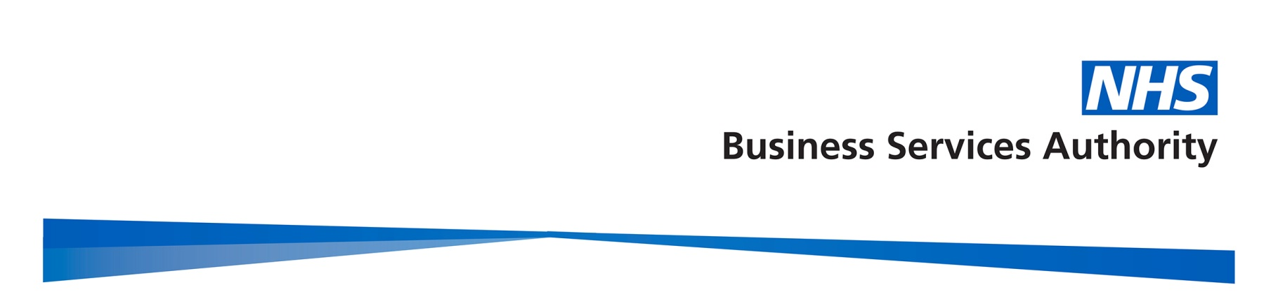
NHS Business Services Authority
Summary of Minutes of the NHSBSA Board Meeting
held at 2.30pm on 5 July 2017 via telephone

Present:

Mark Ellerby Non-Executive Director and Acting Chair
Debra Bailey Non-Executive Director
Andrew Flanagan Non-Executive Director
Tim Nolan Non-Executive Director
Patrick McGahon Director of Finance and Corporate Services
Steven Pink Director of Change & Commercial Delivery

In Attendance:

Mark Dibble Corporate Secretary

Apologies:

Silla Maisey Chair
Alistair McDonald Chief Executive
Nigel Zaman DH

- NHS Pension Accounts 2016/17

With the recommendation of the Audit and Risk Management Committee, Mr Flanagan proposed the Board approve and adopt the Pension Accounts.

Outcome: The Board APPROVED and ADOPTED the NHS Pension Accounts 2016/17.

- Extension of DHL for NHS Supply Chain Services

Mr Pink provided an overview of the contract extension proposal. The Board discussed the proposed extension.

Outcome: The Board APPROVED the contract extension.

- Any Other Business

The Board received and NOTED an update from the Audit Committees held on 5 July 2017.

- Date and Venue of the next Meeting

The next meeting was planned for 9th August 2017 at Stella House in Newcastle.

