Information Services

Information Services Portal – Community Pharmacy Assurance Framework (CPAF)

For pharmacy contractors who recently completed the CPAF survey as a demonstration of compliance with the Community Pharmacy Contract the NHS Business Services Authority has now published the CPAF Screening Response Report where you are able to view the responses you submitted.

Access to this information is via the NHSBSA Information Services Portal hosted on the NHSBSA Prescription Services website https://apps.nhsbsa.nhs.uk/infosystems/welcome

If you're registered for the NHSBSA Information Services Portal, you can access your individual summary report.

If you have not registered for the Information Services Portal and you wish to view the reports, contact Information Services nhsbsa.registration@nhs.net and advise you require access to Information Services Portal to view CPAF Screening Response reports.

This guide provides a brief introduction to the NHSBSA Information Services Portal and how to view the CPAF Screening Response Report.

Once you have activated your account you can log into the NHSBSA Information Services Portal and you will be presented with the home screen:

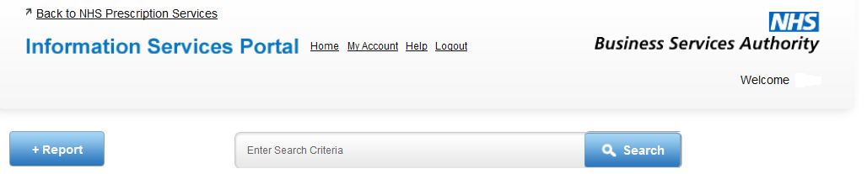

To view your report you will need to click on

+Report contains the following folder – click on this folder

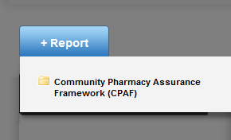

You will be presented with the following screen click on CPAF Screening Responses

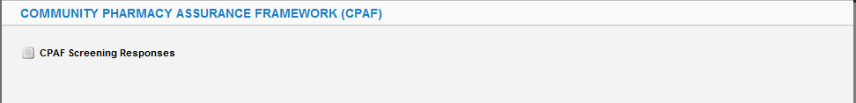

You will be landed on the “Available Reports” screen

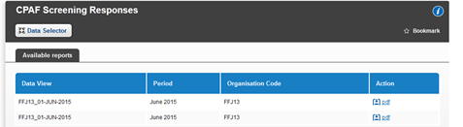

Click on PDF

This will download the relevant data for your Pharmacy.

Access to multiple pharmacies

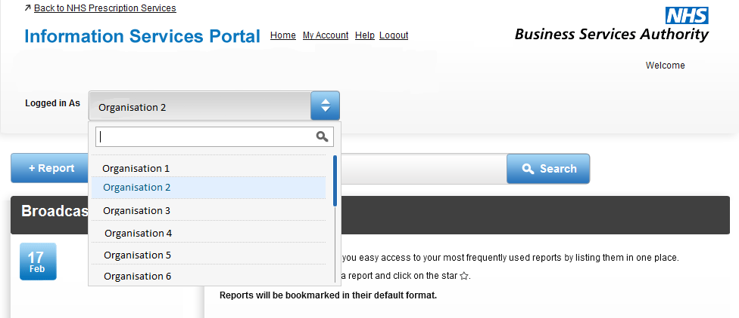

If you have access to the CPAF survey for multiple pharmacies there will be a drop down menu displaying your default active profile. If you wish to access the CPAF survey for an alternative pharmacy, choose the organisation you require from the drop down list.

When the active profile has been changed, a message will appear. The next time you login, the system will have reverted back to the default profile.

Further information
Further information regarding CPAF survey can be found on our webpage (https://www.nhsbsa.nhs.uk/pharmacies-gp-practices-and-appliance-contractors/dispensing-contractors-information/community)

Other useful information for dispensing pharmacy contractors can be found on our webpage (https://www.nhsbsa.nhs.uk/pharmacies-gp-practices-and-appliance-contractors)
Contact us
Information Services support is available 08:30 – 16:30 Monday to Friday.
We can be contacted on 01912035050 or at nhsbsa.help@nhs.net

