ePACT2 User Guide
Accessing Catalyst - Public Insight Portal
Contents
Accessing Catalyst (Public Insight Portal) 1
Logging into Catalyst 2
Understanding the Landing page 4
Reports tab 5
Accessing a report 6
Selecting a report category 6
Report Selection 7
Time Period Comparisons 8
Printing & Exporting 10
Getting Help 12

Accessing Catalyst (Public Insight Portal)
The ‘Catalyst – Public Insight Portal’ can be accessed via the NHSBSA website at https://nhsbsa.nhs.uk/prescription-data/catalyst-public-insight-portal

The ‘Catalyst – Public Insight Portal’ page will be displayed

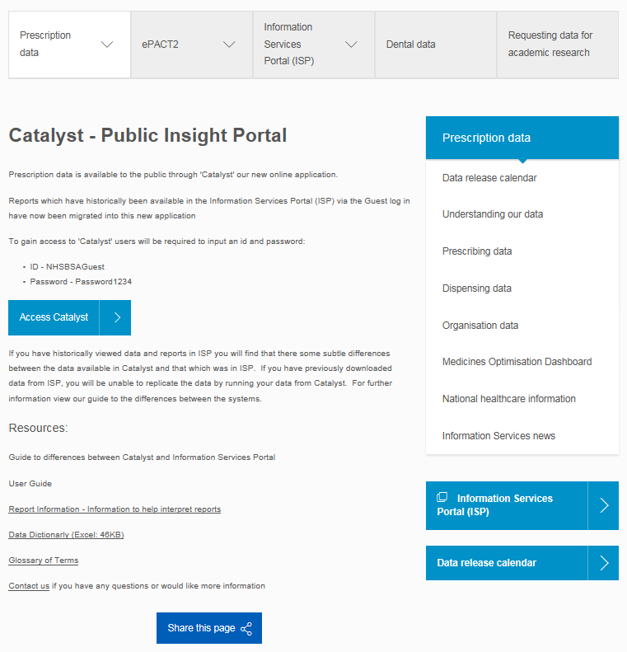

Logging into Catalyst
When accessing ‘Catalyst’ users are required to enter a user ID and Password
- The user ID and password for the system will be displayed on the webpage
- Select the ‘Access Catalyst’ button
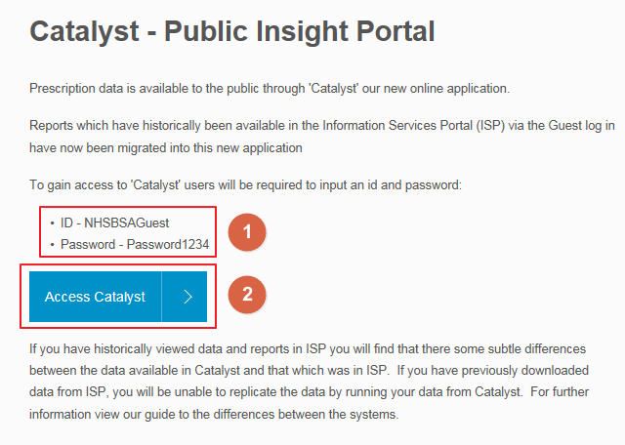

- The login page will be displayed
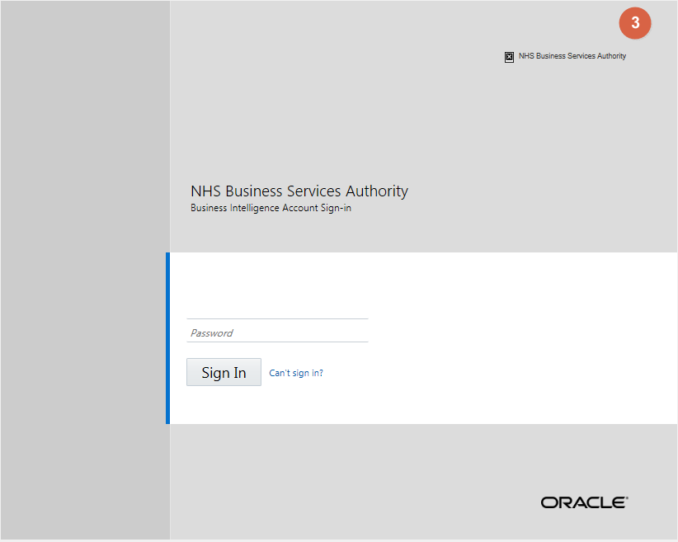
- Enter the login details provided on the webpage
- Click ‘Sign In’
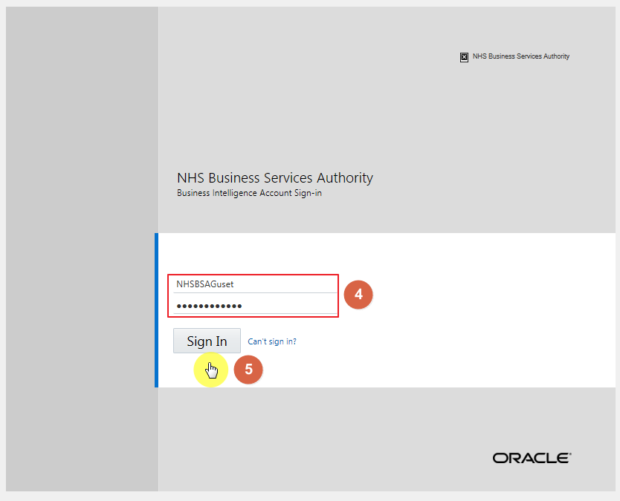

The system will then open on the ‘Catalyst – Public Insight Portal’ landing page

Understanding the Landing page

When you sign into Catalyst you will be taken to the Landing page, the landing page enables you to quickly select the report you would like to view:
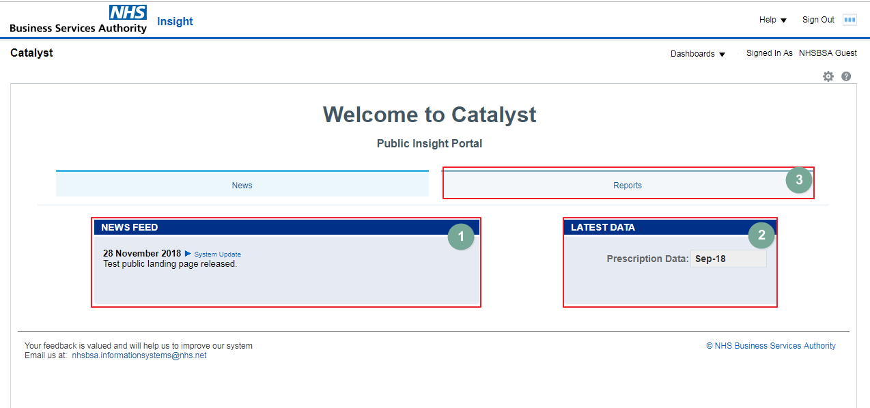
- News feed | The News feed will display the latest news for Catalyst; it will keep you up to date when new reports are released.
- Latest data | This section informs you the latest month’s data that is in the system.
- Reports | You can select this tab to view all available prescribing reports.

To navigate back to the landing page after you have viewed other Catalyst content follow these steps:
- From the ‘Catalyst’ toolbar select ‘Dashboards’
- Select ‘Catalyst’
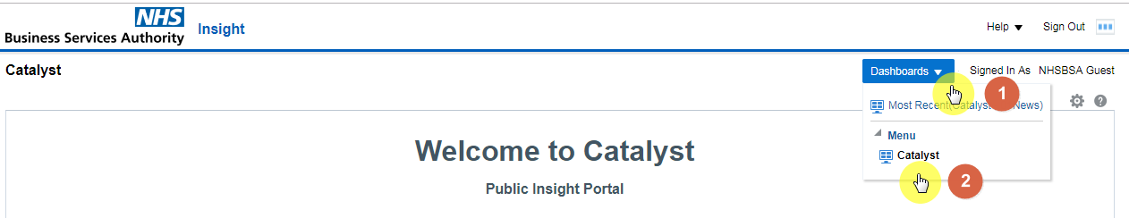

Reports tab
Select the ‘Report’ tab from the ‘Catalyst’ landing page to open the Catalyst Reports page:
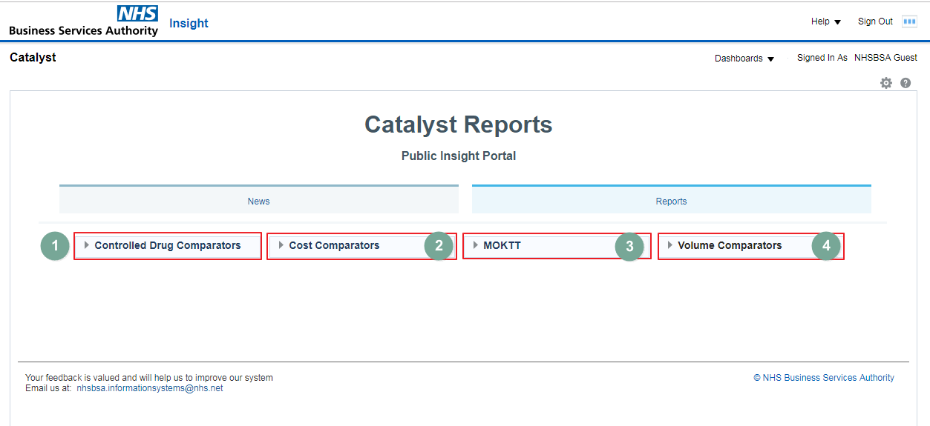
The ‘Reports’ section will allow the selection of the report type required.
- Controlled Drug Comparators | Allows monitoring of the prescribing of Schedule 2 and 3 Controlled Drugs
- Cost Comparators | Allows comparison of the costs of drugs within the therapeutic area using a weighted population.
- MOKTT | Allows organisations and prescribers to review the appropriateness of current prescribing, revise prescribing where appropriate and monitor implementation
- Volume Comparators | Allows comparison of drug utilisation within a therapeutic area on a weighted population basis

Further information on the report categories and the reports available under then can be accessed at https://www.nhsbsa.nhs.uk/information-services-portal-isp/isp-report-information

Accessing a report

Selecting a report category
Report types are grouped together under a category heading.
- To view the report types available under the category click the drop down arrow to the left of the category heading
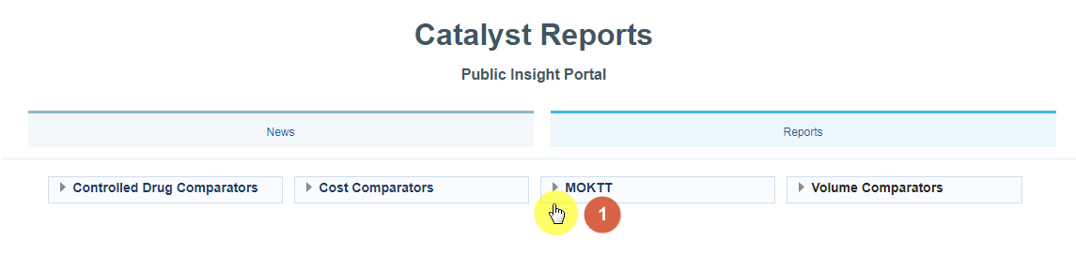
- The report types available will be displayed
- To access the report click the blue hyperlink
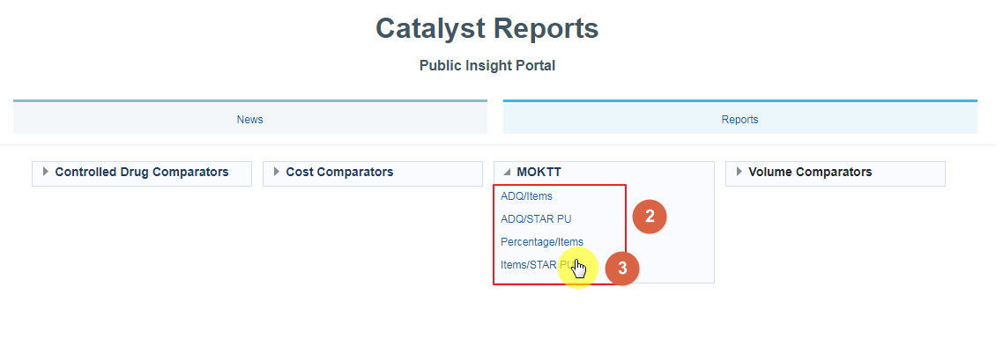
- The Report type page will open
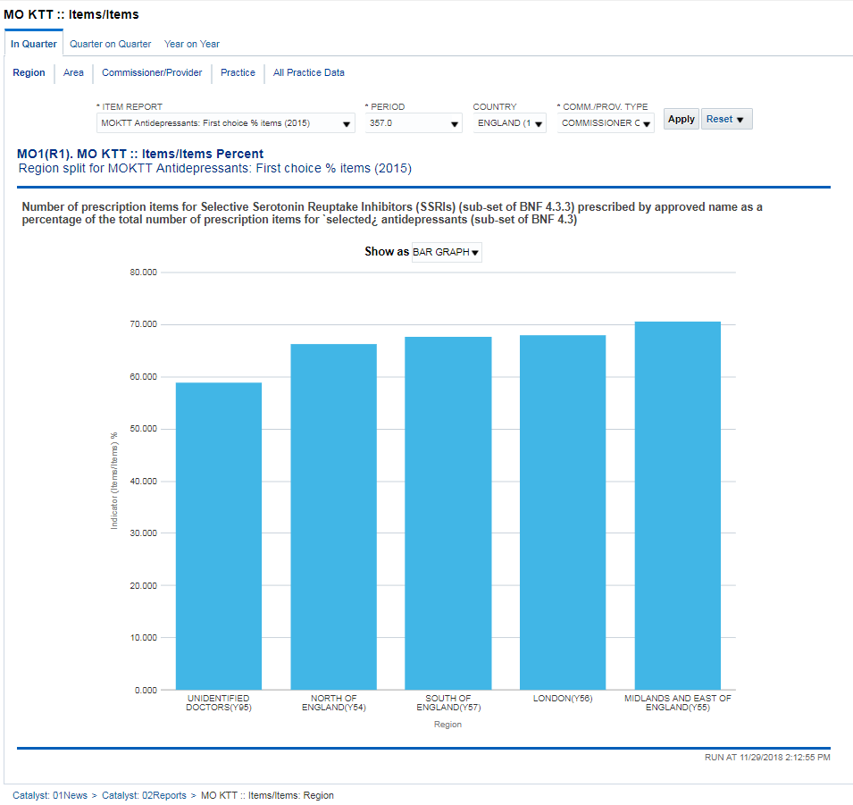

Report Selection
- The report will default to the highest organisational level available however other organisational levels can be viewed by selecting the hyperlink for the organisational level you want to view.
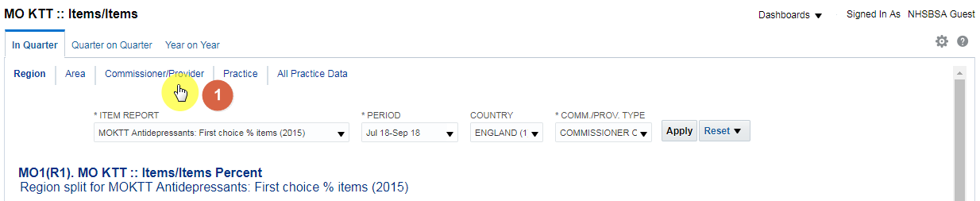
A series of prompts are available on all reports to allow the selection of the report required along with time period, organisation etc.
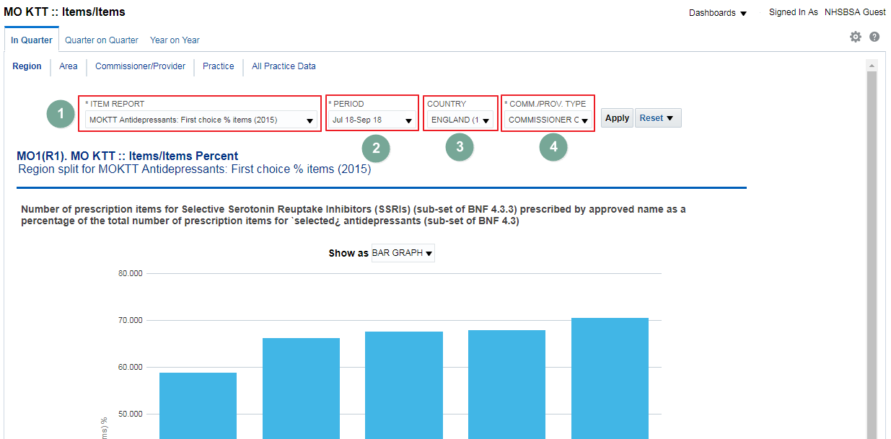
- Report | Allows the selection of the report required, this will default to the first report alphabetically
- Period | Allows the selection of the time period data is required for, this will default to the latest time period available
- Organisation | Allows the selection of the organisation data is required for, this will default to the first organisation alphabetically
- Organisation Type | Allows the selection of the organisation type required, this will default to all types selected

The prompts available to select may differ depending on the report category/report type selected

- Once all criteria has been selected click ‘Apply’ to update the report
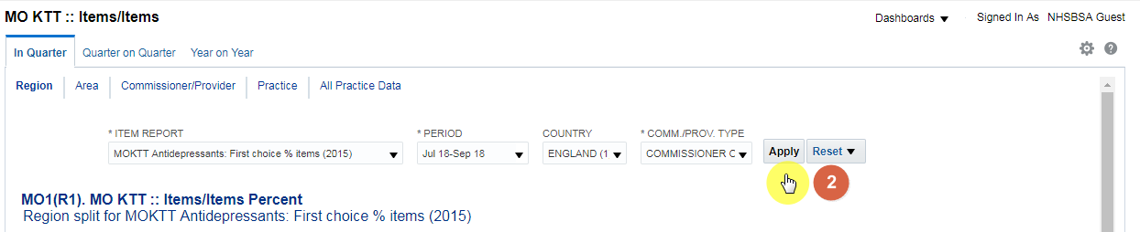

Time Period Comparisons
Within some report categories it is possible to compare prescribing over set time periods
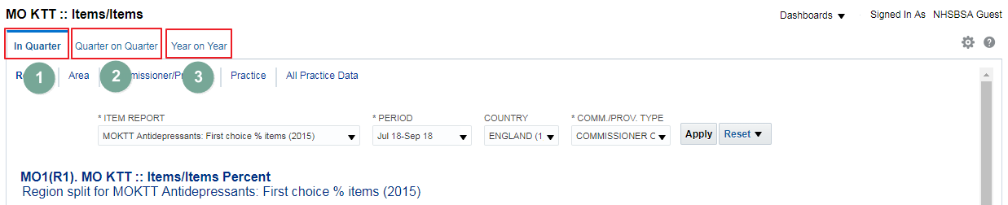

- In Quarter | Shows data for the 3 month period selected
- Quarter on Quarter | Shows data for the quarter selected and the previous 5 quarters
- Year on Year | Shows data for the quarter selected and the same quarter for the 2 previous financial years

- To select an different time period comparison click the link for the time period comparison you want to view.
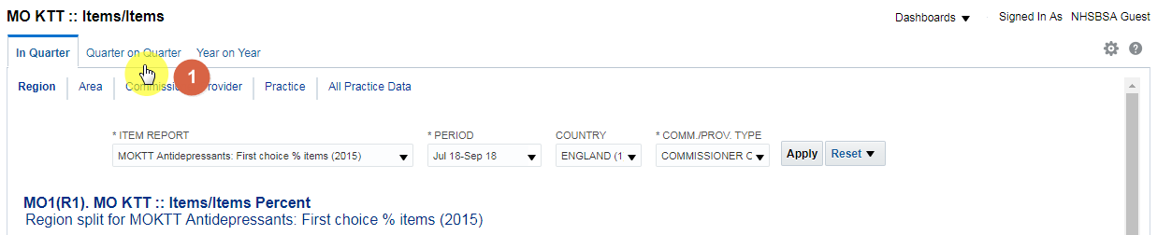
Any prompts selected will remain selected when navigating between time period comparisons

- The time period comparison select will then open
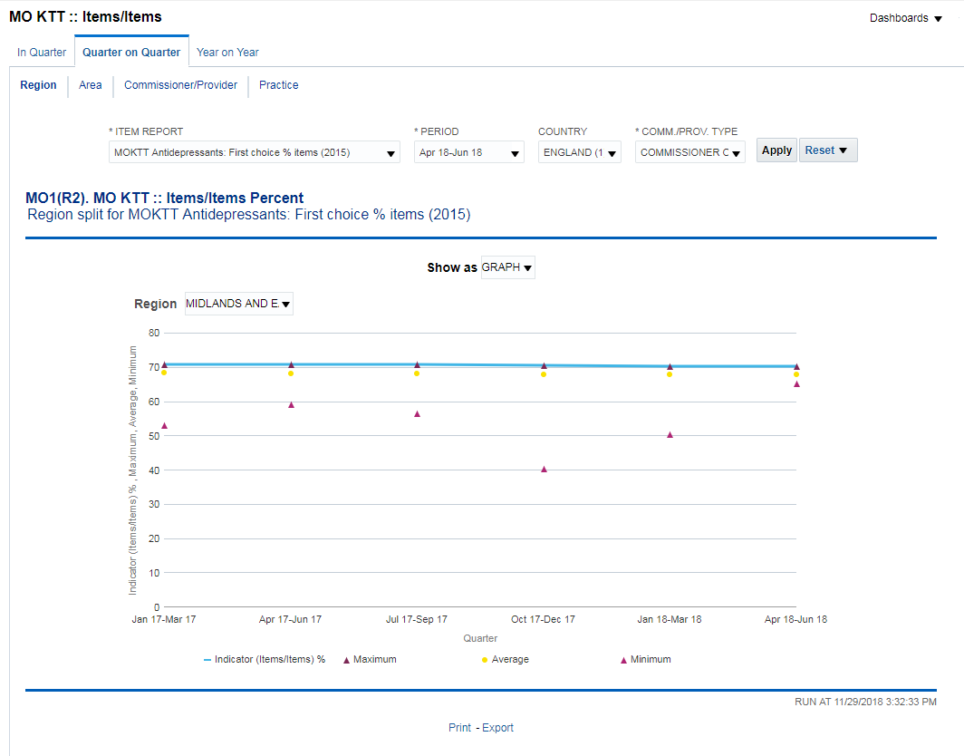

Printing & Exporting

Once reports have been generated they can be printed and exported from the system into a variety of formats

Printing
- To print the report click the ‘Print’ icon shown under the report
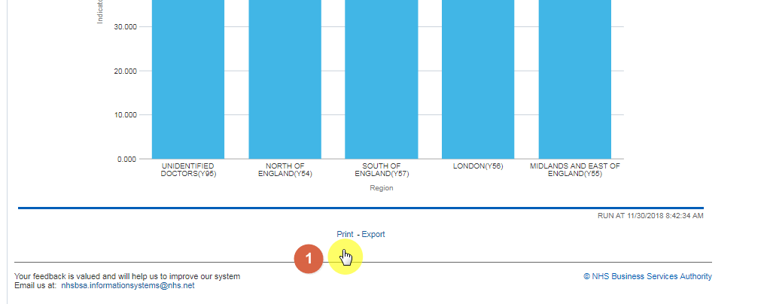
- The formats available to print will be displayed
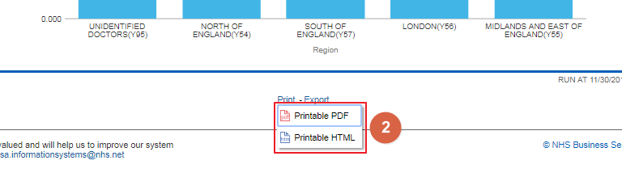

Exporting
- To export the report click the ‘Export’ icon shown under the report
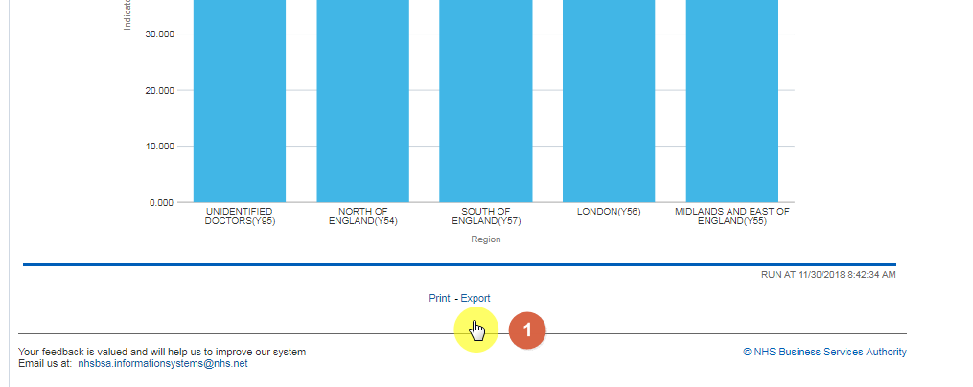
- The formats available to print will be displayed
- CSV format is available to select under the ‘Data’ option
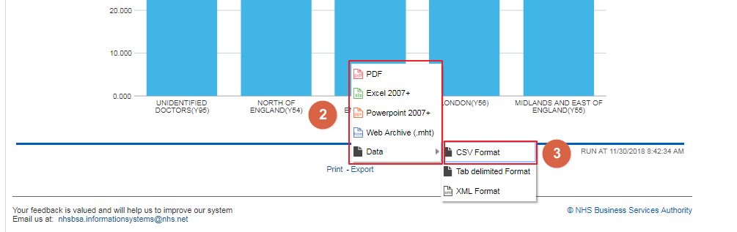

Getting Help

Additional training material and user guides
The NHSBSA has developed a number of how to guides to help you get the best out of ePACT2. These can be found at: Additional User Guides
WebEx sessions
WebEx will be provided on a number of different topics and features. More information about these can be found here: WebEx Training

