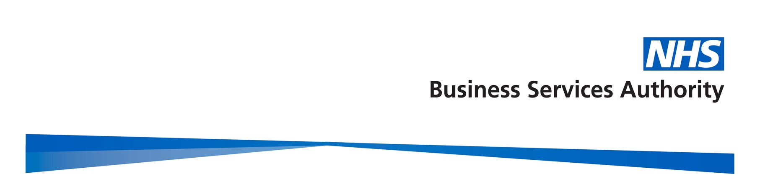

Gender Pay Gap Report

2017/18

Contents
Contents 2
Introduction 3
Gender profile 4
Gender summary of workforce 4
Proportion of males and females in each pay band 4
Proportion of males and females in each pay quartile 6
Gender pay gap in hourly pay 7
Mean gender pay gap in hourly pay 7
Median gender pay gap in hourly pay 7
Bonus gender pay gap 8
Proportion of males and females receiving a bonus payment 8
Mean and median bonus gender pay gap 8
Summary 9
Actions to remove the gender pay gap 10

Introduction

Under the Equality Act 2010 (Specific Duties and Public Authorities) Regulations 2017, the NHS Business Services Authority (NHSBSA), along with all public bodies with more than 250 employees, is required to publish gender pay gap information by 30th March each year. This includes information on the mean and median gender gaps in hourly pay, the mean and median gender gaps in bonus pay, the proportion of men and women who received bonuses, and the proportions of male and female employees in each pay quartile.

The gender pay gap shows the difference in the average pay between all men and women in an organisation. It is different to equal pay, which examines the pay differences between men and women who carry out the same or similar jobs, or work of equal value. It is unlawful to pay people unequally because they are a man or a woman.

At the NHSBSA, our people are at the centre of our business strategy and we aspire to be an employer of choice, which can recruit and retain the most talented of individuals, and create a great place to work. We are committed to a diverse and inclusive culture which supports the fair treatment and reward of all colleagues, irrespective of gender, and our pay framework is based on the principles of fairness, transparency and consistency.

This report fulfils not only our reporting requirements, but sets out what we are doing to address the gender pay gap in our organisation. The data is based on a snapshot of all employees as at 31 March 2018, as this is the date which all public authorities must use each year. The calculations used are those set out in the relevant legislation to ensure the data is calculated consistently across organisations.

Gender profile

Gender summary of workforce

On the 31 March 2018, the NHSBSA employed 2,918 staff. The chart below demonstrates the gender profile of the workforce, which shows that we employ more women (58.6%, and 1711 headcount) than men (41.4% and 1207 headcount).

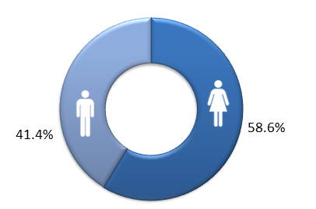

Proportion of males and females in each pay band

The NHSBSA uses NHS Agenda for Change pay bands for the vast majority of staff. Bands vary by levels of responsibility and each band has a set pay range with increments. Colleagues move up the increments in their band on an annual basis so that generally those who have spent longer in the same grade would be expected to earn more, regardless of gender. In addition, we have a small group of employees who are on pay scales other than Agenda for Change. These include; staff on Civil Service grades who transferred into the NHSBSA in 2006, a very small number on NHS Medical and Dental salary scales, and our most senior employees who receive NHS Executive and Senior Manager salaries.

The two charts on the following page reveal the total headcount of staff within each pay band by gender, and the percentages of men and women within each pay band. The salary scales other than Agenda for Change as described above are shown as ‘Non-AfC’ on the charts.

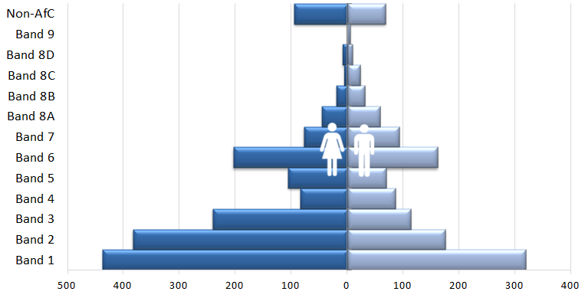

Headcount by Pay Band, by Gender

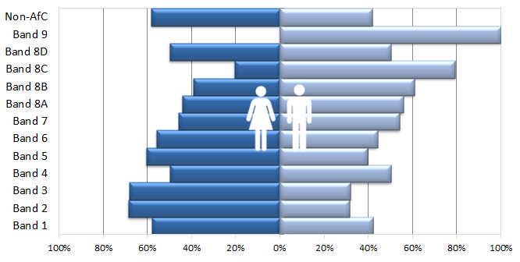

Percentage of men and women in each Pay Band

The charts above reveal that the majority of our staff are concentrated in the lower pay bands (1-3). In addition, these pay bands have significantly higher percentages of female staff, compared to male staff. This gender split is then reversed in the higher pay bands (7 and above).

Proportion of males and females in each pay quartile

The graph below illustrates the gender distribution of the workforce across four equally sized quartiles. The proportion of males and females in each quartile, from the lowest to the highest paid, is calculated by dividing the workforce into four equal parts. It can be seen that the first three quartiles contain a higher percentage of women than men, but this is reversed in the highest quartile. This reflects the analysis by pay band. It is positive to note that there has been an improvement from the previous year in the gender balance in the upper quartile, with 50.4% women in this quartile this year, compared to 48.4% in 2016-17.

2017-18 quartiles

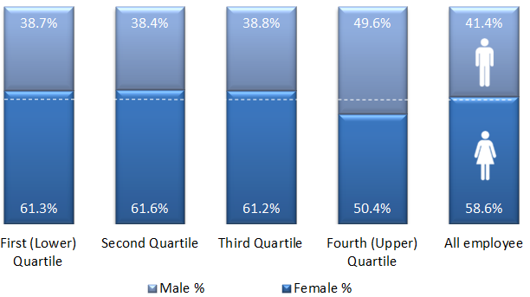
Lowest ← Pay → Highest

2016-17 quartiles

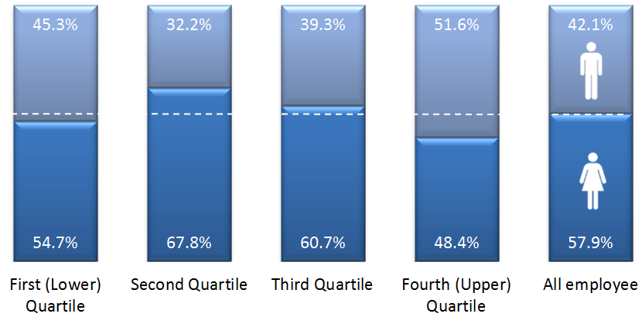
Lowest ← Pay → Highest

Gender pay gap in hourly pay

Mean gender pay gap in hourly pay

The mean, commonly known as the average, is calculated by adding up the wages of all employees and dividing the figure by the total number of employees. The mean gender pay gap is the difference between mean male pay and mean female pay. The mean gender pay gap for hourly pay within the NHSBSA in 2017-18 is 14.1%. This difference in hourly pay is influenced by the greater proportion of male staff in the higher pay bands. It is encouraging to note that this has reduced from 2016-17, by 1.3%.
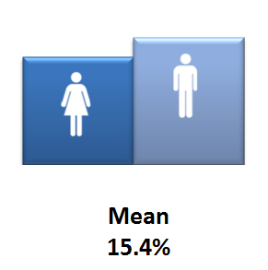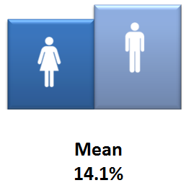
2016-17 2017-18

Median gender pay gap in hourly pay

The median is the figure that falls in the middle of a range when the wages of all employees are lined up from the lowest to the highest salary. The median gap is the difference between the employee in the middle of the range of male wages and the middle employee in the range of female wages. The median is regarded as typically a more representative figure than the mean, which can be distorted by a handful of highly paid employees.

In 2017-18 there is a 3.1% median gender pay gap between men and women in the NHSBSA, compared to 0% in the previous year, which was very unusual statistically.
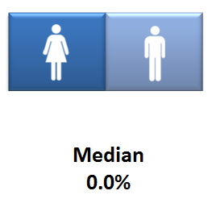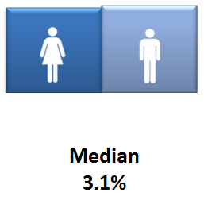
2016-17 2017-18

Bonus gender pay gap

The NHSBSA has a performance related bonus paid in only one area of the organisation (NHS Prescription Services) where the bonus is paid for high volume data entry depending on output and accuracy, regardless of gender. The staff roles that qualify for the bonus are in Agenda for Change pay bands 1 and 2 at the lower end of the pay scale.

Proportion of males and females receiving a bonus payment

More female staff than men received a bonus in 2017-18, with 29.5% of total female staff, compared to 24% of all male staff receiving a bonus in the same period. This was influenced by the greater proportion of female staff in pay bands 1 and 2, in the roles which qualify for the bonus. It is interesting to note that the overall amount of all employees receiving a bonus has reduced from the previous year.

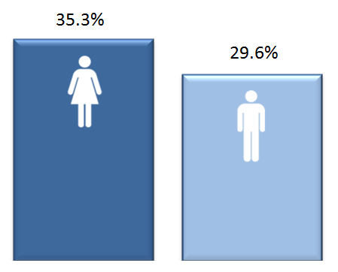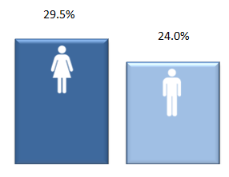
2016-17 2017-18

Mean and median bonus gender pay gap

The chart below reveals that there is a 14.7% pay gap between the mean bonus pay of the male and female staff who received the above bonus in the year 2017-18, and a 12.4% bonus pay gap using the median calculation. This shows that although more women than men received a bonus, on average men received a higher bonus amount, which would be linked to achieving higher rates of output and accuracy. It is positive to note that the median bonus pay gap has reduced by 3.3% from 2016-17, although the mean has increased by 4.2%.
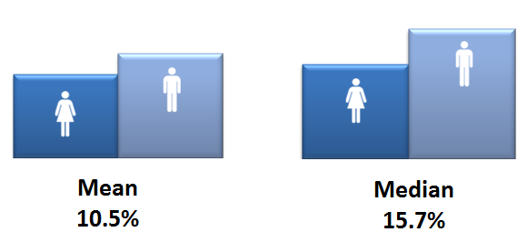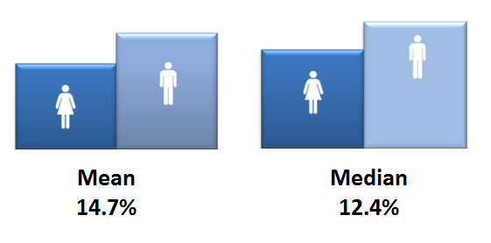
2016-17 2017-18

Summary

The table below summarises the various gender pay gap calculations for 2017-18 and includes those for 2016-17, for comparison purposes. The mean gender pay gap for hourly pay within the NHSBSA in 2017-18 is 14.1%. This difference in hourly pay is influenced by the greater proportion of male staff occupying more roles in the higher pay bands. It is encouraging to note that this has reduced from 2016-17, by 1.3%.

The median is regarded as typically a more representative figure than the mean, which can be distorted by a handful of highly paid employees. In 2017-18 there is a 3.1% median gender pay gap between men and women in the NHSBSA. Although this has increased slightly from 0% in the previous year, 0% was unusual statistically.

 |  |  | % 2016-17 | % 2017-18 | % change
Median gender pay gap |  |  | 0% | 3.1% | + 3.1%
Mean gender pay gap |  |  | 15.4% | 14.1% | - 1.3%
Median bonus gender pay gap |  |  | 15.7% | 12.4% | - 3.3%
Mean bonus gender pay gap |  |  | 10.5% | 14.7% | + 4.2%
Proportion of male and female employees paid a bonus: |  | Male | 29.6% | 24.0% | - 5.6%
 |  | Female | 35.3% | 29.5% | - 5.8%
Proportion of male and female employees in each quartile:
 | 2016-17 |  |  | 2017-18
Quartile | Female % |  | Male % | Female % | Male %
First (lower) quartile | 55% |  | 45% | 61% | 39%
Second quartile | 68% |  | 32% | 62% | 38%
Third quartile | 61% |  | 39% | 61% | 39%
Fourth (upper) quartile | 48% |  | 52% | 50% | 50%

Actions to remove the gender pay gap

The NHSBSA is committed to addressing our gender pay gap and is undertaking a range of actions to reduce this. During the last year, progress has been made in the following key areas:

- Ensuring that gender equality is a key part of our Diversity and Inclusion Strategy, and engaging with staff on these issues through our Diversity and Inclusion Network and Wellbeing and Inclusion Committee, to understand any additional barriers women may face in the workplace.
- Delivering communications campaigns for staff and externally, such as those for International Women’s Day, which raise awareness of female role models working at a senior level within the NHSBSA or in a traditionally male-dominated occupation.
- Supporting all staff to develop their careers and reach their potential through the launch of our new enhanced appraisal and personal development planning process, as well as promotion of learning and development opportunities.
- Reviewing our external and internal recruitment and selection processes, to ensure they support fairness and equality in all our recruitment, and extending our candidate reach by utilising social media and other recruitment platforms to attract a wider and more diverse range of applicants.
- Supporting women returning to work following maternity or adoption leave. We offer shared parental leave and flexible working opportunities for all staff, and are committed to ensuring we have a high return rate from those taking maternity or adoption leave.

Going forward, we will focus on:

- Gathering further insight to understand the experiences of women working in the NHSBSA through holding focus groups, and empowering participants to help address any issues identified through the use of action learning sets.
- Raising awareness amongst managers to support them to hold career conversations with their team members, to help our people to reach their potential.
- Launching a talent management strategy linked to our enhanced appraisal and PDP process, aimed at developing and retaining our people with potential and also attracting external talent.
- Working collaboratively with the NHS Leadership Academy and others on talent programmes.
- Implementing a leadership development programme with bespoke elements aimed specifically at female staff with potential, based on the outputs of the above focus groups, to help develop skills and confidence to progress to senior roles.
- As part of a wider work stream on recruitment and on-boarding, identifying and removing any gender bias, including unconscious bias, in the selection methods we use, and ensure the recruitment process is returner-friendly. We will ensure that interviewers have undergone recruitment training including understanding of bias and the importance of only using structured interviews and standard assessment criteria. We will also increase the use of skill-based assessment tasks in recruitment as a more effective measure of suitability for a role than interview.
- We will actively encourage flexible working, develop guidance for Carers and their managers, to ensure that all colleagues with caring responsibilities know how to access the options available.
- Review our family-friendly HR policies including Shared Parental Leave, develop supporting guidance for colleagues and managers, and increase awareness and uptake of these through promotional campaigns for colleagues.
- Encourage flexible working to be considered for all new vacancies, at every level of the organisation, and that colleagues and managers understand the benefits of flexible working, to ensure that all our people, irrespective of gender, have the opportunity to work in a way that supports their career aspirations and home life balance.
- Measure the impact of flexible working and family-friendly policies to be able to monitor uptake effectively.

