NHSBSA Annex 5.10 Ophthalmic visit form
Guidance document for Contractors

The following guidance is given to inform you of the evidence and policies that are required before a site visit can proceed. This evidence is checked for compliance by the NHSBSA caseworker assigned to your application.

Everything in a green box needs to be submitted prior to site visit. Everything in a red box is information/guidance for the contractor. Can you ensure that all policies have an author and review date.

Section 1 to 6 will be pre-populated, please check this information before proceeding and let NHSBSA know of any changes that need to be made.

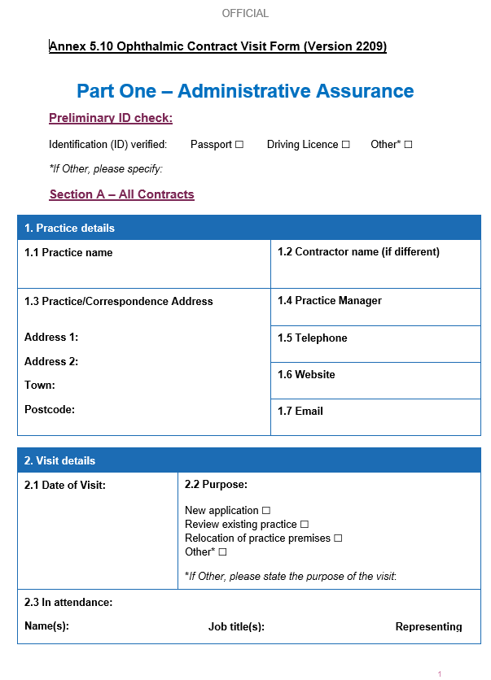
Identification to be provided at or before the virtual site visit taking place.
This should be the email address to be used for all correspondence relating to this document. It may be different to emails for other purposes.
If entering more than one email address, state the purpose of each.

Contractors should check this on an annual basis in April/May.
‘Where applicable’ is only relevant for instances where the Contractor holds the insurance for all their performers centrally.
If the hours GOS is provided within the practice are different to the practice opening hours, then this needs to be stated and differentiated from the practice opening hours.

The Contractor should write in this space, the relevant region responsible for each of their individual performers.
Required prior to visit Printout/
screenshot of GOC registration for each performer.
Required prior to visit. This could be a copy of references for each performer, copy of reference template or copy of practice policy.
Required prior to visit
Copies of valid PI certificate for each performer or company policy showing PI where appropriate.

Required prior to visit.
Required prior to visit. Copy of MRA registration certificate.
Copy required prior to visit.
Required prior to visit. Print out/screenshot of entry from OPL for England for each performer.
Required prior to visit. Written description of how this is done.
If the Contractor does not undertake remote edging/
glazing, N/A can be entered.

Required prior to visit. Copy of current policy clearly showing public liability cover.
Contractor should hold documentary evidence of inclusion.

Submit evidence of this prior to visit.
Details of local contacts with contact details.
Submit copy prior to visit.
Submit name of DPO prior to visit.
Required prior to visit. Copy of current certificate from ICO.
Copy of personalised Freedom of Information Act 2005 required prior to visit.
This is for patient data held on a computer or other electronic device.
Data Protection (Charges and Information) Regulations 2018.

Entries need only be made if value of gift >£100.
Submit copy prior to visit.
Submit name prior to visit.
Submit copy prior to visit.
Submit copy of gifts register prior to virtual visit.

Required prior to visit.
Required prior to visit.
Notice should be displayed in a prominent place, so patients are aware of their right to a chaperone.
Must be completed/
documented if five or more employees or individuals are under contract to provide services within the company/
organisation.
Required prior to visit.
Required prior to visit.
Companies Act 2006.
Running a limited company: your responsibilities: Signs, stationery and promotional material - GOV.UK (www.gov.uk)
GOS Hours information is needed prior to visit.

Evidence
This may be part of the Health and Safety Policy.

Evidence required prior to visit.
Certificate required prior to visit.
Where fire extinguishers are not new submit evidence of last service prior to virtual visit including photographic evidence of up to date service details on each appliance. Where new submit invoice.
Required prior to visit.
Ensure that the fire extinguishers are accessible.
Date of last service should be stated on fire extinguisher.
Ensure that the fire exits are clearly marked in the practice.
If existing practice submit evidence of transfer notes from previous 2 years.
Documents required prior to visit.
This should include adequate toilet and washing facilities.
Workplace (Health and Welfare) Regulations 1992.
I.e., transfer notes two years, and consignment notes three years.

You can register at: www.wastecarriersregistration.service. gov.uk
Required prior to visit.
Required prior to visit.
Submit copy prior to virtual visit.
Submit copy of current domiciliary code of conduct prior to virtual visit.
Required prior to visit.
I.e., transfer notes two years, and consignment notes three years.

