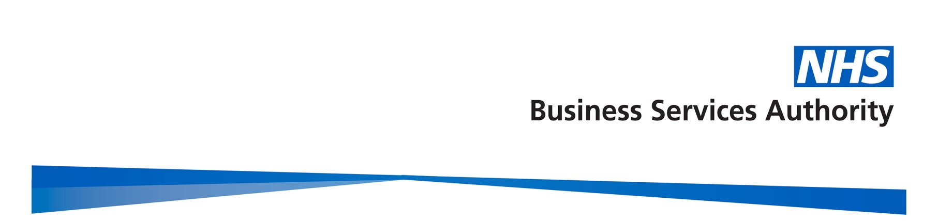

Gender Pay Gap Report

2021/22

January 2023

Contents
Contents 2
Introduction 3
Gender profile 4
Gender summary of workforce 4
Proportion of males and females in each pay band 4
9
Proportion of males and females in each pay quartile 10
Gender pay gap in hourly pay 11
Mean gender pay gap in hourly pay 11
Median gender pay gap in hourly pay 12
Bonus gender pay gap 12
Proportion of males and females receiving a bonus payment 12
Mean and median bonus gender pay gap 13
Further analysis 14
Summary 15
Actions to remove the gender pay gap 16

Introduction

Under the Equality Act 2010 (Specific Duties and Public Authorities) Regulations 2017, the NHS Business Services Authority (NHSBSA), along with all public bodies with more than 250 employees, is required to publish gender pay gap information by 30th March each year. This includes information on the mean and median gender gaps in hourly pay, the mean and median gender gaps in bonus pay, the proportion of men and women who received bonuses, and the proportions of male and female employees in each pay quartile.

The gender pay gap shows the difference in the average pay between all men and women in an organisation. It is different to equal pay, which examines the pay differences between men and women who carry out the same or similar jobs, or work of equal value. It is unlawful to pay people unequally because they are a man or a woman.

At the NHSBSA, our people are at the centre of our business strategy, and we aspire to be an employer of choice who provides a great place to work and can recruit and retain the right talent with the wide range of knowledge, skills and capabilities we need. We are committed to a diverse and inclusive culture which supports the fair treatment and reward of all colleagues, irrespective of gender, and our pay framework is based on the principles of fairness, transparency, and consistency.

This report fulfils our reporting requirements and sets out what we are doing to address the gender pay gap in our organisation. The data is based on a snapshot of all employees as of 31 March 2022, as this is the date which all public authorities must use each year. The calculations used are those set out in the relevant legislation to ensure the data is calculated consistently across organisations.

Gender profile

Gender summary of workforce

On the 31 March 2022, the NHSBSA employed 3,512 staff, an increase in headcount of 220 from the previous year. The chart below demonstrates the gender profile of the workforce, which shows that we employ more women (59.4%, and 2087 headcount) than men (40.6% and 1425 headcount).
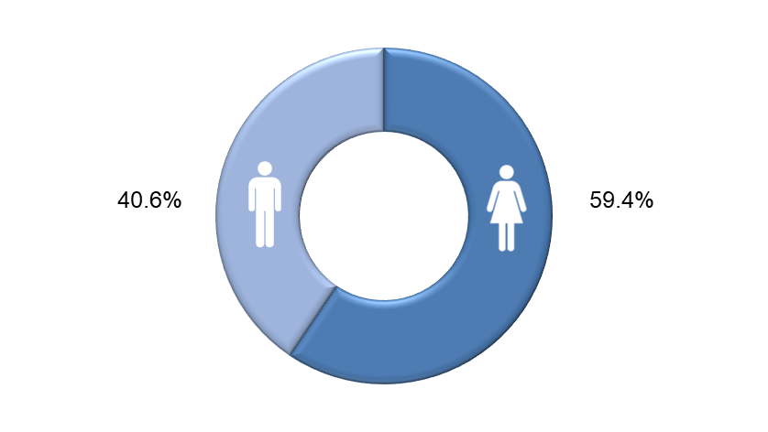

Proportion of males and females in each pay band

The NHSBSA uses NHS Agenda for Change pay bands for the vast majority of staff. Bands vary by levels of responsibility and each band has a set pay range with increments. Colleagues move up the increments in their band on a length of service basis so that generally those who have spent longer in the same grade would be expected to earn more, regardless of gender. In addition, we have a small group of employees who are on pay scales other than Agenda for Change. These include staff on Civil Service grades who transferred into the NHSBSA in 2006, a very small number on NHS Medical and Dental salary scales, and our most senior employees who receive NHS Executive and Very Senior Manager salaries.

The charts on the following page reveal the total headcount of staff within each pay band by gender, and the percentages of men and women within each pay band. Comparisons to the previous year’s data are also included. The salary scales other than Agenda for Change as described above are shown as ‘Non-AfC’ on the charts.

Headcount by Pay Band, by Gender as at March 2022

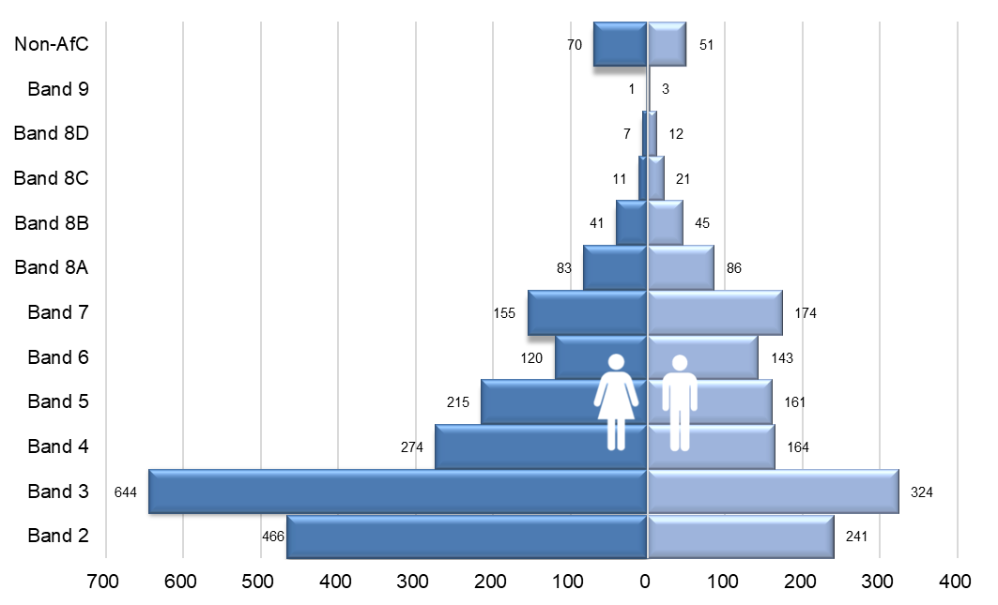

Headcount by Pay Band, by Gender as at March 2021

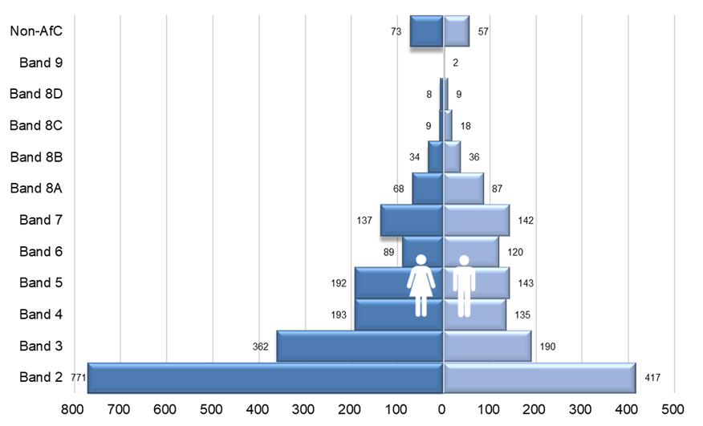

Percentage of men and women in each Pay Band as of March 2022
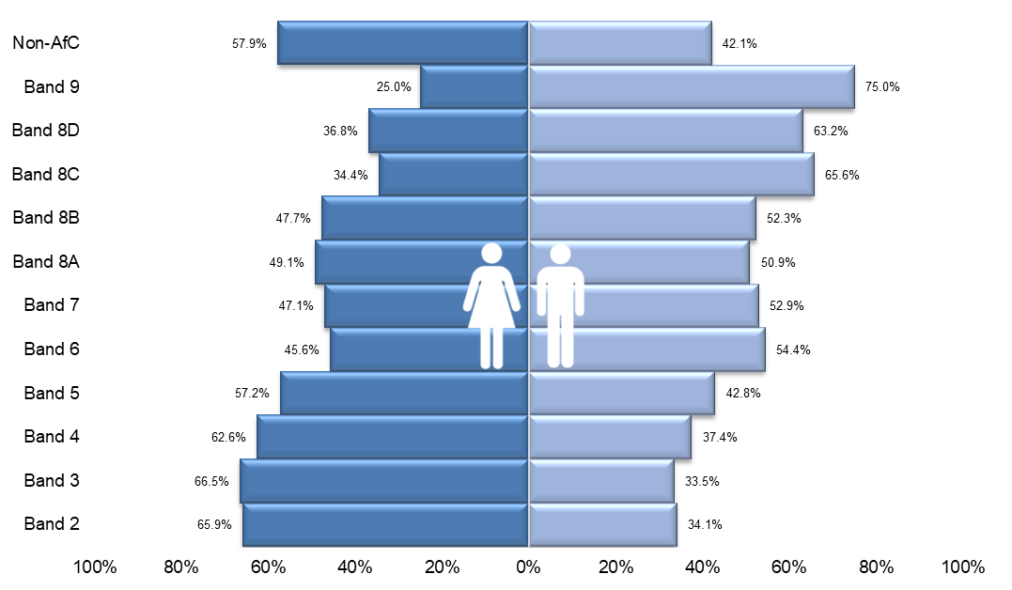

Percentage of men and women in each Pay Band as of March 2021

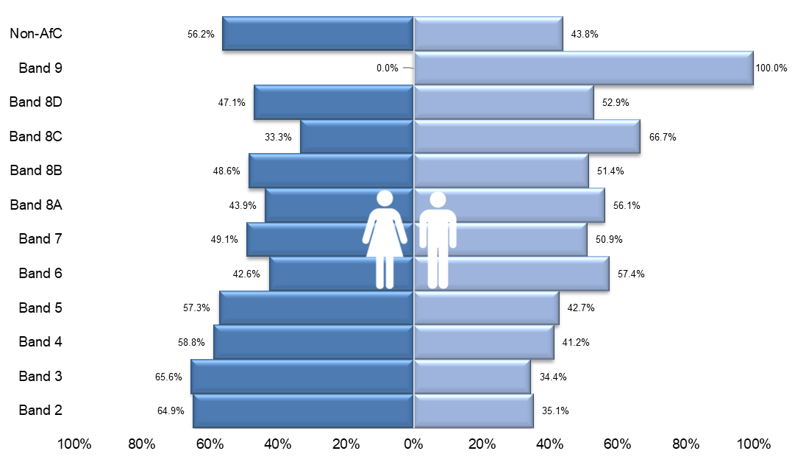

The charts above reveal that most of our staff continue to be concentrated in the lower pay bands (2-5). In addition, these pay bands have higher percentages of female staff, as do non-AfC pay scales, compared to male staff, and this has significantly increased this year in bands 3, 4 and 5. Conversely, there are more male staff in all pay bands from band 6 and upwards. In comparison to last year’s data, male representation in pay bands 7, 8b and 8d has slightly increased, however further analysis of our starters and leavers data for the year revealed that for Band 8a upwards the net change is an increase in headcount of 6 women and 4 men, which is positive to note.

Hourly Rate by gender for each grade

The following graphs show the breakdown by mean and median hourly rates for each grade, by gender.

Mean Hourly rate for each grade

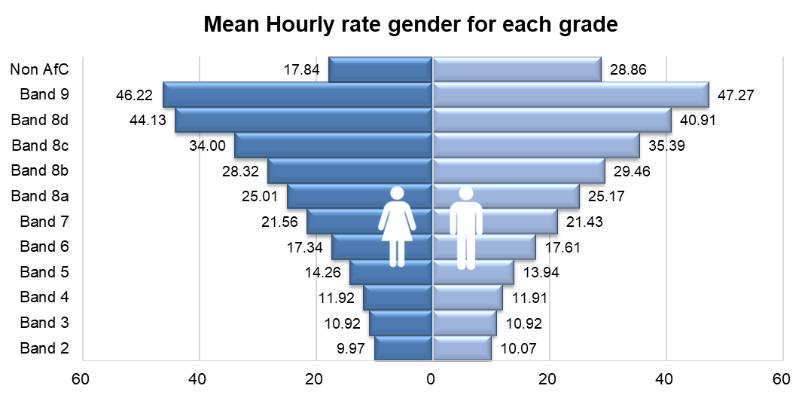

Median Hourly rate for each grade

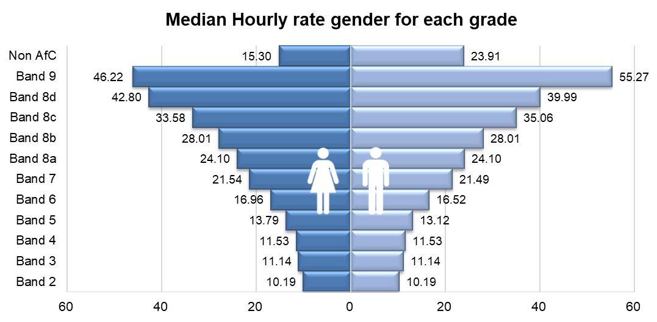

Mean and Median Pay Gap per Band

The charts below demonstrate the mean and median pay gap between men and women at each pay band. These reveal that some of the larger pay gaps are at the bands where there is a small head count and these individuals are mostly of one gender, for example there are less than 5 colleagues within Band 9 and they are mostly male, so the mean and median pay gaps for Band 9 are larger than in other pay bands.
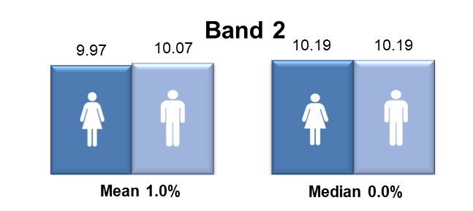
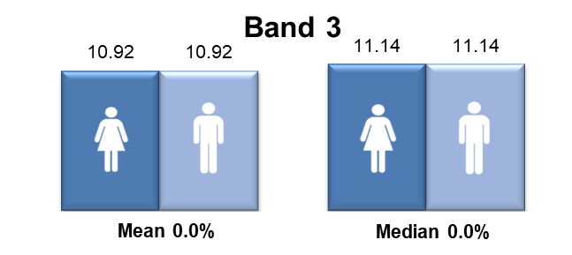
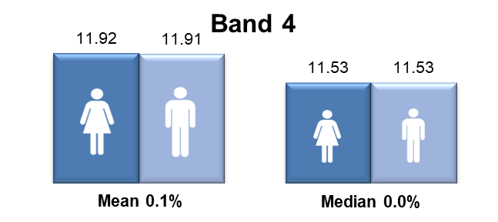
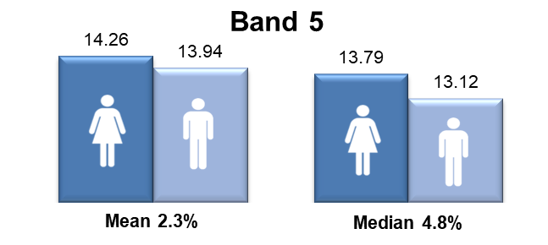
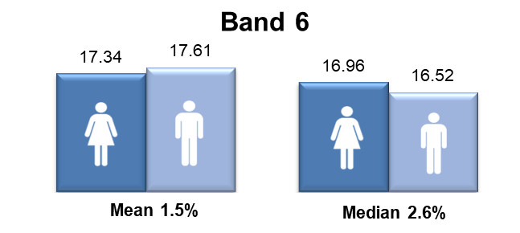
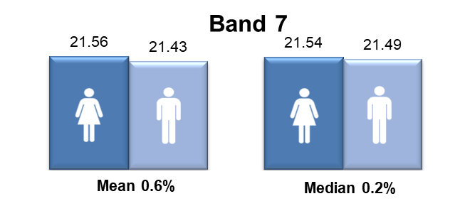
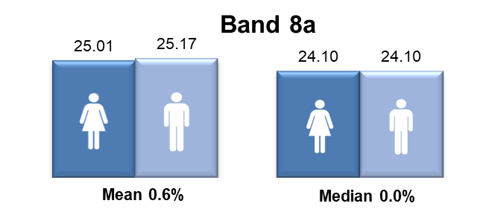
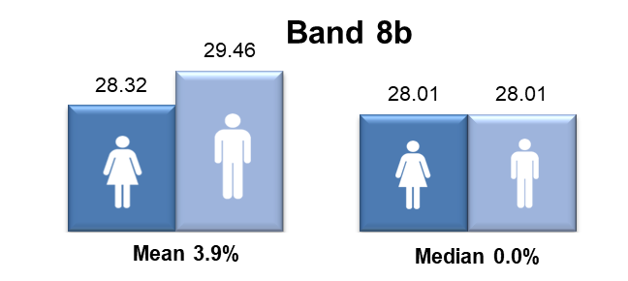
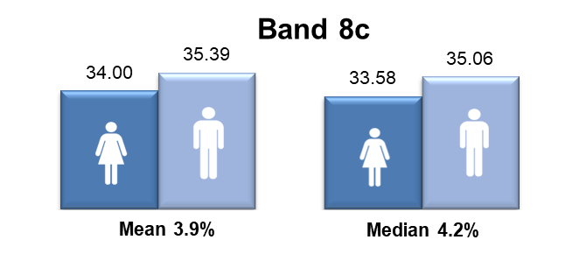
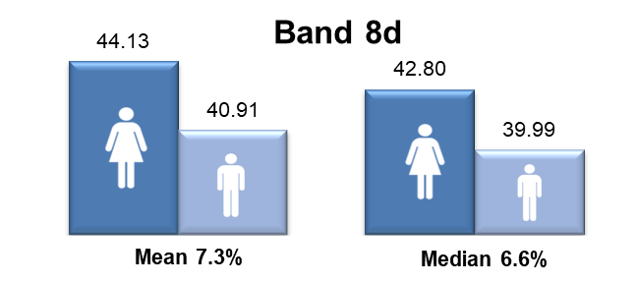

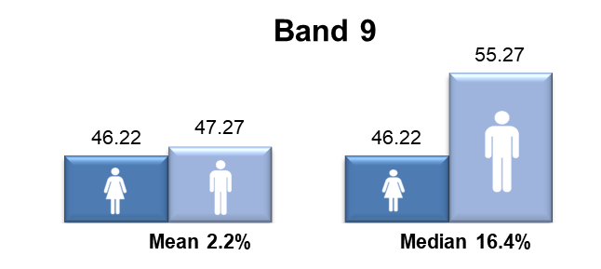

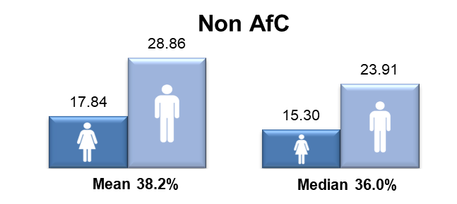

Proportion of males and females in each pay quartile

The graph below illustrates the gender distribution of the workforce across four equally sized quartiles. The proportion of males and females in each quartile, from the lowest to the highest paid, is calculated by dividing the workforce into four equal parts. The first three quartiles contain a higher percentage of women than men, but this is reversed in the highest quartile. This reflects the analysis by pay band.

2021-22 quartiles

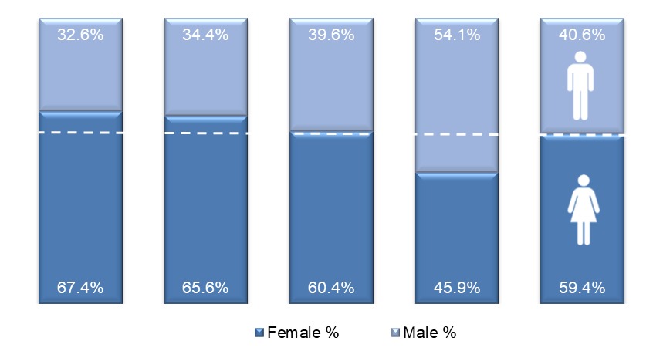
Lowest ← Pay → Highest

For comparison purposes, the pay quartiles from the previous year have been included overleaf. This reveals that the percentage of female colleagues in the first (lower) quartile has increased by 5.1%, reduced by 2% in the second quartile, increased 0.7% in the third quartile, and has increased by 0.3% in the fourth (highest) quartile.

2020-21 quartiles

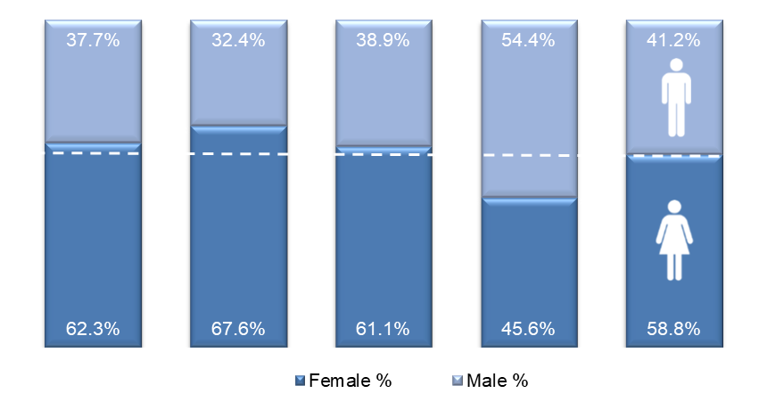

Gender pay gap in hourly pay

Mean gender pay gap in hourly pay

The mean, commonly known as the average, is calculated by adding up the wages of all employees and dividing the figure by the total number of employees. The mean gender pay gap is the difference between mean male pay and mean female pay. The mean gender pay gap for hourly pay within the NHSBSA in 2021-2022 is 14%. This difference in hourly pay is influenced by the greater proportion of female staff in most of the lower pay bands. This has increased by 1.4% since 2020-21 and is an increase for the second year running.
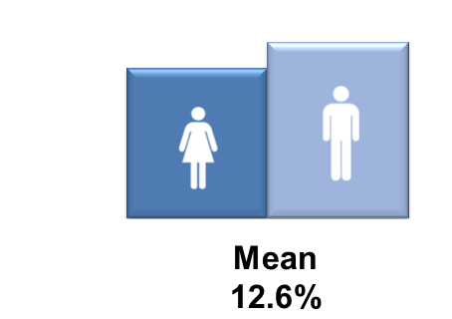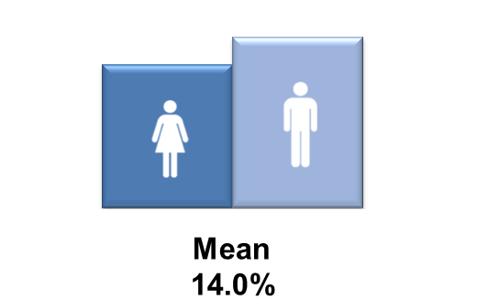
2020-21 2021-22

Median gender pay gap in hourly pay

The median is the figure that falls in the middle of a range when the pay of all employees are lined up from the lowest to the highest salary. The median gap is the difference between the employee in the middle of the range of male pay and the middle employee in the range of female pay. The median is typically regarded as a more representative figure than the mean, which can be distorted by a handful of highly paid employees. In 2022 there is a 12.5% median gender pay gap between men and women in the NHSBSA, this is an increase of 10.2% on the previous year. This can in part, be attributed to the significant increase in female staff headcount in pay bands 3,4 and 5.
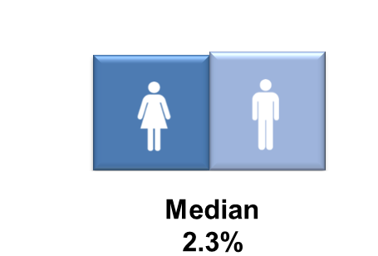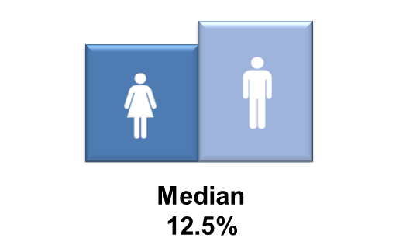
2020-21 2021-22

Bonus gender pay gap

The NHSBSA had a performance related bonus paid in only one area of the organisation (NHS Prescription Services), where the bonus was paid for high volume data entry depending on output and accuracy, regardless of gender. The roles that qualified for the bonus were in Agenda for Change pay band 2 only, the lowest band of the pay scale. The bonus scheme was phased out in September 2021, meaning that bonus payments are no longer paid within the NHSBSA from October 2021 onwards. As the reporting period for the gender pay gap bonus payments covers the 12 month period prior to the snapshot date, those bonuses paid up to and including September 2021 are included in this report.

Proportion of males and females receiving a bonus payment

More female staff than men received a bonus in 2021-22, with 16.9% of total female staff, compared to 13.1% of all male staff receiving a bonus in the same period. This was influenced by the greater proportion of female staff in the roles which qualify for the bonus. It is interesting to note that the overall amount of all employees receiving a bonus had reduced from the previous year.
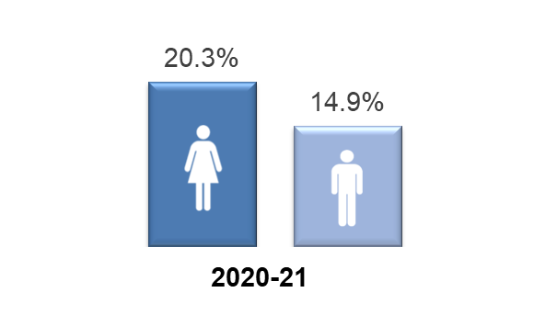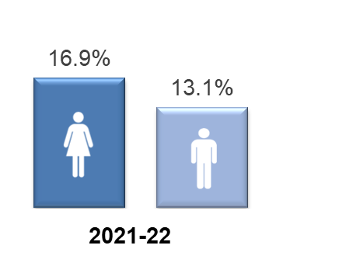

Mean and median bonus gender pay gap

The chart below reveals that there is a 16.1% pay gap between the mean bonus pay of the male and female staff who received the above bonus in the year 2021-22, and a 16.8% bonus pay gap using the median calculation. This shows that although more women than men received a bonus, on average, men received a higher bonus amount. It is positive to note that the mean bonus pay gap has reduced by 0.2% from 2020-21 however the median bonus pay gap has increased by 4.4% in 2021-22.

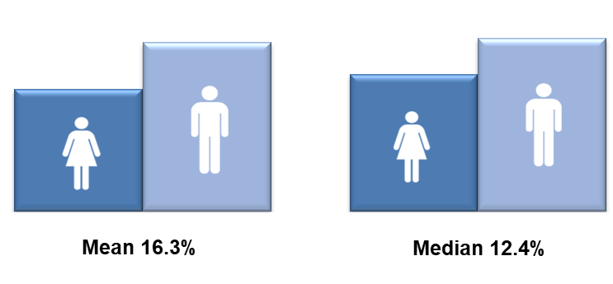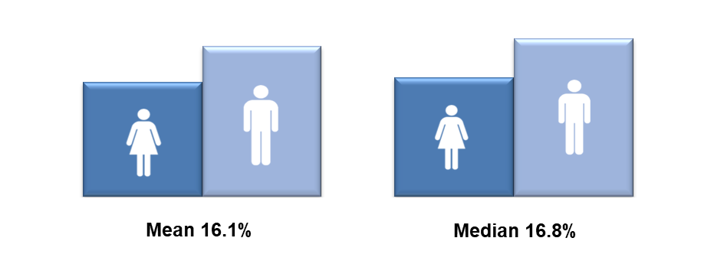

2020-21 2021-22

Further analysis

In order to better understand what has caused the increase in mean and median pay gaps, further data was analysed for the same reporting period including our external recruitment, internal promotion and leavers data. This has identified some key findings as follows:

Male | Female | Finding
16.3% | 20.4% | Percentage of colleagues who moved up by one Band between 31-Mar-21 to 31-Mar 22
5.2% | 5.5% | Percentage of colleagues who moved up by two Bands or more between 31-Mar-21 and 31-Mar-22
21.9% | 24.9% | Percentage of colleagues who had a salary increase of between 10% and 20%, between 31-Mar-21 and 31-Mar-22
193 | 321 | Number of new starters externally recruited after 01-Apr-22
102 | 234 | Number of new starters externally recruited into Bands 2&3 after 01-Apr-22 (included in above totals)
2 | 8 | Number of new starters recruited into Band 8a roles after 01-Apr-22
4 | 6 | Net change (taking into account starters, promotions, and leavers) for headcount in roles in Band 8a and above

This reveals that the gender pay gap has increased because we recruited a significantly higher percentage of women into the organisation in 2021/22 than men, in particular when we recruited to the lower pay bands (2 and 3), and the linear effect of this is that the median point for women has moved to the left. However, within the data we can see there are some very positive outcomes in respect of:

- internal progression for women within the NHSBSA (20.4% of female colleagues moved up one pay band and 24.9% moved up two bands or more, compared to 16.3% and 21.9% of male colleagues respectively during the year)
- external recruitment of women (321 women compared to 193 men), and
- recruitment of women into senior roles (8 women were recruited into band 8a roles compared to 2 men, and a net change of headcount in roles at 8a and above has led to an increase of 6 women compared to 4 men).

Summary

The table below summarises the various gender pay gap calculations for 2021-22 and includes those from the previous year for comparison purposes. The mean gender pay gap for hourly pay within the NHSBSA in 2021-22 is 14%, and this has increased by 1.4% from the previous year. This difference in hourly pay is influenced by the increased headcount and higher concentration of women in the lower pay bands (and lowest pay quartile) as explained previously.

The median is typically regarded as a more representative figure than the mean, which can be distorted by a handful of highly paid employees. In 2021-22 there is a 12.5% median gender pay gap between men and women in the NHSBSA, which has increased by 10.2% from the previous year. Historically the median gap has fluctuated between 0% and 3.1% since 2016. This significant increase is related to the 5.1% increase of female colleagues in the lower pay quartile, meaning an additional 10% proportional difference between men and women. This is on top of an 8% growth in the previous year. The upper quartile has seen a small increase in the proportion of female colleagues of 0.3% on the previous year however this has not been sufficient to offset the large increase of female colleagues in the lower quartile.

 |  |  | % 2020-21 | % 2021-22 | % change
Median gender pay gap |  |  | 2.3% | 12.5% | +10.2%
Mean gender pay gap |  |  | 12.6% | 14.0% | +1.4%
Median bonus gender pay gap |  |  | 12.4% | 16.8% | +4.4%
Mean bonus gender pay gap |  |  | 16.3% | 16.1% | -0.2%
Proportion of male and female employees paid a bonus: |  | Male | 14.9% | 13.1% | -1.8%
 |  | Female | 20.3% | 16.9% | -3.4%
Proportion of male and female employees in each quartile:
 | 2020-21 |  |  | 2021-22
Quartile | Female % |  | Male % | Female % | Male %
First (lower) quartile | 62% |  | 38% | 67% | 33%
Second quartile | 68% |  | 32% | 66% | 34%
Third quartile | 61% |  | 39% | 60% | 40%
Fourth (upper) quartile | 46% |  | 54% | 46% | 54%

Actions to remove the gender pay gap

The NHSBSA is committed to addressing our gender pay gap and achieving equal representation between men and women across all pay bands. We are undertaking a wide range of actions, many of which are aimed at increasing the representation of women in senior roles within our organisation, and during the last year significant progress has been made in the following areas:

- Launching our new Diversity and Inclusion Strategy for 2022-25 which includes key objectives specifically to address the under-representation of women in our leadership community.

- We have introduced mandatory gender diverse recruitment panels for all recruitment processes, requiring all shortlisting and interview panels to have a gender balance. This follows a successful pilot where it was demonstrated that diverse recruitment panels reduce recruitment bias towards male applicants and contributed to improving the proportion of successful female candidates by over 10%.

- Designing, developing and delivering a new in-house Reciprocal Mentoring for Inclusion Programme. This programme is intended to bring about organisational change around diversity and inclusion issues, including those relating to women’s equality, whilst also supporting individual learning and development for under-represented colleagues, and building leadership capability around these issues.

- Our Shadow Board initiative as part of our leadership development offer, with ring-fenced seats for colleagues from the equality groups we are under-represented by at senior levels within the NHSBSA, including women. Each Shadow Board member is also sponsored by a member of our Leadership Team for further development. The Shadow Board meet the day before each main Board to debate, provide constructive challenge and feedback on Board agenda items. This initiative helps us to develop our aspiring future leaders and provides an opportunity to proactively address the under-representation of women within our senior leadership community.

- Our Women’s Colleague Network increases the voice of female colleagues and contributes to the career development of our female colleagues. Focussing on issues specific to women, it links with our other wellbeing and inclusion colleague networks to provide an intersectional focus and also links to the above Shadow Board. Through their lived experience, network members act as a ‘critical friend’ to the NHSBSA to help identify any issues or barriers in relation to practices and policies to ensure they are as inclusive as possible. Membership of the network is open to all female colleagues, regardless of role or pay band, and also provides learning and development opportunities as well as networking and peer support.

- Our Springboard development programme is open to all female colleagues and supports them to build a personal development plan, focussed on their strengths, values and personal aspirations. It aims to act as a springboard to increase confidence and capability, encouraging women to maximise their potential and explore career opportunities.

- We have expanded our menopause support for colleagues and are working towards becoming accredited as a ‘Menopause Friendly Workplace’. We have trained female and male ‘Menopause Champions’ who provide support to colleagues and raise awareness amongst colleagues and managers through delivery of training sessions for teams and ‘Menopause cafes’ which are safe spaces for colleagues to share their experiences and provide support to each other. We have also developed guidance for managers on how to best support colleagues through menopause.

- Other awareness and communications campaigns have been delivered to colleagues and externally, such as those for International Women’s Day, which raise awareness of female role models working at a senior level within the NHSBSA or in a traditionally male-dominated occupation, and we have promoted learning and development opportunities such as external Women in Leadership events.

Going forward, we will continue to build on this progress by focussing on:

- Continuing our in-house Reciprocal Mentoring for Inclusion Programme with a second cohort underway and plans for a rolling programme of cohorts.

- Maximising development opportunities for female colleagues with potential to increase the representation of women at senior levels, including continuing to support new Shadow Board members and ensuring that all members have sponsorship from a Leadership Team member to support their career development and aspirations.

- Developing and retaining our people, enhancing potential and attracting diverse external talent which forms part of our talent management strategy. We are refreshing our appraisal and PDP process with input from our Women’s Colleague Network and working collaboratively with the NHS Leadership Academy and others to offer opportunities to participate in external talent programmes.

- Assessing our menopause support by participating in the ‘Menopause Friendly Workplace’ accreditation scheme, which will help us identify any further support we need to put in place for colleagues

- Supporting our Women’s Colleague Network, empowering them to work on areas and issues they identify for action in collaboration with the Colleague Experience Team and other colleague networks, and ensuring their voice is maximised.

- Continuing to update our family-friendly HR policies to ensure they are as accessible, inclusive and engaging as possible and developing supporting guidance for colleagues and managers and increasing awareness of these through promotional campaigns.

- Continuing to actively seek feedback from our female colleagues about their work/life balance needs as we transition into a fully hybrid working organisation.

- Reviewing and updating our approach to colleagues who are carers to ensure they are supported and can work flexibly in their roles within our organisation.

