NHS Pensions Online Guide (POL)
44. McCloud REMEDY STATUS

Pensions online – McCloud REMEDY STATUS
The new Pensions Online functionality called ‘McCloud REMEDY STATUS’ appears on the list of options from the main ‘Employer menu’ page in Pensions Online and will be shown at the bottom of the list of options (please see below).
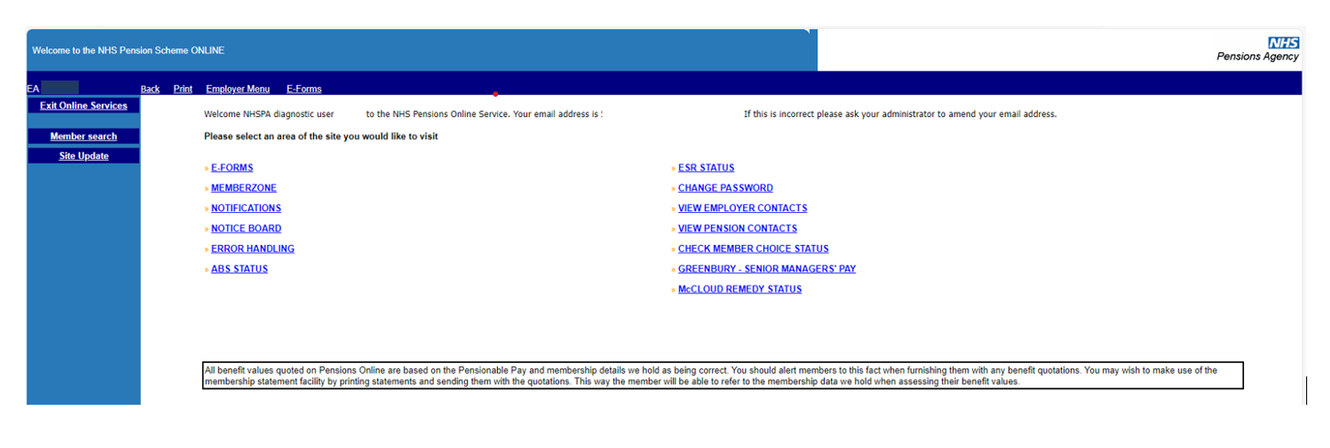
Within this new functionality you will not be able to amend any information or submit any details to the NHSBSA.
The ‘McCloud REMEDY STATUS’ option is there to allow you to check on all your staff members who are currently paying pension contributions to the NHS through your Trust/Surgery and have an ‘Active’ employment under your EA/GP code to see if they were eligible for McCloud remedy and whether they are Remedy Eligible or not.
Once the ‘McCloud REMEDY STATUS’ option is selected, it will list all your staff members who are currently paying pension contributions to the NHS through your organisation and have an ‘Active’ employment under your EA/GP code on our system and the information supplied on the form is – Surname – Forename – NI Number - SD Number – Remedy Eligible (Please see below). 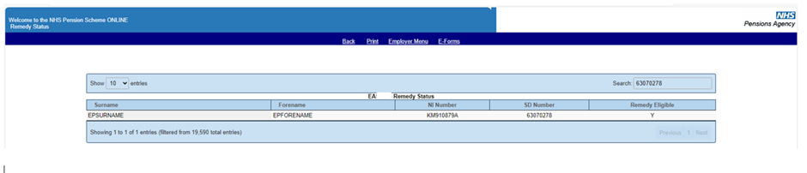
The ‘Remedy Eligibility’ field will either have an ‘Y’ or ‘N’ populated to advise you if the particular member of staff is eligible for McCloud remedy or not.

