NHS Pension Scheme

**Annual Allowance Scheme Pays Election Guide (2017/18 onwards)**

**Contents**

About this guide 3

Scheme pays facilities… 4

More about voluntary scheme pays… 6

Scheme pays election deadline 7

Completing the SPE2… 8

Estimating the pension input amount 17

Maximum amount of scheme pays… 18

Example 1 - Pension input amount in the 1995/2008 NHS Pension Schemes is over the standard annual allowance… 19

Example 2 - Pension input amount in the 2015 NHS Pension Schemes is under the standard annual allowance… 22

Members of the 1995/2008 and 2015 NHS Pension Schemes 25

Example 3 - Pension input amounts for 1995/2008 and the 2015 NHS Pension Schemes are each under the standard annual allowance 26

Example 4 - Pension input amount in one NHS scheme is over the standard annual allowance… 30

Example 5 - Pension input amount in both NHS schemes is over the standard annual allowance… 34

Changing your scheme pays election 38

Paying your annual allowance charge 40

When we don't have to pay an annual allowance charge… 42

Recovering the annual allowance charge at retirement 43

What if you die after making an election? 45

What if you transfer your pension rights? 46

Scheme pays and the lifetime allowance… 47

Reporting the annual allowance charge to HMRC 48

What if I have an annual allowance charge in the NHS MPAVC Scheme… 51

Glossary 52

More information 55

# About this guide

You are responsible for determining whether you have an annual allowance charge to pay to HM Revenue & Customs (HMRC).

By following the steps in the Pension Savings Statement (PSS) Guide, available on our website, you should now have the answers to the following questions.

**Step 1** – what is my total pension input amount? **Step 2** – do I have a tapered annual allowance? **Step 3** – do I have an alternative annual allowance?

**Step 4** – is the total pension input amount more than my annual allowance?

**Step 5** – what unused annual allowance do I have to carry forward?

**Step 6** – do I have an annual allowance charge?

**Step 7** – how much is my annual allowance charge?

If the growth in your NHS benefits exceeds your available annual allowance, this includes any unused annual allowance from the previous three tax years, you will have an annual allowance charge to pay.

The Scheme Pays Election Guide gives you more details about how and when you can ask NHS Pensions to pay your annual allowance charge, from 2017/18 onwards, to HMRC. It aims to:

* give you important information about NHS Pensions scheme pays facilities;
* take you through the Scheme Pays Election (SPE2);
* show you, if applicable, how we calculate the maximum amount of annual allowance split between:
  + mandatory and voluntary scheme pays; and
  + the 1995/2008 and the 2015 NHS Pension Schemes;
* explain how the charge will be recovered from your NHS benefits; and
* highlight what you need to report to HMRC.

If you do end up completing a scheme pays election the declaration you sign confirms you have read this guide, therefore please read the following pages carefully.

If have a charge for a tax year before 2017/18 the following remain available on our website:

* Scheme Pays Facility Factsheet;
* Scheme Pays Facility for Transition Members Factsheet.

**NHS Pensions scheme pays facilities**

You have to ask us in writing if you want the 1995/2008 NHS Pension Scheme, the 2015 NHS Pension Scheme or both NHS schemes to pay some or all of your annual allowance charge.

In return for paying your charge to HMRC your NHS benefits will be permanently reduced when they are paid to you or if you leave and transfer out.

NHS Pensions has two scheme pays facilities; mandatory scheme pays and voluntary scheme pays.

**Mandatory scheme pays**

This facility is only available if your pension input amount, in either the 1995/2008 NHS Pension Scheme or the 2015 NHS Pension Scheme is more than the standard annual allowance, your annual allowance charge for the tax year is more than

£2,000 and we receive your election by the scheme pays deadline. Page 7 confirms the scheme pays deadline dates.

The maximum amount of annual allowance charge you can ask us to pay by mandatory scheme pays is based on the part of your pension input amount that is more than the standard annual allowance.

If we accept your election under mandatory scheme pays the NHS Business Services Authority (the NHSBSA) becomes jointly and severally liable with you for your annual allowance charge. This means that you and the NHSBSA are legally obliged to pay the charge.

**Voluntary scheme pays facility introduced from 01.04.2015**

This facility was available for the tax-years 2015/16 and 2016/17 if you were a member of both the 1995/2008 NHS Pension Scheme and the 2015 NHS Pension Scheme and your pension input amounts in both NHS schemes when added together are more than your available standard annual allowance. This facility did not cover an annual allowance charge as a result of a tapered annual allowance (2016/17) or an alternative annual allowance (2015/16 and 2016/17).

Mandatory scheme pays remained available for any part of your annual allowance charge based on the part of the pension input amount that was more than the standard annual allowance.

**Extension to the voluntary scheme pays facility from 01.04.2017**

The voluntary scheme pays facility from 1 April 2015 continued and more flexibility being introduced from 1 April 2017. The extension to this facility is beneficial if you have an annual allowance charge as a result of an available annual allowance lower than the standard annual allowance. This could happen if you have a tapered annual allowance or an alternative annual allowance.

From 2017/18:

• You no longer have to have an annual allowance charge of more than £2,000 to ask for scheme pays:

• You can now ask us to pay up to 100% of your annual allowance charge that relates to your NHS benefits as long as we receive your election by the deadline; and

• The facility is available if you a member of the 1995/2008 NHS Pension Scheme and/or the 2015 NHS Pension Scheme.

**Standard annual allowance**

The standard annual allowance is currently £40,000. This amount is confirmed on your pension savings statement.

**Tapered annual allowance**

You need to calculate your taxable income at the end of a tax year in order to determine if you have a tapered annual allowance limit for that year. Having a threshold income of more than £110,000 and an adjusted income of more than

£150,000 would result in an annual allowance which is less than £40,000.

The reduction to the annual allowance is tapered, reducing the standard annual allowance by £1 for every £2 of adjusted income you had over £150,000. If you had adjusted income of £210,000 or more you have a tapered annual allowance of

£10,000.

Threshold and adjusted income are HMRC defined terms and you can find more information on how to determine work out these incomes by visiting HMRC’s website at: [www.gov.uk/guidance/pension-schemes-work-out-your-tapered-annual-](http://www.gov.uk/guidance/pension-schemes-work-out-your-tapered-annual-allowance) [allowance](http://www.gov.uk/guidance/pension-schemes-work-out-your-tapered-annual-allowance).

**Alternative annual allowance**

To have an alternative annual allowance in the 1995/2008 NHS Pension Scheme and the 2015 NHS Pension Scheme you must first have a money purchase annual allowance in your money purchase pension scheme.

The alternative annual allowance is currently £36,000.

If you are not a member of a money purchase scheme you do not need to be concerned about this.

More details about the alternative and money purchase annual allowance is on the annual allowance pages of our website.

# More about voluntary scheme pays

If we pay some or all of your annual allowance charge using our voluntary scheme pays facility you need to be aware that you will remain solely liable for the charge until it is paid. We will not share your liability for the charge.

As a consequence of this you alone are responsible for any interest or penalty HMRC may charge if the charge is paid after the tax bill deadline of 31 January. See page 40.

The NHSBSA, the NHS schemes and your NHS employer do not accept any liability for interest or penalty charges in respect of a charge paid by voluntary scheme pays.

You must arrange to pay any interest or penalties directly to HMRC.



**Scheme pays election deadlines**

If you want us to pay your annual allowance charge to HMRC you need to complete a Scheme Pays Election (SPE2) - please ensure you use the latest version available on our website.

We must receive your election by the 31 July deadline date below. An election received after the deadline will not be accepted. It is not enough to just send your election by the deadline.

The 31 July deadline is the same for both mandatory scheme pays and voluntary scheme pays.

|  |  |
| --- | --- |
| **Tax Year** | **Deadline** |
| 2016/2017 | 31 July 2018 |
| 2017/2018 | 31 July 2019 |
| 2018/2019 | 31 July 2020 |
| 2019/2020 | 31 July 2021 |
| 2020/2021 | 31 July 2022 |
| 2021/2022 | 31 July 2023 |

We must receive your election earlier if one of the following events occurs **before** the 31 July deadline:

* you expect to retire – we must receive your completed election before your NHS benefits become payable, or
* you reach age 75 – we must receive your completed election before your 75th birthday.

Once an election has been accepted you can’t change your mind and pay all the charge yourself but you are able to change the amount that you want your NHS scheme to pay – page 7 gives you the deadline to do this.

**Members of both the 1995/2008 and the 2015 NHS Pension Schemes**

If you want both NHS schemes to pay your annual allowance charge then these will be separate elections on the SPE2.

You need to tell us how much of the annual allowance charge you want each NHS scheme to pay.

Because we treat them as separate elections you need to complete Election 1 and Election 2 on the SPE2 and ensure we receive the election before the deadline date.

You can’t ask for one NHS scheme to pay 100% of your annual allowance charge.

# Completing the SPE2

**Part A: Personal details**

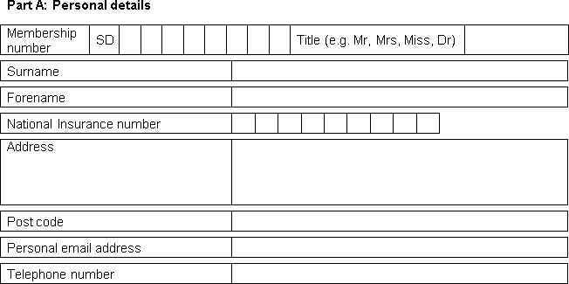

You need to give us all the personal details we have asked for in this part. If you have recently changed address, please make sure your employer updates your pension record.

Your email address and telephone number are necessary in case we need to contact you in connection with the information you provided on the election. Please give us a personal email address rather than a work email address for privacy and security.

Your National Insurance number is a mandatory requirement and is needed for us to report your annual allowance charge to HMRC. If you do not qualify for a National Insurance number then you must attach a letter with your election setting out the reasons for this – this is a requirement of HMRC.

Your election can’t be accepted without a National Insurance number or an explanatory letter.

**Part B: Election**

You should take care when completing the election(s) as we only apply a cursory check to make sure you have:

1. not asked us to pay more than the maximum allowed by the Scheme Actuary in each NHS scheme; and
2. sufficient NHS benefits from which to recover the annual allowance charge payment.
3. **Relevant tax year – to be completed in all elections**



The relevant tax year is the tax year during which the annual allowance charge occurred. The relevant tax year will be shown on your pension savings statement.

For example, for the pension input period of 6 April 2017 to 5 April 2018 the relevant tax year is 2017/18.

1. **Election 1**



You should complete Election 1 if you are a member of the 1995/2008 NHS Pension Scheme and you want this scheme to pay some or all of your annual allowance charge.

If you are a member of both the 1995/2008 and the 2015 NHS Pension Schemes you cannot ask us to pay 100% of your annual allowance charge from the 1995/2008 NHS Pension Scheme.

Page 18 has more information about the maximum amounts each NHS scheme can pay by scheme pays.

**2a) a change to a previous 1995/2008 NHS Pension Scheme election**



If this is your first election for the 1995/2008 NHS Pension Scheme you should tick ‘No’.

If this is not your first election for 1995/2008 NHS Pension Scheme, because you are changing your previous election, then you should tick ‘Yes’.

You can make a change to a previous election if your annual allowance charge has increased or decreased. This is important if you estimated the annual allowance charge on your first election.

An election cannot be revoked once accepted but it can be changed. Page 38 has the deadlines for changing an election.

**2b) the total amount of annual allowance that you want the 1995/2008 NHS Pension Scheme to pay**



By following the ‘next steps’ in the PSS Guide you can determine the amount of your total annual allowance charge.

You need to tell us the total amount of annual allowance charge you want the 1995/2008 NHS Pension Scheme to pay.

If you have ticked to say this is a change to a previous election then ignore what you have previously asked the 1995/2008 NHS Pension Scheme to pay and insert the revised amount. Check out section 2c if you have not yet received a pension savings statement from us and are estimating your annual allowance charge.

If you are a member of both the 1995/2008 and the 2015 NHS Pension Schemes examples of how to calculate the maximum amount of annual allowance charge that each NHS scheme will pay are on page 25.

You can choose to pay some or all of your annual allowance charge directly to HMRC and ask us to pay the balance from your 1995/2008 NHS Pension Scheme.

In this instance you will need to determine how much of your annual allowance charge you want to pay and how much you want your 1995/2008 NHS Pension Scheme to pay and complete Election 1.

If you are changing a previous election because you are no longer liable to an annual allowance charge, possibly because you estimated this on your first election, you should just insert £0.00. You should then attach a letter with your election setting out the reasons for this.

**2c) estimating your 1995/2008 NHS Pension Scheme annual allowance charge**



Where final information is not known or not available you can estimate the amount of the annual allowance charge in respect of your growth in the 1995/2008 NHS Pension Scheme.

You can complete another election to change this amount when we have all the information we need to calculate your pension input amount and a pension savings statement has been sent to you.

If you have estimated your annual allowance charge and you want the 1995/2008 NHS Pension Scheme to pay some or all of this, you should tick the ‘Yes’ box as confirmation of this.

If you are estimating your annual allowance charge and you think you could be subject to a tapered annual allowance in this relevant tax year you should think carefully about the amount of charge you ask us to pay from the 1995/2008 NHS Pension Scheme.

If you have a tapered annual allowance of £10,000, the amount we pay by voluntary scheme pays from the 1995/2008 NHS Pension Scheme could be as much as £13,500 if you are a higher tax rate payer. This is the charge based on the pension input amount between the tapered £10,000 and the standard £40,000

The deadline for paying voluntary scheme pays is earlier than mandatory scheme pays therefore a higher estimated charge could help reduce the amount of interest HMRC asks you to pay if it is paid later than the deadline.

Page 6 tells you what you should be aware of with voluntary scheme pays.

1. **Election 2**



You should complete Election 2 if you are a member of the 2015 NHS Pension Scheme and you want this scheme to pay some or all of your annual allowance charge.

If you are a member of both the 1995/2008 and the 2015 NHS Pension Schemes you cannot ask us to pay 100% of your annual allowance charge from the 2015 NHS Pension Scheme.

Page 18 has more information about the maximum amounts each NHS scheme can pay by scheme pays.

**3a) a change to a previous 2015 NHS Pension Scheme election**



If this is your first election for the 2015 NHS Pension Scheme you should tick ‘No’.

If this is not your first election for 2015 NHS Pension Scheme, because you are changing your previous election, then you should tick ‘Yes’.

You can make a change to a previous election if your annual allowance charge has increased or decreased. This is important if you estimated the annual allowance charge on your first election.

An election cannot be revoked once accepted but it can be changed. Page 38 has the deadlines for changing an election.

**3b) the total amount of annual allowance that you want the 2015 NHS Pension Scheme to pay**



By following the ‘next steps’ in the PSS Guide you can determine the amount of your total annual allowance charge.

You need to tell us the total amount of annual allowance charge you want the 2015 NHS Pension Scheme to pay.

If you have ticked to say this is a change to a previous election then ignore what you have previously asked the 2015 NHS Pension Scheme to pay and insert the revised amount. Check out section 3c if you have not yet received a pension savings statement from us and are estimating your annual allowance charge.

If you are a member of both the 1995/2008 and the 2015 NHS Pension Schemes examples of how to calculate the maximum amount of annual allowance charge that each NHS scheme will pay are on page 25.

You can choose to pay some or all of your annual allowance charge directly to HMRC and ask us to pay the balance from your 2015 NHS Pension Scheme.

In this instance you will need to determine how much of your annual allowance charge you want to pay and how much you want your 2015 NHS Pension Scheme to pay and complete Election 2.

If you are changing a previous election because you are no longer liable to an annual allowance charge, possibly because you estimated this on your first election, you should insert £0.00. You should then attach a letter with your election setting out the reasons for this.

**3c) estimating your 2015 NHS Pension Scheme annual allowance charge**



Where final information is not known or not available you can estimate the amount of the annual allowance charge in respect of your growth in the 2015 NHS Pension Scheme.

You can complete another election to change this amount when we have all the information we need to calculate your pension input amount and a pension savings statement has been sent to you.

If you have estimated your annual allowance charge and you want the 2015 NHS Pension Scheme to pay some or all of this you should tick the ‘Yes’ box as confirmation of this.

If you are estimating your annual allowance charge and you think you could be subject to a tapered annual allowance in this relevant tax year you should think carefully about the amount of charge you ask us to pay from the 2015 NHS Pension Scheme.

If you have a tapered annual allowance of £10,000, the amount we pay by voluntary scheme pays from the 2015 NHS Pension Scheme could be as much as £13,500 if you are a higher tax rate payer. This is the charge based on the pension input amount between the tapered £10,000 and the standard £40,000.

The deadline for paying voluntary scheme pays is earlier than mandatory scheme pays therefore a higher estimated annual allowance charge may help to reduce the amount of interest HMRC asks you to pay if it is paid later than the deadline.

Page 6 tells you what you should be aware of with voluntary scheme pays.

1. **Additional information**



You should supply the additional information if you have completed Election 1, Election 2 or both elections.

**4a) the reduced annual allowance**



You need to let us know if you are, or think you maybe, subject to a tapered or an alternative annual allowance. You should tick the box relevant to you.

If you are subject to both reductions, you should tick both boxes.

If you are not subject to a tapered or alternative annual allowance then leave the boxes blank.

You will find more information about the tapered and alternative annual allowance in the PSS Guide.

**4b) your tapered annual allowance**



If you have ticked to confirm that you are subject to a tapered annual allowance box in section 4a) you need to let us know how much this is.

We will use this amount when calculating the maximum amount of annual allowance charge your NHS scheme(s) can pay by mandatory and/or voluntary scheme pays.

If you are estimating your annual allowance charge you should also estimate your tapered annual allowance. If you leave this section blank, we will assume that you are subject to the standard annual allowance of £40,000. When you make the final change to your first election you will also need to confirm your tapered annual allowance.

The PSS Guide has more information about the tapered annual allowance.

**4c) your marginal tax rate**



Please confirm your maximum marginal rate the relevant tax year. We will use this amount when calculating the maximum amount of annual allowance charge your NHS scheme(s) can pay by mandatory and/or voluntary scheme pays.

If you are a Scottish taxpayer, the tax rates above are replaced with the ‘Scottish main rates’ equivalent which you can find at [www.gov.uk](http://www.gov.uk/).

If you were subject to more than one tax rate during the relevant tax year you should insert the higher amount.

HMRC has published guidance and examples on how to calculate the annual allowance charge in their Pensions Tax Manual at [www.gov.uk/hmrc-internal-](http://www.gov.uk/hmrc-internal-manuals/pensions-tax-manual) [manuals/pensions-tax-manual](http://www.gov.uk/hmrc-internal-manuals/pensions-tax-manual).

**Part C: Anticipated events**

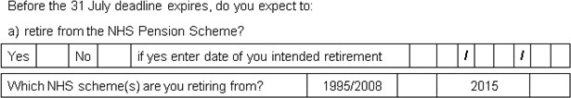

If you are retiring before the 31 July deadline, we must receive your completed election before your NHS benefits become payable.

You should tick the ‘Yes’ box and enter the date of your intended retirement. You should think about sending your election in with or before your retirement application form.

We also need to know from which NHS scheme you are retiring; the 1995/2008 NHS Pension Scheme; the 2015 NHS Pension Scheme or both. This is important if you are a member of both NHS schemes. You should tick the relevant box.

If you are retiring from one NHS scheme your election for this scheme must be received before these NHS benefits become payable. The deadline for the other NHS scheme will remain as 31 July.

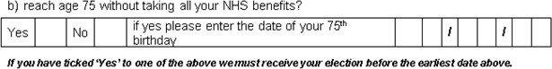

If you will have your 75th birthday before the scheme pays deadline, we must receive your completed election before your 75th birthday.

You should tick the ‘Yes’ box and enter the date of your 75th birthday.

**Part D: Member declaration**

You should now read the declaration carefully, then sign and date the election.

By signing the declaration, you confirm you want your NHS scheme(s) to pay your annual allowance charge, if you have estimated this amount that you will notify us of the confirmed amount when you have it but before the election change deadline and that you have read this guide.

You also declare that you understand the implications of making a scheme pays election on any future NHS benefits or in the event of your death.

Page 43 tells you how the annual allowance charge we pay is recovered from your NHS benefits.

Page 45 tells you what happens if you die after making an election.

**Where to return your election**

You should return your completed election to:

NHS Pensions

PO Box 683

Unit 5

Newcastle Upon Tyne

NE5 9EE

**How we use your information**

The NHS Business Services Authority – NHS Pensions will use the information provided for administering your NHS Pension Scheme membership and processing payment of your NHS pension benefits. We may share your information to administer and pay your NHS pension, enable us to prevent and detect fraud and mistakes, for debt collection purposes, or as required by law.

For more information about whom we share your information with and how long we keep your personal data and your rights, please visit our website at [www.nhsbsa.nhs.uk/yourinformation](http://www.nhsbsa.nhs.uk/yourinformation)

# Estimating the pension input amount

**Pension savings statement not yet received**

You may not have the information from us about your pension input amount to assess if you are subject to a tapered annual allowance and determine if you have an annual allowance charge in the relevant tax year. This could be because:

* we do not have the information from your NHS employer or a third party needed to enable us to calculate the pension input amount; or
* you are not entitled to an automatic pension savings statement and you have not asked for an on demand statement.

HMRC confirms that if this is the case you should estimate your liability to a tapered annual allowance and annual allowance charge based on available information.

HMRC cites possible sources of information as an annual benefit statement. You should check to see if your previous annual total reward statements (TRS) include your NHS benefits.

You can now access your TRS online at: www.totalrewardstatements.nhs.uk and via ESR Employee Self Service for organisations that use the facility. More details about TRS can be found on our website.

If you are a medical practitioner, you may be able to use the previous year’s certified earnings as a starting point.

To meet the scheme pays deadline you should consider completing an election using estimated amounts. It is important when estimating the annual allowance charge to provide us with a ‘best estimate’ on the SPE2.

Because we pay voluntary scheme pays earlier than mandatory scheme pays this will help reduce the amount of interest HMRC will ask you to pay if you change your election because the annual allowance charge to be paid by voluntary scheme pays has increased.

**Pension savings statement received**

Once you receive a pension savings statement with the confirmed details needed to determine your available annual allowance you can work out if you have an annual allowance charge. You will then need to amend your tax return and scheme pays election. More information about correcting a tax return can be found at: [www.gov.uk/self-assessment-tax-returns/corrections](http://www.gov.uk/self-assessment-tax-returns/corrections).

Page 38 tells you more about changing your election.

# Maximum amount of scheme pays

**More than one pension scheme**

If you are also a member of another registered pension scheme, outside the 1995/2008 NHS Pension Scheme and the 2015 NHS Pension Scheme, and the total amount of your pension savings is more than your available annual allowance you may be able to make separate scheme pays elections to each of your pension schemes.

The amount of annual allowance charge you may ask each pension scheme to pay is limited by HMRC. It is not possible for you to ask NHS scheme to pay your entire annual allowance charge when part of this liability relates to another pension scheme, outside of the 1995/2008 NHS Pension Scheme and the 2015 NHS Pension Scheme.

**The maximum amount of scheme pays**

The maximum annual allowance charge that we will pay to HMRC is based on the pension input amount in either the 1995/2008 NHS Pension Scheme or the 2015 NHS Pension Scheme, or both NHS schemes if you are a member of both, which is more than your available annual allowance.

If you are a member of both the 1995/2008 and 2015 NHS Pension Schemes this is the total pension input amount across both schemes.

You cannot ask us to pay an annual allowance charge you have incurred in another pension scheme.

**The amount you want your NHS Pension Scheme to pay**

You do not have to ask us to pay 100% of your annual allowance charge that relates to your NHS benefits by scheme pays. You may decide to pay some of your annual allowance charge directly to HMRC and ask us to pay the balance.

We will calculate the maximum amount your NHS scheme(s) can pay and notify you if we are able to accept your scheme pays election. We will also tell you how we intend to pay your charge whether this is by mandatory scheme pays, voluntary scheme pays or using both facilities.

## Example 1 – Pension input amount in the 1995/2008 NHS Pension Schemes is over the standard annual allowance

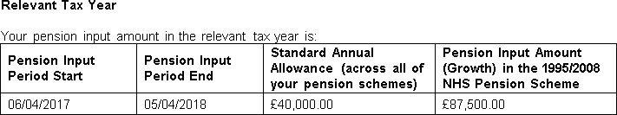

Paul is a member of the 1995/2008 NHS Pension Scheme and received a pension savings statement for tax year 2017/18.

Following the steps in the PSS Guide he has worked out that he is subject to a tapered annual allowance of £25,000 because of his adjusted income of £180,000.

|  |  |
| --- | --- |
| **Information** | |
| 1995/2008 pension input amount | £87,500 |
| Standard annual allowance | £40,000 |
| Tapered annual allowance | £25,000 |
| Tax rate | 45% |

1. The maximum annual allowance charge from the NHS benefits

£87,500 – £25,000 = £62,500

£62,500 x 45% = **£28,125**

1. The maximum annual allowance charge that can be paid by mandatory scheme pays in the 1995/2008 NHS Pension Scheme

1995/2008 NHS Pension Scheme

£87,500 – £40,000 = £47,500

£47,500 x 45% = £21,375

1. The maximum annual allowance charge that can be paid by voluntary scheme pays in the 1995/2008 NHS Pension Scheme

1995/2008 NHS Pension Scheme

£28,125 - £21,375 = £6,750

1. Maximum scheme pays summary

|  |  |  |  |
| --- | --- | --- | --- |
| **Scheme** | **Mandatory** | **Voluntary** | **Total** |
| 1995/2008 | £21,375 | £6,750 | **£28,125** |

If Paul has no unused annual allowance to carry forward and wants his NHS schemes to pay 100% of the annual allowance, he needs to complete the scheme pays election as follows:

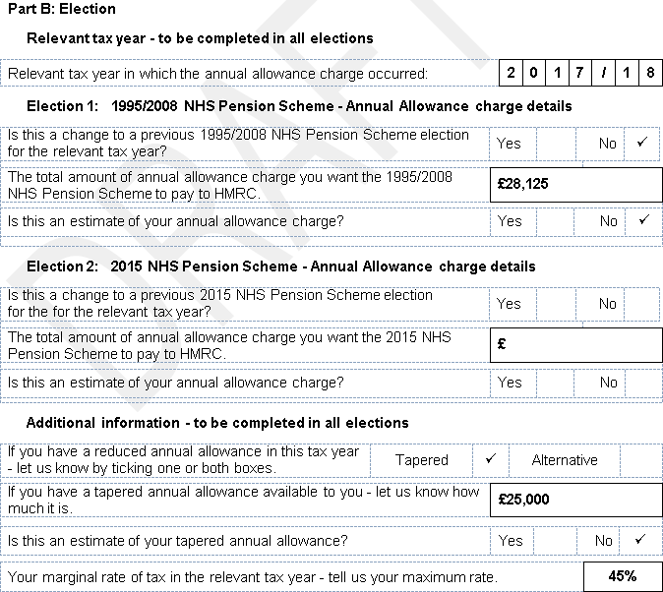

The same example would apply if Paul was a member of the 2015 NHS Pension Scheme instead.

1. Paul asks us to pay an annual allowance charge lower than the maximum

Paul may decide to pay some of his annual allowance charge directly to HMRC or could have unused annual allowance from the previous three tax years to carry forward. He could ask us to pay a charge lower than the maximum calculated at l.

V (i) If Paul had unused annual allowance of £8,000, he would have an annual allowance charge of £24,525. This is less than the maximum charge of £28,125.

£87,500 – £25,000 – £8,000 = £54,500

£54,500 x 45% = **£24,525**

Maximum mandatory scheme pays = £21,375 Maximum voluntary scheme pays = £6,750

The unused annual allowance has increased his annual allowance from the tapered annual allowance of £25,000 to an available £33,000.

**10,000 £25,000 £33,000 £40,000 £87,500**

**I I I I l**

**voluntary scheme pays mandatory scheme pays**

Because the amount Paul has asked us to pay is more than £21,375 not all his charge can be paid by mandatory scheme pays some must be paid by voluntary scheme pays.

£21,375 - mandatory scheme pays

£3,150 - voluntary scheme pays

V (ii) If Paul had unused annual allowance of £18,000, he would have an annual allowance charge of £20,025. This is less than the maximum charge of £28,125.

£87,500 – £25,000 – £18,000 = £44,500

£44,500 x 45% = **£20,025**

Maximum mandatory scheme pays = £21,375

The unused annual allowance has increased his annual allowance from the tapered annual allowance of £25,000 to an available £43,000.

**10,000 £25,000 £40,000 £43,000 £87,500**

**I I I I l**

**voluntary scheme pays mandatory scheme pays**

Because the amount Paul has asked us to pay is less than £21,375 all the £20,025 charge can be paid by mandatory scheme pays from the 1995/2008 NHS Pension Scheme.

£20,025 - mandatory scheme pays £0.00 - voluntary scheme pays

## Example 2 – Pension input amount in the 2015 NHS Pension Schemes is under the standard annual allowance

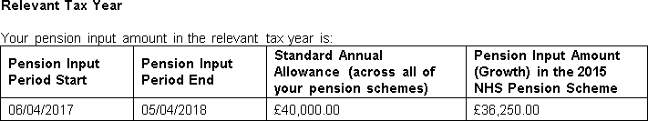

Kathryn is a member of the 2015 NHS Pension Scheme and requested an on demand pension savings statement for tax year 2017/18.

Following the steps in the PSS Guide she has worked out that she is subject to a tapered annual allowance of £10,000 because of her adjusted income of £230,000.

|  |  |
| --- | --- |
| **Information** | |
| 1995/2008 pension input amount | £36,250 |
| Standard annual allowance | £40,000 |
| Tapered annual allowance | £10,000 |
| Tax rate | 45% |

1. The maximum annual allowance charge from the NHS benefits

£36,250 – £10,000 = £26,250

£26,250 x 45% = **£11,812.50**

1. The maximum annual allowance charge that can be paid by mandatory scheme pays in the 2015 NHS Pension Scheme

As the pension input amount in the 2015 NHS Pension Scheme is less than the standard annual allowance none of the charge can be paid using mandatory scheme pays.

1. The maximum annual allowance charge that can be paid by voluntary scheme pays in the 2015 NHS Pension Scheme

All the £11,812.50 charge can be paid using voluntary scheme pays from the 2015 NHS Pension Scheme.

1. Maximum scheme pays summary

|  |  |  |  |
| --- | --- | --- | --- |
| **Scheme** | **Mandatory** | **Voluntary** | **Total** |
| 1995/2008 | £0.00 | £11,812.50 | **£11,812.50** |

If Kathryn has no unused annual allowance to carry forward and wants her NHS schemes to pay 100% of the annual allowance she needs to complete the scheme pays election as follows:

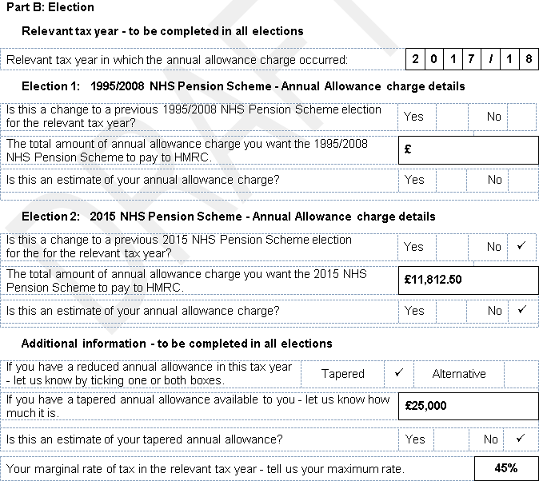

The same example would apply if Kathryn was a member of the 2015 NHS Pension Scheme instead.

1. Kathryn asks us to pay an annual allowance charge lower than the maximum

Kathryn may decide to pay some of her annual allowance charge directly to HMRC or could have unused annual allowance from the previous three tax years to carry forward. She could ask us to pay a charge lower than the maximum calculated at l.

If she had unused annual allowance of £5,000, she would have an annual allowance charge of £9,562.50. This is less than the maximum charge of £11,812.50.

£36,250 – £10,000 – £5,000 = £21,250

£21,250 x 45% = £9,562.50

All the £9,562.50 charge can be paid by voluntary scheme pays from the 2015 NHS Pension Scheme.

**Members of the 1995/2008 and the 2015 NHS Pension Scheme**

You should read this section if you are a member of both the 1995/2008 NHS Pension Scheme and the 2015 NHS Pension Scheme and you have an annual allowance charge.

It is not possible to elect for one NHS scheme to pay all your charge. You must tell us how much of the charge you want each NHS scheme to pay.

How much of your charge each NHS scheme can pay depends on the pension input amount in each NHS scheme and the total pension input amount when they are added together from the two pension savings statements we sent you.

You can make an election even where the pension input amount in one or both schemes is under your annual allowance, as long as the total pension input amount from both schemes is more than your annual allowance.

The method of splitting the annual allowance charge between the 1995/2008 NHS Pension Scheme and the 2015 NHS Pension Scheme has been agreed by the Scheme Actuary.

**Mandatory or voluntary scheme pays**

The amount of pension input period in either the 1995/2008 NHS Pension Scheme, the 2015 NHS Pension Scheme or the total amount of both when added together will determine whether your election is mandatory or voluntary.

The table below confirms on what basis we will accept your scheme pays.

|  |  |  |  |
| --- | --- | --- | --- |
| **NHS**  **Scheme** | **Pension Input Amount** | **Total**  **Amount** | **Scheme Pays** |
| 1995/2008 | Under standard annual allowance | Under | Voluntary |
| 2015 | Under standard annual allowance |
| 1995/2008 | Under standard annual allowance | Over | Voluntary |
| 2015 | Under standard annual allowance |
| 1995/2008 | Under standard annual allowance | Over | Voluntary |
| 2015 | Over standard annual allowance | Mandatory1 |
| 1995/2008 | Over standard annual allowance | Over | Mandatory1 |
| 2015 | Under standard annual allowance | Voluntary |
| 1995/2008 | Over standard annual allowance | Over | Mandatory1 |
| 2015 | Over standard annual allowance |

1 any charge from a pension input amount between your reduced annual allowance and the standard annual allowance is voluntary scheme pays

## Example 3 – Pension input amounts for 1995/2008 and the 2015 NHS Pension Schemes are each under the standard annual allowance

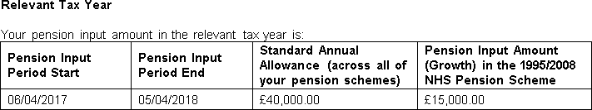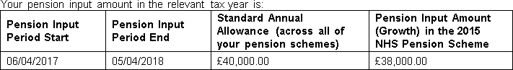

Gillian is a member of both the 1995/2008 and the 2015 NHS Pension Schemes and received two pension savings statements for tax year 2017/18.

Following the steps in the PSS Guide she has worked out that she is subject to a tapered annual allowance of £20,000 because of her adjusted income of £190,000.

She now needs to work out the maximum charge each of her NHS schemes will pay.

|  |  |
| --- | --- |
| **Information** | |
| 1995/2008 pension input amount | £15,000 |
| 2015 pension input amount | £38,000 |
| Total NHS pension input amount | £53,000 |
| Standard annual allowance | £40,000 |
| Tapered annual allowance | £20,000 |
| Tax rate | 45% |

1. The maximum annual allowance charge from the NHS benefits - across both NHS schemes

£53,000 - £20,000 = £33,000

£33,000 x 45% = **£14,850**

1. The maximum annual allowance charge that can be paid by mandatory scheme pays in each NHS scheme

As the pension input amount in each NHS scheme is less than the standard annual allowance none of her charge can be paid using the mandatory scheme pays facility.

1. The maximum annual allowance charge that can be paid by voluntary scheme pays in each NHS scheme

1995/2008 NHS Pension Scheme

£15,000 x £14,850 = £4,202.83

£53,000

2015 NHS Pension Scheme

£38,000 x £14,850 = £10,647.17

£53,000

1. Maximum scheme pays summary

|  |  |  |  |
| --- | --- | --- | --- |
| **Scheme** | **Mandatory** | **Voluntary** | **Total** |
| 1995/2008 | £0.00 | £4,202.83 | £4,202.83 |
| 2015 | £0.00 | £10,647.17 | £10,647.17 |
|  | | | **£14,850** |

If Gillian has no unused annual allowance to carry forward and wants her NHS schemes to pay 100% of the annual allowance she needs to complete a scheme pays election as follows:

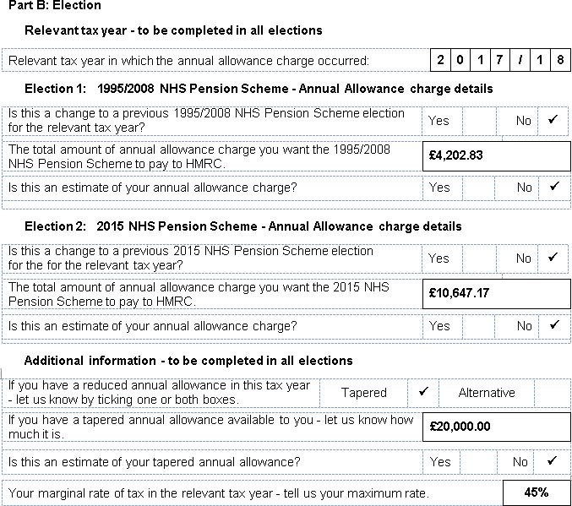

1. Gillian asks us to pay an annual allowance charge lower than the maximum

Gillian may decide to pay some of her annual allowance charge directly to HMRC or could have unused annual allowance from the previous three tax years to carry forward. She could ask us to pay a charge lower than the maximum calculated at l.

If she had unused annual allowance of £10,000, she would have an annual allowance charge of £10,350. This is less than the maximum £14,850.

She can choose to split this between both her NHS schemes. 1995/2008 NHS Pension Scheme

£15,000 x £10,350 = £2,929.25 - voluntary scheme pays

£53,000

2015 NHS Pension Scheme

£38,000 x £10,350 = £7,420.75 - voluntary scheme pays

£53,000

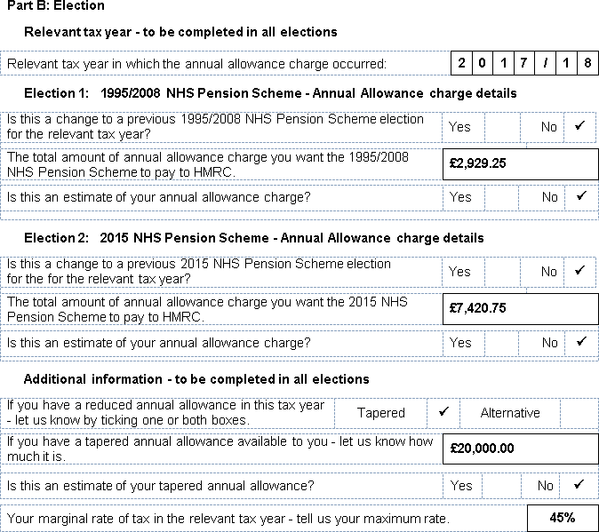

Alternatively, she may decide to ask one NHS scheme to pay more of her charge. This is acceptable as long as she does not go over the maximum amount allowed by the Scheme Actuary in each NHS scheme.

## Example 4 – Pension input amount in one NHS scheme is over the standard annual allowance

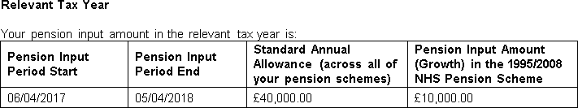

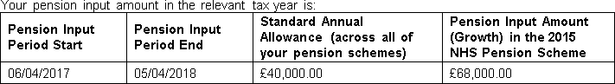

Andrew is a member of both the 1995/2008 and the 2015 NHS Pension Schemes and received two pension savings statements for tax year 2017/18.

Following the steps in the PSS Guide he has worked out that he is subject to a tapered annual allowance of £10,000 because of his adjusted income of £240,000.

He now needs to work out the maximum charge each of his NHS schemes will pay.

|  |  |
| --- | --- |
| **Information** | |
| 1995/2008 pension input amount | £10,000 |
| 2015 pension input amount | £68,000 |
| Total NHS pension input amount | £78,000 |
| Standard annual allowance | £40,000 |
| Tapered annual allowance | £10,000 |
| Tax rate | 45% |

1. The maximum annual allowance charge from the NHS benefits - across both NHS schemes

£78,000 - £10,000 = £68,000

£68,000 x 45% = **£30,600**

1. The maximum annual allowance charge that can be paid by mandatory scheme pays in each NHS scheme

1995/2008 NHS Pension Scheme

As the pension input amount in the 1995/2008 NHS Pension Scheme is less than the standard annual allowance none of the charge can be paid using mandatory scheme pays in this NHS scheme.

2015 NHS Pension Scheme

£68,000 – £40,000 = £28,000

£28,000 x 45% = £12,600

1. The maximum annual allowance charge that can be paid by voluntary scheme pays in each NHS scheme

1995/2008 NHS Pension Scheme

£10,000 x £30,600 = £3,923.08

£78,000

Less mandatory scheme pays

£3,923.08 – £0.00 = £3,923.08

2015 NHS Pension Scheme

£68,000 x £30,600 = £26,676.92

£78,000

Less mandatory scheme pays

£26,676.92 – £12,600 = £14,076.92

1. Maximum scheme pays summary

|  |  |  |  |
| --- | --- | --- | --- |
| **Scheme** | **Mandatory** | **Voluntary** | **Total** |
| 1995/2008 | £0.00 | £3,923.08 | £3,923.08 |
| 2015 | £12,600 | £14,076.92 | £26,676.92 |
|  | | | **£30,600** |

If Andrew has no unused annual allowance to carry forward and wants his NHS schemes to pay 100% of the annual allowance he needs to complete the scheme pays election as follows:

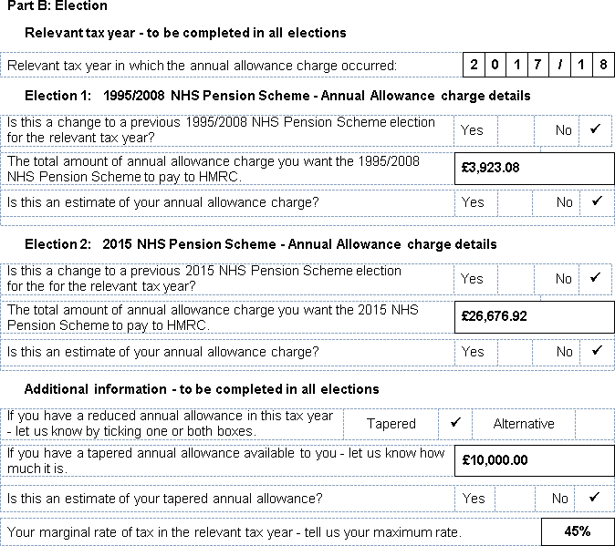

1. Andrew asks us to pay an annual allowance charge lower than the maximum

Andrew may decide to pay some of his annual allowance charge directly to HMRC or could have unused annual allowance from the previous three tax years to carry forward. He could ask us to pay a charge lower than the maximum calculated at l.

If he had unused annual allowance of £15,000, he would have an annual allowance charge of £23,850. This is less than the maximum £30,600.

He can choose to split this between both his NHS schemes. 1995/2008 NHS Pension Scheme

£10,000 x £23,850 = £3,057.69 - voluntary scheme pays

£78,000

2015 NHS Pension Scheme

£68,000 x £23,850 = £20,792.31 - mandatory and voluntary scheme pays

£78,000

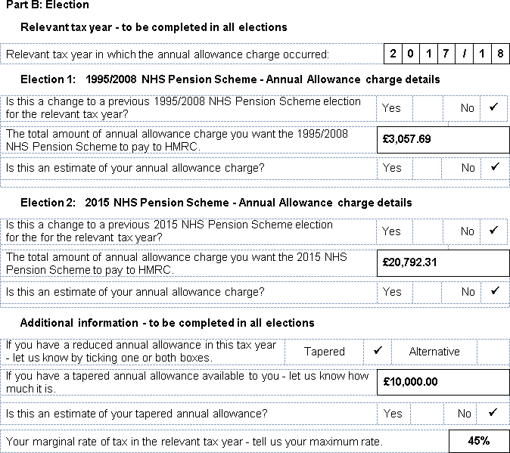

Alternatively, Andrew may decide to ask one NHS scheme to pay more of his charge. This is acceptable as long as he does not go over the maximum amount allowed by the Scheme Actuary in each NHS scheme.

## Example 5 – Pension input amount in both NHS schemes is over the standard annual allowance

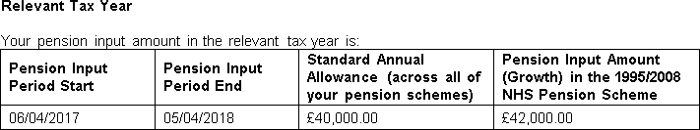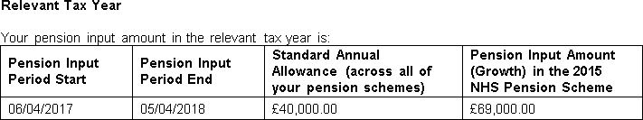

Christine is a member of both the 1995/2008 and the 2015 NHS Pension Schemes and received two pension savings statements for tax year 2017/18.

Following the steps in the PSS Guide she has worked out that she is subject to a tapered annual allowance of £10,000 because of her adjusted income of £215,000.

She now needs to work out the maximum charge each of her NHS schemes will pay.

|  |  |
| --- | --- |
| **Information** | |
| 1995/2008 pension input amount | £42,000 |
| 2015 pension input amount | £69,000 |
| Total NHS pension input amount | £111,000 |
| Standard annual allowance | £40,000 |
| Tapered annual allowance | £10,000 |
| Tax rate | 45% |

1. The maximum annual allowance charge from the NHS benefits - across both NHS schemes

£111,000 – £10,000 = £101,000

£101,000 x 45% = **£45,450**

1. The maximum annual allowance charge that can be paid by mandatory scheme pays in each NHS scheme

1995/2008 NHS Pension Scheme

£42,000 – £40,000 = £2,000

£2,000 x 45% = £900

2015 NHS Pension Scheme

£69,000 – £40,000 = £29,000

£29,000 x 45% = £13,050

1. The maximum annual allowance charge that can be paid by voluntary scheme pays in each NHS scheme

1995/2008 NHS Pension Scheme

£42,000 x £45,450 = £17,197.30

£111,000

Less mandatory scheme pays

£17,197.30 – £900 = £16,297.30

2015 NHS Pension Scheme

£69,000 x £45,450 = £28,252.70

£111,000

Less mandatory scheme pays

£28,252.70 – £13,050 = £15,202.70

1. Maximum scheme pays summary

|  |  |  |  |
| --- | --- | --- | --- |
| **Scheme** | **Mandatory** | **Voluntary** | **Total** |
| 1995/2008 | £900 | £16,297.30 | £17,197.30 |
| 2015 | £13,050 | £15,202.70 | £28,252.70 |
|  | | | **£45,450** |

If Christine has no unused annual allowance to carry forward and wants her NHS schemes to pay 100% of the annual allowance, she needs to complete the scheme pays election as follows:

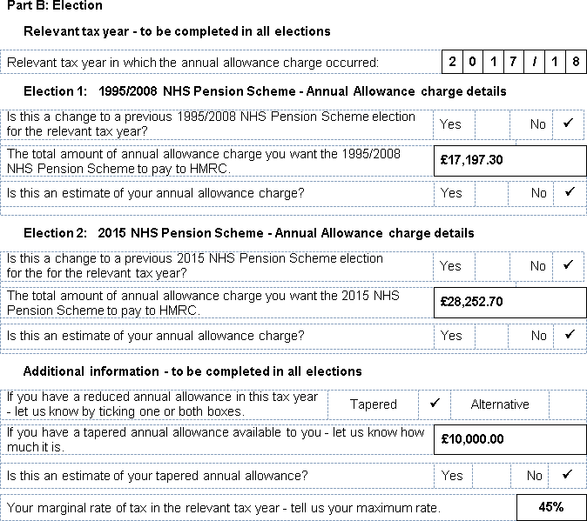

1. Christine asks us to pay an annual allowance charge lower than the maximum

Christine may decide to pay some of her annual allowance charge directly to HMRC or could have unused annual allowance from the previous three tax years to carry forward. She could ask us to pay a charge lower than the maximum calculated at l.

If she had unused annual allowance of £22,000, she would have an annual allowance charge of £35,550. This is less than the maximum £45,450.

She can choose to split this between both her NHS schemes. 1995/2008 NHS Pension Scheme

£42,000 x £35,550 = £13,451.35 - mandatory and voluntary scheme pays

£111,000

2015 NHS Pension Scheme

£69,000 x £35,550 = £22,098.65 - mandatory and voluntary scheme pays

£111,000

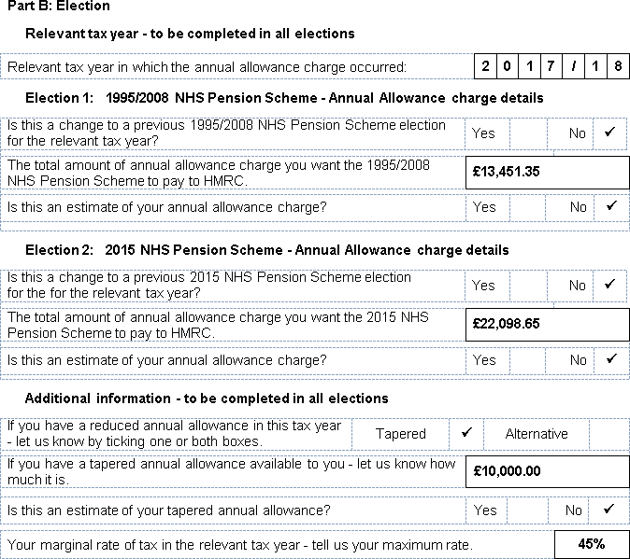

Alternatively, Christine may decide to ask one NHS scheme to pay more of her charge. This is acceptable as long as she does not go over the maximum amount allowed by the Scheme Actuary in each NHS scheme.

# Changing your scheme pays election

**Changing the amount of annual allowance charge you want us to pay**

After you have made a first election asking us to pay your annual allowance charge from your NHS scheme(s) you have the opportunity of changing the charge amount if your tax liability changes. This could happen because your liability for the relevant tax year was more or less than you realised when you sent us your first election.

HMRC impose a deadline for changing an election. We must receive your change no later than the 31 July that follows the end of the period of 4 years from the end of the tax year to which your annual allowance charge liability relates.

Example

|  |  |
| --- | --- |
| **Tax Year** | **Deadline** |
| 2016/2017 | 31 July 2021 |
| 2017/2018 | 31 July 2022 |
| 2018/2019 | 31 July 2023 |
| 2019/2020 | 31 July 2024 |
| 2020/2021 | 31 July 2025 |
| 2022/2023 | 31 July 2026 |
| 2023/2024 | 31 July 2027 |

**Changing an estimated annual allowance charge**

If you estimated your annual allowance charge on your first election you need to notify us of the correct amount as soon as possible once you have received a pension savings statement from us.

**You now want us to pay less annual allowance charge**

If the charge amount you want us to pay has gone down we will either pay the reduced amount to HMRC or, if the higher amount was already paid, we will reclaim any overpaid tax from HMRC.

If you have retired your NHS benefits will be reassessed once HMRC repays any overpaid tax.

**You now want us to pay more annual allowance charge**

If the charge amount you want us to pay has gone up we will pay any outstanding charge to HMRC. You will be responsible for any interest or penalty that HMRC may decide to impose if the charge is paid later than the payment deadlines. HMRC may contact you separately about this.

If you have retired your NHS benefits will be reassessed and reduced from the date we accept your changed election.

**How to change your election**

You need to complete another SPE2 and we need to receive this by the deadline.

You should tick ‘Yes’ on Election 1, Election 2 or both to confirm that this is a change to a previous election for the relevant tax year.

You should then ignore what you have previously asked your NHS scheme(s) to pay and insert the revised amount.

**If the relevant tax year was before 2017/18**

If it turns out that your actual overall annual allowance charge liability for a tax year before 2017/18 was reduced to £2,000 or less, you can no longer make an election asking for us to pay your lower charge from your NHS scheme.

The overall annual allowance charge is the total charge from all your pension schemes not just your NHS scheme.

**When we pay any additional annual allowance charge to HMRC**

Page 40 tells you the deadlines for paying an annual allowance charge to HMRC.

If the appropriate deadline has not yet passed and we have not paid the original amount you asked us to pay to HMRC then this deadline will continue to apply for the higher annual allowance charge amount.

If the appropriate deadline has already passed and we have paid the original amount you asked us to pay then the deadline for paying the outstanding charge will depend on the quarter in which we receive and accept your new election. See the quarter deadlines confirmed on page 41.

**You are no longer liable for an annual allowance charge**

Once we receive and accept your election you can only revoke it if your first election was completed in error because you are no longer liable to any annual allowance charge in the relevant tax year.

This could happen if you estimated the amount of your annual allowance charge and possibly your tapered annual allowance in order to meet the scheme pays deadline.

Complete another SPE2 inserting £0.00 into Election 1, Election 2 or both. You should also attach a letter with your election setting out the reasons for this.

# Paying your annual allowance charge

When an annual allowance charge must be paid depends on who pays it, you or us and if we have paid it which of our scheme pays facilities we have used.

**If you pay the annual allowance charge yourself**

You must pay some or all of your annual allowance charge to HMRC by 31 January, following the end of the relevant tax year. You can pay this as part of a normal self- assessment tax return tax bill.

Example

|  |  |
| --- | --- |
| **Tax Year** | **Tax Bill Deadline** |
| 2019/2020 | 31 January 2021 |
| 2020/2021 | 31 January 2022 |
| 2021/2022 | 31 January 2023 |
| 2022/2023 | 31 January 2024 |
| 2023/2024 | 31 January 2025 |
| 2024/2025 | 31 January 2026 |

There may be interest applied if the annual allowance charge is paid after this date.

**If you ask us to pay your annual allowance charge and it is paid by mandatory scheme pays**

If we are paying all or part of your annual allowance charge using mandatory scheme pays we must pay this by the second 14 February that follows the end of the relevant tax year.

Example

|  |  |
| --- | --- |
| **Tax Year** | **Mandatory Deadline** |
| 2018/2019 | 14 February 2021 |
| 2019/2020 | 14 February 2022 |
| 2020/2021 | 14 February 2023 |
| 2021/2022 | 14 February 2024 |
| 2022/2023 | 14 February 2024 |
| 2023/2024 | 14 February 2025 |

We have an option to pay the annual allowance charge earlier if required.

**If you ask us to pay your annual allowance charge and it is paid by voluntary scheme pays**

If we are paying any of your annual allowance charge by voluntary scheme pays this must be paid earlier than HMRC’s mandatory deadline. The deadline for paying by voluntary scheme pays is the same as HMRC’s deadline for paying tax on a self- assessment tax return - 31 January following the end of the relevant tax year.

Example

|  |  |
| --- | --- |
| **Tax Year** | **Voluntary Deadline** |
| 2019/2020 | 31 January 2021 |
| 2020/2021 | 31 January 2022 |
| 2021/2022 | 31 January 2023 |
| 2022/2023 | 31 January 2024 |
| 2023/2024 | 31 January 2025 |
| 2024/2025 | 31 January 2026 |

In line with statutory requirements, we pay tax quarterly to HMRC; this includes voluntary scheme pays, with the final dates for payment being 15 May, 14 August, 14 November and 14 February.

Which quarter we aim to pay your voluntary scheme pays will depend on when we receive and then accept your election.

Example

|  |  |
| --- | --- |
| **Election acceptance** | **Quarter Deadline** |
| 1 October 2020 - 31 December 2020 | 14 February 2021 |
| 1 January 2021 - 31 March 2021 | 15 May 2021 |
| 1 April 2021 - 30 June 2021 | 14 August 2021 |
| 1 July 2021 - 30 September 2021 | 14 November 2021 |
| 1 October 2021 - 31 December 2021 | 14 February 2022 |
| 1 January 2022 - 31 March 2022 | 15 May 2022 |
| 1 April 2022 - 30 June 2022 | 14 August 2022 |
| 1 July 2020 - 30 September 2022 | 14 November 2022 |
| 1 October 2022 - 31 December 2022 | 14 February 2023 |
| 1 January 2023 - 31 March 2023 | 15 May 2023 |
| 1 April 2023 - 30 June 2023 | 14 August 2023 |
| 1 July 2023 - 30 September 2023 | 14 November 2023 |

With voluntary scheme pays you remain solely liable for your annual allowance charge, therefore if it is paid in a quarter later than 31 January HMRC may ask you to pay interest because of the late payment.

# When we don’t have to pay an annual allowance charge

**When we can’t accept your election**

We can’t accept a scheme pays election if we don’t receive it within the 31 July deadline, or earlier if you are retiring or will reach age 75 before this deadline.

We can refuse to pay your annual allowance charge, even if we receive it within the deadline if we are unable to recover some or all of the charge paid because you have retired, transferred out or taken a refund of contributions from the NHS scheme.

**Appeals against not accepting an election**

You can appeal against this decision by writing to the Annual Allowance Team Manager and explaining why you did not meet the conditions.

If your appeal is successful, we will confirm under which scheme pays facility, mandatory or voluntary, we can pay your annual allowance charge.

If unsuccessful we will explain why it is has been unsuccessful.

If your election has been rejected or returned to you because it is incomplete or you have provided insufficient or incorrect details you will be asked to complete another SPE2 and your election will be reassessed.

**Discharge from paying an annual allowance charge**

We can ask HMRC for a discharge from paying your annual allowance charge if you:

* have insufficient NHS benefits from which to recover the annual allowance charge. This may be an issue if you have a large pension share debit on your NHS benefits because of divorce or dissolution of a civil partnership or other negative DC accounts;
* die after your election is accepted but before we pay the charge to HMRC.

Where the scheme administrator is discharged of their liability then the member will become solely liable to the annual allowance charge.

# Recovering the annual allowance charge at retirement

**Notional negative defined contribution DC account**

The amount of annual allowance charge we pay to HMRC is recorded as a separate account on your pension record, known as a notional negative DC account.

In basic terms this account is comparable to us loaning you the money now to pay your annual allowance charge which you must then pay us back, with interest, when you retire or if you transfer out.

**Interest on the notional negative DC account**

Interest is added to the account based on the:

* previous September’s CPI figure; plus
* Superannuation Contributions Adjusted for Past Experience (SCAPE) discount rate.

The SCAPE is variable.

|  |  |
| --- | --- |
| **Dates** | **SCAPE** |
| Up to 15 March 2016 | 3.0% |
| From 16 March 2016 to 5 April 2019 | 2.8% |
| From 6 April 2019 | 2.4% |

Interest applies from 1 January following receipt of your election until retirement benefits become payable or pension rights are transferred out.

|  |  |
| --- | --- |
| **Tax Year** | **Interest applied from** |
| 2011/2012 | 1 January 2014 |
| 2012/2013 | 1 January 2015 |
| 2013/2014 | 1 January 2016 |
| 2014/2015 | 1 January 2017 |
| 2015/2016 | 1 January 2018 |
| 2016/2017 | 1 January 2019 |
| 2017/2018 | 1 January 2020 |
| 2018/2019 | 1 January 2021 |
| 2019/2020 | 1 January 2022 |
| 2020/2021 | 1 January 2023 |
| 2021/2022 | 1 January 2024 |

**At retirement**

At retirement the total account owing, including interest, is converted into a debit amount to be permanently deducted from your NHS pension benefits.

The Scheme Actuary has provided actuarial factors to convert the total account owing into a benefit reduction. Separate factors are provided for ill-health retirement cases to reflect reduced life-expectancy. These factors are available on our website.

1995 Section members

If you are a 1995 Section member your pension and lump sum will be permanently reduced when you retire.

2008 Section members

If you are a 2008 Section member your pension will be permanently reduced when you retire.

This remains the same even if you chose to move from the 1995 Section to the 2008 Section under one of the NHS Pensions Choice exercises.

2015 Scheme members

If you are a 2015 Scheme member your pension will be permanently reduced when you retire.

Scheme transition members

If you are a member of both the 1995/2008 NHS Pension Scheme and the 2015 NHS Pension Scheme there will be a separate benefit reduction in each scheme.

The reduction is apportioned based on each scheme’s pension input amount and the combined pension input amount across both schemes.

**‘Annual Allowance – Estimating the Cost of Scheme Pays’**

If you are considering making an election you should read the factsheet ‘Annual Allowance – Estimating the Cost of Scheme Pays’ which can be found on the Annual Allowance pages of our website.

It is produced by the Scheme Actuary and explains the effect that scheme pays may have on your future NHS benefits. It should only ever be used as a guide to estimating the cost of scheme pays and does not include the relevant interest rate in excess of inflation up to retirement.

The factors used in the factsheet are indicative and may be revised before you retire.

# What if you die after making an election?

**Before we pay your annual allowance charge**

If you die before we pay your annual allowance charge your election is cancelled and we will write to your estate to let them know that they retain liability for your annual allowance charge.

When you complete the declaration on the SPE2 you are signing to confirm that you understand that your estate is liable for the charge if you die before it is paid.

**After we pay your annual allowance charge**

If you die after we’ve paid your annual allowance charge to HMRC, but:

* before your retirement – we write-off the total negative DC balance owing; or
* after your retirement and your pension benefits had already been reduced - this has a consequential effect on the amount of initial dependent’s pension that may be payable as this is calculated on your reduced pension in payment at the time of your death.

A continuing dependent’s pension will be calculated on your unreduced pension.

You should ensure that you fully understand the implications of making a scheme pays election on your future NHS benefits before completing an election.

# What if you transfer your pension rights?

**Transferring out**

If you transfer out your NHS pension rights before making an election you can ask your new pension scheme to pay your annual allowance charge. Your notice to the new pension scheme must be made on their election and received by them within their deadline.

If you have made a scheme pays election with us, then transfer out and now want to make a change to the election you must make a request to your new pension scheme.

If you are transferring out after we have accepted an election the negative DC balance owing will be revalued up to the date at which the transfer value is calculated.

If you leave and transfer your NHS pension rights to another registered pension scheme, the transfer value is reduced to recover the total negative DC balance owing.

**Transferring in**

If after making a scheme pays election you subsequently transfer out of a pension scheme the transfer value payment is reduced. How this reduction is reflected within the NHS benefits when you transfer in depends if the transfer in is on a Club or Non- club basis.

Non-Club transfer in

NHS benefits calculated using on the reduced transfer value payment actually received.

Club transfer in

The transferring Club scheme will also provide a gross Club transfer value calculation (excluding the reduction for scheme pays).

NHS benefits are calculated using the gross Club transfer value. The difference between the gross and the net transfer value will be converted to a negative DC balance in the NHS Pension Scheme as at the date of transfer. Interest will apply to the negative DC balance from the 1 January following receipt of the net transfer value payment until benefits become payable or are transferred out.

# Scheme pays and the lifetime allowance

When your NHS pension benefits are reduced because of scheme pays it is the capital value of the reduced NHS benefits that are tested against the lifetime allowance at retirement.

If you are transferring pension benefits to an overseas pension scheme it is the reduced transfer value that is tested against the lifetime allowance.

More information about the lifetime allowance is on our website.

**Reporting your annual allowance charge to HMRC**

**Reporting an annual allowance charge to HMRC**

If you have an annual allowance charge you will need to tell HMRC about this and confirm how you will pay this amount.

If you usually complete a self-assessment tax return then you must tell HMRC about your pension input amount and liability to the annual allowance charge as part of this return.

You will need to use the supplementary additional information form (SA101) of the tax return to confirm that the total pension input amount exceeds your annual allowance. You need to complete boxes2 10, 11 and 12 of the Pension Savings Tax Charges section.

You can find the additional information form by inserting ‘SA101’ into the search box at [**www.gov.uk**](http://www.gov.uk/).

HMRC has published a help sheet, HS345 - ‘Pensions - tax charges on any excess over the lifetime allowance, annual allowance and on unauthorised payments’ to help you to complete this section.

You can find the help sheet by inserting ‘HS345’ into the search box at [**www.gov.uk**](http://www.gov.uk/).

If you do not usually complete a self-assessment tax return or it has been some time since you last did so you will need to register for one by completing form SA1.

It can take up to 20 working days to complete HMRC’s registration process at the end of which you will be given a Unique Taxpayer Reference (UTR).

You can register on line by inserting ‘SA1’ into the search box at [**www.gov.uk**](http://www.gov.uk/). **If you ask NHS Pensions to pay the annual allowance charge**

To complete box 12, you will need to know the scheme’s pension scheme tax reference (PSTR) number.

|  |  |
| --- | --- |
| 1995/2008 NHS Pension Scheme | 00328820RJ |
| 2015 NHS Pension Scheme | 00820574RJ |

2 Based on the SA101 2018

**Estimating scheme pays**

If you have not received a pension savings statement you should estimate whether your potential NHS growth during the pension input period will be more than your available annual allowance. If this is the case, you should put the estimated excess figure in the box 10 of the SA101.

You should then make a note in box 21 - additional information - to explain that you have used an estimated figure when calculating the amount in excess of your available annual allowance.

You will also need to put an X in the relevant boxes on the self-assessment tax return to confirm that:

* + the return contains provisional or estimated figures; and
  + you have completed a SA101. These boxes are just above the declaration.

**Members of both the 1995/2008 and 2015 NHS Pension Schemes**

The SA101 only allows one annual allowance charge and one PSTR number. If you want both of these schemes to pay your charge then you need to add together the charges from each scheme and insert one of the above PSTRs.

Next, in the additional information part of this form you will need to include a note of the annual allowance charge for each scheme and provide the second PSTR.

**If you pay the annual allowance charge yourself**

You must pay your annual allowance charge to HMRC by 31 January, following the end of the relevant tax year. HMRC will charge interest if the annual allowance charge is paid after this date.

**Self-assessment forms already submitted to HMRC**

If, after reading this page, you think you may have submitted an incorrect tax return or SA101 you have one year to make any changes. For more information on changing a tax return visit:

[**www.gov.uk/self-assessment-tax-returns/corrections**](http://www.gov.uk/self-assessment-tax-returns/corrections)

**When you do not need to notify HMRC**

You don’t need to tell HMRC about the total pension input amount in your NHS benefits if this amount is:

* below your available annual allowance; or
* above your available annual allowance but you don’t have an annual allowance charge because you had sufficient unused annual allowance from the previous three tax years to carry forward to the relevant tax year.

**We make a report to HMRC**

We report the annual allowance charges we are paying by scheme pays at the end of each quarter; 31 March, 30 June, 30 September and 31 December.

**What if I have an annual allowance charge in the NHS Money Purchase AVC Scheme?**

We offer mandatory and voluntary scheme pays facilities to pay your annual allowance charge because you have paid more pension contributions into the NHS Money Purchase AVC Scheme than the standard or money purchase annual allowance.

To make use of the scheme pays facility you need to complete the NHS MPAVC Scheme Pays Election (SPE3) which is available by contacting the Annual Allowance Team Manager at NHS Pensions.

We must receive the SPE3 by the 31 July deadline date below. An election received after the deadline will not be accepted. It is not enough to just send your election by the deadline. The 31 July deadline is the same for both mandatory scheme pays and voluntary scheme pays.

|  |  |
| --- | --- |
| **Tax Year** | **Deadline** |
| 2016/2017 | 31 July 2018 |
| 2017/2018 | 31 July 2019 |
| 2018/2019 | 31 July 2020 |
| 2019/2020 | 31 July 2021 |
| 2020/2021 | 31 July 2022 |
| 2021/2022 | 31 July 2023 |

We must receive your SPE3 earlier if one of the following events occurs **before** the 31 July deadline:

* you expect to retire – we must receive the completed SPE3 before your NHS Money Purchase AVC benefits become payable, or
* you reach age 75 – we must receive the completed SPE3 before your 75th birthday.

Once a SPE3 has been accepted you can’t change your mind and pay all the charge yourself but you are able to change the amount that you want the NHS Money Purchas AVC Scheme to pay – page 40 gives you the deadline for do this.

We will notify you that we have accepted your SPE3 and whether the charge is to be paid using our mandatory or voluntary scheme pays facility, or both.

We recover the cost of paying your annual allowance charge by deducting this from your fund value when we accept the SPE3.

The PSTR for the NHS Money Purchas AVC Scheme is 00328923RA.

# 

# Glossary

|  |  |
| --- | --- |
| **1995/2008 NHS**  **Pension Scheme** | This NHS scheme closed with effect from 1 April 2015 at which time a new pension scheme was introduced. Although closed, some members were entitled to continue in this scheme through protection arrangements.  The scheme has two sections; the 1995 Section and the 2008 Section.  There is a scheme identifier tool on our website to assist you in understanding which scheme(s) you are part of. This can be found at <https://applications.nhsbsa.nhs.uk/Pension_Scheme_Identifier/MemberID.html>  and the member guides can be found under the Member Hub on the website. |
| **2015 NHS**  **Pension Scheme** | This NHS scheme was introduced on 1 April 2015 and includes all eligible workers with the exception of members that have protection arrangements in place in the 1995/2008 NHS Pension Scheme.  There is a scheme identifier tool on our website to assist you in understanding which scheme(s) you are part of. This can be found at <https://applications.nhsbsa.nhs.uk/Pension_Scheme_Identifier/MemberID.html>  and the member guides can be found on the website. |
| **Alternative Annual Allowance** | If the money purchase annual allowance limit is exceeded for the tax year you will have a lower alternative annual allowance for your defined benefit pension savings during this tax year. |
| **Annual Allowance** | This is the maximum amount of pension savings on which HM Revenue and Customs (HMRC) will allow tax relief during a tax year. If pension savings growth is more than the annual allowance, you may have to pay an annual allowance tax charge.  The standard annual allowance is currently £40,000. The annual allowance available to you may be lower if you had taxable income of more than £110,000. |
| **Annual Allowance Charge** | If your total pension input amount is more than your annual allowance plus any unused annual allowance carried forward then you will have an annual allowance tax charge. |
| **Carry Forward** | Any unused annual allowance from the last three tax years can  be carried forward and added to the relevant tax year’s annual allowance. See PSS Guide. |
| **Notional Negative Defined Contribution (DC) Account** | This is similar to us ‘loaning’ you an amount of money now to pay your annual allowance charge which you will have to pay back with interest at a future date. This is usually when you retire or if you transfer out. |
| **Pension Input Amount** | The pension input amount is the difference between the value of the NHS pension benefits at the beginning, the opening value, and the end, the closing value, of the pension input  period. See PSS Guide. |
| **Pension Input Period** | This is the period over which the pension input amount is measured. A pension input period normally runs for a period of 365 days; however it can be for a shorter period of time if a person joins a pension scheme in the middle of a pension input period.  Only tax year 2015/2016 has a pension input period of more than 365 days. From 6 April 2016 the pension input period  matches the tax year. See PSS Guide. |
| **On Demand Statement** | You or a third party have contacted us and asked for a pension savings statement.  This may be appropriate if you did not receive an automatic statement by 6 October or if your employer has made changes to the data they sent us and you need a revised statement. |
| **Relevant Tax Year** | The relevant tax year for annual allowance purposes is the year in which the pension input period ends. |
| **Scheme Pays** | If you have an annual allowance charge, you may be able to ask us to pay this tax charge to HMRC. We will then recover this payment by permanently reducing your NHS benefits. |
| **Scheme Transition Member** | A member who moved to the 2015 NHS Pension Scheme from the 1995/2008 NHS Pension Scheme on or after 1 April 2015 and has pensionable service in both. |
| **Tax Year** | A tax year starts on 6 April and ends on the 5 April |
| **Tapered Annual Allowance** | If you had a threshold income of more than £110,000 and an  adjusted income of more than £150,000 you may have available annual allowance which is less than the standard annual allowance.  The reduction is tapered reducing the standard annual allowance by £1 for every £2 of adjusted income you had over  £150,000. If your adjusted income is £210,000 or over your tapered annual allowance is £10,000. |

# More information

The annual allowance pages on our website have a number of factsheets on the following subjects, pertaining to the annual allowance that may be useful to you.

Annual Allowance – does it affect me? HMRC transitional rules for 2015/2016 Tapered Annual Allowance

Money Purchase and Alternative Annual Allowance

You can also find more information in HMRC’s Pensions Tax Manual at:

## <https://www.gov.uk/hmrc-internal-manuals/pensions-tax-manual>

The information in this guide is based on our understanding of the tax and legal position at the date of publication and does not allow for any changes that may be communicated by us or HMRC after this date.