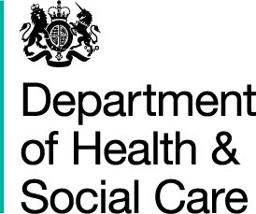

Sarah Wilkinson Chief Executive NHS Digital

1. Trevelyan Square Boar Lane

Leeds LS1 6AE

09 August 2019 Dear Sarah

# NHS Business Services Authority (NHSBSA) Medicines Data Directions 2019

I am writing to provide Directions to the Health and Social Care Information Centre, known as and hereafter referred to in these Directions as **NHS Digital**.

These Directions are given in exercise of the powers conferred by sections 254(1), and (6), 260(2)(d), 261(2)(e), and 304(9), (10), (11) and (12)(a)(v) of the Health and Social Care Act 20121 (**the Act**).

In accordance with section 254(2)(b) of the Act, the Secretary of State considers that it is in the interests of the health service in England for these Directions to be given.

These Directions are to be known as the **NHS Business Services Authority Medicines Data Directions 2019** and come into effect on 09 August 2019.

Pursuant to sections 254(1) and 254(6) of the Act, NHS Digital is directed to establish and operate an information system to be known as the **NHSBSA Medicines Data Information System** for the collection and analysis of data about medicines dispensed or supplied, as held by the NHS Business Services Authority and as specified in the **NHSBSA Medicines Data Information System Specification** (the Specification) attached to these Directions. The Specification may be updated periodically (within the confines of the scope set out in these Directions) by NHS Digital and agreed in writing by the Secretary of State.

The purpose is to deliver comprehensive data about medicines dispensed or supplied, as currently held by the NHSBSA, and drive the linkage of medicines data

1 2012 c.7

1. S.I. 2013/259

with other data sets to provide intelligence about the safety and effectiveness of medicines.

# Publication

In accordance with section 260(2)(d) of the Act, NHS Digital is directed not to publish information that is specified as not for publication in the Specification. Any other information must be published in line with NHS Digital’s duty under section 260(1) of the Act, unless it falls within section 260(2) of the Act.

# Dissemination

Where a prohibition on publication is specified in the Specification, NHS Digital may disseminate that information under sections 261(1) and 261(2)(e) of the Act, in such form and manner and at such times as it considers appropriate. Any other information may be disseminated in line with NHS Digital’s powers under section 261 of the Act.

In accordance with section 254(5) of the Act, NHS Digital has been consulted before these Directions have been given.

Please accept this letter as Directions given under section 254(1) of the Act to NHS Digital to establish and operate an information system for the collection and analysis of medicines data as described above.

With effect from 09 August 2019, the Medication Safety Data Collection and Analysis Direction (No 2) 2018 issued on 9 July 2018 are revoked.

Yours sincerely

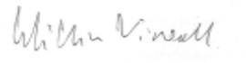

William Vineall

Director, Acute Care and Quality Policy

# Specification

This Direction is supported by the NHSBSA Medicines Data Information System Specification, which has been issued with these Directions.