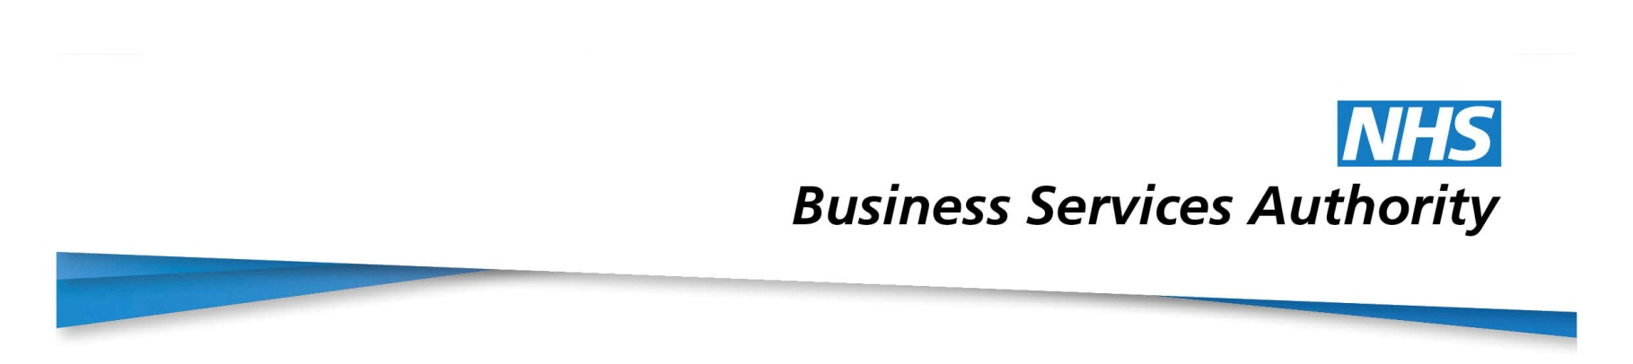
CCTV locations
The NHSBSA has CCTV cameras at the following locations:

Newcastle upon Tyne
NE1 6SN
NE15 8NY
NE12

Bolton
BL6 6PQ

Fleetwood
FY7 8LG

Wakefield
WF1 3AZ

