How to Sort the Pharmacy MIS Tool
Step 1: Use the toolbox buttons to navigate to either “MUR”, “NMS”, “Out of Pocket Expenses” or “Staff Hours”.
Step 2: Select the area you want to investigate further – “Upper Outlier”, “Above Average”, “Upper Quartile”, “Lower Quartile”, “Below Average” or “Lower Outlier”. This will update the pivot table below.
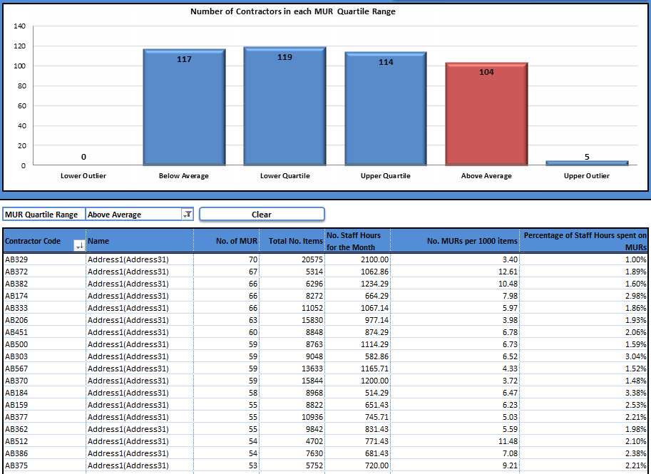
Step 3: The data is displayed with the contractor with the most of the select area (In this example MUR) being at the top and the values descending.
Left click on the contractor column such that only one Contractor code is selected.
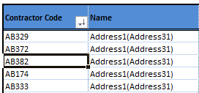
Step 4: Right click on the contractor code, move along the menu to “Sort” and follow the arrow across to “More Sort Options…” and left click.

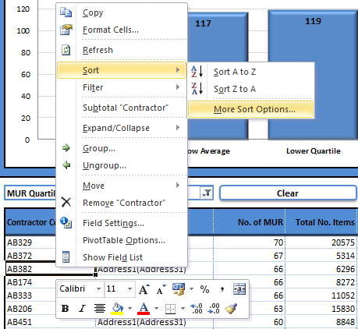

Step 5: On the new pop up window select the column heading you would like to sort by from the drop down list. In this example we will be sorting by “Percentage of Staff Hours spent on MURs”.
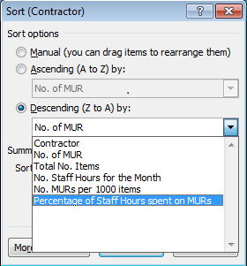
The pivot table will now be sorted according to your selection:
