Information Services Portal
Automated Registration

Contents Page

- How to Register
- Manage Authorisations

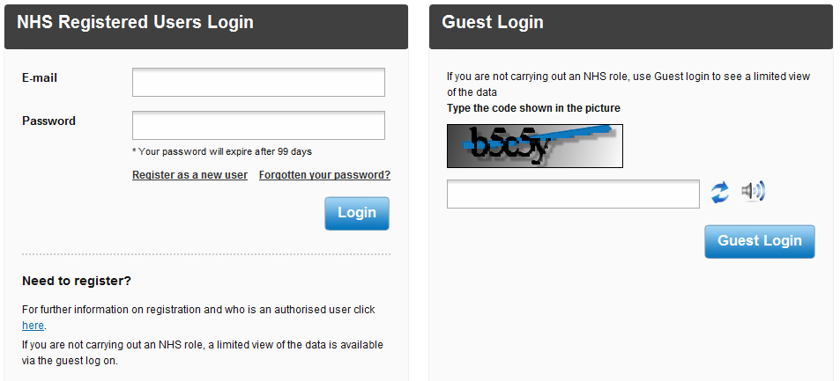
How to Register
1a
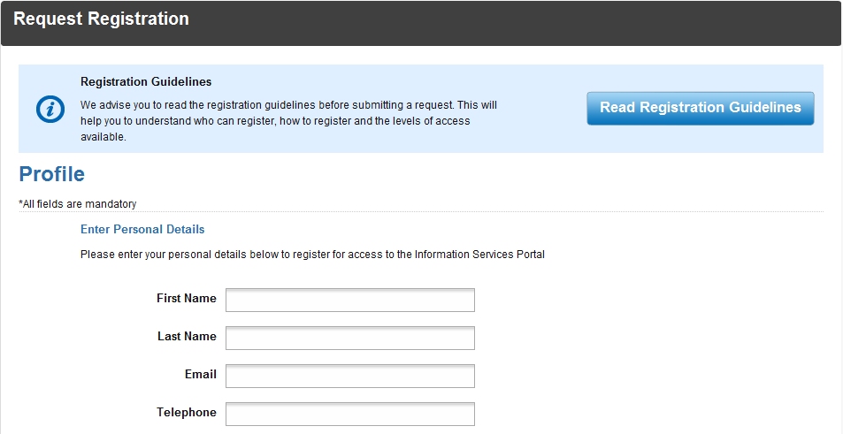
If you wish to register as a user of the Information Services Portal, go to the ISP login page and click Register as a new user.
1a
1a
2a
2a
2b
Before registering it is recommended that you read the registration guidelines for information on who can register and the levels of access available.
2b
Enter your personal details in the spaces provided.

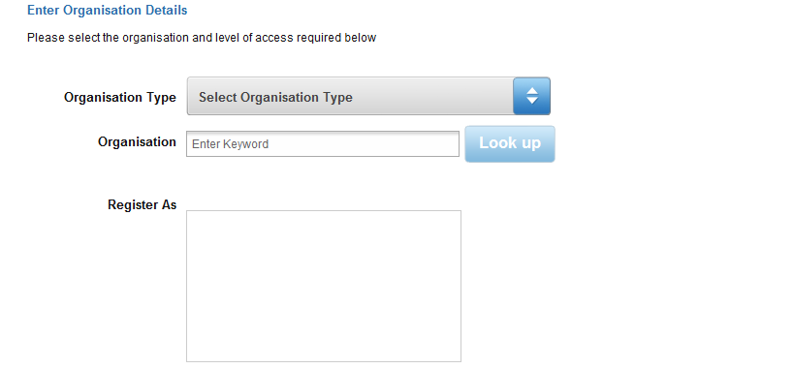

3a

3a
To select the organisation you wish to register for, click on the drop down menu.
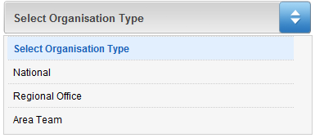

3b

3b
From the drop down list choose the organisation type your desired organisation belongs to.

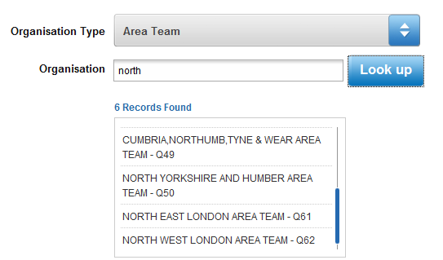
3c

3d

3c
Once you have chosen your organisation type, search for your desired organisation. Enter the name, or partial name, of the organisation and select Look up.
3d
From the search results, select your organisation.

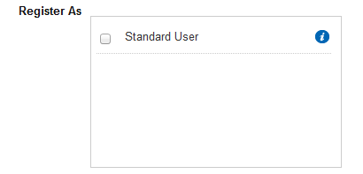

3f
3e

3e
Choose which type of user you wish to register as.
3f
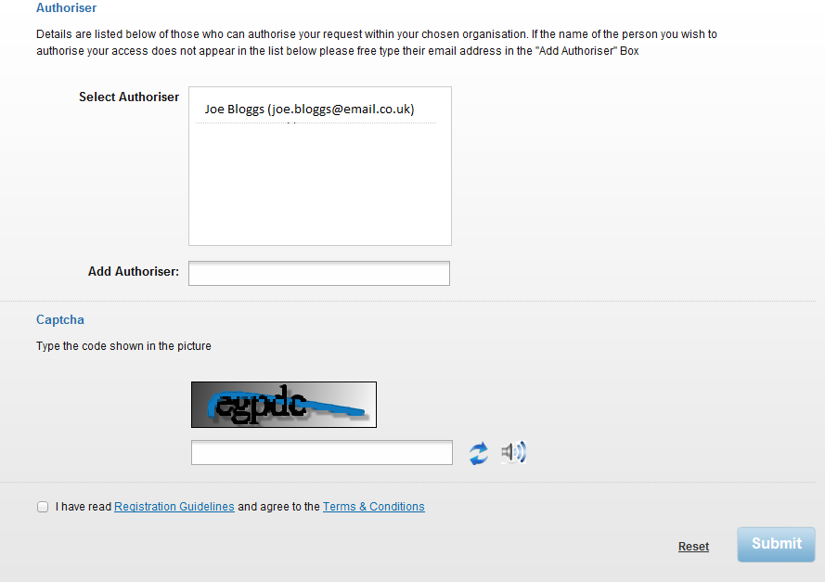
For information on which reports each user type has access to, hover the mouse over the symbol.
3h
3g
3j
3k
3i

3g
From the list of authorisers, choose the person that you wish to authorise your registration.
3h
If your desired authoriser is not listed, enter their email address in the space provided.
3i
Enter the code in the space provided. If you cannot read the code, you can either refresh the code or select the speaker icon symbol to hear the code.
3j
After reading the Registration Guidelines and Terms & Conditions, click the box to confirm this.
3k
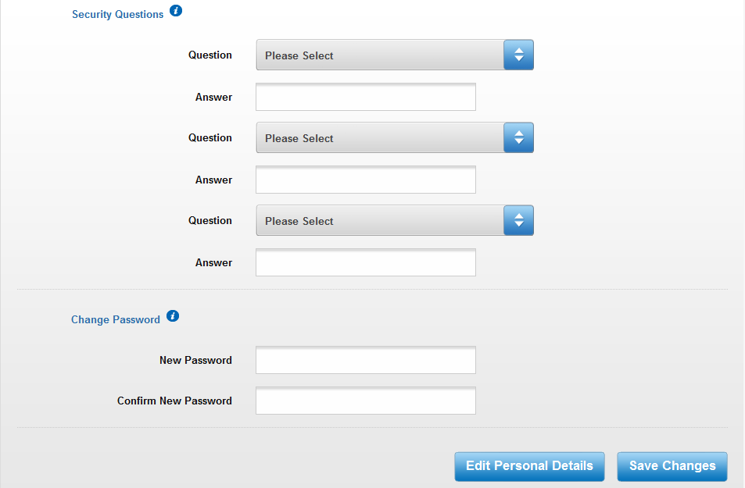
Select Submit to submit your registration. You will receive an email confirming you have applied for access. If your access has been denied, you will receive an email explaining why it was denied and a link to resubmit your application. If your access has been approved, you will receive a confirmation email. Follow the link in the email to continue setting up your account and the following page will open;
4a
4c
4a

4e
4d
4b
To set up your three security questions, choose a question form the drop down box and then enter your desired answer.
4b
Enter your desired password.
4c
For information on security questions and choosing your password, hover your mouse over the I symbol.
4d
Your personal details will be pre-populated, but if you wish to edit these details, select Edit Personal Details.
4e
Once you have finished, select Save Changes. You will be sent to the home page.

Manage Authorisations

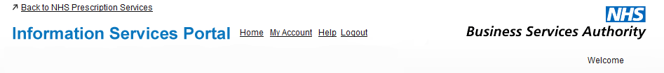
5a
5a
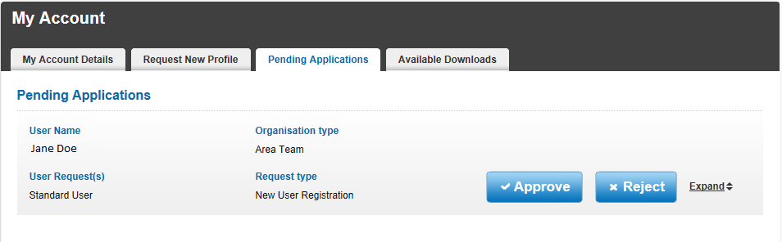
If you are an authoriser for your organisation, you can manage the applications for you to authorise from My Account. Select My Account from the home page and the select the Pending Applications tab. The following page will appear;
5b
5c
5d
5b
The details of the application will be shown, but for more details select Expand and the expanded details will be revealed.
5c
If you wish to approve the the application, select Approve and the following will appear;
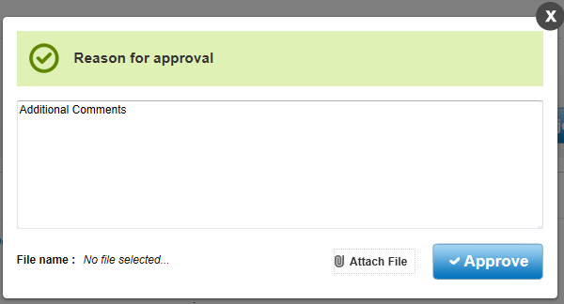

If you wish to leave a reason for approval, leave a comment in the space provided. If you wish to attach a file to the approval, select Attach File and choose the desired file. Select Approve to approve the application. The following message will appear;
5d
To reject the application, select Reject and the following will appear;
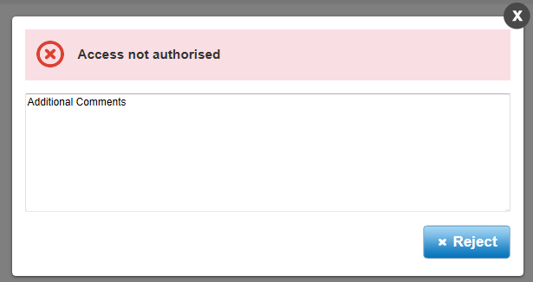
Type your reason for rejecting the application into the space provided, then select Reject. The following will then appear;

