Information Services Portal
Bookmarking a Report

Report Page
1a
1b
To Bookmark a report
1a
From the report, click Bookmark at the top right of the page.
1b
When the report has been bookmarked, the symbol will change to ‘Bookmarked’. Click here again to remove the bookmark.

Search Page
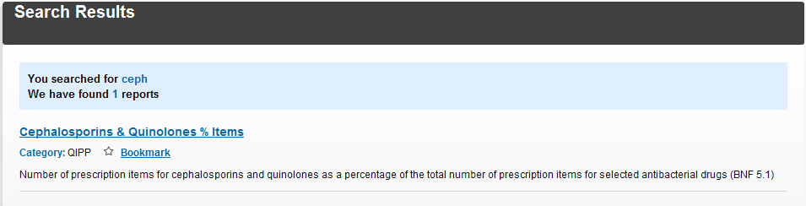

2a

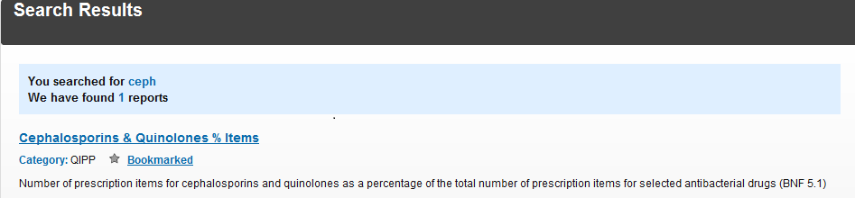
2b
To Bookmark from Search Page
2a
From a search result, click Bookmark.
2b
When the report has been bookmarked, the symbol will change to ‘Bookmarked’. Click here again to remove the bookmark.

Home Page
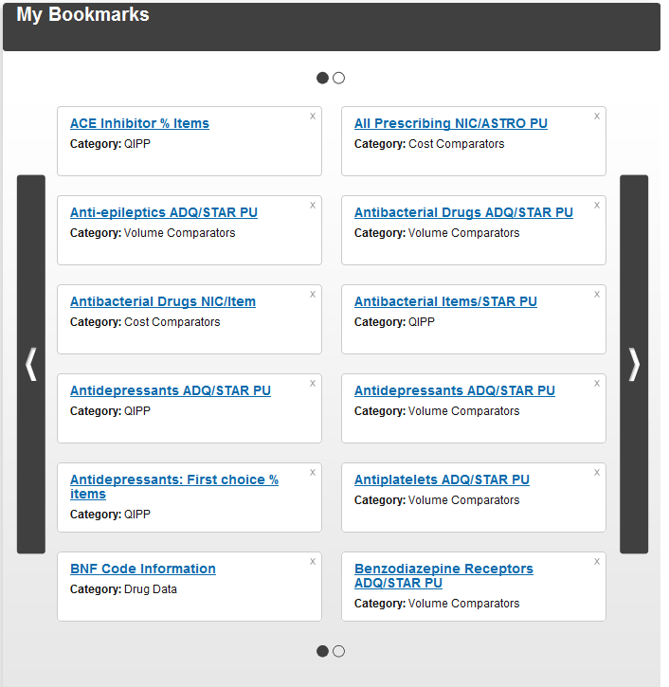
3b
3a

3a
When a report has been bookmarked it will appear on the homepage in alphabetical order.
3b
If more than 12 reports have been bookmarked, click on the arrows to scroll through each page of bookmarks.

Report Page

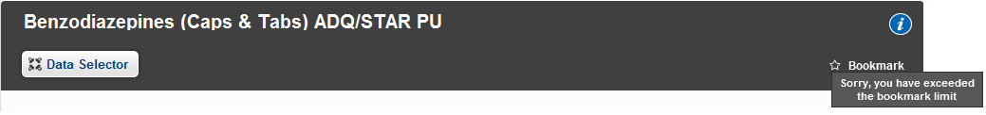
4a

Search Page
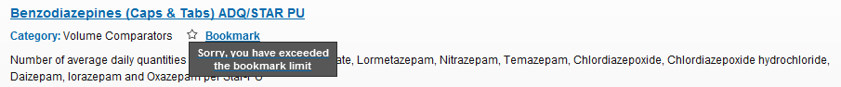
4b
4a
You can only store 50 bookmarks. Once you reach this limit a message will appear and your report will not be bookmarked.
4b
The same message will appear when bookmarking from a search.

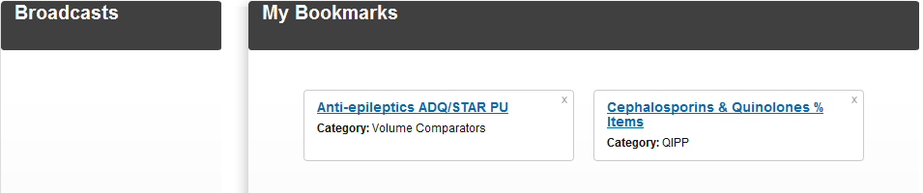
Home Page
5a
5a
To add another bookmark after the limit has been exceeded you must remove an existing bookmark. Click on the X to remove a bookmark from the home page.

