Information Services Portal
Data Download

Home Page
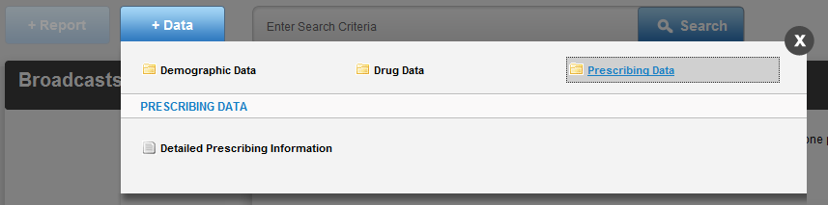
1a
1a
From the home page, select the +Data tab, then the report category you wish to view. The following page will appear;
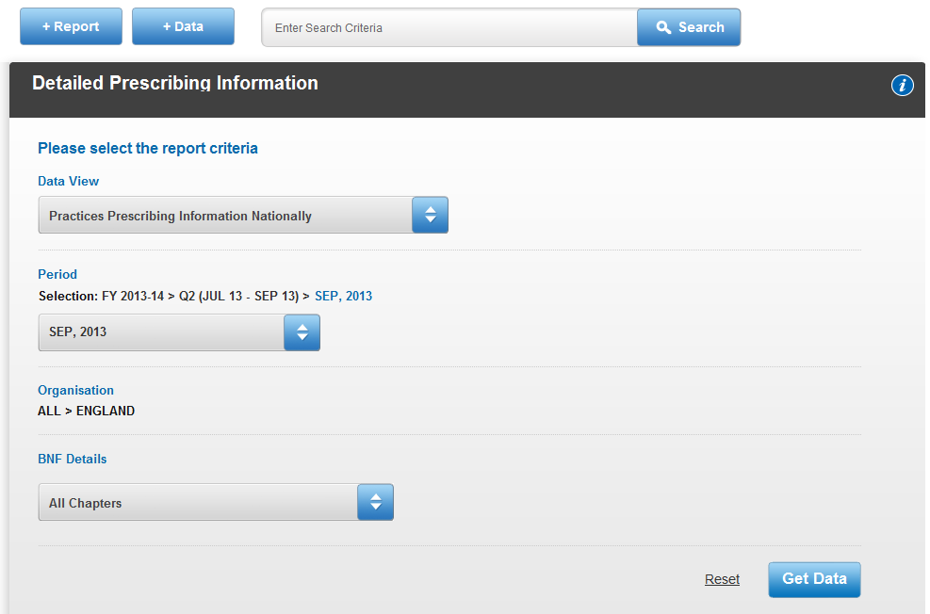

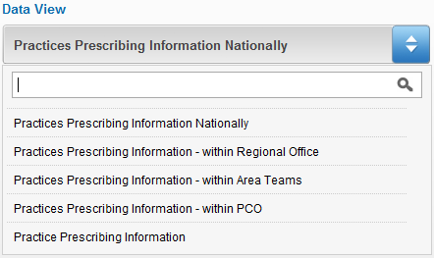

2b

2a

2a
Under Data View there is a drop down box of available views for your report.
2b
To search for a data view type the name, or partial name, of the view you require into the space provided. The drop down box will then only show you the views with those characters in the title.
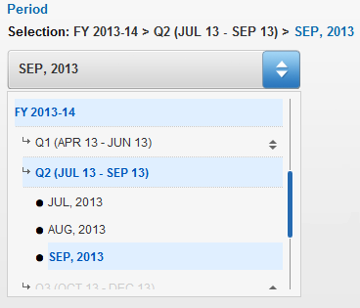

2c

2c
Select the time period you wish to view. You can choose a financial year, financial quarter, or month, depending on the report.

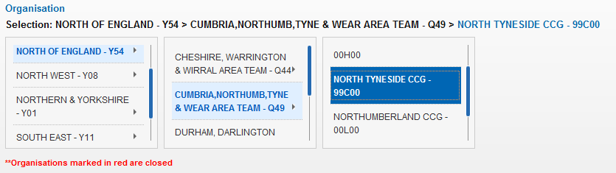
2d
2d
If you are a registered user your organisation will already be selected. If you are a guest user you will have to select an organisation to view. To select an organisation, drill down from Regional Office to Area Team, PCO, and Practice, depending on your report.

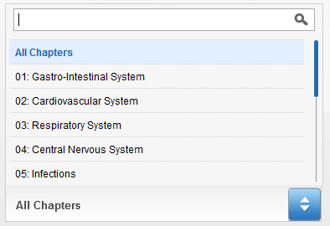
2f

2e

2e
If applicable to your report, you can choose the BNF Chapter you want to view. Select the desired chapter from the drop down list.
2f
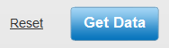
You can search for a chapter using the search box.

2g

2g
Once you have made your selections, select Get Data to download the data. Select Reset if you wish to return the selections to the default settings. If the data is available, it will download in .zip format.

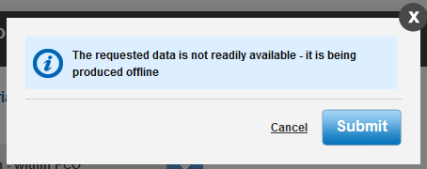
3a

3a
If that data is not available to download immediately, you will be notified when the data is available. Select Submit
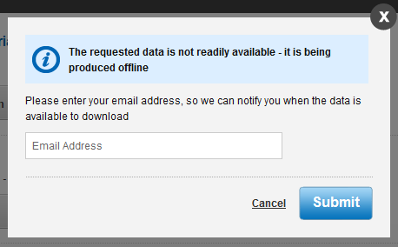
3b

3b
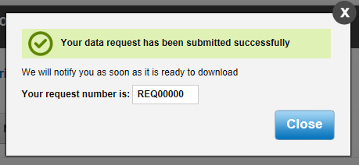
If you are a guest user, you will have to enter your email address to be notified when the data is available.

3c

3c
Once your request has been submitted you will be provided with a request number. When your data request is available to download you will receive an email. If you are a registered user click the link within the email to open the following page;

Please be aware when downloading information standard spreadsheet applications may not be able to handle the volumes of data contained in the monthly data sets. It is intended that users who are downloading large volumes of data (National, Regional Office and some Area Teams) will be using a bespoke IT Solution or an add-on that can handle larger data sets such as the Microsoft PowerPivot add-on for Excel.
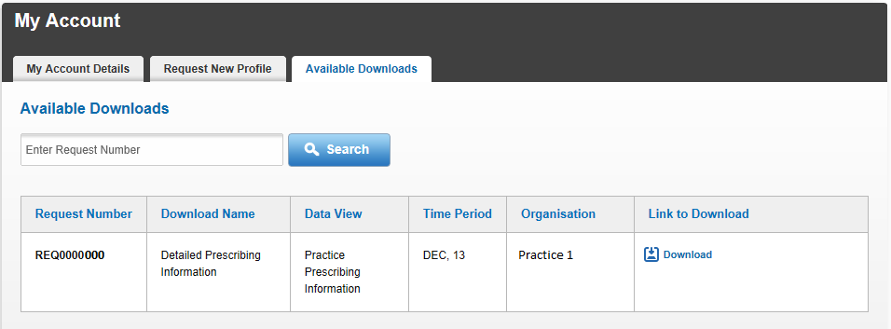
4a
4b
4c
4a
The details of your download request will be shown here.
4b
To search for a specific download request, type the request number in the space provided and select Search. The specific download request will then be shown.
4c
To download your report, select Download. It will download in .zip format. You can return to this page at any time through the My Account link on the home page.
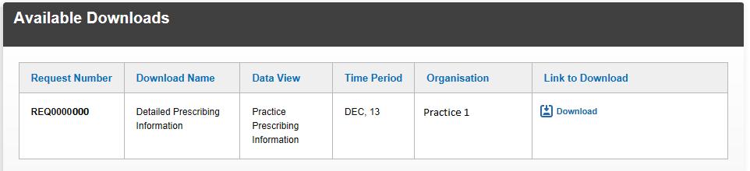
4e
4d
4d
If you are a guest user, this page will open from the link within the email. The details of your download request will be shown here.
4e
To download your report, select Download. It will download in .zip format.

