Information Services Portal
Downloading and Printing Reports

Report Page

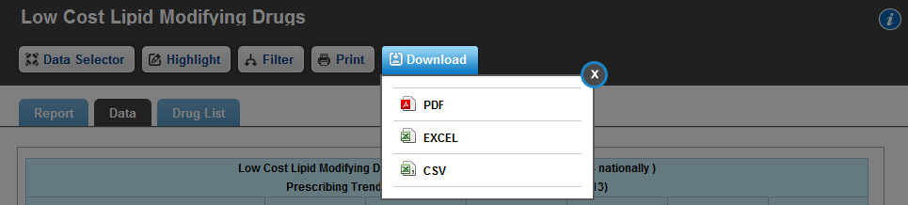
Download a Report
1a
1a
If you wish to download a report, click Download. This will give you the option to download the report in PDF, Excel, or CSV format. Please note that graphs will only be available to download in PDF format.

Print a Report
2a
2a
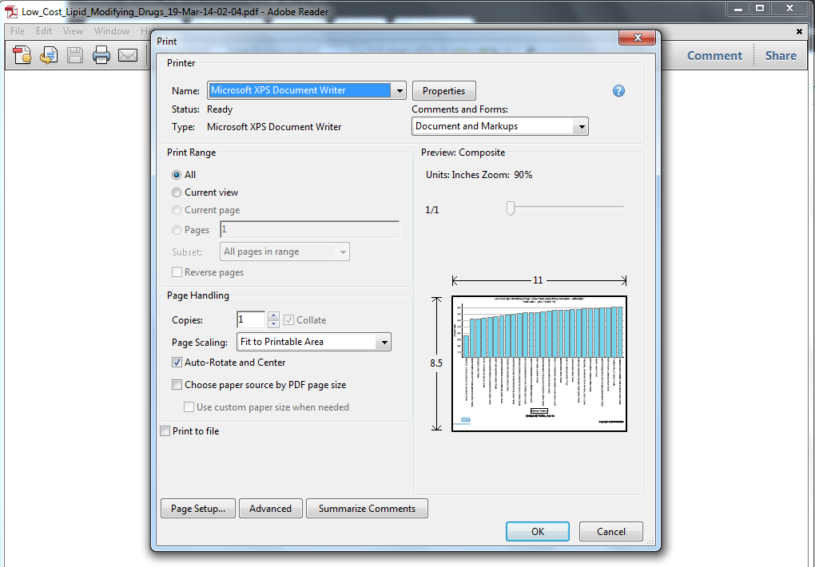
To print a report, click Print. This will open the report in PDF format as shown below;

