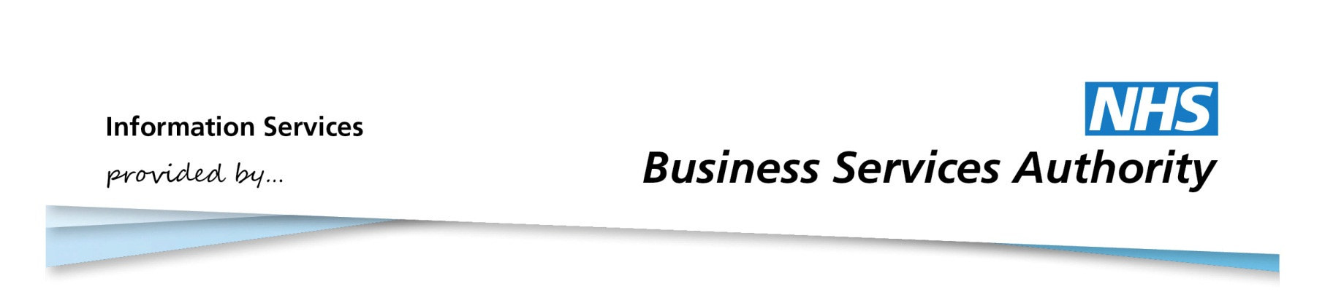

Information Services Portal
GP Guide

Contents Page

- Login
- Selecting and Viewing Reports
- Bookmarking a Report
- My Account
- Logout
- Other Information

LOGIN PAGE

Login
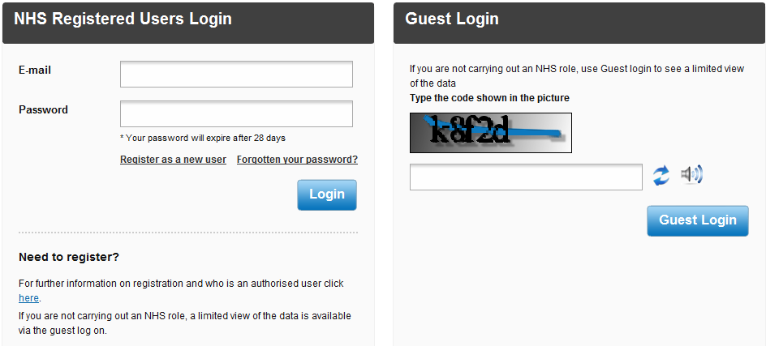
1b
1a

1a
From the ISP login page, enter your email address and password in the spaces provided.
1b
Click the Login button. For more information please see the Login/Logout User Guide. Once you have successfully logged into the system you will be directed to the home page.

Home Page

Selecting and Viewing Reports
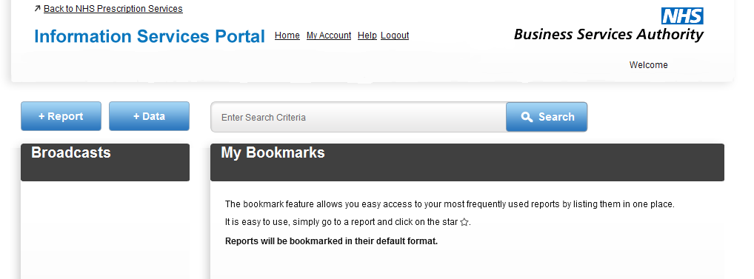
2c
2b
2a

2a
From the home page, click +Report to view relevant report categories.
2b
Click +Download to view Data Download categories. For more information on Data Download, please see the Data Download User Guide.
2c
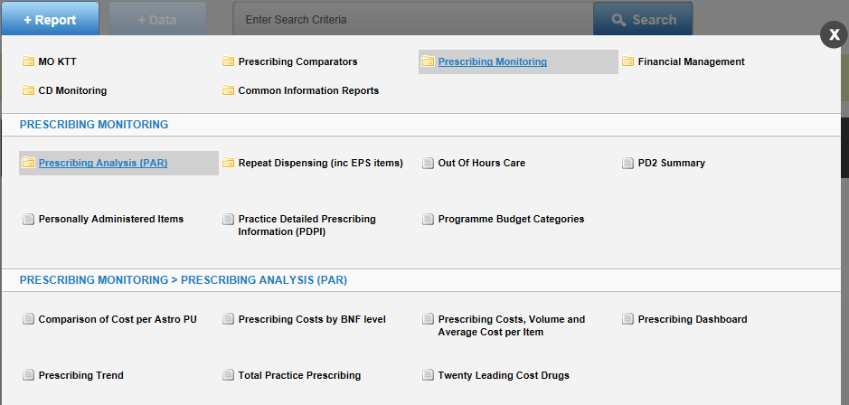
Important messages and news items will appear under Broadcasts.
3c
3b
3a
3a
Reports available to GPs can be found under Prescribing Monitoring.
3b
Select the desired report. Select Prescribing Analysis (PAR) to view PAR reports. For more information on Practice Detailed Prescribing Information (PDPI), see the PDPI User Guide.
3c
Click on the X if you wish to close this menu and return to the home page

4b
4c
4a

4a
Select to choose different organisational view and time periods.
4b
Select to print the report. For more information, please see the Downloading and Printing Reports User Guide.
4c
Select to download the report. For more information, please see the Downloading and Printing Reports User Guide.

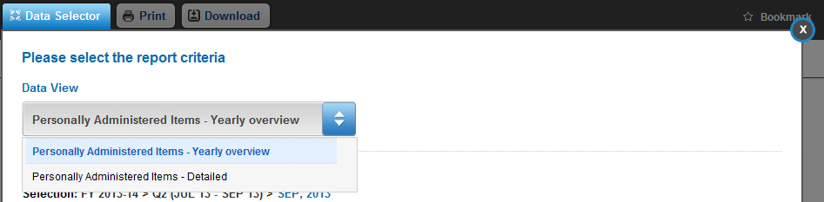
5a
5a
Under Data View there is a drop down box of available views for your report. Your current view will be highlighted. To search for a data view type the name, or partial name, of the view you require into the space provided and the drop down box will only show the views with those characters in the title.
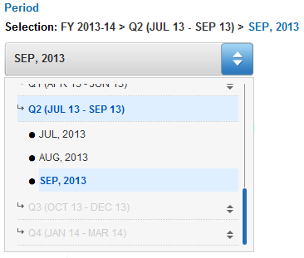

5b

5b
Select the time period you wish to view. You can choose a financial year, financial quarter, or month, depending on the report. Your current selection will be highlighted.

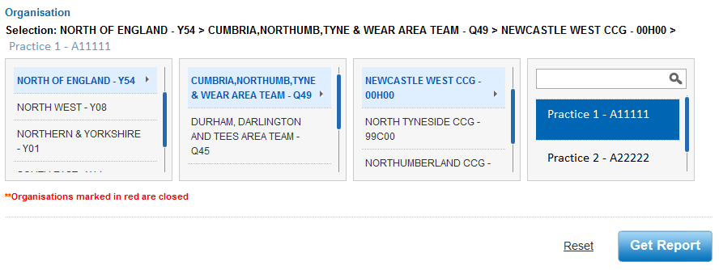
5b
5c
5b
Your practice will already be selected.
5c
Once you have made your selections, select Get Report to view the report with the new data view. If you wish to reset the data selections to the default selections, click Reset.

Report Page

Bookmarking a Report

6b
6a

To bookmark a report from the report page, select Bookmark.
6a
6b
When the report has been bookmarked, the symbol will change to Bookmarked. Select again to remove the bookmark.

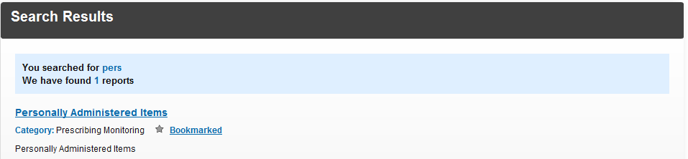
6c
6c
You can also bookmark reports from a search. For more information on searching for reports, please see Searching for a Report User Guide.

Home Page
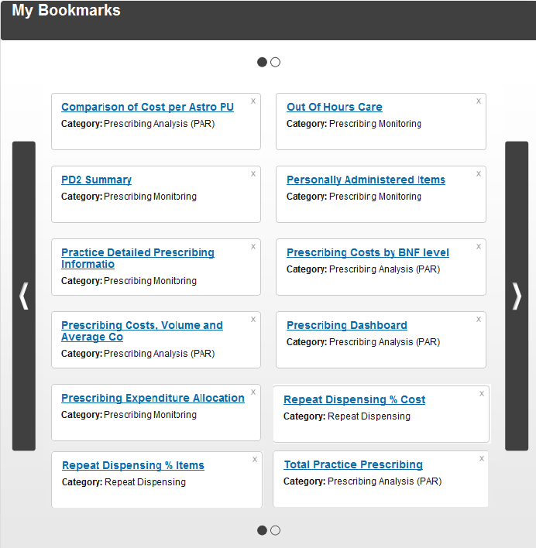

6d

6e

6d
When reports have been bookmarked they will appear on the home page in alphabetical order.
6e
If more than 12 reports have been bookmarked, click on the arrows to scroll through each page of bookmarks. A maximum of 50 reports can be bookmarked. Once you reach that limit you will have to remove a bookmark to add a new bookmark. For more information please see the Bookmarking a Report User Guide.

Home Page

My Account
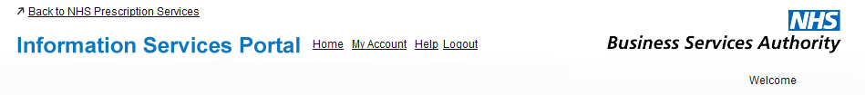
7a
7a
From the home page, click My Account to access your account details.

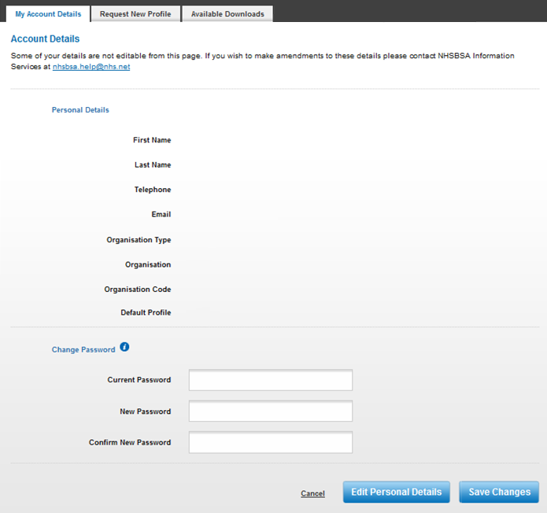
7g
7f
7e
7d
7c
7b

7b
This section will display your personal details, as well as the details of your organisation. If you have access to multiple organisations then your default organisation will be shown.
7c
If you wish to amend your personal details, click Edit Personal Details. This will allow you to change your first name, last name, and telephone number. Click Save Changes when you have finished.
7d
If you wish to change other details, such as your organisation, please contact NHSBSA Information Services team on the email address given.
7e
If you want to change your password, enter the relevant details here.
7f
To view information on how to choose a new password, click on this symbol.
7g
For information about the Request New Profile tab please see the Requesting a New Profile User Guide. For information about the Available Downloads tab, please see the Data Download User Guide.

Logout
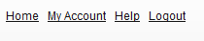
8a
8a
To logout of the system, click Logout. If you do not submit any requests for 30 minutes you will automatically be logged out of the system.

Other Information

- Your password will expire after 28 days. If you try to logon after your password has expired you will be directed to the change password screen where you have to enter a new password.
- If you do not logon for 12 months your access will expire and you will have to re-register.
- There are more in depth user guides which can be found on our website. These pages provide information on what you will see and instructions on how to navigate around the system.
http://www.nhsbsa.nhs.uk/PrescriptionServices/3625.aspx
- Report Information - contains links which are intended to assist users of the Information Services Portal put into context the data included within reports/charts in each Report Category. http://www.nhsbsa.nhs.uk/PrescriptionServices/3624.aspx

