Information Services Portal
MIS
(Management Information Spreadsheet)

LOGIN PAGE

Login
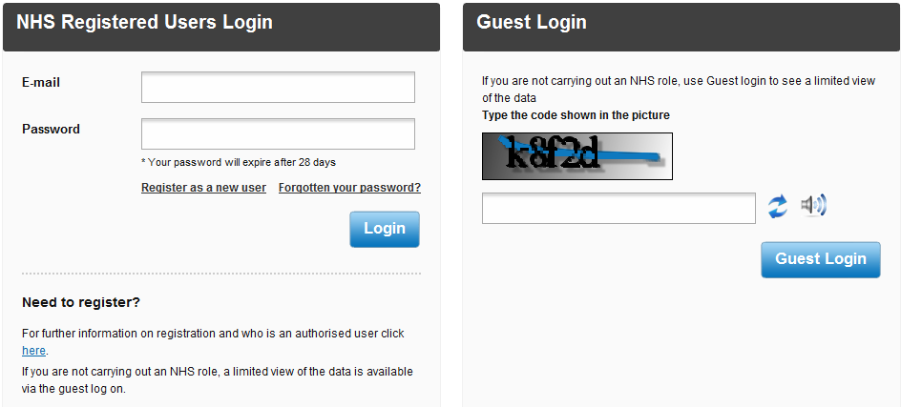
1b
1a

1a
From the ISP login page, enter your email address and password in the spaces provided.
1b
Click the Login button. For more information please see the Login/Logout User Guide. Once you have successfully logged into the system you will be directed to the home page.

Home Page
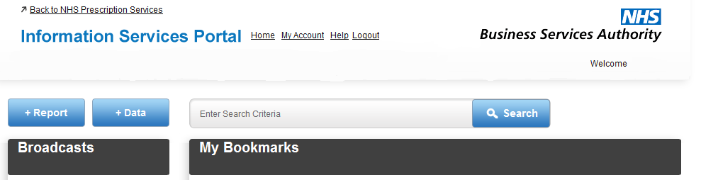

2a

2a
From the home page, select the +Report tab.
2a

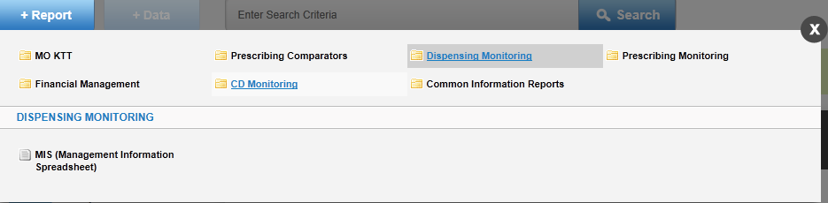
3c
3a

3b

3a
Select Dispensing Monitoring.
3b
Select MIS (Management Information Spreadsheet).
3c
Click on the X if you wish to close this menu and return to the home page.

MIS Report Page

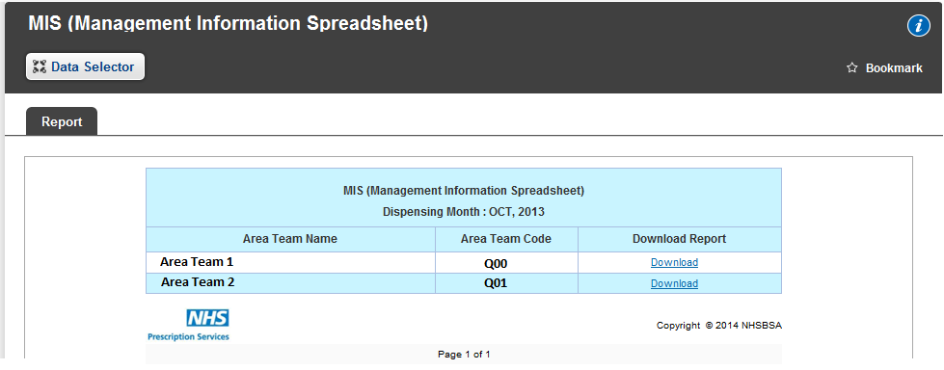
4a
4b
4a
From this page you can see the organisations for which you have access.
4b
To view the report, click on Download next to the relevant organisation. The following is the default view of the report in Excel;
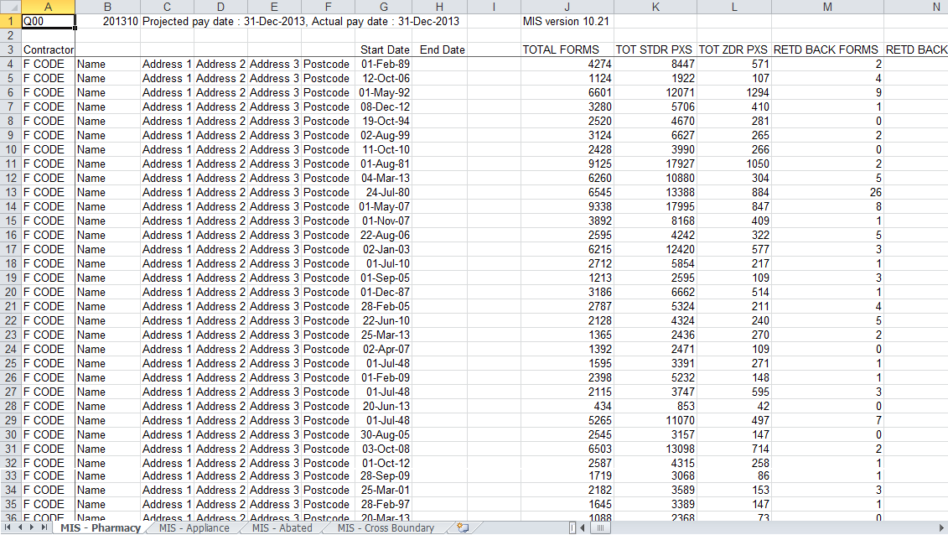
5a
5a
Users have access to the previous 24 months of reports. Click on the Data Selector to choose a different month.

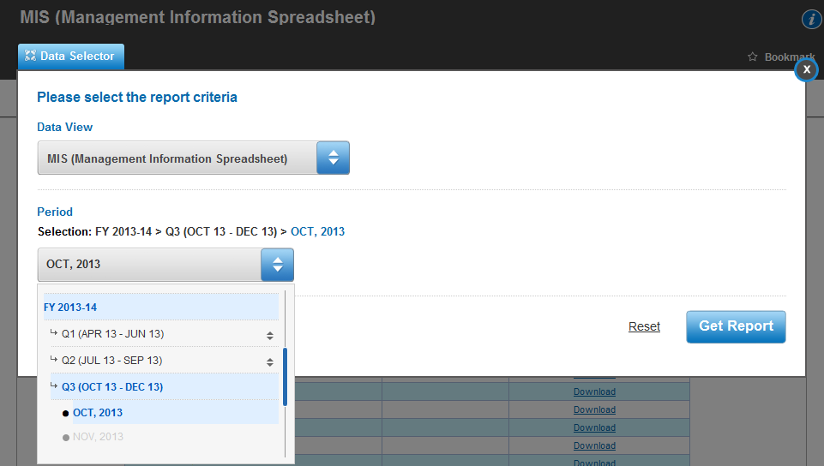
4b
5d
5c
5b
5b
From the drop down menu select the month you want to view.
5c
When you selected the month you want, click Get Report to return to the report screen to view the report.
5d
Click Reset to return the month back to the latest available month.

6b
6a
6a
For more information on the MIS Report, click on this symbol.
6b
To bookmark the MIS Report, click Bookmark. For more information on how to bookmark reports, see the Bookmarking a Report User Guide. When the report has been bookmarked it will appear on the home page, as shown below;

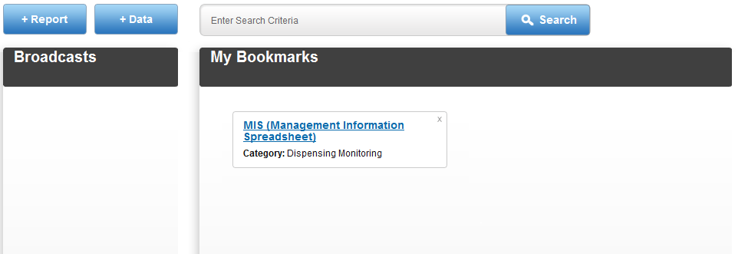

Logout
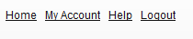
7a
7a
To logout of the system, click Logout. If you do not submit any requests for 30 minutes you will automatically be logged out of the system.

Other Information

- Your password will expire after 28 days. If you try to logon after your password has expired you will be directed to the change password screen where you have to enter a new password.
- If you do not logon for 12 months your access will expire and you will have to re-register.
- There are more in depth user guides which can be found on our website. These pages provide information on what you will see and instructions on how to navigate around the system.
http://www.nhsbsa.nhs.uk/PrescriptionServices/3625.aspx
- Report Information - contains links which are intended to assist users of the Information Services Portal put into context the data included within reports/charts in each Report Category. http://www.nhsbsa.nhs.uk/PrescriptionServices/3624.aspx

