Information Services Portal
Request New Profile

Contents Page

- How to Request New Profile
- Manage Authorisations

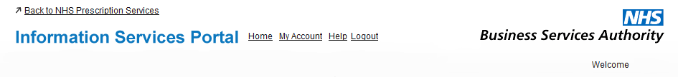
Request New Profile
1a
1a
From the home page, select My Account.
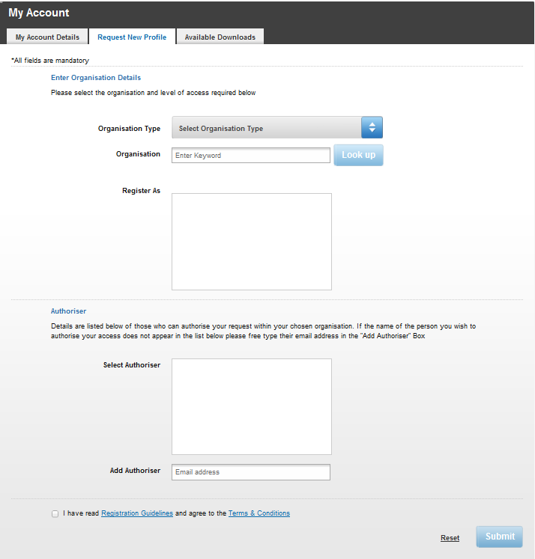
2a

2a
Select the Request New Profile tab from the My Account page.

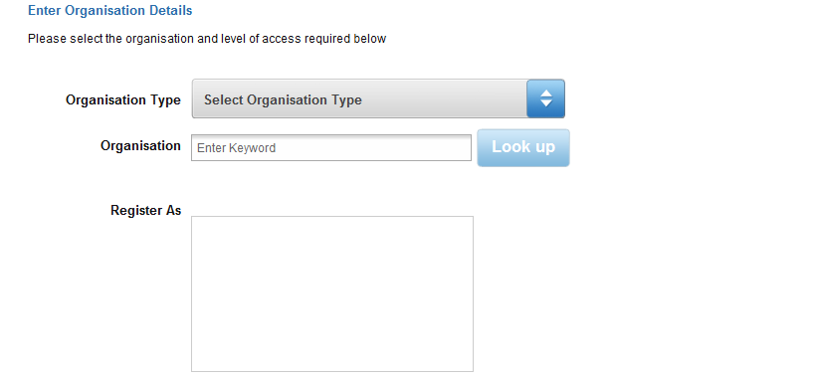
3a

3a
To select the organisation you wish to request a new profile for, click on the drop down menu.
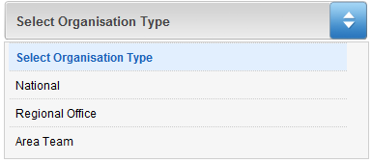
3b

3b
From the drop down list choose the organisation type your desired organisation belongs to.

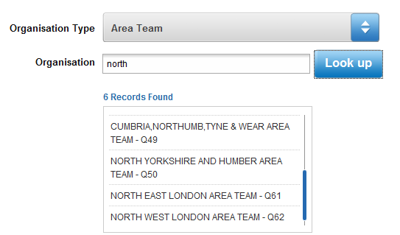
3c
3d

3c
To search for your desired organisation, enter the name or partial name of the organisation into the search box and select Look up.
3d
The search results will appear. Select your desired organisation.

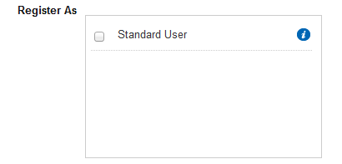
3f
3e

3e
Choose which type of user you wish to register as.
3f
For information on which reports each user type has access to, hover the mouse over the symbol.

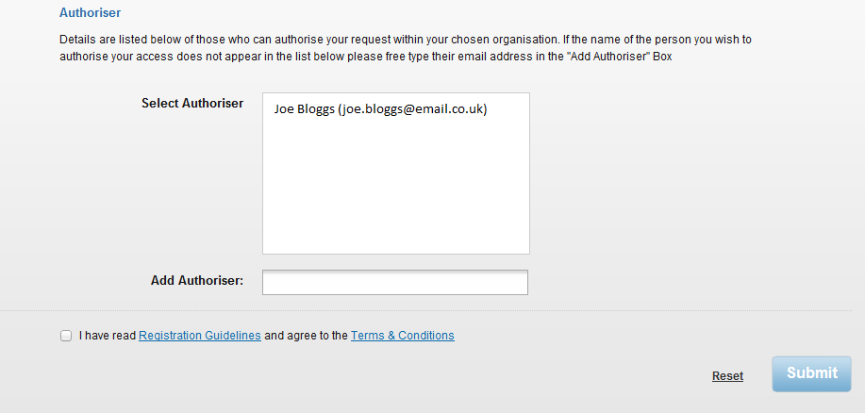
3g
3i
3j
3h

3g
Select which person you wish to authorise your registration.
3h
If your desired authoriser is not listed, enter their email address in the space provided.
3i
After reading the Registration Guidelines and Terms & Conditions, click here.
3j
Select Submit when you have completed the registration form. If you wish to remove all information from the registration form, click Reset. The following message will appear after submitting your request;

If your access has been denied, you will receive an email explaining why it was denied and a link to resubmit your application. If your access has been approved, you will receive a confirmation email with a link to log back into the system. For information on how to switch between profiles, please see the Changing Active or Default Profiles User Guide.

Manage Authorisations

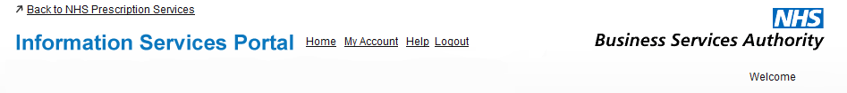
4a
4a
If you are an authoriser for your organisation, you can manage the applications for you to authorise from My Account. Select My Account from the home page and the select the Pending Applications tab. The following page will appear;
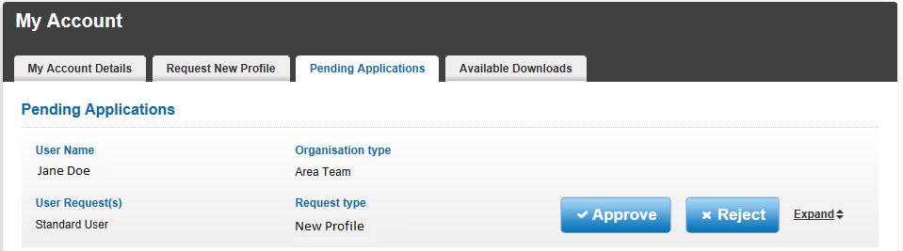
4b
4d
4c

4b
The details of the application will be shown, but for more details select Expand and the expanded details will be revealed.
4c
If you wish to approve the the application, select Approve and the following will appear;

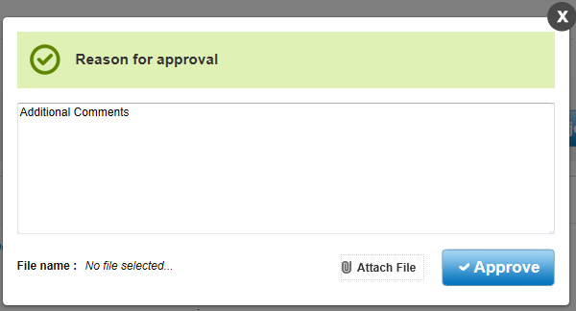

If you wish to leave a reason for approval, leave a comment in the space provided. If you wish to attach a file to the approval, select Attach File and choose the desired file. Select Approve to approve the application. The following message will appear;
4d
To reject the application, select Reject and the following will appear;
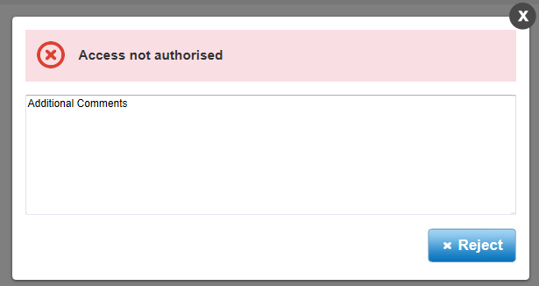

Type your reason for rejecting the application in the space provided, then select Reject. The following will then appear;

