Information Services Portal
Searching for a Report

Home Page
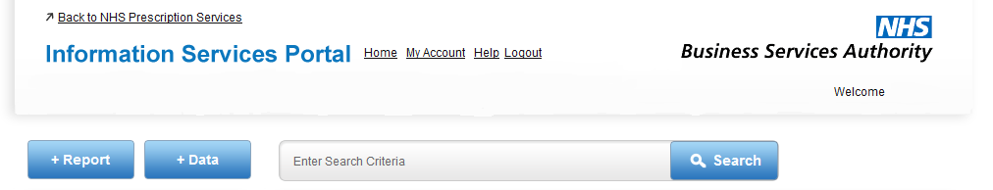
1a
1a
From the home page enter the name, or partial name, for the report you are searching for and click Search.
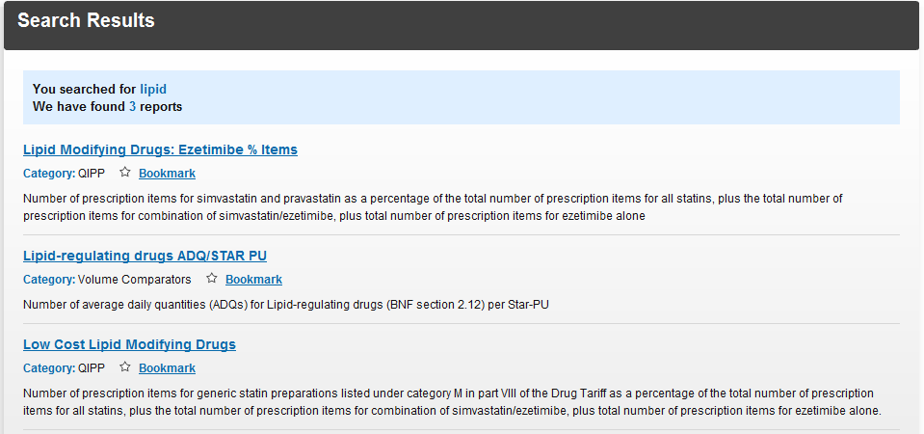
2b
2a
2c
2a
The system will then display all reports that have the characters you searched for anywhere in the title. The results will be shown in alphabetical order. Click on the report name to open that report.
2b
Search results will show the characters searched for and how many results there are for your search. Only reports which you are authorised to view will be shown.
2c
Each report will have a brief explanation of the report, which category it belongs to, and the ability to bookmark that report. For more information on bookmarking a report, please see the Bookmarking a Report User Guide.

