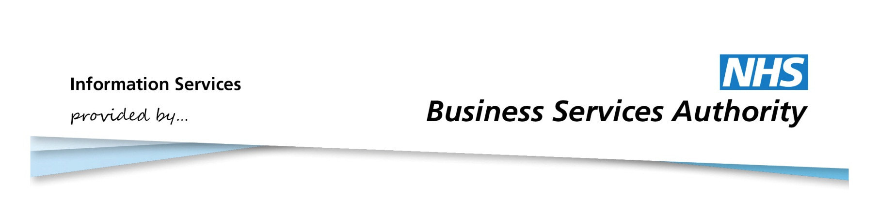

Information Services Portal
Selecting and Viewing Reports

Contents Page

- Selecting Reports
- Viewing Reports
- Highlight
- Filter
- Management Information Spreadsheet (MIS)

Home Page

Selecting Reports
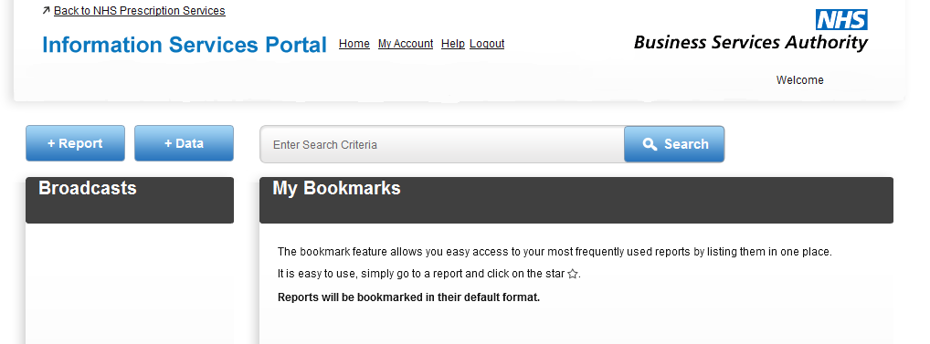
1a
1b
1c
1a
From the home page, click +Report to view relevant report categories.
1b
Click +Data to view available Data Download categories. For more information on Data Download, please see the Data Download User Guide.
1c
Important messages and news items will appear under Broadcasts.
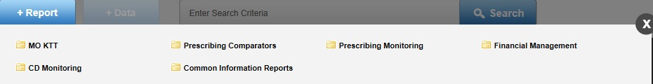
2a
2b
2a
Select a report category to view relevant reports. You will only be able to view reports you are authorised to view.
2b
Click the cross if you wish to close this menu.

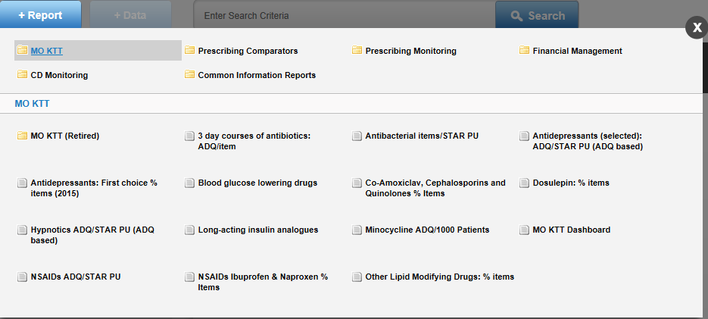

3b

3a

3a
When a report category is selected, reports available for that category will be shown. Select the report you wish to view. This will open in a new window.
3b
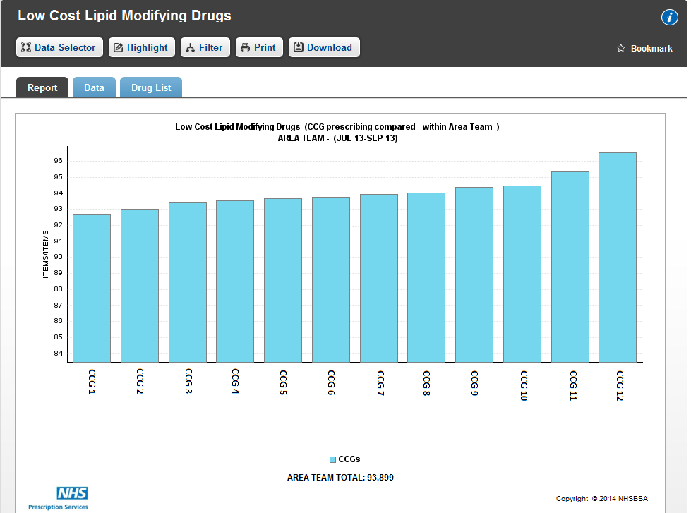
Click the cross if you wish to close this menu.
4e
4b
4d
4c
4a

4a
Once you have selected a report, a default chart of your organisation will be shown.
4b
The tabs along the top of the chart will allow you to select different aspects of the report. For information on how to download and print report, please see the Downloading and Printing User Guide.
4c
The chart will provide the name of the report, data view, area, and time period.
4d
For information on how to bookmark reports, please view the Bookmarking a Report User Guide.
4e
For additional report information, click here.
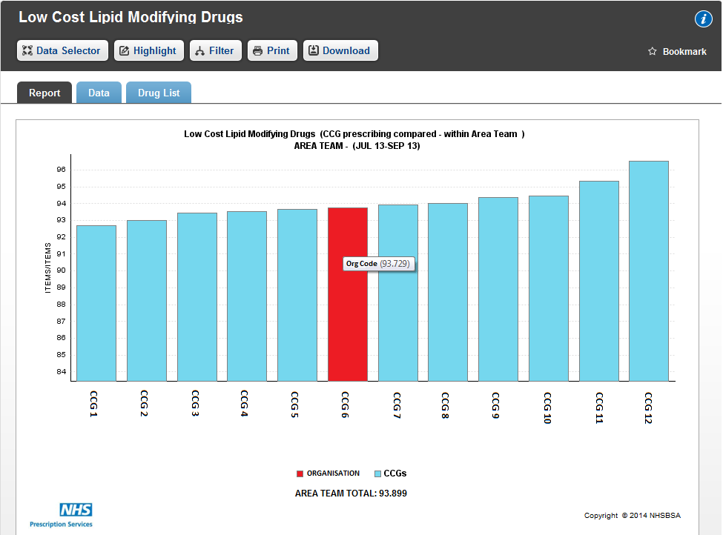
4g
4f
4f
If relevant, your organisation will automatically be highlighted.
4g
Hovering your mouse over a bar in the chart will show the organisation code and value for the organisation that bar represents.

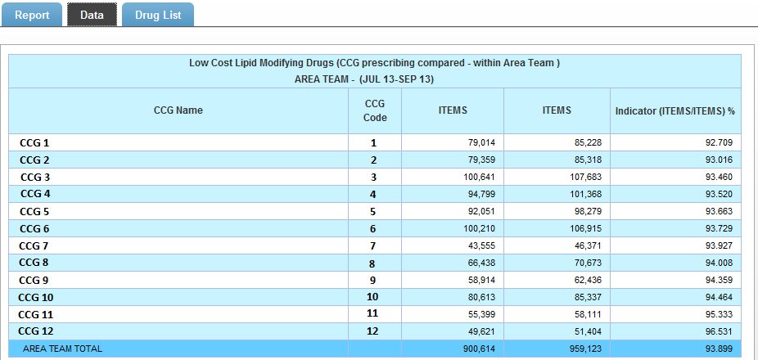
5a
5a
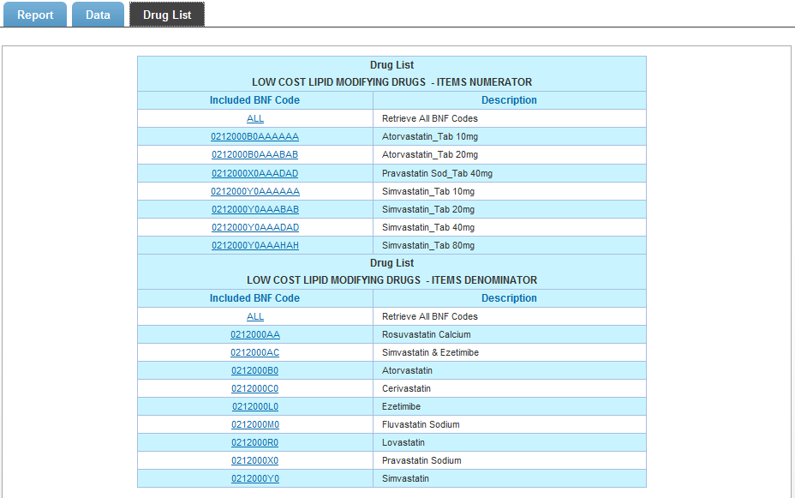
To view the report as a table of data, click on the Data tab.
5b
5b
If available, select the Drug List tab to view the drug list for the selected report.
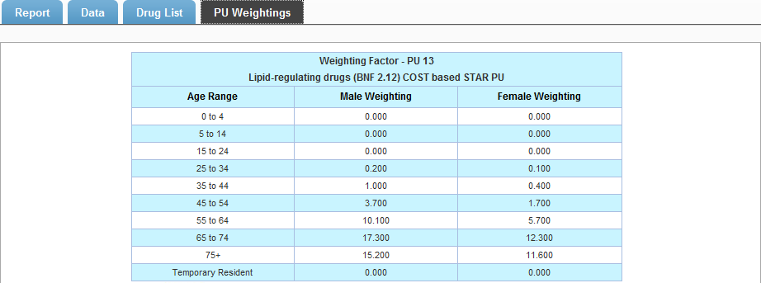
5c
5c
If available, select the PU Weightings tab to view to PU weightings for the selected report.
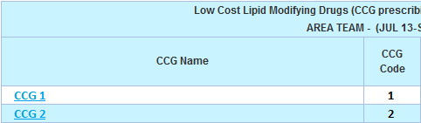
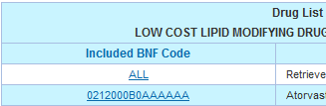
5d
5d
If a report has an underlined heading, you can drill down through that report by selecting the heading. If you select a heading on the drug list you will sort that report alphabetically by BNF Code or by description. You can also drill down from a chart by clicking on a bar.
5e

5e
When you have drilled down through a report, a new set of tabs will appear above the report. Click on the appropriate tab to return to that level of the report. Select the home tab to return to the top level of that report.

Viewing Reports

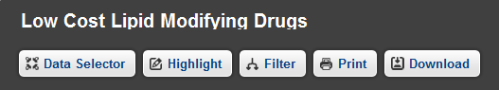
6a

6a
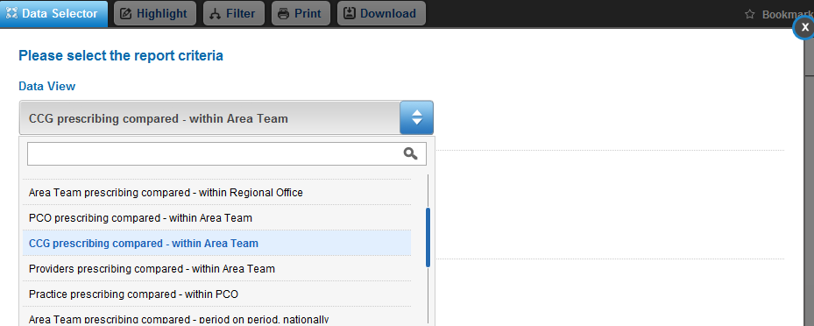
To choose different views of the selected report, click the Data Selector tab.
6c
6b
6b
Under Data View there is a drop down box of available views for your report. Your current view will be highlighted.
6c
To search for a data view type the name, or partial name, of the view you require into the space provided and the drop down box will only show you the views with those characters in the title.

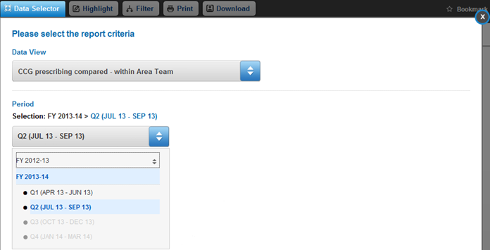
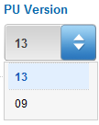
6e
6c
6d
6d
Select that time period you wish to view. You can choose a financial year only, financial quarter, or month, depending on the report. Your current selection will be highlighted.
6e
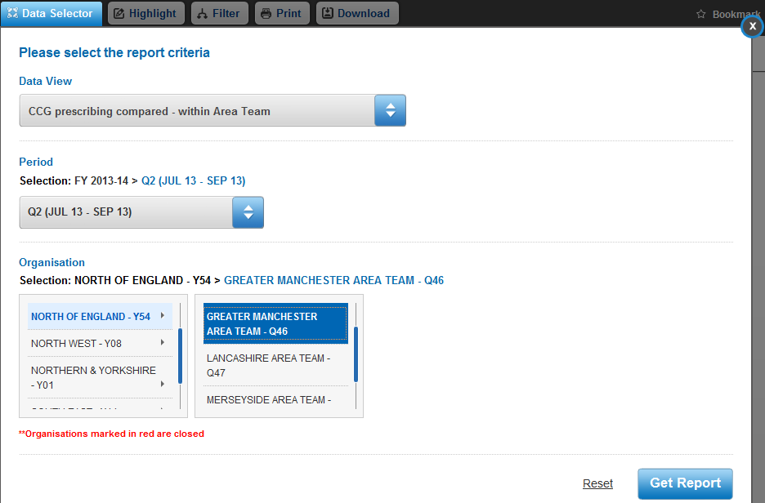
If available for you report, choose the PU version from the drop down box.
6g
6f

6f
Select the organisation you wish to view. You can drill down from Regional Office to Area Team, PCO, and Practice, depending on your report. Your current choice will be highlighted.
6g
Once you have made your selections, select Get Report to view the report with the new data view. If you wish to rest the data selections to the default selections, click Reset.

Highlight
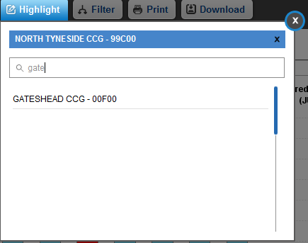
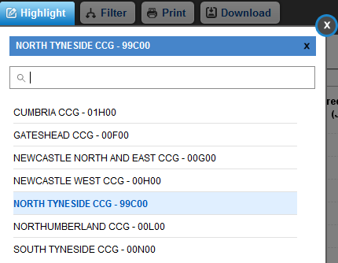
7b
7c

7a

7a
The highlight function allows you to highlight a certain organisation within the report. Select the Highlight tab and choose an organisation from the drop down list.
7b
To remove the highlight, click the X next to the organisation name.
7c
To search for an organisation, enter the name or partial name of the organisation in the search box. The available organisations will then appear in the drop down list.
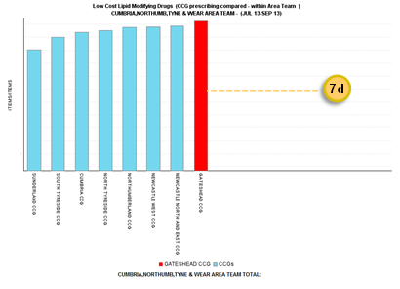

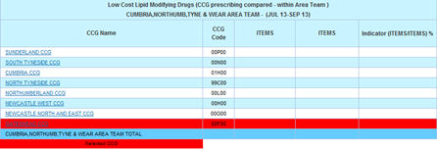

7d

7d
The report will then open with the selected organisation highlighted. You can highlight from both report view and data view.

Filter
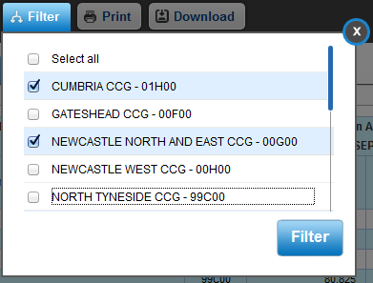

8b
8a

8a
The filter function allows you to remove organisations from the report. When you select the Filter tab a drop down box will appear with that reports organisations highlighted. Click on an organisation to deselect it.
8b
Click Filter when finished to go back to the report. The report will now only show the selected items, as shown below;

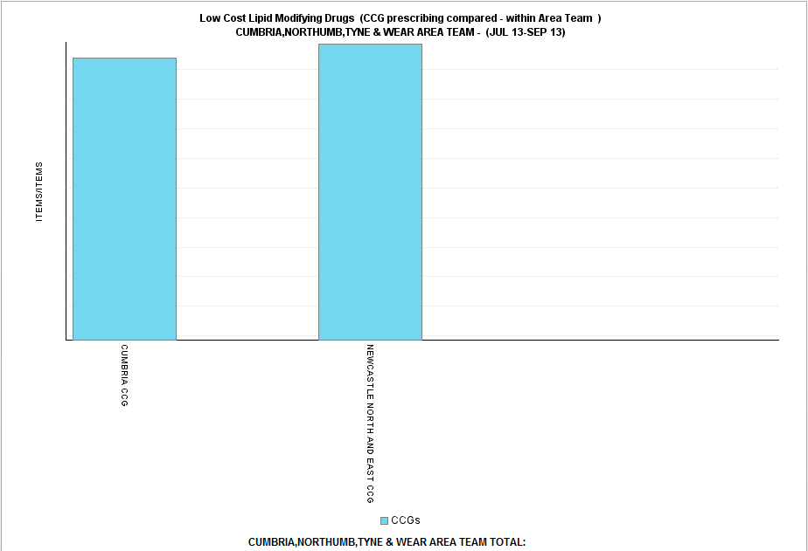

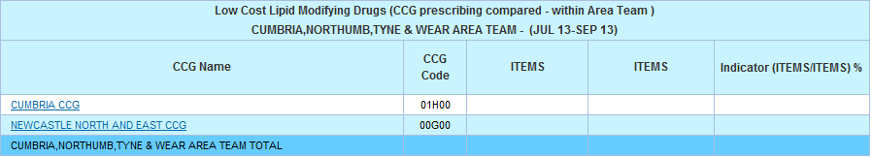

Management Information Spreadsheet (MIS)
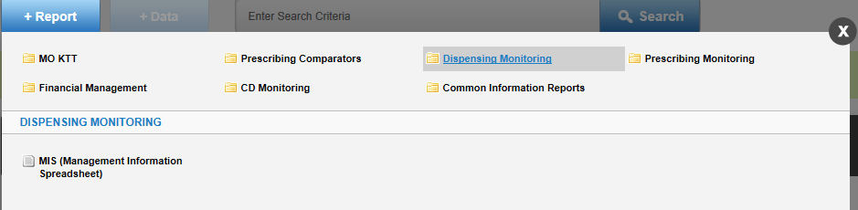
9a
9a
To view the MIS report, select Dispensing Monitoring from the +Report tab on the home page and then MIS (Management Information Spreadsheet). This report is only available to authorised users.

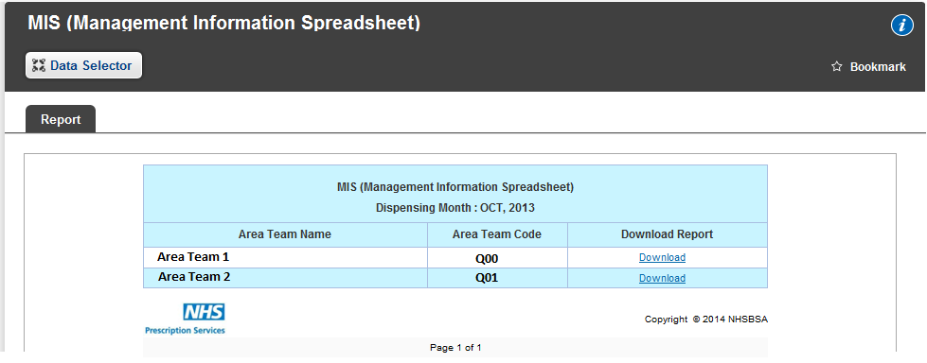
9b
9b
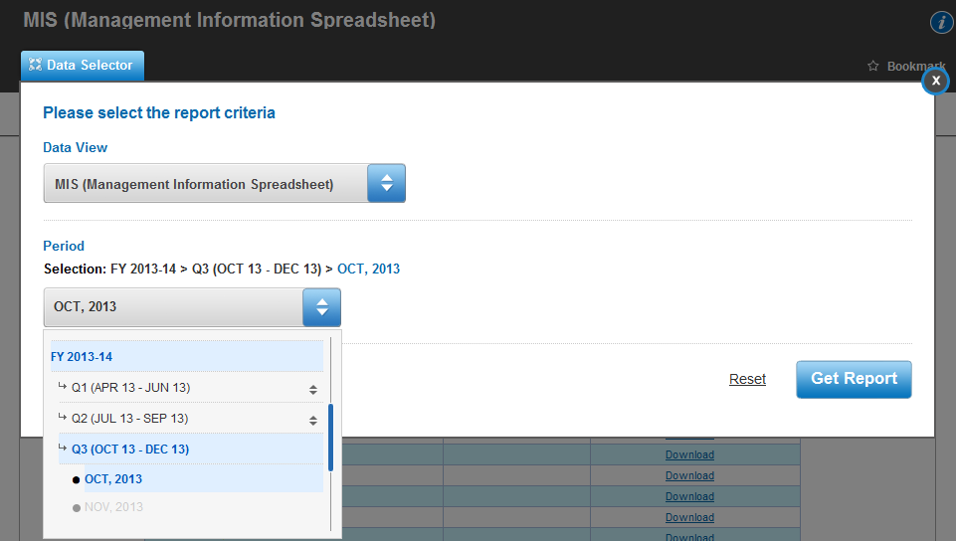
To view the report, click Download next to the relevant organisation.
9d
9c
9c
To choose a different month, select the Data Selector tab and then the desired month from the Period drop down box.
9d
Select Get Report to refresh the previous page for the newly selected month. For more information about MIS, please see the MIS User Guide.

