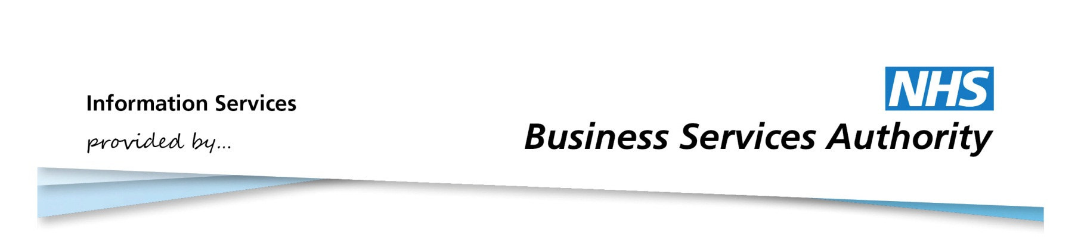

Information Services Portal
CD Monitoring

LOGIN PAGE

Login
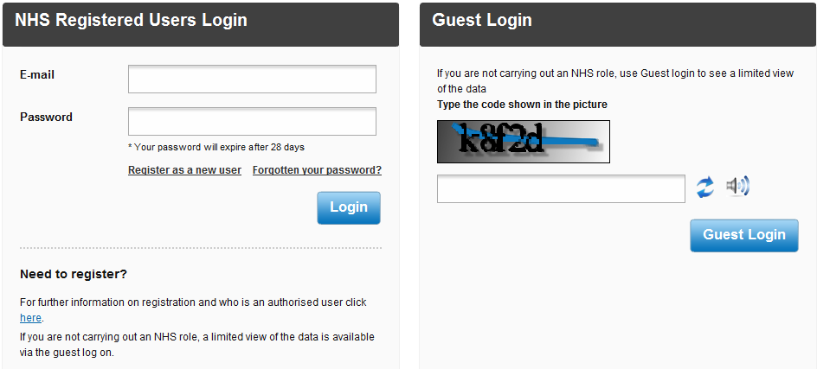
1b
1a

1a
From the ISP login page, enter your email address and password in the spaces provided.
1b
Click the Login button. For more information please see the Login/Logout User Guide. Once you have successfully logged into the system you will be directed to the home page.

Home Page

Selecting Reports

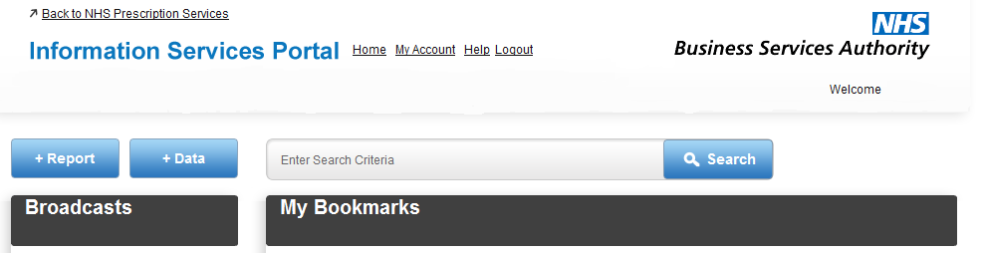
2a

2a
From the home page, select the +Report tab.

3b
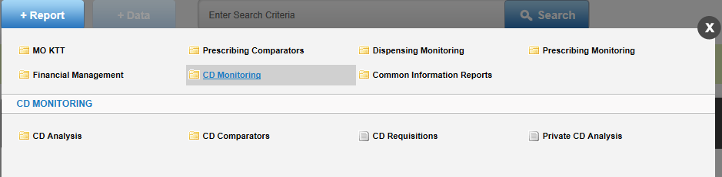
3b
3a
3c
3b

3a
Select CD Monitoring.
3b
You are now presented with four report categories.
3c
Click on the X if you wish to close this menu and return to the home page.

For further guidance on the individual report categories select the links below.

CD Analysis – click here
CD Comparators – click here
CD Requisitions – click here
Private CD Analysis – click here

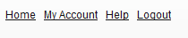
Logout
8a
8a
To logout of the system, click Logout. If you do not submit any requests for 30 minutes you will automatically be logged out of the system.

Other Information

- Your password will expire after 28 days. If you try to logon after your password has expired you will be directed to the change password screen where you have to enter a new password.
- If you do not logon for 12 months your access will expire and you will have to re-register.
- There are more in depth user guides which can be found on our website. These pages provide information on what you will see and instructions on how to navigate around the system.
http://www.nhsbsa.nhs.uk/PrescriptionServices/3625.aspx
- Report Information - contains links which are intended to assist users of the Information Services Portal put into context the data included within reports/charts in each Report Category. http://www.nhsbsa.nhs.uk/PrescriptionServices/3624.aspx

