Information Services Portal
Using CD Monitoring Analysis Reports

CD Monitoring Analysis Reports

NB You must be a registered user of the Information Services Portal to access these reports. To access the Portal or to register, please go http://www.nhsbsa.nhs.uk/PrescriptionServices/3607.aspx

These charts are designed to indicate prescribers or prescribing cost centres showing unusual behaviour with respect to prescribing of the drug list selected.

Selecting CD Monitoring will bring up all available CD Monitoring report categories

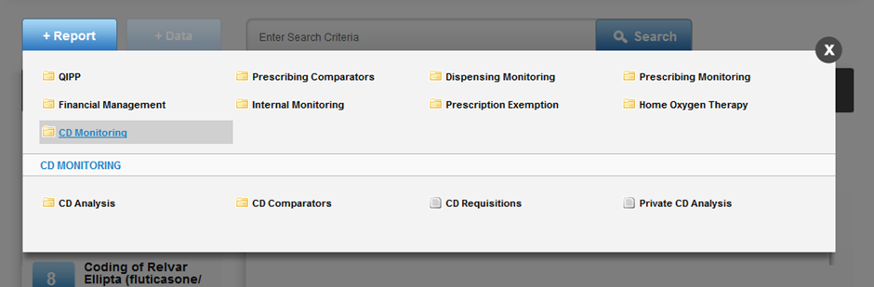

Selecting CD Analysis will bring up all available report titles

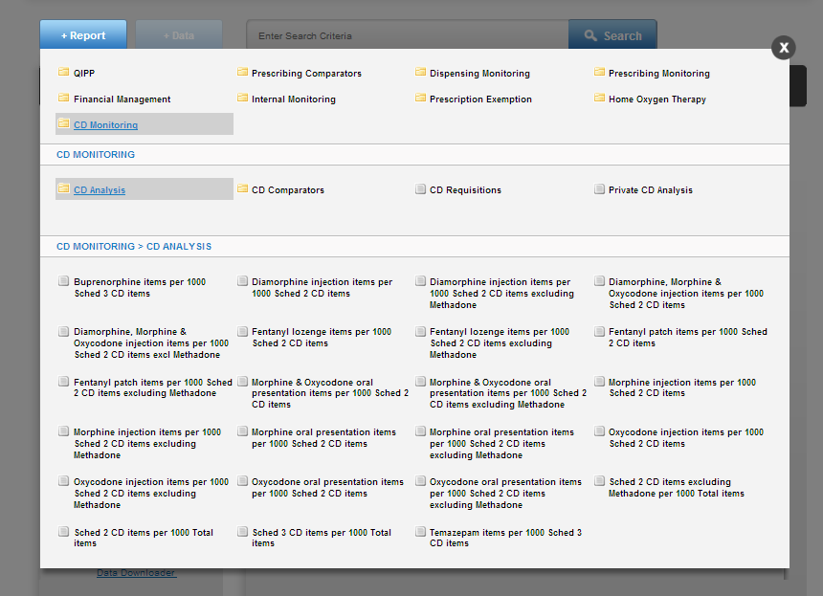
1b
1a

1a
Select CD Monitoring in the Information Services Portal
1b

Once you click on “CD Analysis” the report list is brought up.
Select a report from this list. E.G.
Diamorphine injection items per 1000 Sched 2 CD items
For each report title (i.e. the drug list as shown above), three types of report are available:
- All prescribing cost centres within an Area Team – report and data
- All prescribers within an Area Team –report and data
- All prescribers within prescribing cost centres – data only
NB If you are an Area Team or PCO user, the report you select will open at the view showing “All prescribing cost centres within an Area Team” for your area, for the most recent quarter’s data.

NB If you are a prescribing cost centre user, the report you select will open at “All prescribers within a Prescribing cost centre” for your prescribing cost centre, for the most recent quarter’s data.

To select a different data view, time period or organisation the user should select the Data Selector option.

NB National users will automatically be presented with the Data Selector when selecting a report.

Data Selector
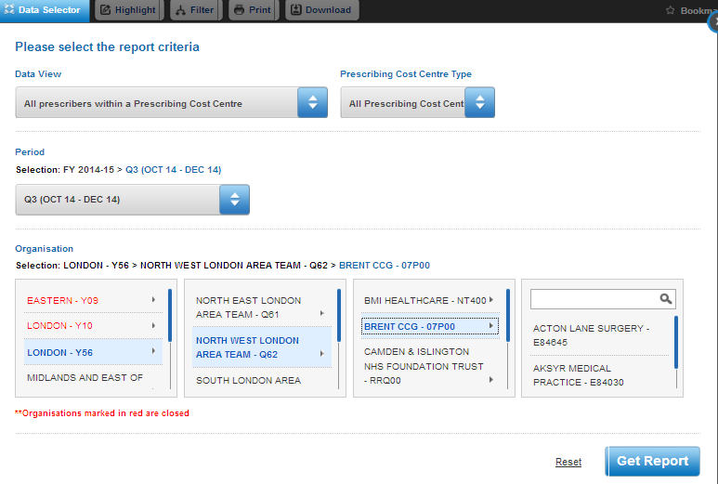
2e
2d
2c
2b
2a

2a
Select one of the three report types from Data View.
2b
There is then a further option to select whether you wish this to include all prescribing cost centres, GP practices only, or non-GP practices only. The default view is All Prescribing Cost Centres, but you can change this selection from the Prescribing Cost Centre Type option.
2c
Select the time period. The default will be the latest available quarter’s data.
2d
Select an organisation. If the data view you require is All Prescribers within an Area Team, or All Prescribing Cost Centres within an Area Team, you should select one of four Regional Offices, and then the Area Team.
2e
If the data view you require is All Prescribers within a Prescribing Cost Centre, the selection options will progress to Primary Care Organisation and then Prescribing Cost Centre. You can search for a Prescribing Cost Centre, or use the scroll bar.

The following describes the three types of report available through the Data view options;

A) All prescribing cost centres within an Area Team

This has three tabs: Report, Data, and Drug List.

Report

The example below shows all prescribing cost centres within an Area Team. Each red dot represents a prescribing cost centre. The Y axis is the value of the indicator, in this case the number of Diamorphine injections per 1,000 Schedule 2
CD items. The X axis is an indication of the size of the prescribing cost centre, as measured by the total number of items prescribed.

Those prescribing cost centres which fall outside of the funnel lines are deemed to be outliers. The further a point lies away from the boundary lines of the funnel, the larger the extent to which the prescribing behaviour is deemed to be unusual. For a more detailed explanation of the methodology used, please see here.

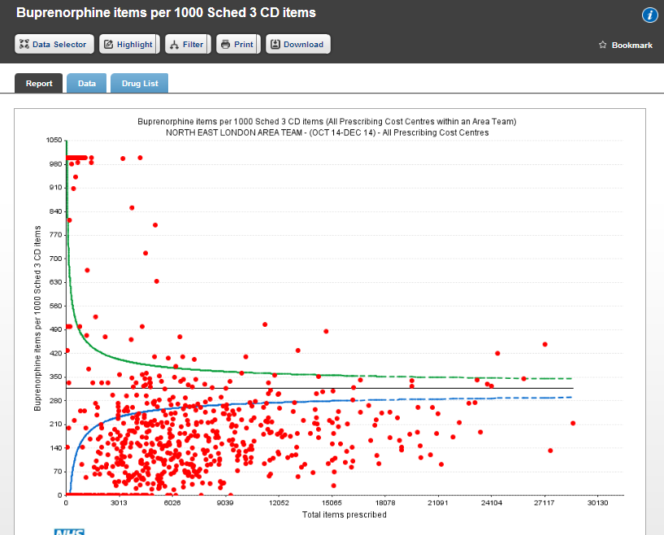

Data

NB Data is only displayed for those prescribing cost centres which are outliers.

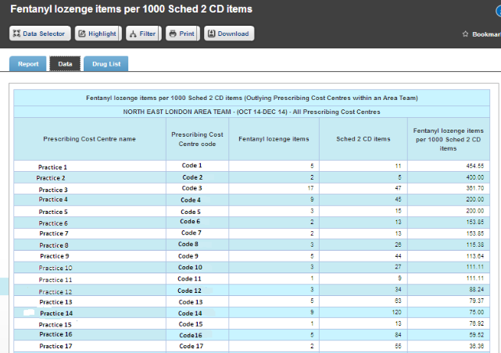

The data shows outlier prescribing cost centres only and is ranked in order of the degree to which a prescribing cost centre is deemed to be an outlier for this measure. This is not necessarily in descending order of the comparator value.

For the methodology used in determining what constitutes an outlier, please see here.

The numerator (in this case diamorphine injection items), the denominator (Sched 2 items) and the resulting comparator value are given.

NB the comparator value is per 1,000 items.

Drug List
This is an extensive list and specifies all presentations which, if prescribed, will contribute to the numerator and the denominator components of the measure.

Highlight and Filter facilities
Highlight allows one organisation to be highlighted in the report or data. The highlighted prescribing cost centre will appear in the report as a black dot rather than red. The line in the data relating to the prescribing cost centre will be coloured red.

Filter allows one or more organisations to be removed from the report or data. After selecting Filter, it may take a minute or two before the list of prescribing cost centres appears so please be patient. When the list of prescribing cost centres appears, you may choose which you want to appear in the report and data. Note that this does not change the position of the remaining prescribing cost centres within the report.

B) Prescribers within an Area Team

Report

The example below shows all prescribers within an Area Team. Each red dot represents a prescriber. The Y axis is the value of the indicator, in this case the number of Diamorphine injections per 1,000 Schedule 2 CD items. The X axis indicates the level of overall prescribing by a prescriber, as measured by the total number of items prescribed.

Those prescribers which fall outside of the funnel lines are deemed to be outliers. The further a point lies away from the boundary lines of the funnel, the larger the extent to which the prescribing behaviour is deemed to be unusual. For a more detailed explanation of the methodology used, please see here.

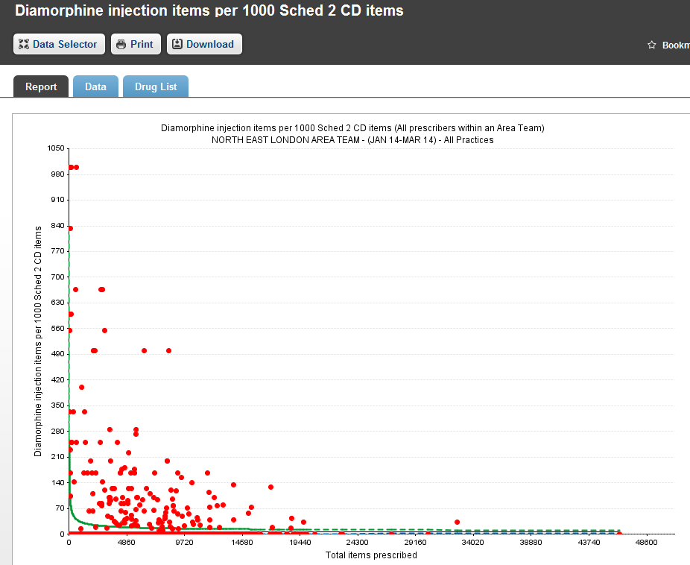

Data

NB Data is only displayed for those prescribers who are outliers.

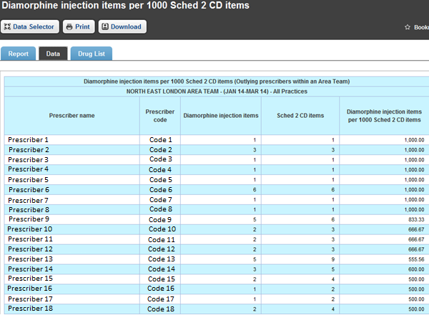

The data shows outlier prescribers only and is ranked in order of the degree to which a prescriber is deemed to be an outlier for this measure. This is not necessarily in descending order of the comparator value.

For the methodology used in determining what constitutes an outlier, please see here.
The numerator (in this case diamorphine injection items), the denominator (Sched 2 items) and the resulting comparator value are given.

NB the comparator value is per 1,000 items.

Drug List
This is an extensive list and specifies all presentations which, if prescribed, will contribute to the numerator and the denominator components of the measure.

Highlight and Filter facilities
There are no highlight or filter facilities for this view.

C) Prescribers within Prescribing Cost Centre

Report
There is no report for this selection as a small number of prescribers within a prescribing cost centre does not lend itself to a funnel plot analysis.

Data
Data is provided for all prescribers that are associated with and have prescribed on behalf of the prescribing cost centre within the time period.

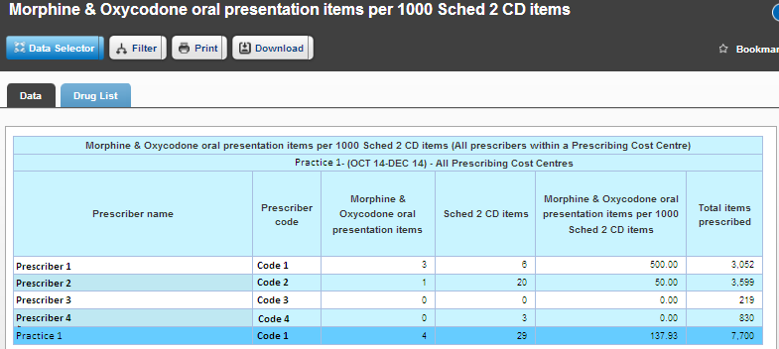

Data comprises: the numerator, denominator, the resulting indicator value (i.e. numerator divided by denominator) and the total items prescribed by each prescriber. Data is ordered in descending order of the indicator value. Where this is zero, prescribers are then presented in alphabetical order.

NB The comparator value is per 1,000 items.

Drug List
This is an extensive list and specifies all presentations which, if prescribed, will contribute to the numerator and the denominator components of the measure.

Highlight and Filter facilities
There is no highlight facility for this view. Filter allows one or more prescriber, or the prescribing cost centre itself, to be removed from the data table.

Notes on using the three Data View options

Prescribers within a Prescribing Cost Centre

This view will show prescribing on behalf of the prescribing cost centre within a particular time period. Therefore if a prescriber has moved from one prescribing cost centre to another, their data will be included within any prescribing cost centre for which they prescribed during that period.

This means that they may appear in different prescribing cost centres for different time periods. In order to monitor the data for a prescriber who has moved prescribing cost centres, it may be preferable to refer to the Prescriber within an Area Team view.

Prescribers within an Area Team

This view will show data for all prescribers who are currently attached to a prescribing cost centre which is part of the Area Team at the time the report is accessed. If a prescriber has moved within the last five quarters, all of their prescribing data will be included, for all five quarters, within the Area Team report to which they currently belong.

Prescribing Cost Centres within an Area Team

This view will show data for prescribing cost centres belonging to an Area Team. Any prescribing on behalf of a prescribing cost centre will be included within the Area Team to which it currently belongs. If a prescribing cost centre has moved from one Area Team to another, the prescribing cost centre will be included within the Area Team report to which it currently belongs.

Troubleshooting

The data appears to be in a strange order. How is it ordered?

Prescribers within an Area Team and Prescribing Cost Centres within an Area Team show outlier prescribers or prescribing cost centres only. They are listed in order of the degree to which they are

deemed to be an outlier. This is not necessarily the same order as indicator value, as the total amount of prescribing is also considered. For further details please see here.

What is the horizontal axis?

For both the Prescribers within an Area Team and Prescribing Cost Centres within an Area Team reports, the X axis indicates the total number of prescription items for the prescriber or prescribing cost centre respectively.

One of the dots in the report is black, whereas all the others are red. Why is this?

If you have highlighted a Prescribing Cost Centre within an Area Team, this will show within the chart as a black dot instead of red. Also, if you have been set up as a Prescribing Cost Centre user, your own prescribing cost centre will automatically be highlighted in the report. This is the case unless you opt to highlight a different prescribing cost centre.

On selecting the “All prescribers within prescribing cost centre” view and then a particular prescribing cost centre, the report returns no data. I would expect to see some prescribing yet this suggests none.

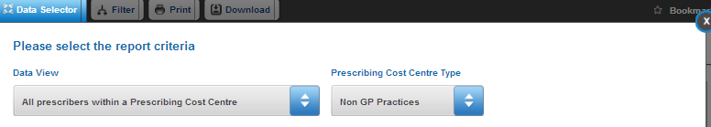
3a

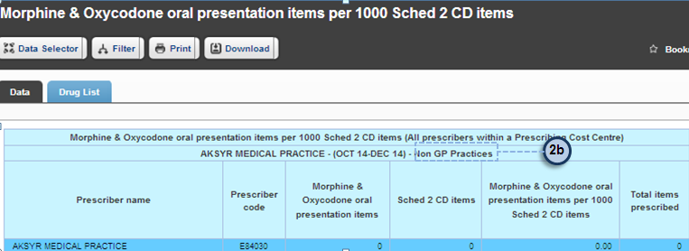
3b

This is because there is no prescribing for the prescribing cost centre with the prescribing cost centre type
3a
2b
( ( ) ) you have selected. It may be that you have selected a non-GP practice with the option to show
only GP practices. Conversely, you may have selected a GP practice with the option to show only non-GP practices. This is the case in the example view above. The prescribing cost centre type selected is shown in the data table title. ( )
3b

I have selected the “All prescribers within Prescribing Cost Centre” view and yet the report title says “All Prescribing Cost Centres”. Why is this?

All reports, including Prescribers within a Prescribing Cost Centre will default to the “All Prescribing Cost Centre” option. This will be reflected in the title of your data table. It may appear odd when you are considering prescribing within one prescribing cost centre, but this title merely reflects which Prescribing Cost Centre Type (All Practices, GP Practices or Non-GP Practices) has been selected.

