

Information Services Portal

Using CD Monitoring Comparators Charts

# CD Monitoring Comparator charts

These charts provide a high level view of Controlled Drug prescribing. For each report title comparisons can be made at Regional Office, Area Team, or Primary Care Organisation (PCO) level.

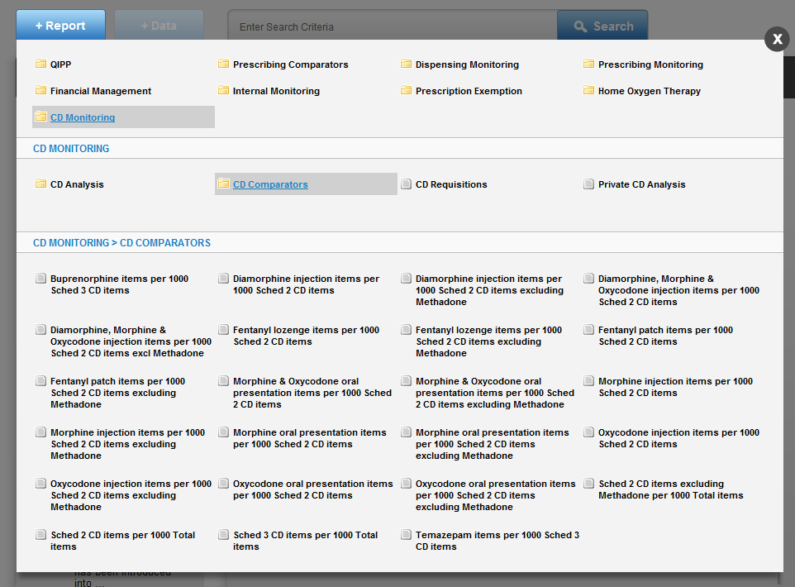

Select CD Monitoring in the Information Services Portal

Once you click on “CD Comparators” the report list is brought up. Once you select a report the Data Selector is brought up.

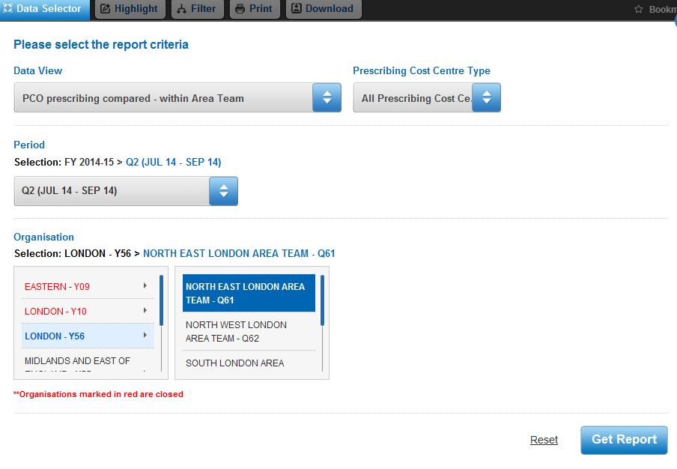

Select one of the six report types from Data View.

* Regional Office prescribing compared - nationally
* Area Team prescribing compared - nationally
* PCO prescribing compared – nationally
* Area Team prescribing compared – within Regional Office
* PCO prescribing compared – within Regional Office
* PCO prescribing compared – within Area Team

There is then a further option to select whether you wish this to include all Prescribing Cost Centres, GP practices only, or non-GP practices only. The default view is All Prescribing Cost Centres, but you can change this selection from the Prescribing Cost Centres Type option.

Select the time period. The default will be the latest available quarter’s data.

Select an organisation. This option is based on the selection made for Data View.

The following describes the reports available in the six types of Data View.

These reports have three tabs: Report, Data, and Drug List.

**Report**

The example below shows all Area Teams within England.

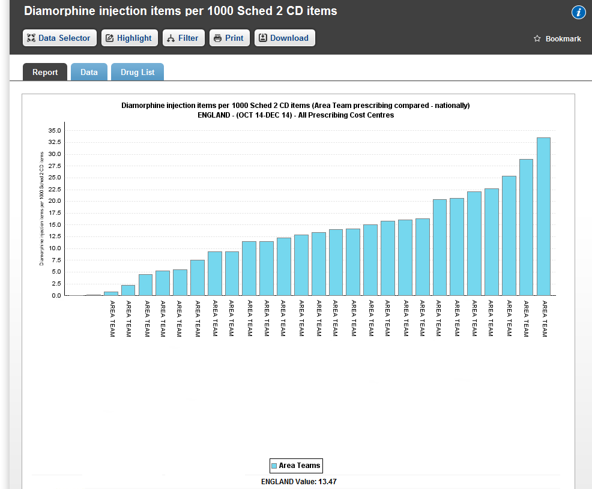

The bar chart shows the value of the comparator (numerator/denominator) for each organisation.

**N.B** For all reports, the denominator is per 1,000 items prescribed.

For example, in the report *Diamorphine injection items per 1000 Sched 2 CD items*

if an organisation prescribed one Schedule 2 item out of a total of one total BNF (all prescribing) item, the indicator value will appear in the data as 1,000 (one thousand).

**Data**

This will present the data used in the Report as a Table view.

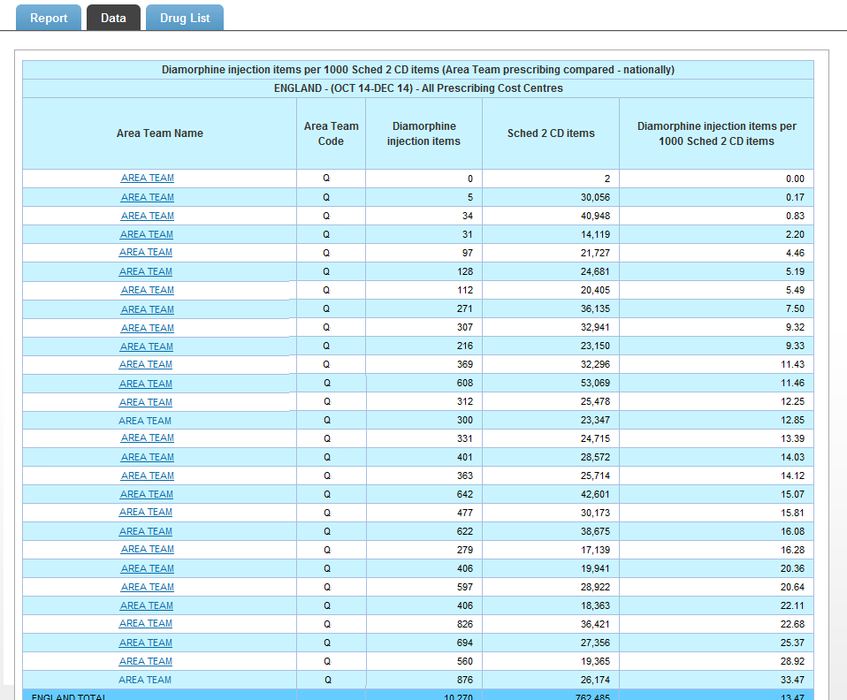

**Drug List**

This is an extensive list and specifies all presentations which, if prescribed, will contribute to the numerator and the denominator components of the measure.

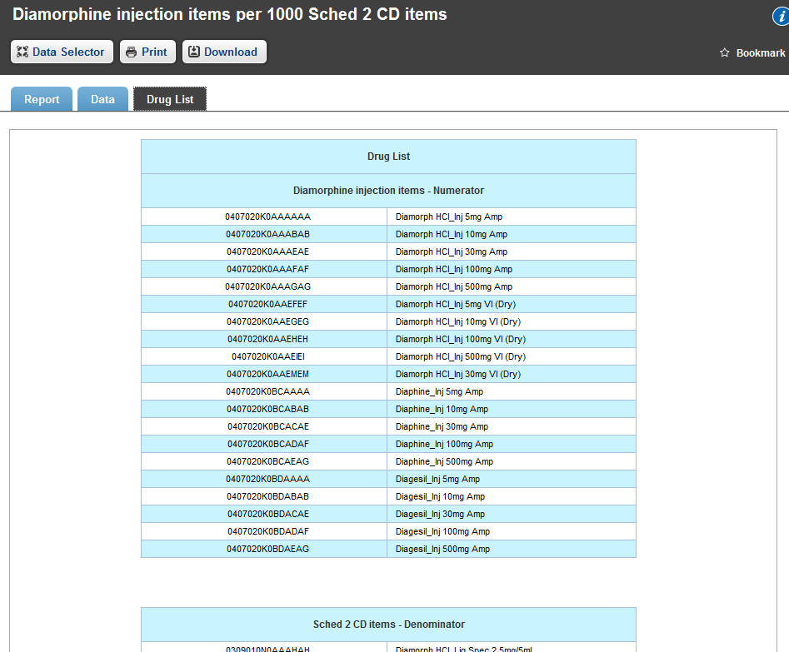

**Highlight and Filter facilities**

Highlight allows one organisation to be highlighted in the report or data. The highlighted organisation will appear in the report as a red bar. The line in the data relating to the organisation will be coloured red.

Filter allows one or more organisations to be removed from the report or data. When the list of organisations appears, you may choose which you want to appear in the report and data.

Further information on how to use the Filter and Highlight function can be found in the user guide “CD Monitoring”.