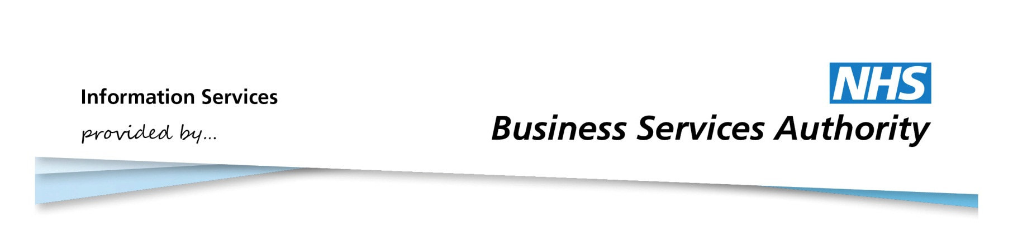

Information Services Portal

Using CD Requisition Reports

# CD Requisition Reports

The Controlled Drug Requisitions Report shows all Schedule 2 and 3 Controlled Drug (CD) requisitions supplied at Area Team level.

The report will show requisitions written and supplied in England for all people who can legally order or supply a CD on a requisition working in the community, excluding the following suppliers:

• NHS Hospitals (except when writing a requisition for dispensing in the community)   
• Manufacturers   
• Wholesalers

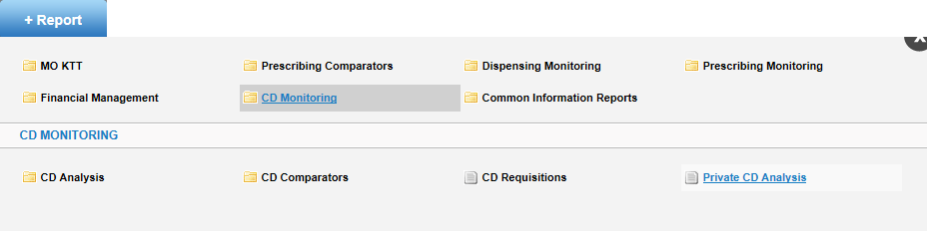

Select CD Monitoring in the Information Services Portal

Once you click on “CD Requisitions” the data selector is brought up.

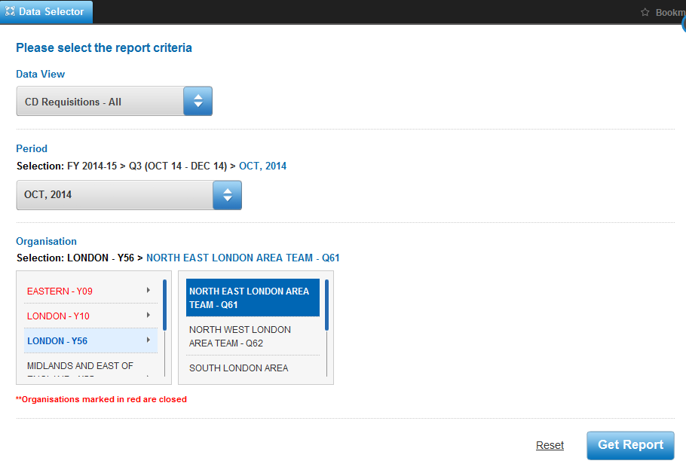

Select one of the three Requisition types from Data View:

* CD Requisitions – All
* CD Requisitions – NHS
* CD Requisitions – Private

Select the time period. The default will be the latest available month’s data.

Select the relevant Area Team.

**Report**

The report that is generated is in one tabular view only, and will list all requisitions for the selected Area Team, for the chosen month. There is no Drug List or graph available for this report.

**Example Report**

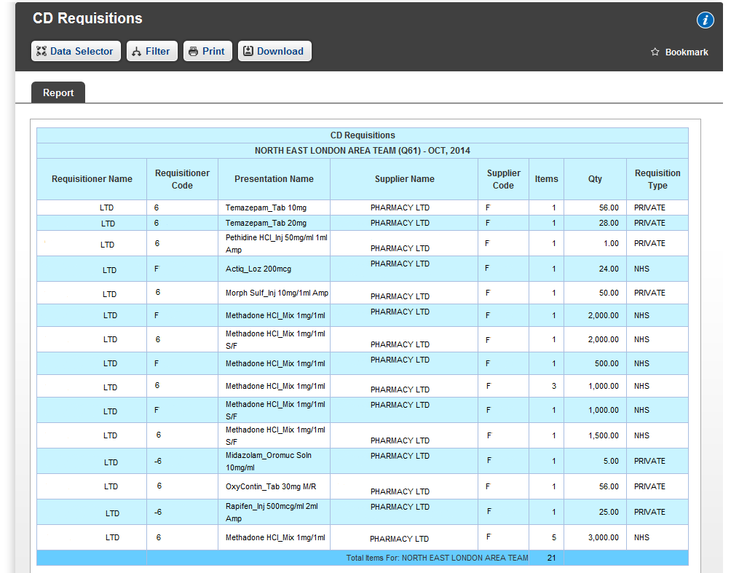

The Requisition Type will be based on what was selected in the Data View of the Data Selector, the example above is for “CD Requisitions – All”.

**Filter facilities**

Filter allows one or more Requisitioner Name to be removed from the report. When the list of organisations appears, you may choose which you want to appear in the report. Further information on how to use the Filter function can be found in the user guide “CD Monitoring”.

There is no highlight facility for this report.

If there is no data available associated with the Data View selected or default view, the following message will be displayed “This report is not available. No data is available for your selected criteria.