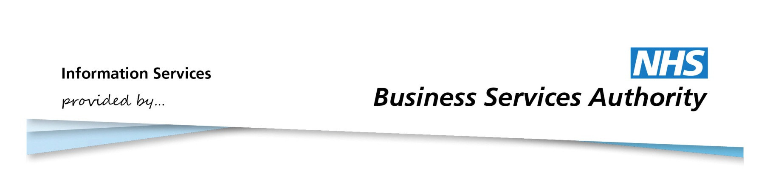

Information Services Portal

Using Private CD Analysis Reports

# Private CD Analysis Reports

Private CD Analysis Reports provides information on the private prescribing of controlled drugs.

The report is at Area Team level.

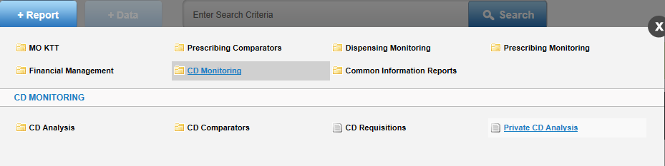

Select CD Monitoring in the Information Services Portal

Once you click on “Private CD Analysis” the data selector is brought up

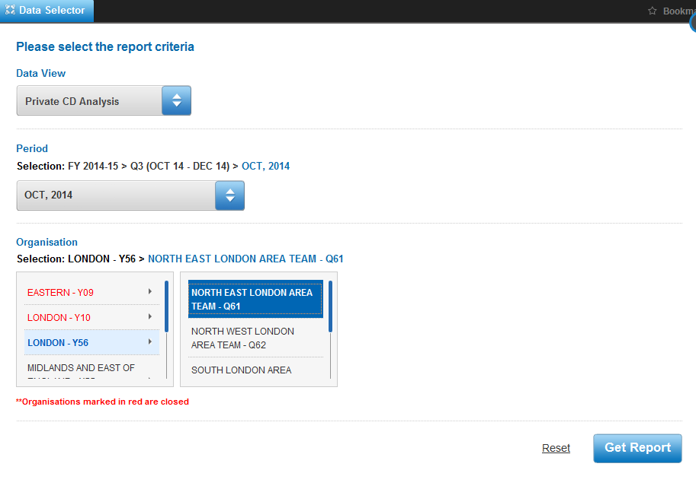

The Data View will show “Private CD Analysis” only.

Select the time period. The default will be the latest available month’s data.

Select the relevant Area Team.

**Report**

The report that is generated is in one tabular view, and will list all private prescribing by prescriber and where the order was dispensed for the selected Area Team, for the chosen month. The report will show number of Items and Quantity prescribed, with BNF Presentation name. There is no Drug List or Graph available for this report.

**Example report**

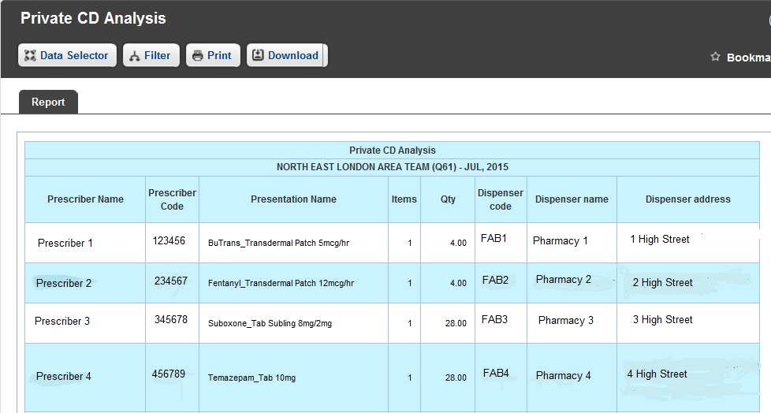

**Filter facilities**

Filter allows one or more Prescriber Name to be removed from the report. When the list of prescribers appears, you may choose which you want to appear in the report.

Further information on how to use the Filter function can be found in the user guide “CD Monitoring”.

There is no highlight facility for this report.

If there is no data available associated with the Data View selected or default view, the following message will be displayed “This report is not available. No data is available for your selected criteria.