

User Guide

Cumulative MIS Dashboard

Contents
MIS Cumulative Toolbox 2
Home Page 3
Import MIS Files 3
Clear Workbook 4
The Dashboard 4
Contractor Dropdown 5
Scatter Plots 6
Box Plots 9
Contractor Detail Form 10
Metric Details (MUR/NMS/OOPE) 13

MIS Cumulative Toolbox
The workbook has been designed to assist in identifying normal and abnormal contractor practices. Although we may flag a contractor as displaying outlier behaviour, it is only a statistical measure comparable to the sample and in reality it may be normal (or good) practice.
Outlier identification within the worksheet is done in many ways.
For example:
- Single or repeatedly high or low value
- Cumulatively High value
- Wide variance in activity or claims between months

To assist you in using the workbook we will cover the each of the functions and worksheets in turn.
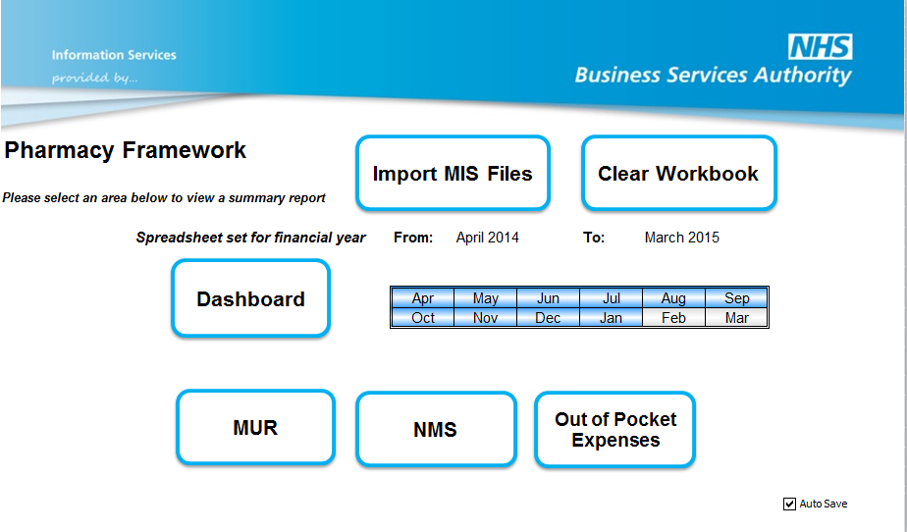
MIS Cummulative Toolbox front page

Home Page
The home page is designed to give you information about the data that has been loaded into the toolbox.

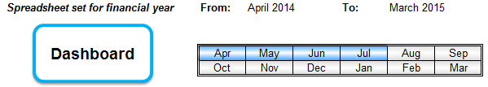
MIS Cummulative Toolbox front page
When data has been loaded into the MIS toolbox the financial year of the data in the toolbox is shown along with the months within that financial year that have been imported into the MIS toolbox.

Import MIS Files
The toolbox is set up to allow data for a specific financial year and cannot span more than 1 financial year. It requires consecutive months from April onwards. No validation is currently present to ensure the months are contiguous, so should the data be loaded out of sequence the workbook is likely to lose some functionality (e.g. forecasts will not work correctly).
This function works similar to other windows based application. It allows navigation to files on a local machine or network. Files can be called anything, but should be Excel files and structured as per the MIS files available on the NHSBSA portal. Files where the structure of the MIS data has been altered will not work in the MIS toolbox.
One or more files can be selected by clicking and holding down Shift Key (For a list of files) or by clicking and holding down CTRL Key (to select random files).

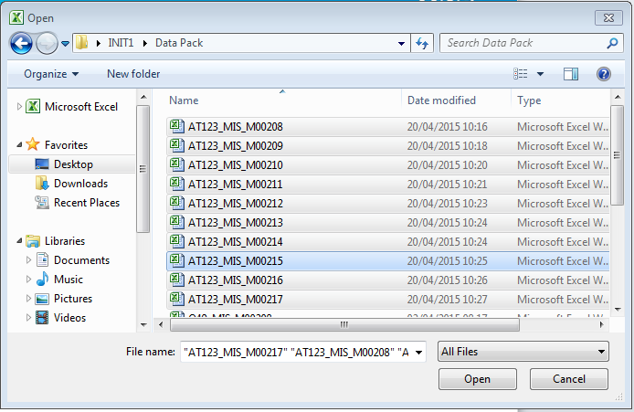
You are able to select multiple files at the same time for loading into the toolbox

Clear Workbook
The clear workbook is designed to reset to the toolbox to blank. This option will delete any data out of the toolbox to present you with a fresh starting point.

The Dashboard
This is accessed from the home main screen.
Clicking this will show you an analysis of the data held in the sheet for MUR, NMS and OOPE data.
The sheet shows three scatter plots on the left and three boxplots on the right; one of each for each metric (MUR, NMS and OOPE).
How to read the Scatter Plots
These can provide a lot of information speedily so we’ll break things down into how you can get the most from the scatter plots and boxplots.

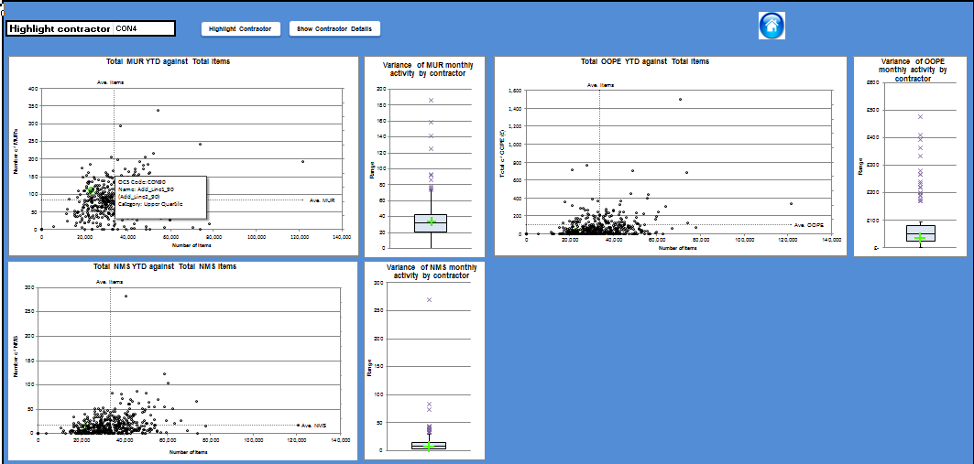

Contractor Dropdown
The dashboard allows you to access contractor information by either knowing the contractors code or by navigating to the scatter / box plots.

You are able to select an individual contractor based on their Alt-code.

To use the dropdown option, select the contractor code from the drop down and then click either ‘Highlight Contractor’ or ‘Show Contractor Details’.
The ‘Highlight Contractor’ will highlight the contractor on the scatter and box plots.
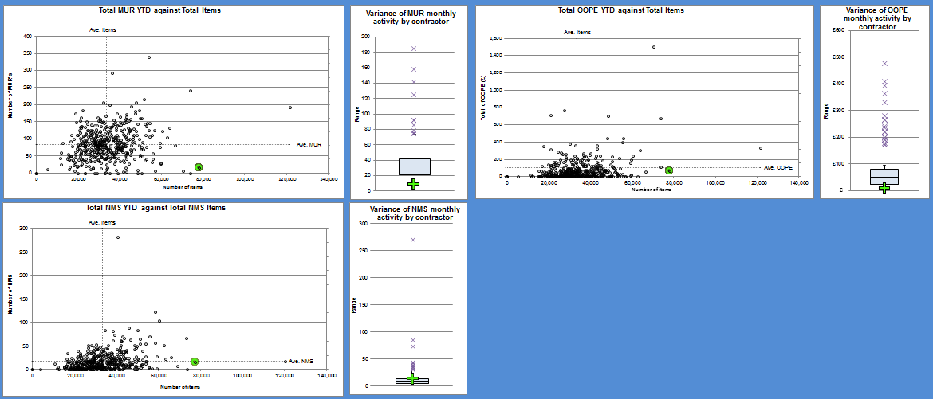
The selected Alt-code will then be highlighted in each of the scatterplots and box plots.

The ‘Show Contractor Details’ option will open the contractor specific information pop box which will be covered later in this guide.

Scatter Plots

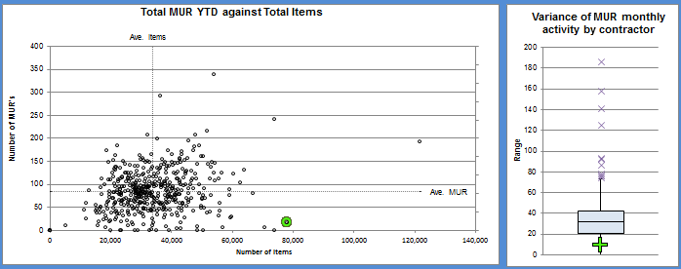
Scatter plot and boxplot showing contractors cumulative totals
Each point on the scatter represents a contractor. The X Axis plots the number of items dispensed so far (for NMS this is the number of items that is used for calculating NMS bandings). The Y axis plots the number (MUR/NMS) or the value (OOPE) for all months contained in the sheet for that contractor.
There are two average lines. These are the average (mean) of the metric for the data within the sheet. Therefore this will vary as data is added to the workbook.
For speedy visual analysis the two average lines can be viewed as forming 4 quadrants. As such:

D | B
A | C

There will most likely be a cluster around where the average lines cross; this is normal distribution around the average. Small deviations in all directions are expected. We will take each quadrant in turn to suggest what you might observe from each quadrant:
Quadrant A – Contains those contractors fulfilling lower than average prescription items and performing lower than average within the metric. It can be assumed that unless the interest is in those not doing enough of something, this is the least likely place for outliers.
Quadrant B – Contains the contractors who fulfil more than average prescription items and performing more than average within the metric. As such these are not necessarily outliers. However dots deviating from the rest are possibly worth looking at. For outliers, look to the top left or bottom right of this quadrant.
Quadrant C – Contains the contractors who fulfil more than average prescription items and less than average within the metric. MUR and NMS could view these as outliers (to the right) from a medicines optimisation perspective, but for OOPE they may not.
Quadrant D – Contains the contractors who fulfil less than average prescription items but performing more than average within the metric. There is likely to be a cluster close to the means that are probably not so significant, but those that deviate upwards and/or left are worthy of investigation.
If we take a simple example, comparing two similar contractors within a sample on MUR activity over two months:

 | April | May | Total to date
Contractor 1 | 40 | 40 | 80
Contractor 2 | 80 | 0 | 80
Median (of entire sample) | 24 | 26 | 50

As can be seen, each contractor has conducted 80 MUR’s over the two months. However, Contractor 2 would be weighted more as an outlier for April; Contractor 1 may be above average but not significantly to be classed as an outlier in this case. The sheet will have detected April’s data for Contractor 2 and weighted this contractor for investigation.
The scatters are also designed to be interactive. First you need to click on the graph to make it active. This is indicated by the thick bar around the graph and/or drag points appearing.
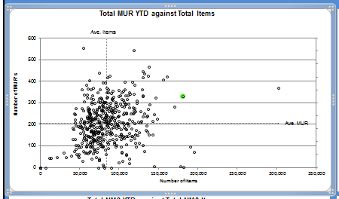
Activating the Graph
This allows two things. If you move the mouse over a point in the chart, the contractor information appears in a hover box. Also, the point is highlighted, not only in the current plot, but the other two scatter plots and the three box-plots.
The same contractor is highlighted in green on all 3 scatter plots.
By clicking on a point, a pop up window appears to display Contractor specific information, this will be covered in more detail later in the guide.
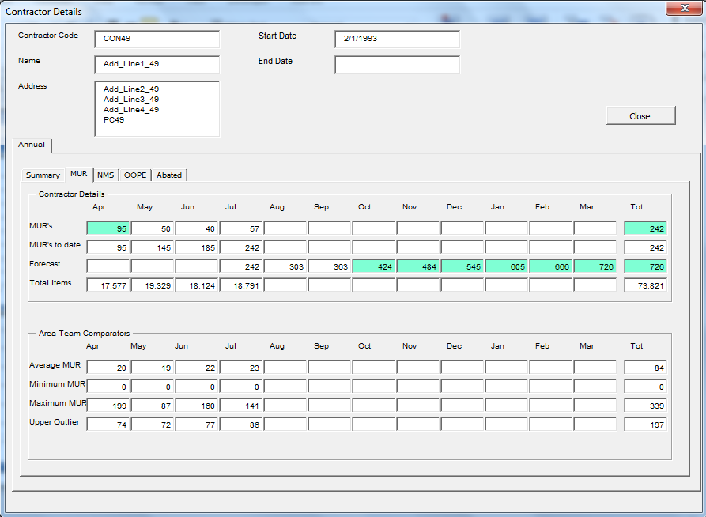
Contractor Detail Form: The contractors’ information appears in a pop up box from the scatter plot.

Box Plots
As per the monthly sheet the box plot is a way of grouping data.  The middle point of a box plot is the Median (the middle value); either side of the median is the Upper and Lower Quartile Ranges. After that as we move further away from the median we have Above/ Below average and Upper/Lower Outliers. | 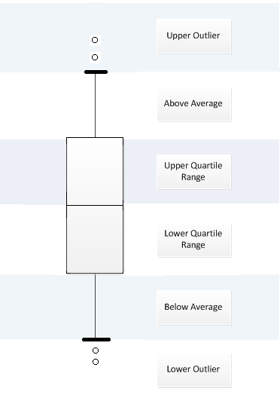
The box plots on the dashboard sheet represent spread in activity for contractors or simply put the difference between the highest and lowest values for a metric.
In other words it considers the consistency of the given activity by a contractor; therefore the data of interest will be the upper outliers.

For example:
 | April | May | Jun | Spread
Contractor 1 | 35 | 45 | 40 | 10 | (45 - 35)
Contractor 2 | 80 | 0 | 10 | 80 | (80 – 0)
Median |  |  |  | 11
Contractor 2 would be of more interest based on the spread of the data.
As per the scatterplots, clicking points on the chart opens the contractor detail form.

Contractor Detail Form
This is activated by clicking a point in one of the scatter or box plots and when you click on ‘Show Contractor Details’ from either the Dashboard or one of the metric sheets. It is designed to allow you to view a contractor’s activity to date.

The intimal form view differs from where the form is activated. (i.e. when you access from the MUR scatter plot or MUR page you will see MUR details, NMS from NMS scatter plot or NMS Sheet etc.)

The top half shows the general information for the contractor provided on the MIS report. The Annual tab has three views. The first one "Summary" gives an overview and allows comparison of metric, in particular outlier activity

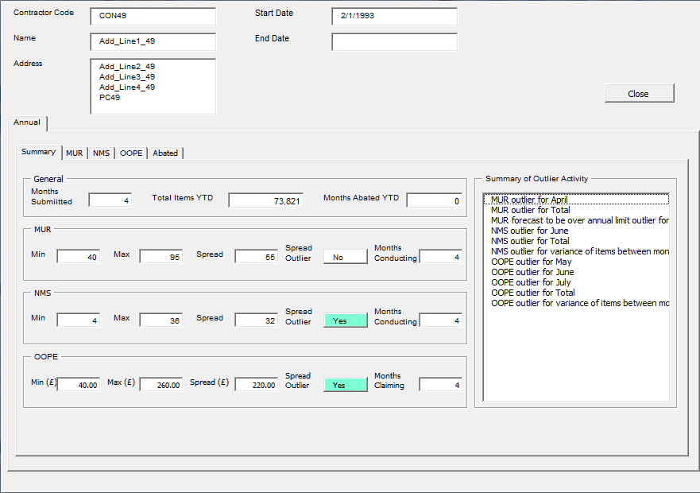
Areas where the contractor has been found to be an outlier
Areas where the spread analysis is an outlier are highlighted green.
Summary contractor information

Summary form in the Contractor Details Form
Clicking the tab for one of the three metrics shows a view of cumulative data in detail. Outlier activity is also highlighted and a forecast calculation is shown. Area Team summary details are also provided which allows you to compare performance within the Area Team.

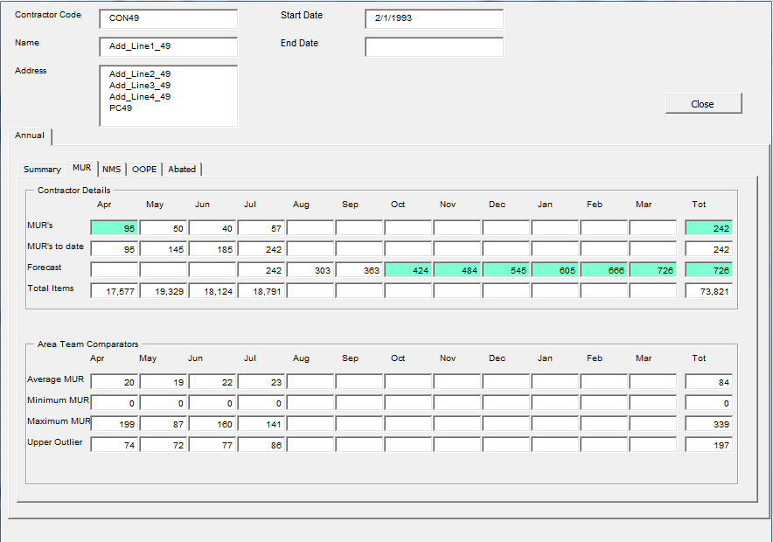
Outlier activity is highlighted in green
Forecasted MURs over 400 are highlighted in green

OOPE Metric sheet in the Contractor Details Form

Metric Details (MUR/NMS/OOPE)
These sheets are similar to those on the monthly sheet. Each metric can be accessed from the main page.

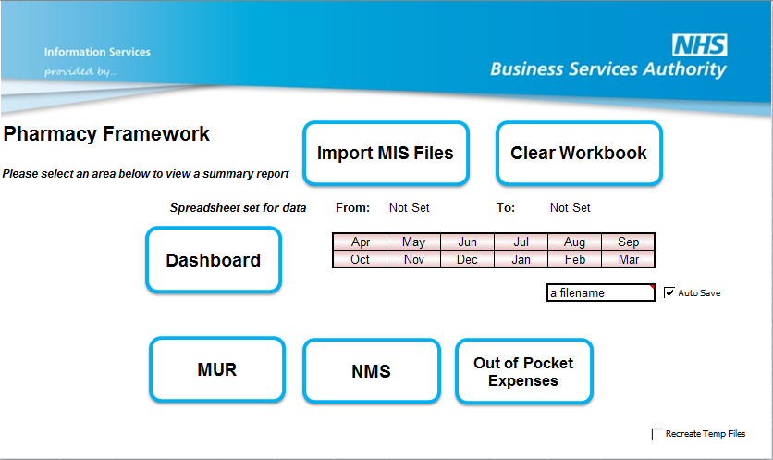
The metric areas which can be accessed from the front page

Selecting a metric area opens the metric analysis screen:

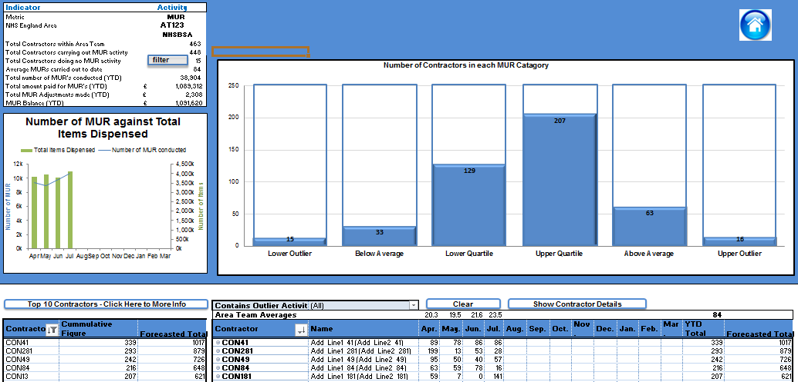

The box in the upper left hand corner provides summary details for the Area Team. The summary includes the metric name, total number of contractors, number of contractors carrying out the metric, and the financial information for that metric.

Filter: This allows you select all the contracts who are not completing any of the selected metric (MUR or NMS) and updates the pivot table on the right of the sheet.

Below this is a line graph showing the month average trend with a bar chart showing the cumulative total number completed each month.

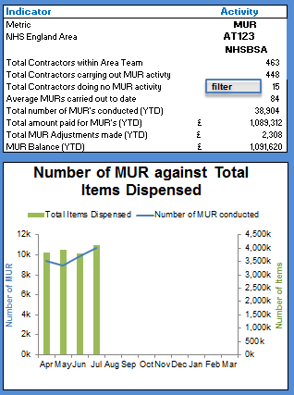
Filters the main pivot table to show contractors who are not conducting MURs

Summary information on the metric selected, in this example Medical Use Reviews (MUR).

The large graph on the main panel shows contractors grouped by likelihood of outlier behaviour based on monthly activity across the entire period. As per the monthly sheet the columns can be selected and the details shown on the table below.

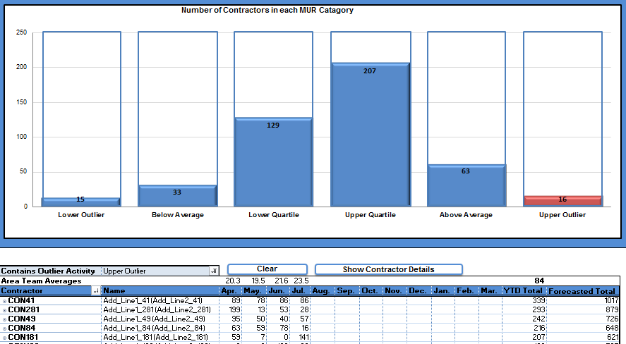
Selecting an area to filter on changes the graph to red
By selecting a column in the bar chart the pivot table below is update, in this example all contractors that fall into the Upper Outlier group.

To access the Contractor form from the metric sheets you use the show contractor details button after selecting an Alt Code field from the contractor.

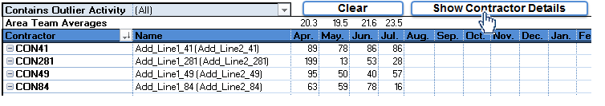

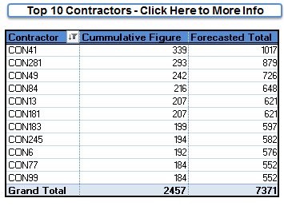
Select Cell before clicking button.
Two ways of viewing the Contractor form for CON281.

Forecast is simply done by calculating the average to date for the contractor and replicating for each future month.

