Information Services Portal
MIS User Guide

Contents Page

- Login & Home Screen
- MUR Summary Report
- NMS Summary Report
- Out of Pocket Expenses Summary Report
- Staff Hours Summary Report
- Other Information

Login Screen

Login
Open toolbox detailed below via email link or from NHSBSA website http://www.nhsbsa.nhs.uk/PrescriptionServices/3729.aspx
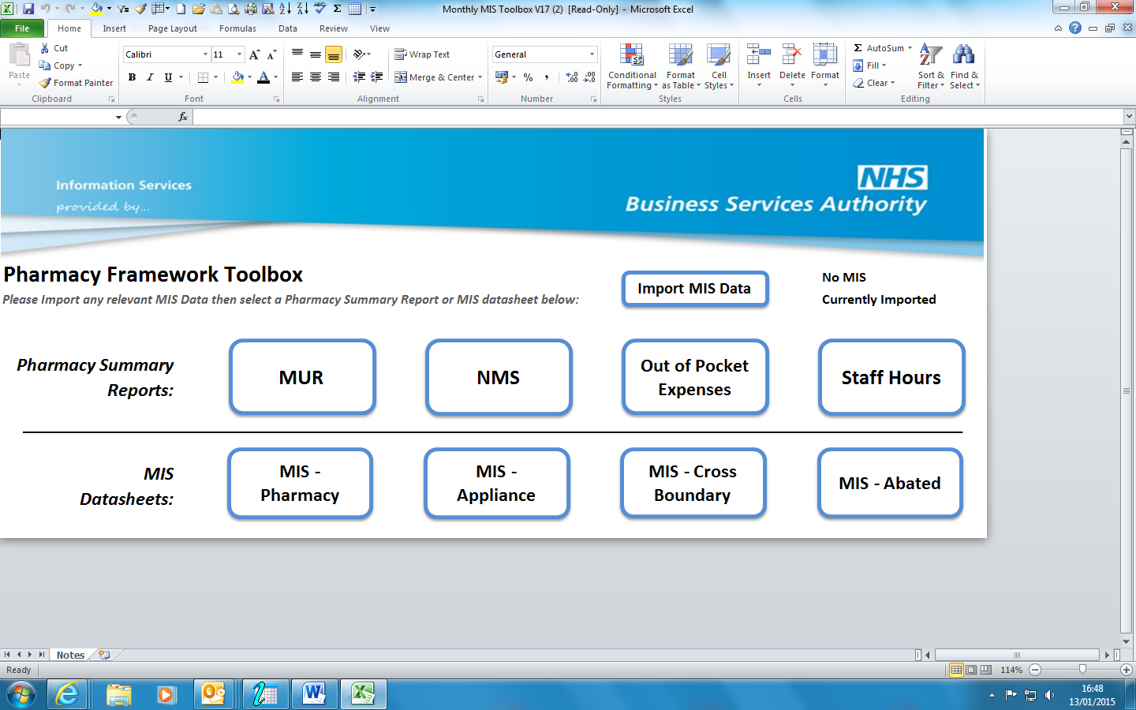
1a
1a
Click on import MIS data and select relevant month data required.
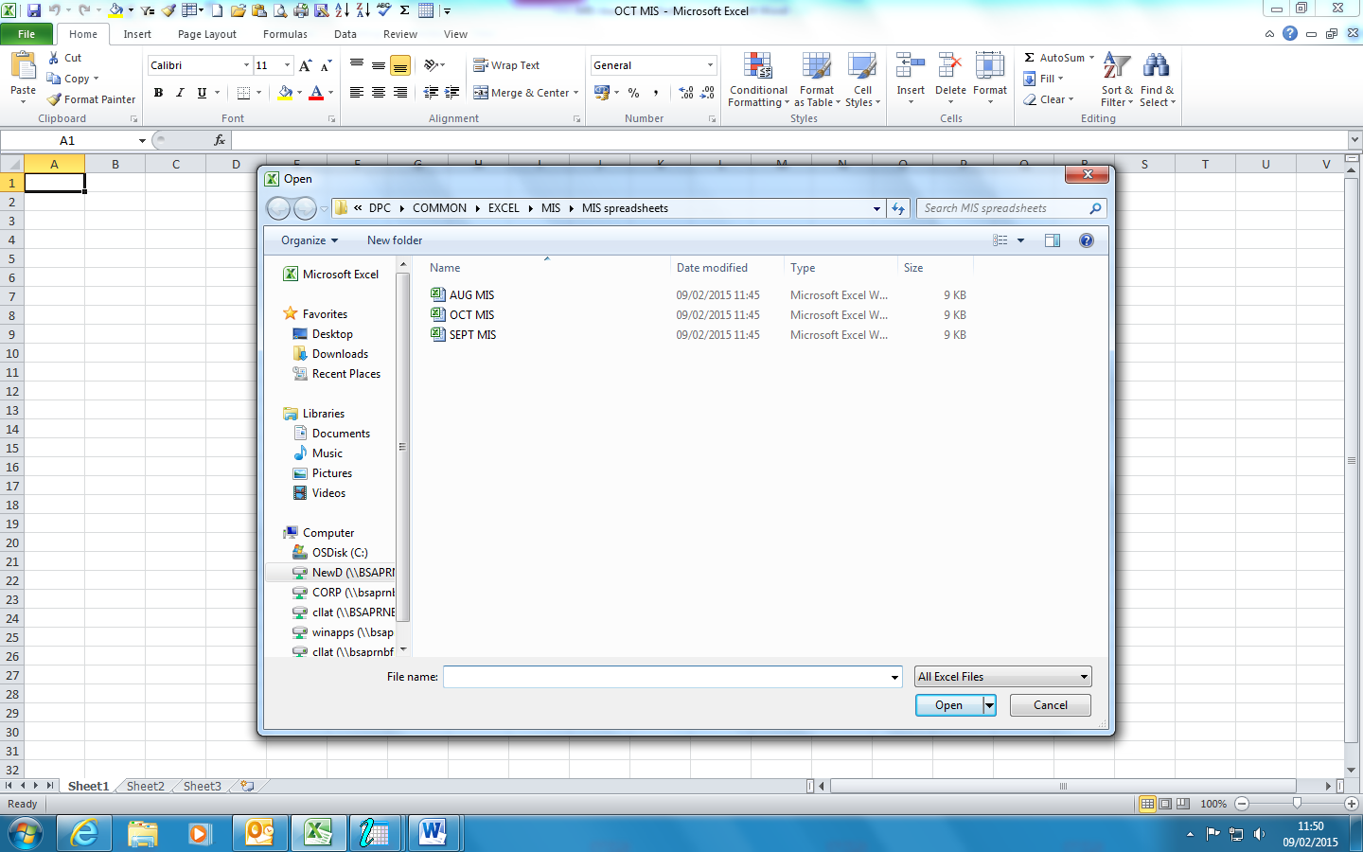
1b
Select file with the months data you require.
1b

Home Screen

Home screen shows summary reports available to view.
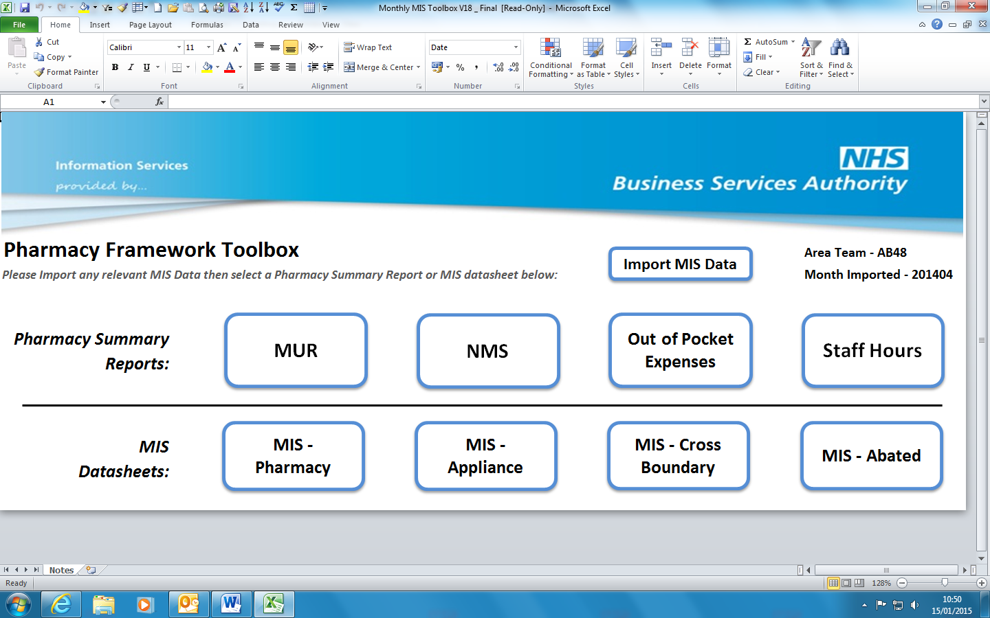
1e
1d
1c
Details of month and area team data that has been imported will be displayed.
1c
1d
There are four Pharmacy Summary reports available to choose from.

MIS Datasheets are the raw data the analysis is created from.
1e

MUR Summary Report

2a
2aa
Click on required summary report
The default screen will open displaying the upper outlier.
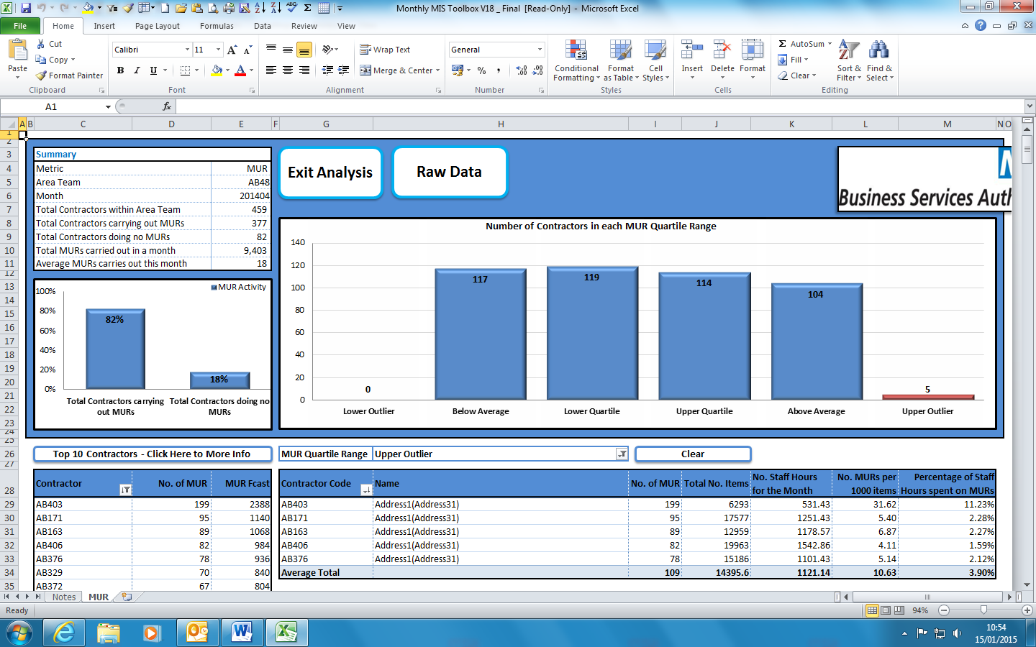
2c
2d
2e
2bb
2i
2j
2g
2l
2k
2h
2f

Details Summary for Area Team
2b

Details High level activity
2c
2d
Details Top 10 Contractors for Area Team
2e
You are able to click on individual columns to review results in each quartile
2f
Contractors OCS code
2g
Contractors name and address identifier
2h
No. of MUR -The number of MUR’s declared by the contractor that month.
2i
Total No. Items -The number of items processed by the contractor that month
2j
No. Staff hours for the month – (Number of days per week declared in the MIS/7)* the number of days in the month
2k
No. MUR per 1000 items – (Number of MURs declared/Number of items processed)* 1000
2l
Percentage of Staff Hours spent on MUR’s – (Number of MUR’s declared/number of staff hours for month )*100

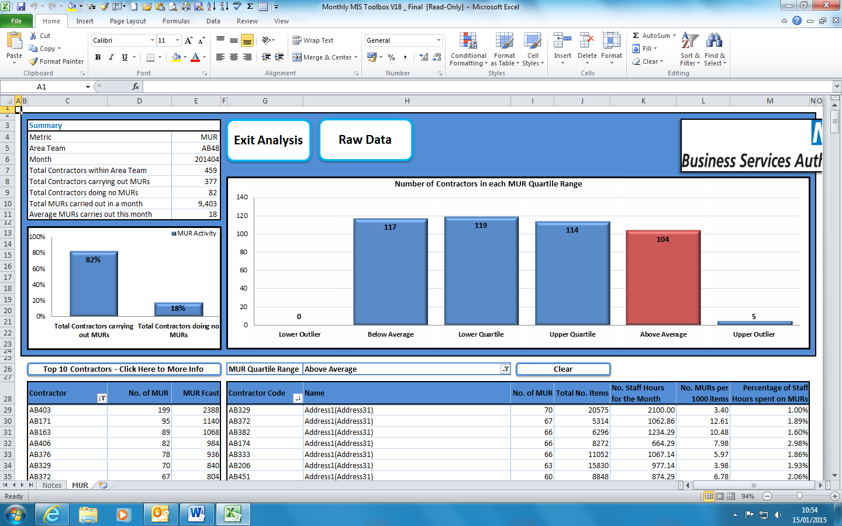
2n
2o
2m
2m
Click exit analysis and you will return to home screen
2n
Click raw data and you will be returned to the actual MIS spreadsheet
2o
By clicking on different columns allows the results to be detailed for that quartile.

Raw data
By clicking on ‘Raw Data’ you will see the actual MIS spreadsheet and will be able to locate columns that refer to data.
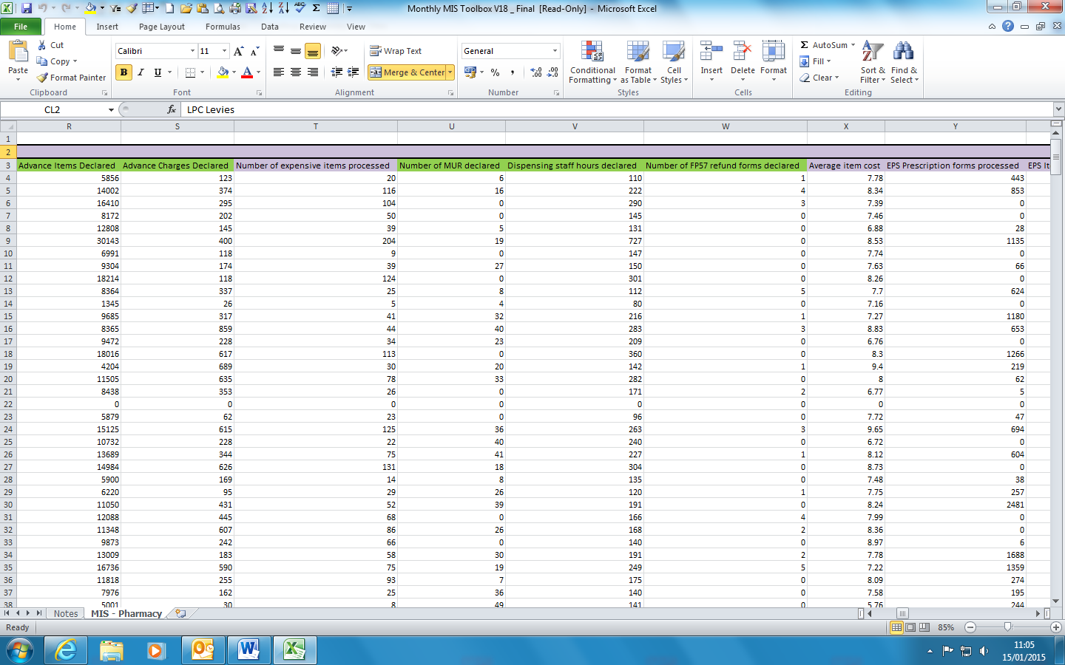
2p
2p
Total no. of MUR’s declared as displayed in summary report.

2r
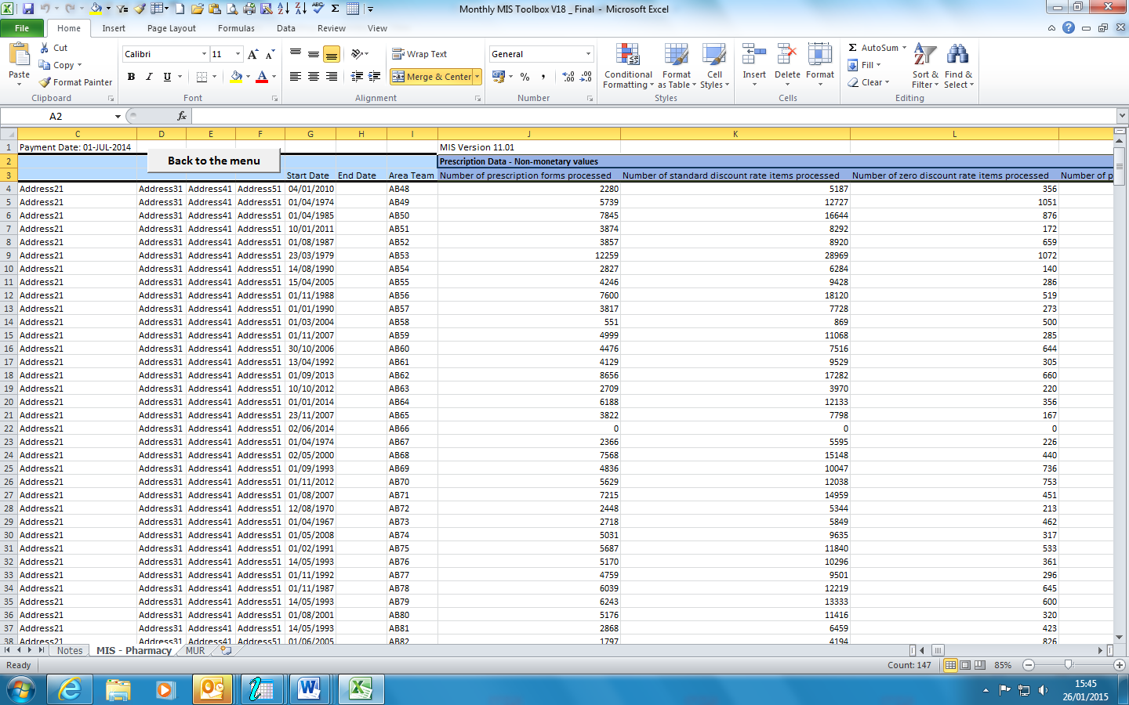
2s
2r
By clicking ‘Back to the menu’, you will be returned to analysis screen
2s
Total no. of items as displayed in the metric

NMS Summary Report

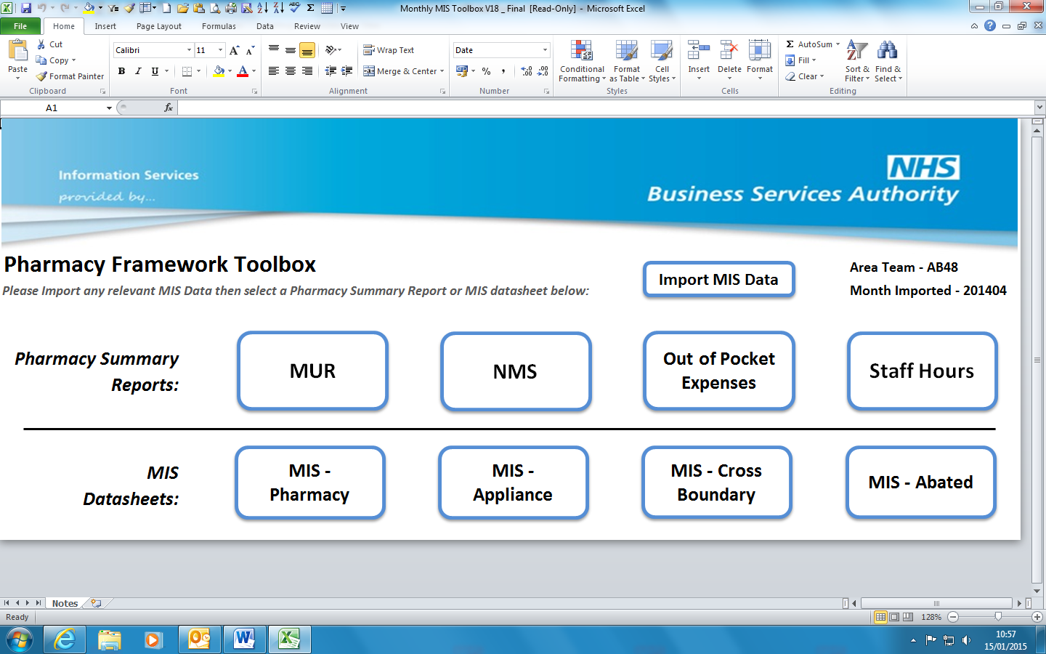
3a
3a
Can select to view a different pharmacy summary report by clicking relevant box

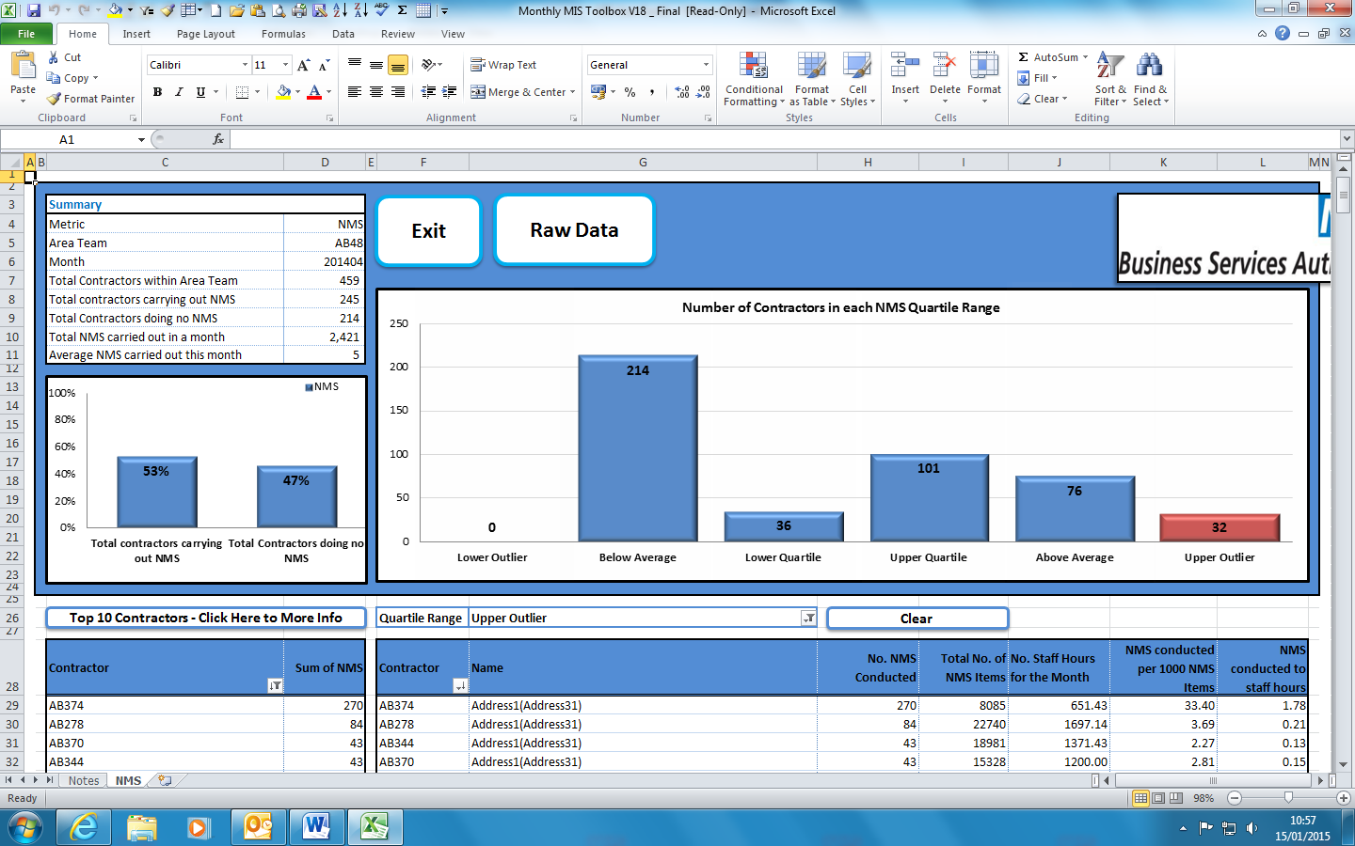
3f
3e
3d
3c
3b

Number of NMS conducted – the total number of NMS declared by the contractor that month
3b

Total number of NMS items
3c

Number staff hours for the month – (Number of days per week declared in the MIS/7)* the number of days in the month
3d
3e
Number of NMS conducted per 1000 NMS items – (Number of NMS conducted/Number of NMS items)*1000
3f
Number of NMS conducted to staff hours – (Number of NMS conducted/Number of staff hours for the month)*100
3g
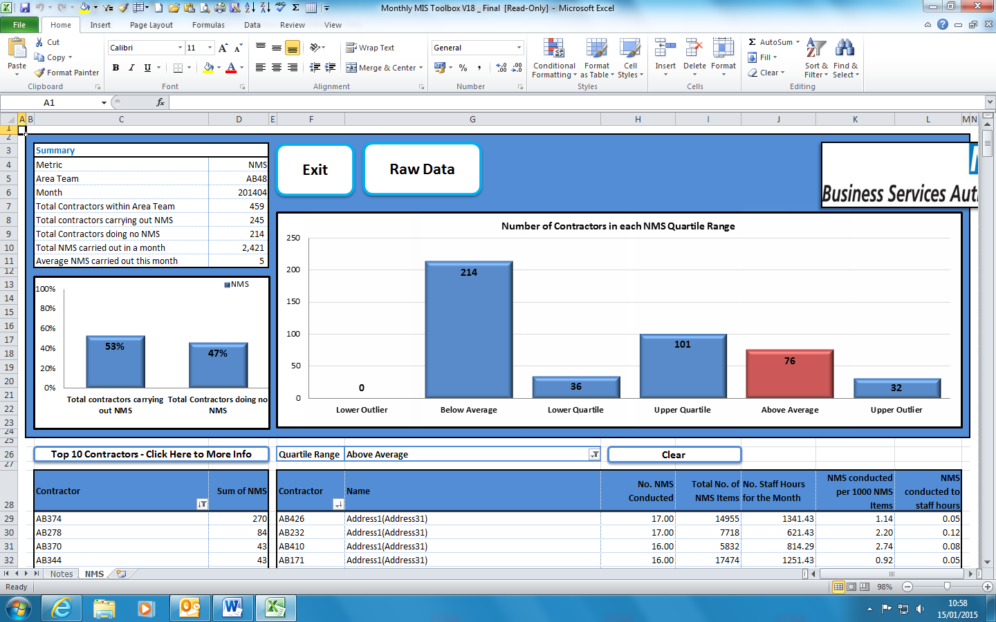
3h
By clicking raw data you will be returned to the actual MIS spreadsheet
3g
3h
Click clear and the search results will be cleared and the highlighted column and relevant
breakdown information will be cleared, and the full listing will be displayed.

3i
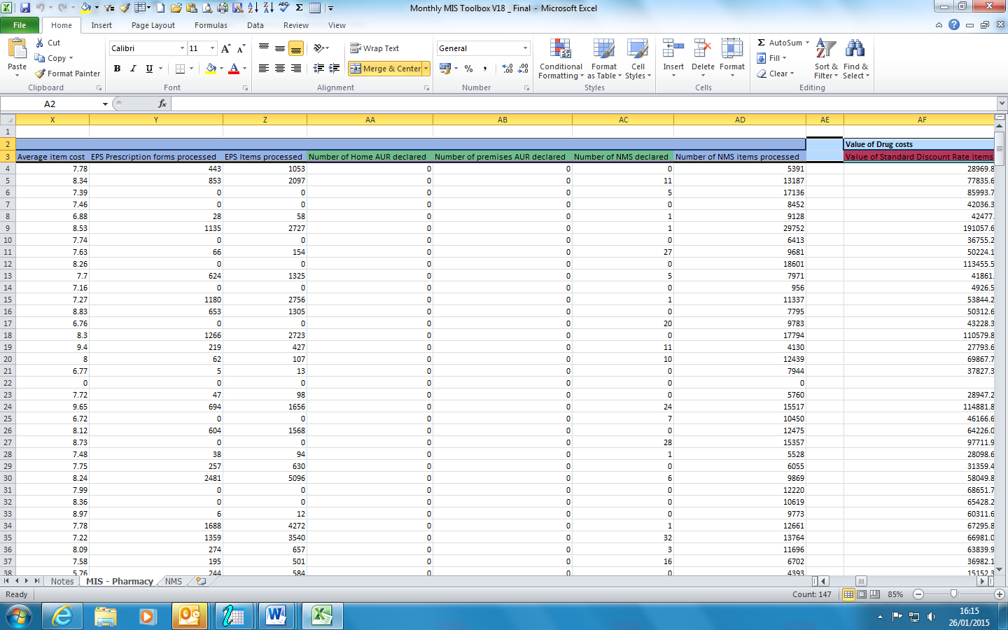
3i
Total number of NMS declared

Click on back button to return to the summary report information by scrolling to the left on the raw data sheet to where the address details are held.

Out of Pocket Expenses Summary Report

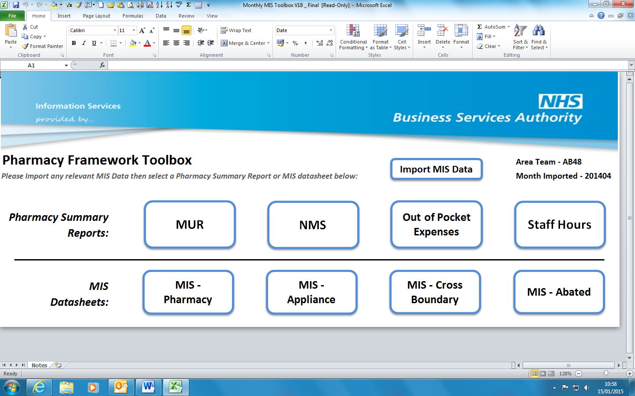
4a
Click on ‘Out of Pocket Expenses’, to display the pharmacy summary report
4a

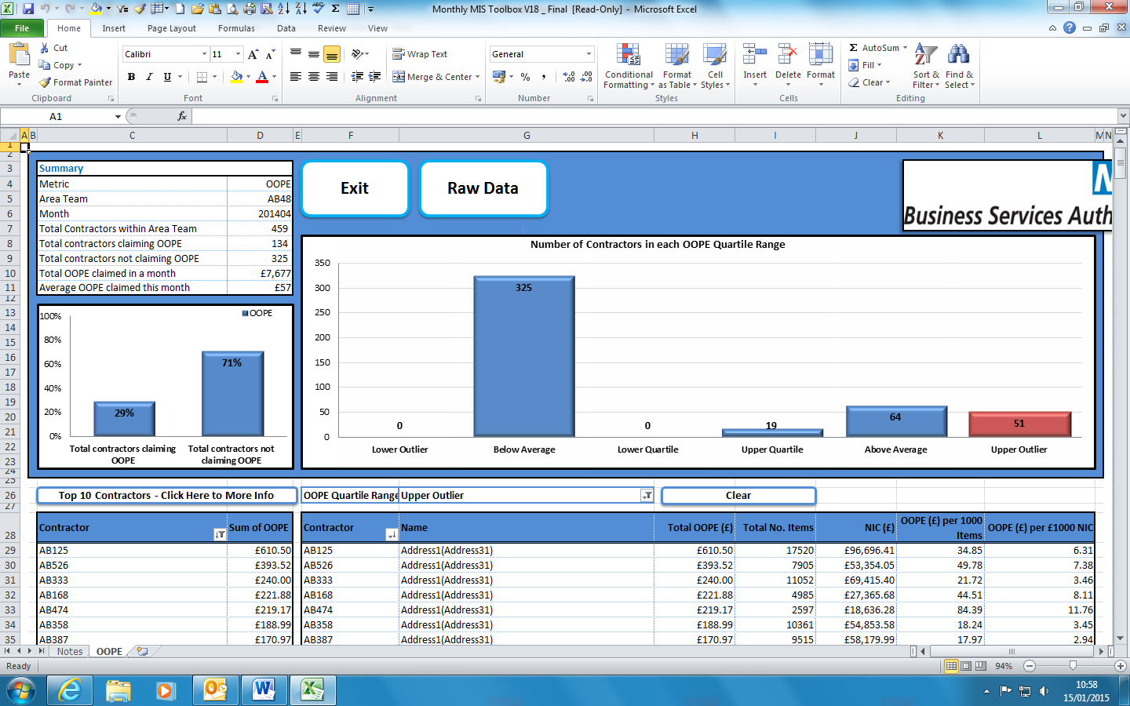
4f
4c
4e
4d
4b

4b
Total OOPE (£) – Total amount of Out of Pocket Expenses (OOPE) declared for that month
4c
Total Number of items – the number of items processed by the contractor that month
4d
NIC (£)- Value of standard discount rate items + value of discount deducted + value of zero rate items
4e
OOPE (£) per 1000 items – (Total OOPE declared/Total number of items for the month)*1000
4f
OOPE (£) per £1000NIC – (Total OOPE declared/total NIC)*1000

Click on ‘Raw Data’ to view data in MIS spreadsheet
4g
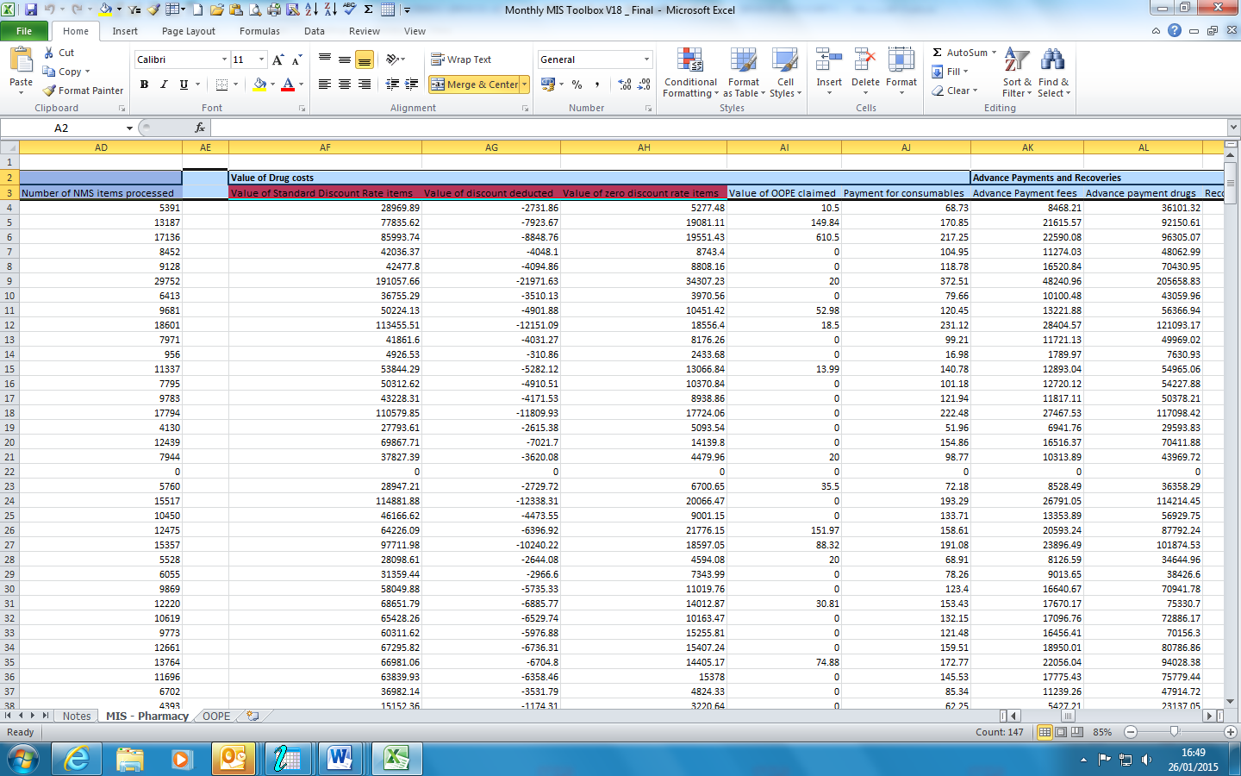
4g
The MIS spreadsheet displaying OOPE claimed

Staff Hours Summary Report

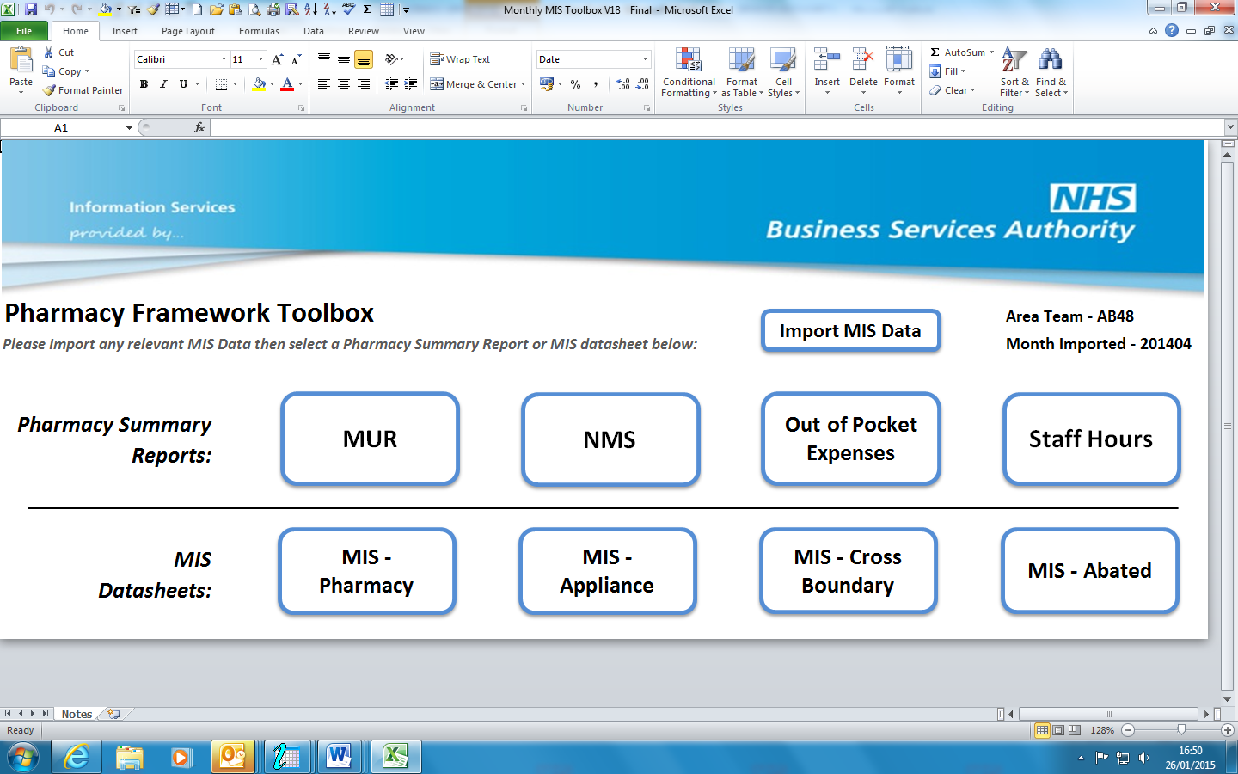
5a
Click on ‘Staff Hours’, to display results from Pharmacy Summary report
5a

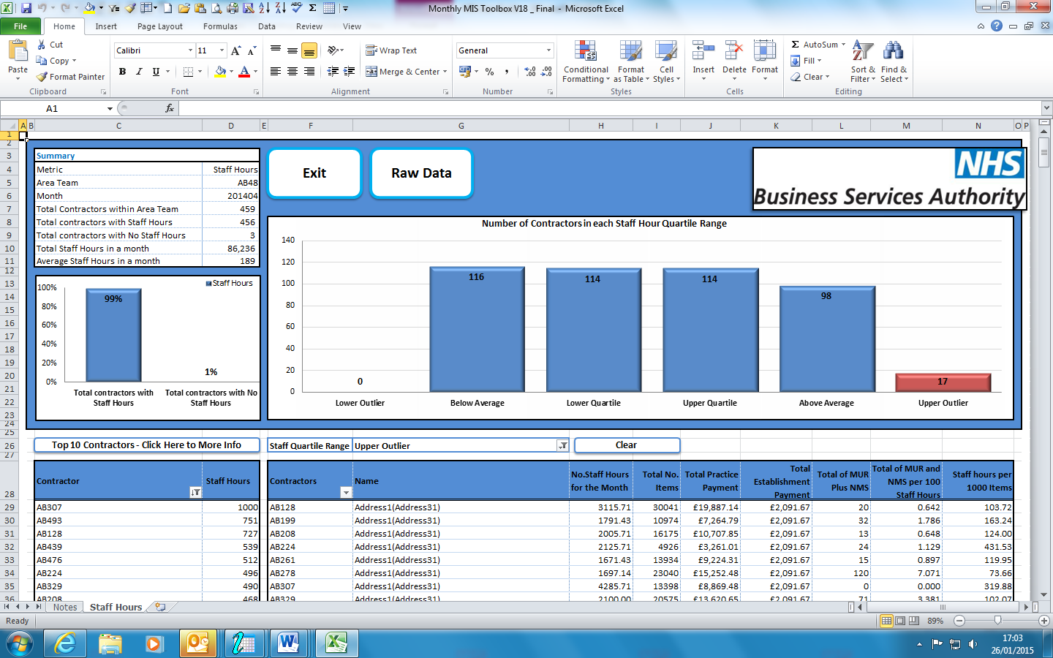
5h
5g
5f
5e
5b
5c
5d

5b
Number of staff hours for the month (Number of hours per week declared in the MIS/7)* the number of days in the month
5c
Total Number of Items – The number of items processed by the contractor that month
5d
Total Practice Payment – total practice payment paid to the contractor that month.
5e
Total Establishment Payment – total establishment paid to the contractor that month.
Total of MUR plus NMS - Number of MURs declared + Number NMS conducted
5f
5g
Total of MUR and NMS per 100 staff hours - ((Number of NMS + Number MURs)/ Staff Hours per month) * 100.
Staff hours per 1000 items – (Number of staff hours for the month/Number of items for the month)*1000
5h

5i
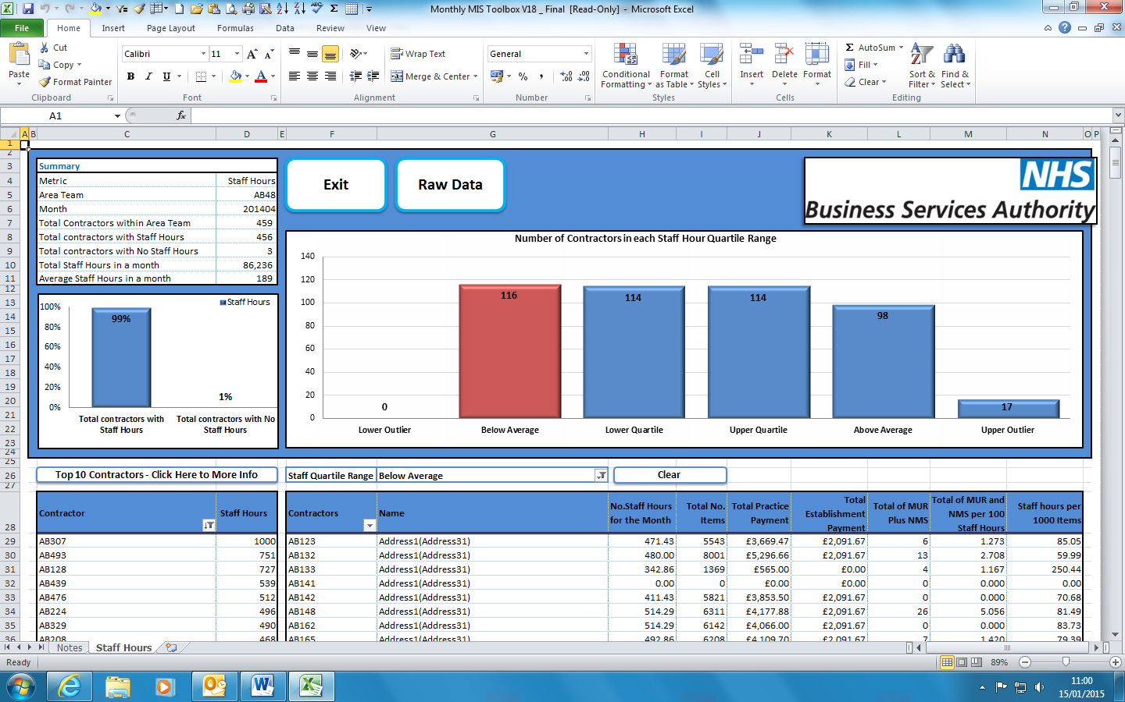
5i
Click on ‘Raw Data’ to view data in MIS spreadsheet.

5j
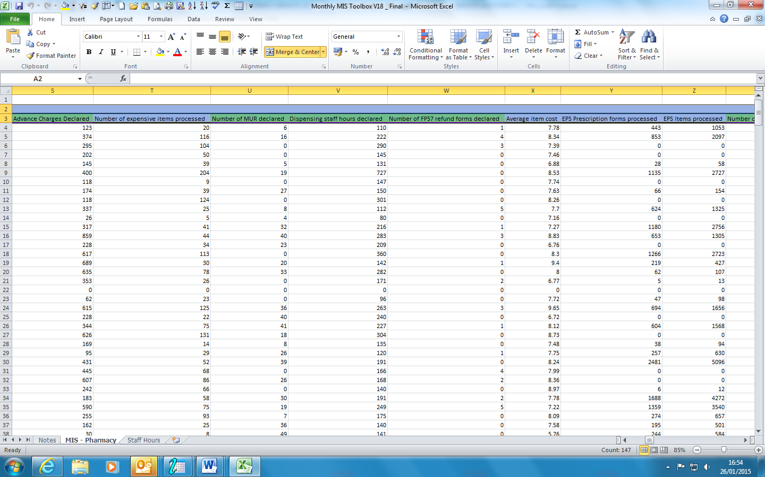
5j
Related columns can be found in raw data.

Raw data provides details of the services claimed by the contractor, but does not show any subsequent adjustments. The data displayed shows the actual data processed for that particular payment date and does not record subsequent adjustments processed as adjustment.
The raw data spreadsheet has been enhanced to display overarching headings representing the columns that denote the following:
- Prescription data – non-monetary values
- Value of drug costs
- Advance payments and Recoveries
- Prescription Fee values
- Prescription Charge Values
- Appliance Fee values
- Area Team Payments
- LPC Levies
- Contract specific payments
- Pre- payment Certificate deduction
- NHSBSA Authorised Payments

