Guide to using the Forecast Template for drug spend

Disclaimer

- The Forecast Template is intended to support commissioners in their primary care drug spend planning. The output does not state the position of DH or NHSBSA.

Pre-requisite

- To use the template you must have Analysis Toolpack and Analysis Toolpack VBA installed on your computer. See the “possible errors” section of the guide on how to install these packages.

Introduction

- This document is to help users run their own primary care drug spend in year forecast from the Forecast Template. This guide provides information on the data required, how to run the forecast and possible errors that might occur.

Opening the template

- When the pop up window appears mentioning there are macros in the workbook, click on ‘Enable Macros’. If ‘Disable macros’ is selected, the regression will not run.

Entering data

- Data is entered in the yellow cells of the ‘Data’ worksheet for historical actual monthly spend and policy/local adjustments.

Actual monthly spend

- Historical monthly spend is needed for years 2012/13- 2016/17 to run the forecast. The data are entered in the relevant column for every month in £’s. Data can be entered for less than 5 years as this is taken into account in the forecast – the earliest year with data will be treated as the first year for calculating the regression. However, a full year is needed to start with, for example the forecast won’t be accurate if actual monthly spend started in August not April. More detail on using less than 5 years’ worth of data below.

- We describe below how data will be filled in to the column for 2017/18 as it becomes available through the year.

Policy/local adjustments

2012/13 to 2017/18

- The historical monthly spend could be noisy due to the impact of policy changes and local initiatives. These should be stripped out prior to running the regression. This is done by adding back the effect of any policy adjustments and local initiatives through the “Policy/local adjustments” table. This should be done cumulatively for 2012/13 through to 2017/18. This table should contain an estimate for how much has been saved (or in the case of 2017/18 how much is expected to be saved) each month due to policies and local adjustments – see later. Also, if there are some policy changes or local initiatives that add to the spend rather than saving, then this can be entered by taking the amount away from the cumulative value through 2012/13 to 2016/17. 2017/18 can be treated in the same way too.

- Policy/local adjustment could include any changes to prescribing spend incurred by
  - Category M policies,
  - Local prescribing initiatives
  - QIPP better care better value indicators
  - QOF Quality and Productivity (QP) indicators

- This is best illustrated by an example. Say the following was likely to have happened:

- no adjustments in April to September 2011;
- in October 2011, there was a policy that was expected to save £40,000 per month from then on;
- there were no further adjustments until May 2012;
- in May 2012 there was a further policy that saves a further £30,000 per month from then on;
- in October 2012 there is a further policy to reduce prices by an extra £30,000 per month.

- The table below is how the above example would be entered.

Table 1: Policy/local adjustments example
Month | 2011/12 | 2012/13
April | 0 | 40,000
May | 0 | 70,000
June | 0 | 70,000
July | 0 | 70,000
August | 0 | 70,000
September | 0 | 70,000
October | 40,000 | 100,000
November | 40,000 | 100,000
December | 40,000 | 100,000
January | 40,000 | 100,000
February  i.e. 40,000+30,000 | 40,000 | 100,000
March | 40,000 | 100,000

- An example including policy adjustments that increase spend:
- no adjustments in April to September 2011;
- in October 2011, there was a policy that was expected to save £40,000 per month from then on;
- there were no further adjustments until May 2012;
- in May 2012 there was a further policy that increases spend by £20,000 per month from then on;
- in October 2012 there is a further policy to reduce prices by an extra £10,000 per month.

- The table below is how the above example would be entered.
Table 2: Example of entering increases due to policy/local adjustments
i.e. 40,000-20,000
Month | 2011/12 | 2012/13
April | 0 | 40,000
May | 0 | 20,000
June | 0 | 20,000
July | 0 | 20,000
August | 0 | 20,000
September | 0 | 20,000
October | 40,000 | 30,000
November | 40,000 | 30,000
December | 40,000 | 30,000
January | 40,000 | 30,000
February | 40,000 | 30,000
March | 40,000 | 30,000

2017/18

- If there are any known policy/local adjustments for 2017/18, add them to the cumulative adjustments in the month they will be introduced. Otherwise, continue the previous months cumulative adjustment throughout the year and enter the true adjustment when known. Note this all has to be done cumulatively. For example, if there are no policy adjustments in 2017/18 then just carry forward the cumulative total for March 2017.

When data for the most recent month is available

- At the start of the financial year the “Actual monthly spend(£)” column will be blank. When this data is reported for a month, the value should be inputted to the ‘Actual Monthly Drugs Spend’ table. This will update the end of year forecast, which is explained in more detail below.

Please note

- Don’t cut data from the yellow cells in the ‘Data’ worksheet to other cells, this will stop the forecast from working. However, data can be copied and pasted from other workbooks.

The forecast

- The forecast for drug spend is calculated using regression statistics based on the previous five years’ actual monthly spend, taking into account dispensing days, seasonality and the year that a month is in.

- On the ‘Notes’ worksheet of the Forecast Template, there is the R square value of the regression used for the forecast and the P-values for the three variables year, month and dispensing days.

- The R square value describes how much the variability in spend is explained by variations in the variables dispensing days, seasonality and year. The closer to 1, the more variability in spend is explained by variations in the variables. It is also a good indicator of how suitable the regression is for forecasting future months, so the closer to 1, the more suitable it is for forecasting.

- The P-value is used to see how significant each variable is to the regression. If the P-value is less than 0.05 or 0.01, then the variable is significant (at a 95% and 99% level respectively) to the regression. That is we are confident that the drugs expenditure is affected by the variable and there is a 1 in 20 chance (if 95% level used ) of this being incorrect.

- If you are not using 5 years’ worth of data, check the R square value to see if the forecast is reasonable for further use.

Running the forecast

- To run the forecast, after all the data required has been entered, select the ‘Forecast’ worksheet and click the ‘Update regression for new financial year’ button. This will fill the ‘Predicted Monthly Spend’ column with figures calculated from the regression.

WARNING - once the forecast buttons have been clicked, you cannot click undo as macros cannot be undone.

- There is another forecast sheet ‘Forecast Updated’ which is explained below.

Predicted Monthly Spend

- The predicted monthly spend is calculated using the coefficients for each variable from the regression statistics and the dispensing days and rank of month.

End of Year Forecast

- If April 2017/18 actual monthly spend has not been entered in the ‘Data’ worksheet, then the end of year forecast is shown at the bottom of the ‘Predicted Monthly Spend’ column. Once actual April 2017 data is entered, the end of year forecast is shown in the ‘End of Year Forecast’ column. This forecast takes into account the predicted monthly spend for the future months and the actual monthly spend for all previous months where data is available and used.

- For example, in the table below, the predicted monthly spend and the actual spend for April and May are shown with the end of year forecast. When April is the most recent months’ data, the end of year forecast is calculated from April actual and May to March predicted spend. When May data is available, then the end of year forecast is adjusted to use April and May actual and the remaining months’ predicted spend (June to March).

- Each time a new month is available, the end of year forecast is presented in the same row for that month.

Month | Actual monthly spend (£) |  | Predicted monthly spend (£) |  | End of year forecast (£)
April | 526,249 |  | 549,864 |  | 6,995,802
May | 587,436 |  | 578,181 |  | 7,005,057
June |  |  | 600,153
July |  |  | 578,096
August |  |  | 593,851
September |  |  | 584,398
October |  |  | 587,549
November |  |  | 606,455
December |  |  | 565,620
January |  |  | 603,304
February |  |  | 565,534
March |  |  | 606,412
Table 3: End of year forecast example

- Note: The regression does not change when 2017/18 data is inputted - the predicted monthly spends do not change. However, what does change is the end of year forecast as each month a predicted spend is replaced by an actual spend.

Percentage Change in End of Year Totals

- There is a summary table that gives detail on the percentage change across the total end of year spend below the ‘Update regression for new financial year’ button. It takes the total for each year from the ‘Actual Monthly Spend’ table in the ‘Data’ sheet and displays the percentage change.

- Alongside the ‘End of year forecast’ column, there is another column that shows how the percentage change between the 2016/17 total and 2017/18 forecast has modified when the 2017/18 end of year forecast is updated. When most recent months are added, the percentage change for 2017/18 in the summary table shows the percentage change for the most up to date end of year forecast.

‘Forecast Updated’ sheet

- There is an extra forecast sheet in the template that is optional to run. It has been included as tests show at a national level adding the most recent months’ data to the regression improves the reliability of the forecast. This will not necessarily be the case and the descriptive statistics of the two regressions should be compared to decide which is most appropriate. This sheet allows you to run a forecast that uses the 2017/18 reported spends to update the regression.

- It has exactly the same layout as the ‘Forecast’ sheet and still runs off the data in the ‘Data’ sheet, so you do not need to add any extra data.

- When you click the ‘Update regression for new financial year taking into account most recent months’ button, it changes the layout of the monthly predicted spend and end of year forecast, shown in the example below. As data for current year is entered and the regression re-run, there is no predicted monthly spend as there is no need to forecast this month when the actual data is available. Therefore, the further into the current year, the fewer predicted monthly spends are shown.

Month | Actual monthly spend (£) |  | Predicted monthly spend (£) |  | End of year forecast (£)
April | 526,249 |  |  |  | 7,118,282
May | 587,436 |  |  |  | 7,107,573
June |  |  | 546,522
July |  |  | 668,752
August |  |  | 633,213
September |  |  | 557,600
October |  |  | 613,139
November |  |  | 579,830
December |  |  | 597,497
January |  |  | 602,061
February |  |  | 630,589
March |  |  | 564,685
Table 4: End of year ‘Forecast updated’ example

Possible errors when running the forecast

Missing data

- If there are any yellow cells left blank in columns 2012/13-2016/17 for both actual monthly spend and policy/local adjustments and 2017/18 for policy/local adjustments then a message in red will appear next to the table in the same row with the blank cell. A message will also appear at the top of the worksheet. If these messages appear, the forecast won’t run. If these messages are ignored and the button on the ‘Forecast’ worksheet is clicked, a pop up window with the message ‘Data Missing. Forecast won’t run’ will appear leaving the predicted monthly spend column blank. Make sure either ‘-‘, ‘0’ or the actual value are entered into the yellow cells before pressing the button on the ‘Forecast’ worksheet.

- If there are less than 5 years’ worth of data available, then the remaining years need to have ‘-‘ or ‘0’ entered otherwise the data missing message will appear.

- Note even if there are no policy adjustments, zeros should be entered for each cell of the policy adjustments table so the forecast can still run.

Press button, nothing happens

- If the forecast column is blank and there are no missing data messages, then press F9. For the forecast to automatically appear, calculations need to be on automatic. To do this, go to the 'Options' menu under the 'Tools' bar, then click on the 'Calculations' tab and select the 'Automatic' box and click 'OK'.

#REF error in Predicted Monthly Spend or in ‘Data’ worksheet

- The #REF error appears when data has been cut and pasted within the workbook. If this happens, a new template is needed.

- If a pop up window appears stating a Run time error, click ‘End’.

Any error that mentions ATPVBAEN.XLA or ATPVBAEN.XLAM

- There are lines in the VBA that takes into account different versions of Excel, but if at any point in opening the workbook or clicking the forecast buttons you get an error message mentioning either ATPVBAEN.XLA or ATPVBAEN.XLAM then follow the steps below depending on which version of Excel you are using.

Adding ATPVBAEN.XLA or ATPVBAEN.XLAM

Excel 2003
Tools (drop down menu)
Add-ins
Click in box for Analysis Tool Pack – VBA
Click OK

Excel 2007/2010
MS Office button (in top left corner)
Excel options
Add-Ins
Manage box – select Excel Add-Ins
Click Go
Add-Ins available box, Analysis Toolpak-VBA

Worked Example

Disclaimer

- The figures used in this worked example are purely fictional.

Opening the template and Notes page

- When the Forecast Template is first opened you will come across the ‘Notes’ page. This provides some information on what is required to calculate a forecast. At the bottom of the page, there is the R squared value and the P-values for the regression (shown in the screen shot below). These values will only be visible once the forecast button has been pressed.

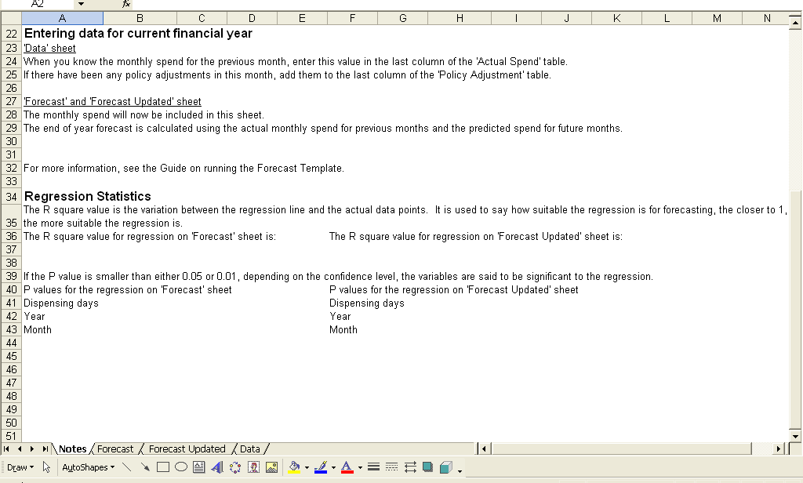

Entering Data

- When you go to the ‘Data’ sheet, you will notice that there are warnings in red that data is missing. Once data is entered, the warnings will disappear. If you only have 3 years’ worth of data, as the warnings cover all 5 years, you will need to enter ‘-‘ or ‘0’ into the earlier years. This is shown in the screen shot below.

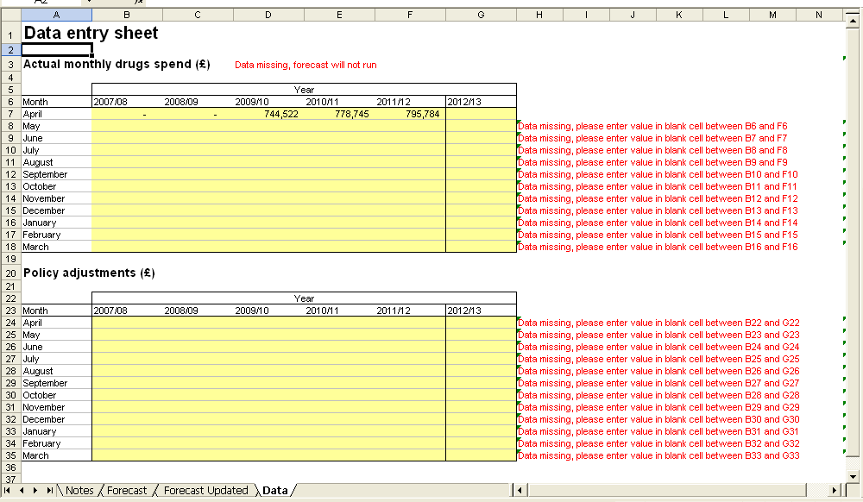

- If after entering the data, you have missed a month or not included any values in the cells required, the red warnings will still appear (as shown in the screen shot below). The forecast won’t run even if there are blanks in the current year policy adjustment column. If you don’t know what the Policy adjustment will be, carry the cumulative value from the previous March over the whole year. Once you know the policy adjustment, edit the table in the ‘Data’ sheet, and this will change the predicted monthly spend without having to re-run the forecast.

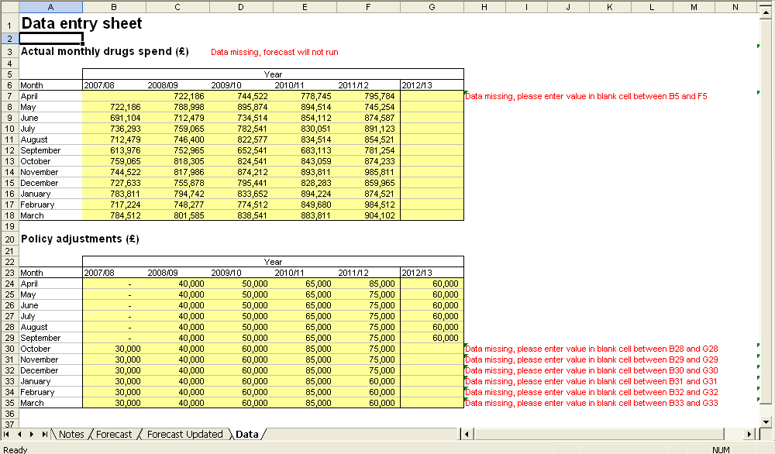

Entering data for less than 5 years

- If you don’t have 5 years’ worth of data to enter, you can add less, but the remaining years need to have either ‘-‘ or ‘0’ entered (as illustrated below). Only enter full years data – always start at April even if you have data for August the previous year.

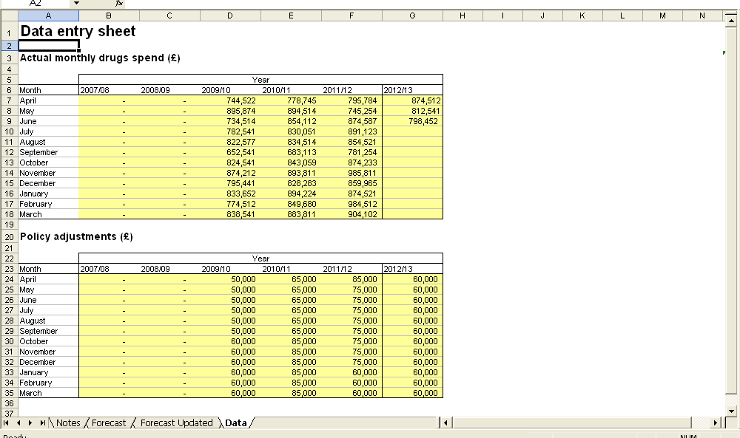

The Forecast sheet and running the forecast

- If you ignore the red warnings on the ‘Data’ sheet and try to run the forecast, you will receive a pop-up window (as below) stating that the forecast can’t run. If you receive this message, you will need to return to the ‘Data’ sheet and add the missing data.

- Before clicking the regression button on the ‘Forecast’ sheet, you will notice that the percentage change in end of year totals is visible. The percentage change from 2016/17 to 2017/18 will be visible once the forecast has been run.

- Clicking on the ‘Update regression for new financial year’ button will present the predicted monthly spend with an end of year total at the bottom of the list, as shown below.

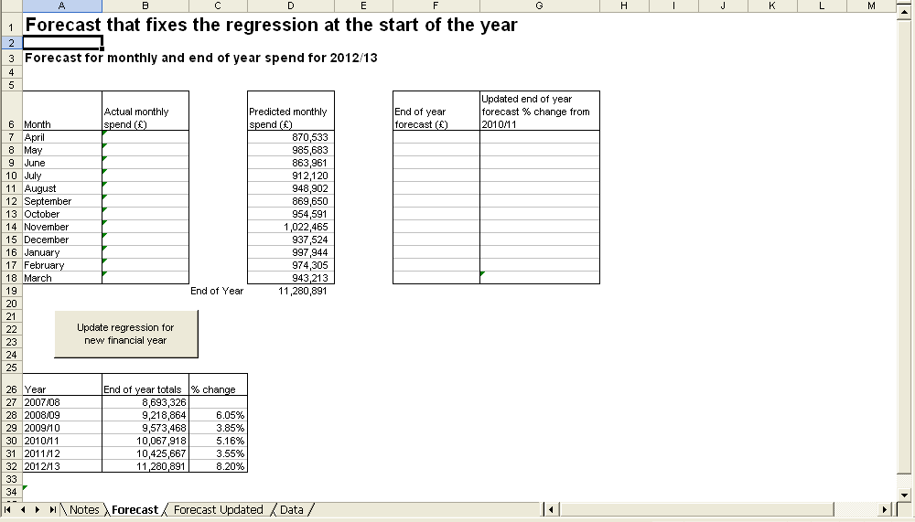

- To check if the forecast is appropriate to use, go back to the ‘Notes’ page and scroll down to the ‘Regression Statistics’ section.

- In this example, the R square value for the regression is 0.792. This means 80% of the variability in drug spend is explained by the variables in the regression model. There is a vast array of literature on appropriate R square values. R-squared values are a descriptive statistic, they describe how much of the variability in the dependent variable is explained by the independent variable, they are not a yes/no around whether to use a model or not.

- A value of 80% would suggest ‘continue with the model, but use any outputs with high caution’.

- The P-value for this regression shows that the variables dispensing days, year and month are significant at a 99% level. That is we are confident that the drugs expenditure is affected by all variables and there is a 1 in 100 chance of this being incorrect.

Entering actual data for 2017/18

- When actual data for 2016/17 is available, add it to the ‘Data’ sheet. This will update the end of year forecast taking into account actual data available and predicted monthly spend for the remaining months.

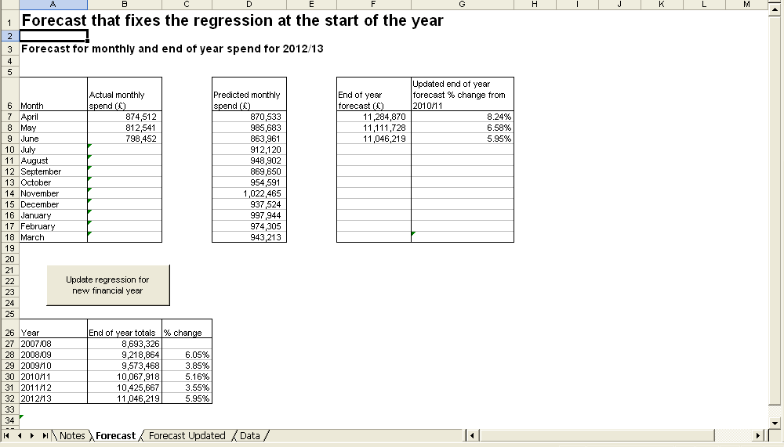

- As more actual months are added, the updated end of year forecast is under the same month as the most recent months’ data. In this example, June data is the most recent so the end of year forecast taking into account the most recent month’s data is £11,046,219 (highlighted above).

- As shown in the screen shot above, there is a column for the percentage change from 2011/12. This shows how it has changed with each time the end of year forecast has been updated. From this example the current percentage growth is 5.95%

Forecast Updated sheet

- The ‘Forecast Updated’ sheet looks exactly the same as the ‘Forecast’ sheet but the regression takes into account the most recent month. So if the ‘Update regression for new financial year taking into account most recent months’ button is pressed, the predicted monthly spend and end of year forecast will be slightly different to that in the ‘Forecast’ sheet. This sheet requires the data mentioned earlier, but the regression will need updating every time a new months’ actual spend is added.

- This sheet can be treated as ‘what will happen if we include the most recent months actual data in the regression’. It will not change the forecast on the ‘Forecast’ sheet.

- As the regression includes the most recent month, there is not a predicted monthly spend for that month. The layout of the worksheet will be as follows for including most recent month’s data.

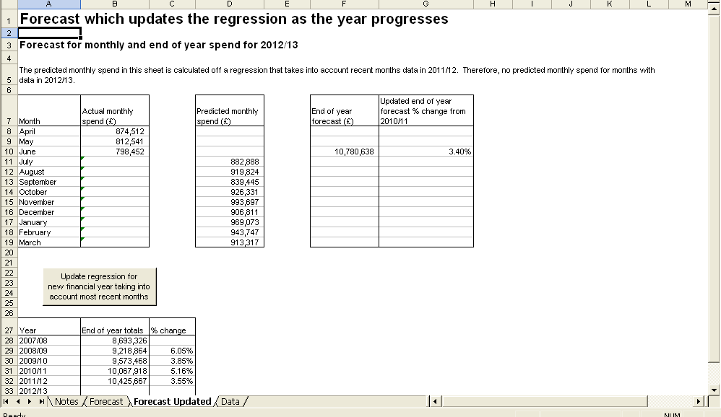

- Once again looking at the ‘Notes’ sheet to see if the forecast is appropriate.

- As the R square value for this example is 0.68, we would not suggest using this forecast for further work.

If there are less than 5 years’ worth of data available, then the remaining years need to have ‘-‘ or ‘0’ entered otherwise the data missing message will appear.
Note even if there are no policy adjustments, zeros should be entered for each cell of the policy adjustments table so the forecast can still run.

