ePACT2 guide

Accessing the Useful Reports Templates

Contents

1. | Getting started |  |  | page 2
2. | Accessing the Useful Reports Folder |  |  | page 2
3. | Running a Useful Report Template |  |  | page 4
4. | Saving a Useful Report Template |  |  | page 5

- Getting started

Log in to ePACT2.

This will open the homepage.

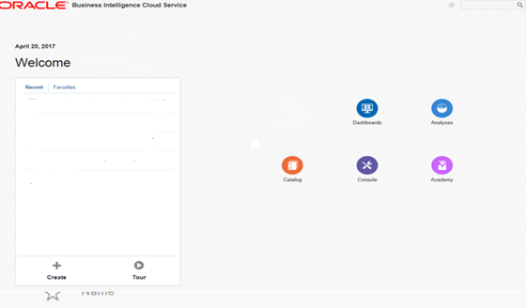

- Accessing the Useful Reports Folder

The Useful Reports templates are available to all users via the ‘Company Shared’ folder.

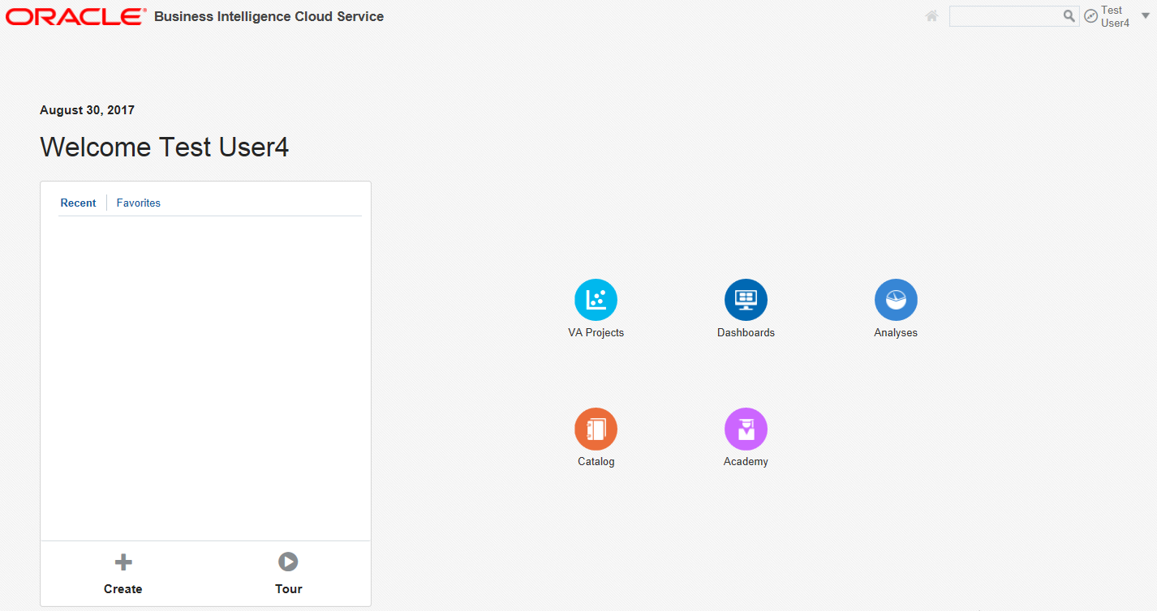
1

Select the ‘Catalogue’ icon.
1

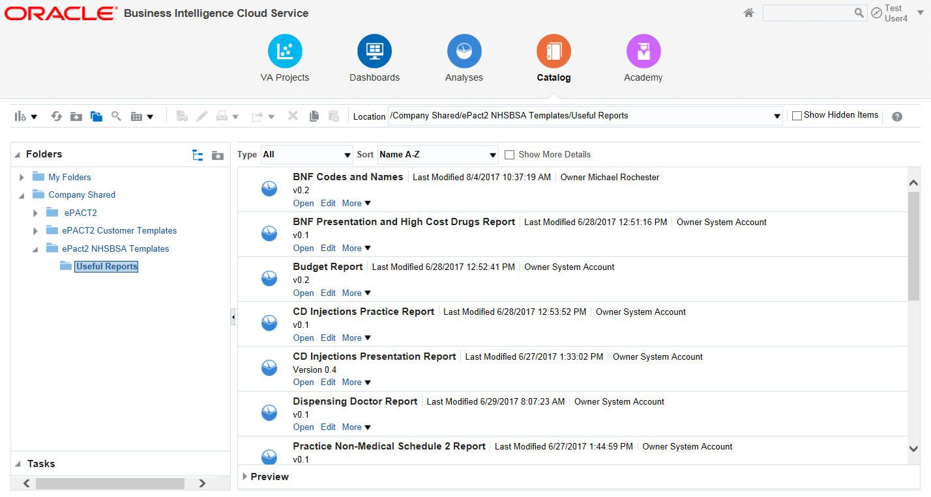
2
2
2
2

2
Expand the ‘Company Shared’ folder.
2
Expand the ‘ePACT2 NHSBSA Templates’ folder.
2
Double click the ‘Useful Reports’ Folder.

The list of Useful Reports available will then be displayed in the file pane to select.
2

- Running a Useful Report Template

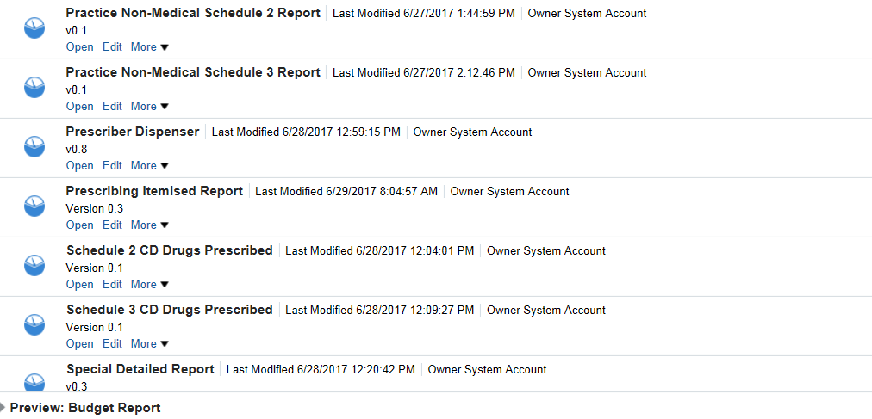
2

2
Select ‘Open’ to run the Report

The template will open at the ‘Prompt’ page which will allow users to select the time period, organisation and BNF level the report is required for.

Please note the options available will vary depending on the report and will default to the latest time period and the organisation the user is registered under.

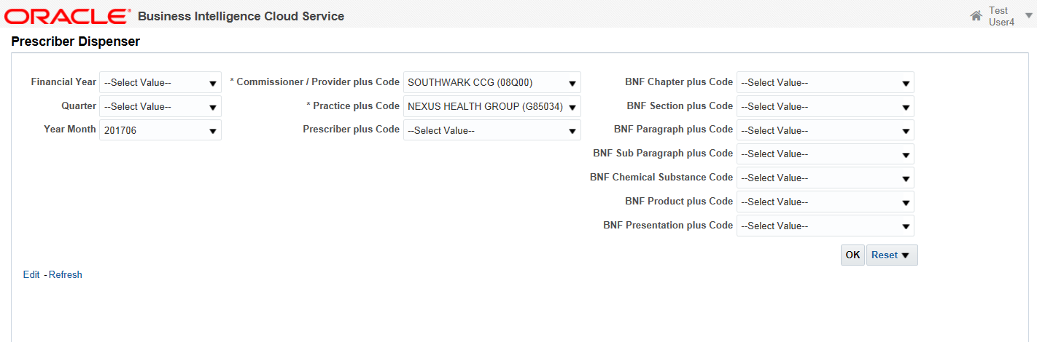
2
2
2
2

Select the ‘Time Period’ required.
1
2
Select ‘Organisation Level’ required.
2
Select the ‘BNF Level’ required.

Prescriber level data is only available for organisations the user is registered under, if data which the user is not authorised to view is selected the system will display ‘No Results’.

- Saving a ‘Useful Reports’ template.

The available templates can be saved to a user ‘My Folder’ area to be edited and amended.
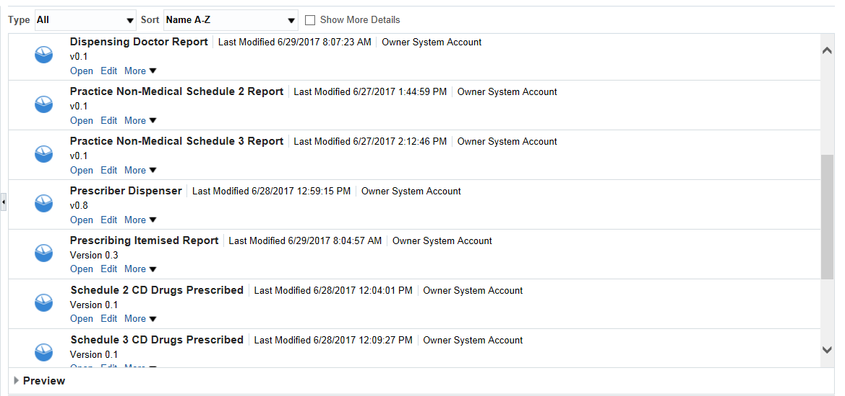
2

2
Select the ‘More’ drop down list.

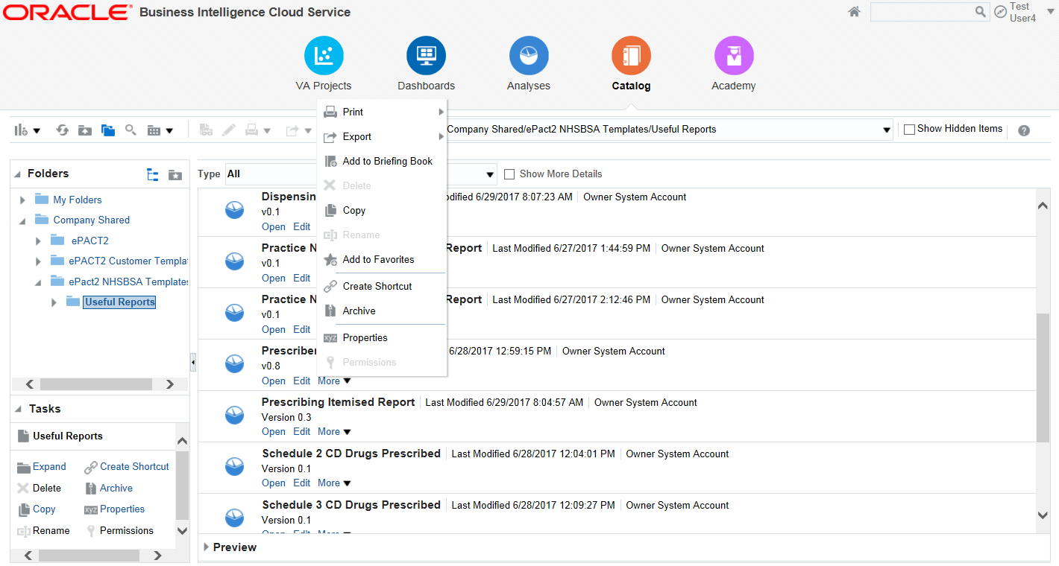
2
Select ‘Copy’ from the drop down list presented.
2

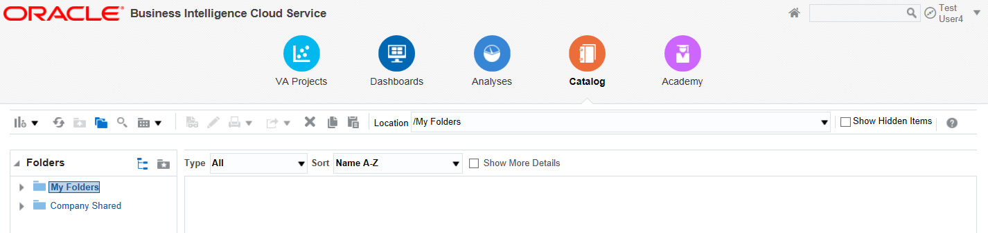
3
3

3
Select ‘My Folders’.
3
Select the ‘Paste’ icon.

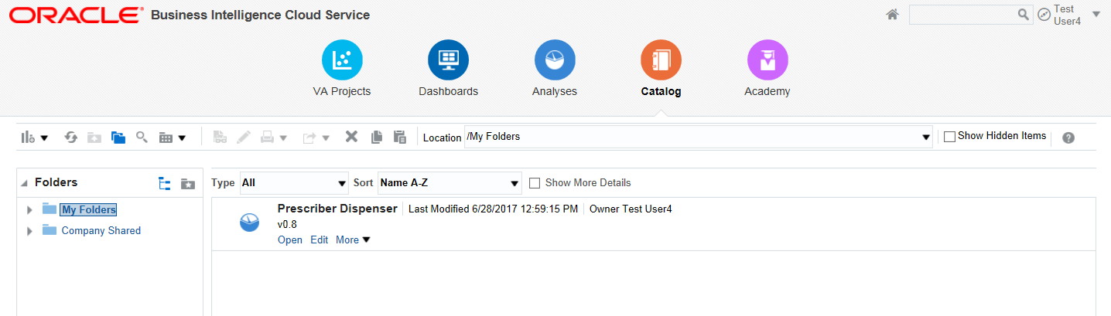
3

The ‘Useful Report’ template selected will then be displayed with the users ‘My Folder’.
3

