ePACT2 guide

Accessing the
Potential Generic Savings Dashboard

Contents

1. | Getting started |  | page 2
2. | Accessing the ‘Potential Generic Savings’ Dashboard |  | page 2
 | Overview |  | page 4
 | CCG Summary  Practice Summary  Organisation Summary  Datasets  Glossary |  | page 6  page 7
3. | Data Views |  | page 8
4. | Exporting the Data  Exporting Individual Analysis |  | page 9  page 9

- Getting Started

Log in to ePACT2.

This will open the homepage.
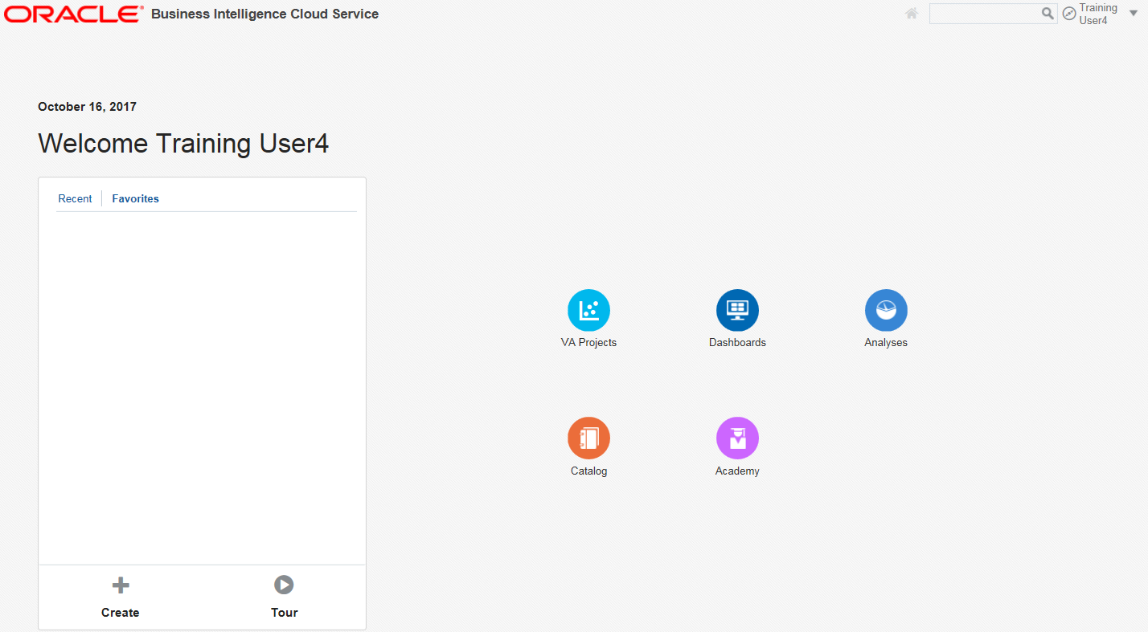

- Accessing the ‘Potential Generic Savings’ Dashboard

1

Select the ‘Dashboards’ option.
1
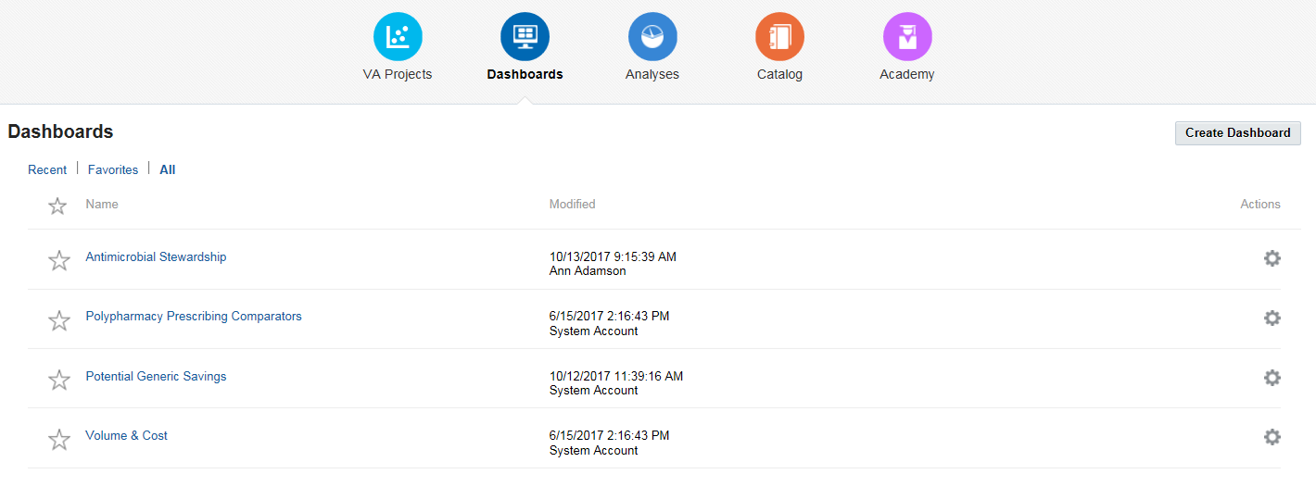
2
2
Select the ‘Potential Generic Savings’ dashboard.

The ‘Potential Generic Savings’ dashboard will open

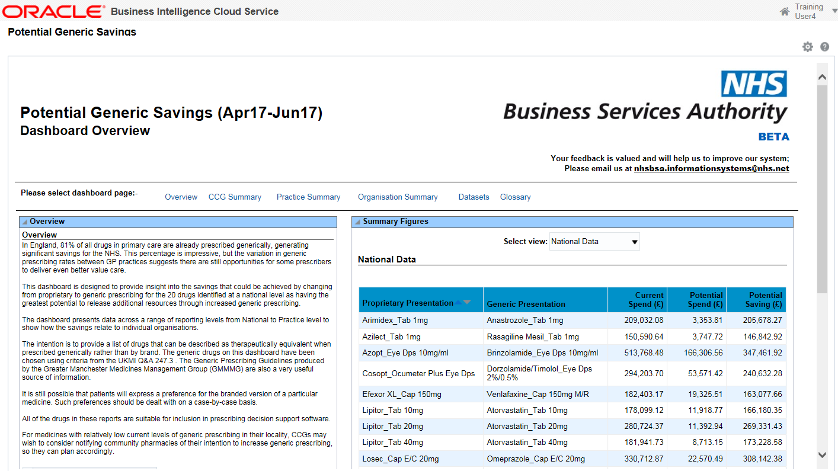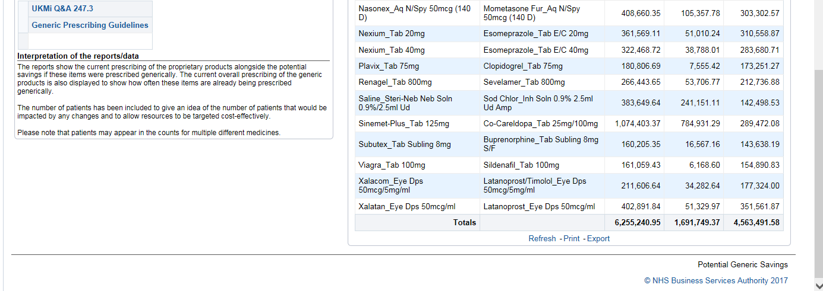
3

3
It may be necessary to use the scroll bar to view the entire dashboard.

Overview

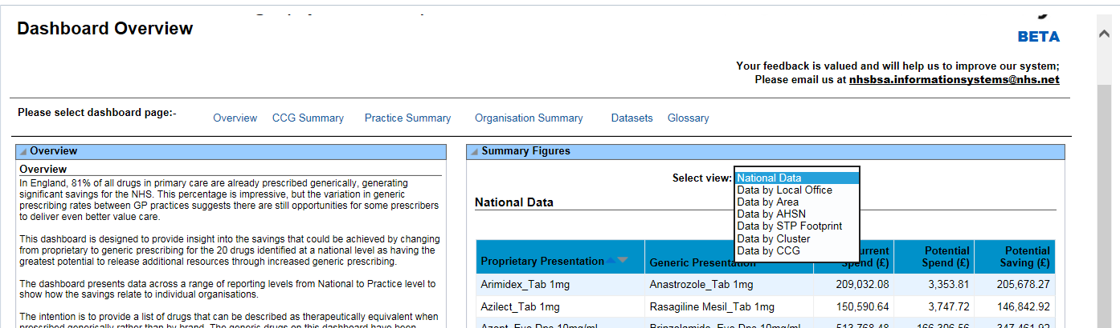
5
4

Select the ‘Overview’ link to navigate to the ‘Overview’ page.
4
5
Use the ‘Select View’ drop down list to select the organisation level required.

CCG Summary
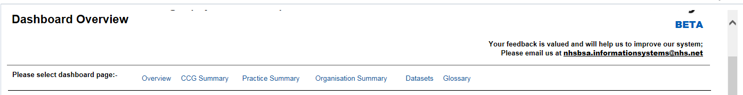
6
6
Select the CCG Summary link.

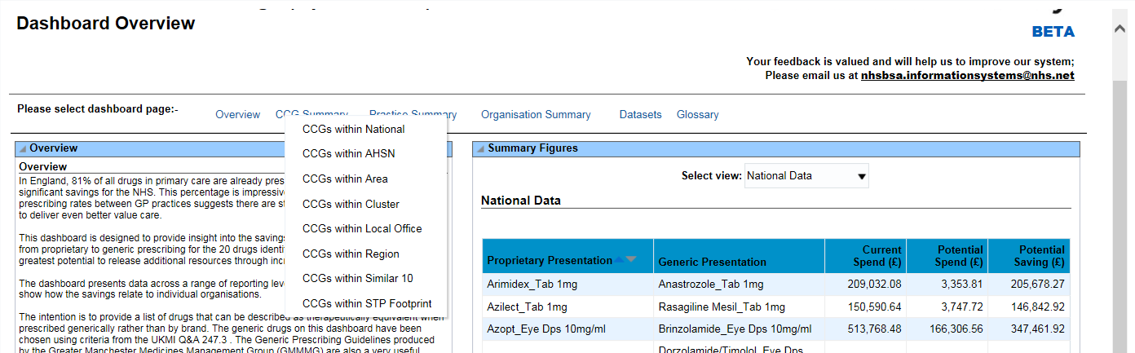
7
7
Select the organisation level required.

The summary page selected will open.

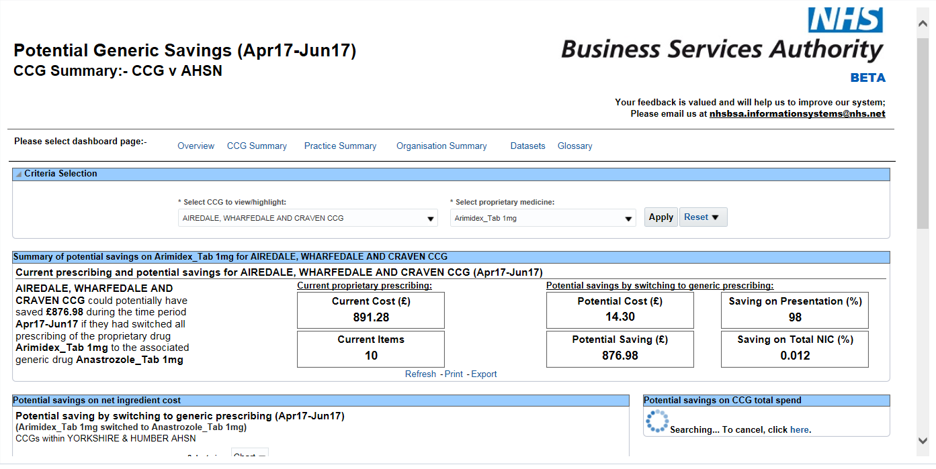
9
8

The ‘Criteria Selection’ pane allows organisation and proprietary medicine selection.
8
9
Once the selections are complete select ‘Apply’ to regenerate the dashboard.

Practice Summary

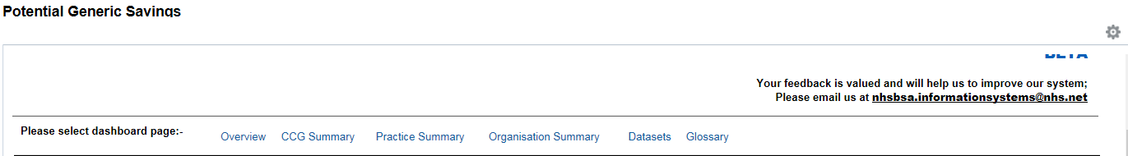
10

10
Select the Practice Summary link.

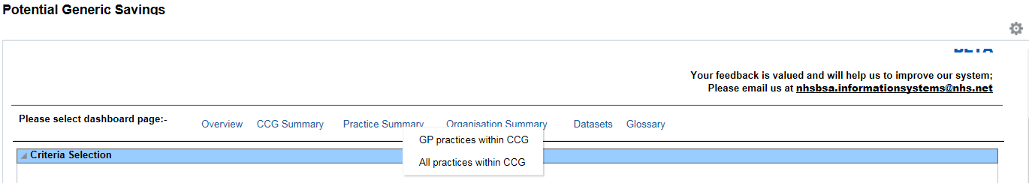
11

11
Select the organisation level required.

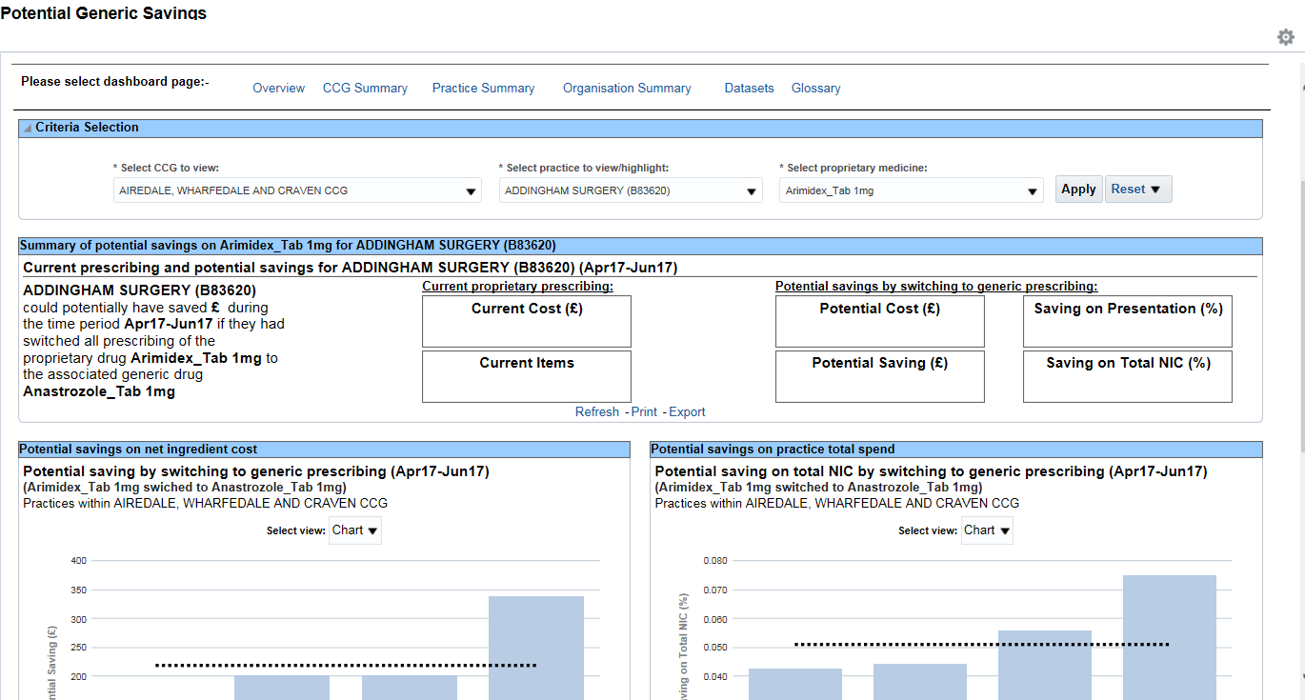
12
13

The ‘Criteria Selection’ pane allows organisation and proprietary medicine selection.
12
13
Once the selections are complete select ‘Apply’ to regenerate the dashboard.

Organisation Summary

14

14
Select the Organisation Summary link.

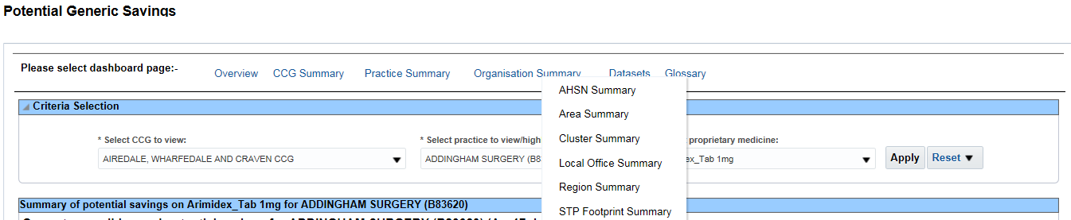
15

Select the organisation level required.
15

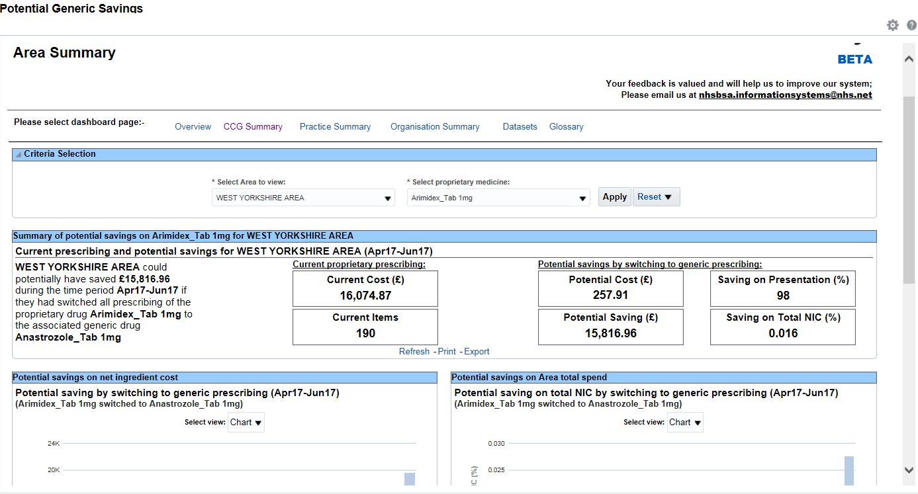
17
16

The ‘Criteria Selection’ pane allows organisation and proprietary medicine selection.
16
17
Once the selections are complete select ‘Apply’ to regenerate the dashboard.

Datasets

18

18
Select the Datasets link.

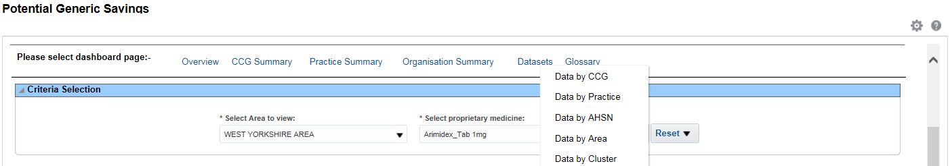
19

19
Select the organisation level required.
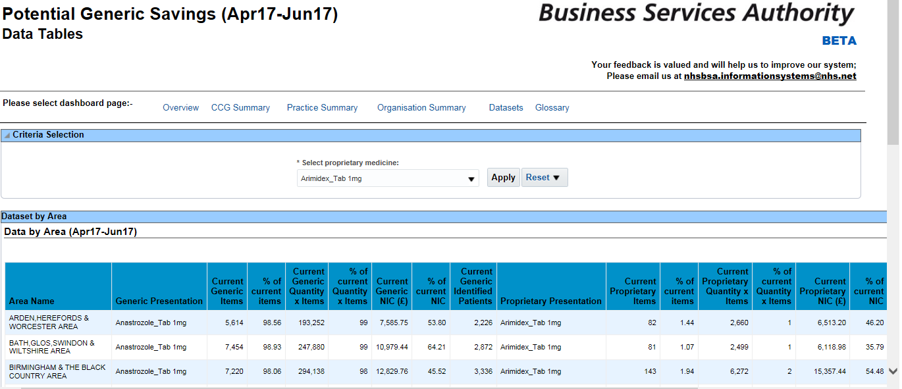
20

The ‘Criteria Selection’ pane allows proprietary medicine selection.
20

Glossary

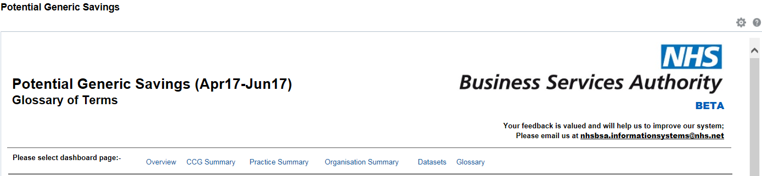
21

21
Select the Glossary link.

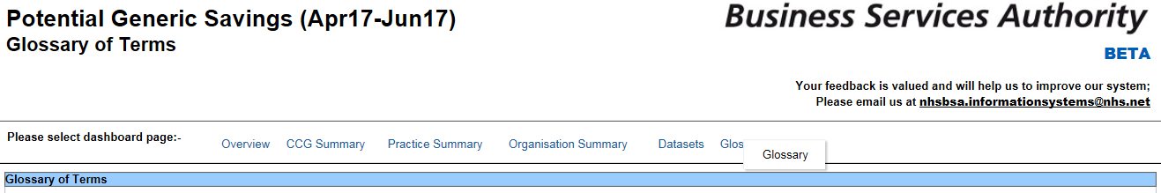
22

22
Select ‘Glossary’.

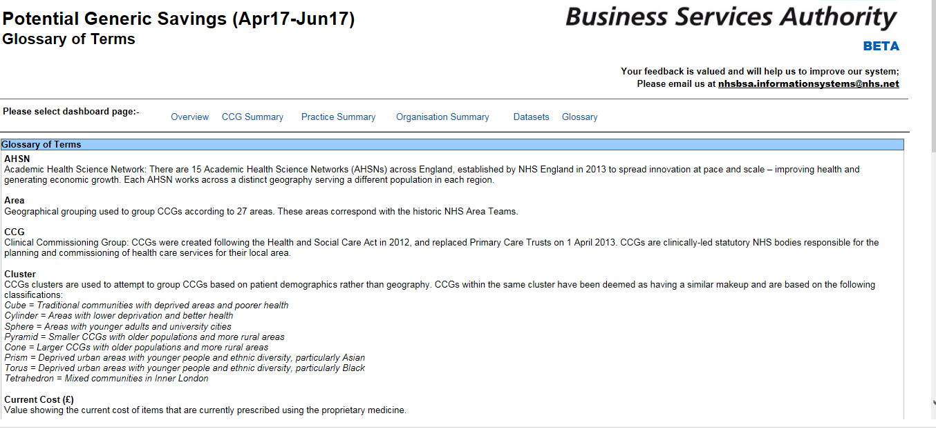
23

Definitions of the terms used within the dashboard will be listed alphabetically.
23

- Data Views

Where applicable, it is possible to change between table and chart views within the dashboard.

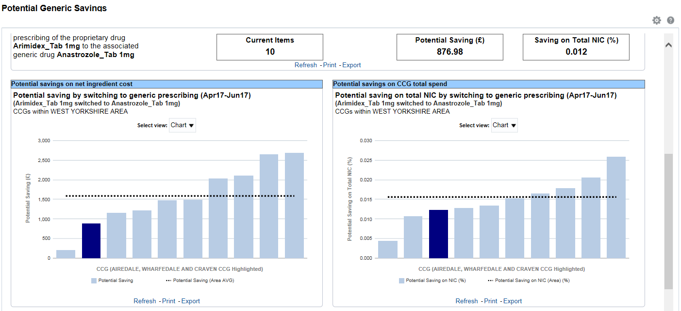
24

Click the ‘Select view’ drop-down arrow to choose between table and chart views.
24

- Exporting the Data

Exporting Individual Analysis

Some component within the Dashboard can be exported individually.

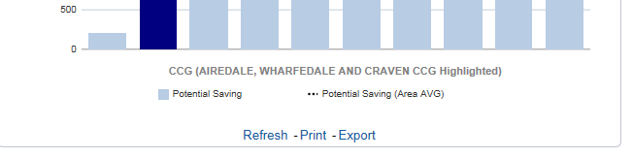
25

25
Select ‘Export’

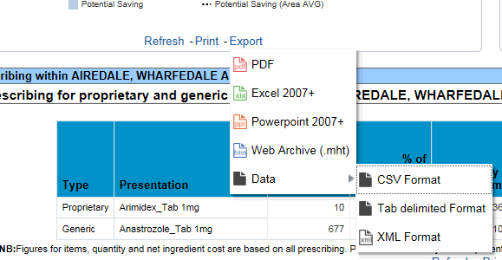
27
26

26
The formats available to export in to will be displayed
27
Additional formats will be listed under the ‘Data’ option

