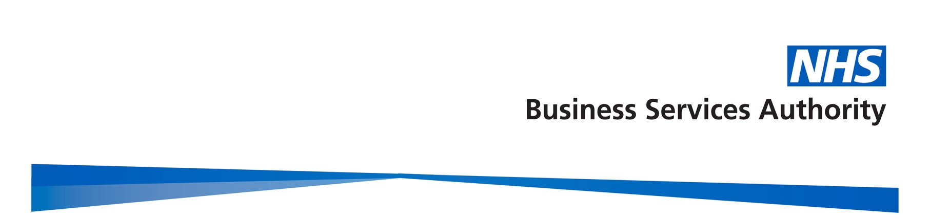

Gender Pay Gap Report

2016/17

Contents
Contents 2
Introduction 2
Gender profile 2
Gender summary of workforce 2
Proportion of males and females in each pay band 2
Proportion of males and females in each pay quartile 2
Gender pay gap in hourly pay 2
Mean gender pay gap in hourly pay 2
Median gender pay gap in hourly pay 2
Bonus gender pay gap 2
Proportion of males and females receiving a bonus payment 2
Mean and median bonus gender pay gap 2
Summary 2
Actions to remove the gender pay gap 2

Introduction

Under the Equality Act 2010 (Specific Duties and Public Authorities) Regulations 2017, schedule 2, the NHSBSA, along with all public bodies with more 250 employees, is required to publish gender pay gap information by 30 March 2018 (and then annually on this date). This includes information on the mean and median gender gaps in hourly pay, the mean and median gender gaps in bonus pay, the proportion of men and women who received bonuses, and the proportions of male and female employees in each pay quartile.

The gender pay gap shows the difference in the average pay between all men and women in a workforce. The gender pay gap is different to equal pay, which deals with the pay differences between men and women who carry out the same or similar jobs, or work of equal value. It is unlawful to pay people unequally because they are a man or a woman.

The NHSBSA supports the fair treatment and reward of all staff irrespective of gender, and our pay framework is based on the principles of consistency, fairness and transparency. We are also committed to a culture that is transparent, diverse, and inclusive for all.

This report fulfils not only our reporting requirements, but sets out what we are doing to address the gender pay gap in our organisation. The data is based on a snapshot of all employees as at 31 March 2017, as this is the date which all public authorities must use each year. The calculations used are those set out in the relevant legislation to ensure the data is calculated consistently across organisations.

Gender profile

Gender summary of workforce

On 31 March 2017, the NHSBSA employed 2,781 staff. The chart below demonstrates the gender profile of the workforce, which shows that we employ more women (57.9%, and 1610 headcount) than men (42.1% and 1171 headcount).
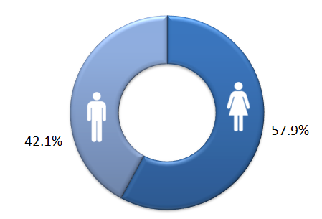

Proportion of males and females in each pay band

The NHSBSA uses NHS Agenda for Change pay bands for the vast majority of staff. Bands vary by levels of responsibility and each band has a set pay range with increments. Colleagues move up the increments in their band on an annual basis so that generally those who have spent longer in the same grade would be expected to earn more, regardless of gender. In addition, we have a small group of staff who are on pay scales other than Agenda for Change. These include; staff on Civil Service grades from when they transferred into the NHSBSA in 2006, a very small number of staff who are on NHS Medical and Dental salary scales, and our most senior staff who receive NHS Executive and Senior Manager salaries.

The two charts on the following page reveal firstly the total headcount of NHSBSA staff within each pay band, and then secondly the percentages of men and women within each pay band. The salary scales other than Agenda for Change as described above are shown as ‘Non-AfC’ on the charts.
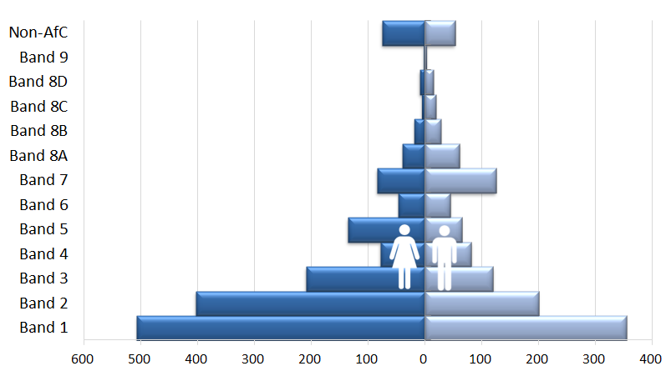

Headcount

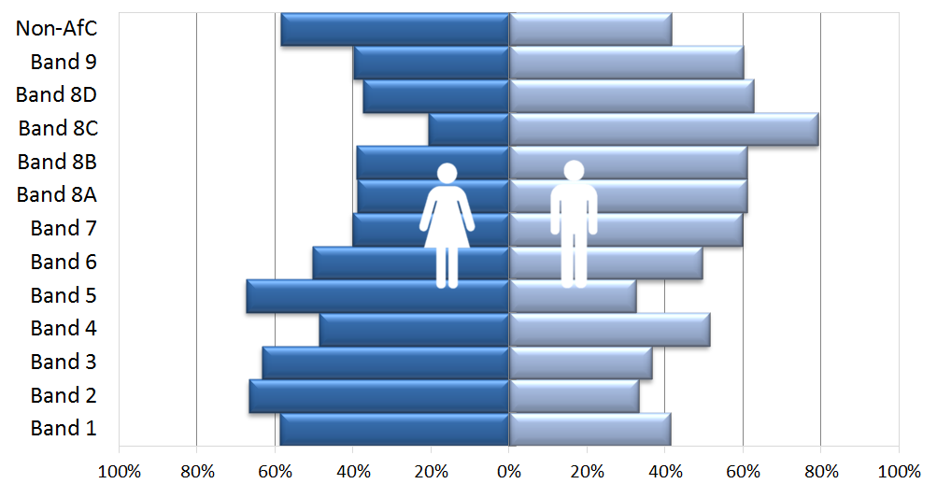
Percentage of staff

The charts reveal that the majority of our staff are concentrated in the lower pay bands (1-3). In addition, these pay bands have significantly higher percentages of female staff, compared to male staff. This gender split is then reversed in the higher pay bands (7 and above).

Proportion of males and females in each pay quartile

The graph below illustrates the gender distribution of the workforce across four equally sized quartiles. The proportion of males and females in each quartile, from the lowest to the highest paid, is calculated by dividing the workforce into four equal parts. It can be seen that the first three quartiles contain a higher percentage of women than men, but this is reversed in the highest quartile. This reflects the analysis by pay band.

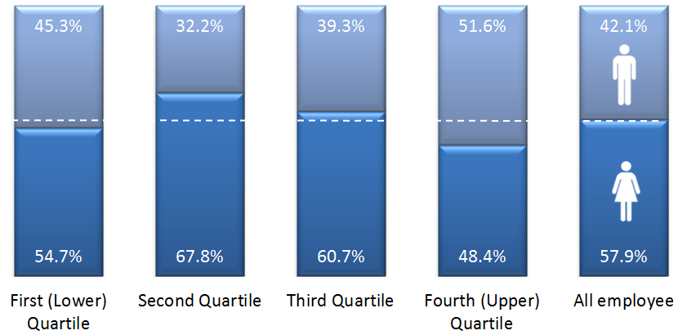

Lowest ← Pay → Highest

Gender pay gap in hourly pay

Mean gender pay gap in hourly pay

The mean, commonly known as the average, is calculated by adding up the wages of all employees and dividing the figure by the total number of employees. The mean gender pay gap is the difference between mean male pay and mean female pay. It can be seen from the chart on the following page that the the mean gender pay gap for hourly pay within the NHSBSA is 15.43%. This difference in hourly pay is influenced by the greater proportion of male staff in the higher pay bands, and in the highest quartile.
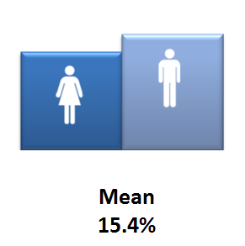

Median gender pay gap in hourly pay

The median is the figure that falls in the middle of a range when the wages of all staff are lined up from the lowest to the highest salary. The median gap is the difference between the employee in the middle of the range of male wages and the middle employee in the range of female wages.

The chart below reveals that there is no median gender pay gap between men and women in the NHSBSA. The median is regarded as typically a more representative figure than the mean, which can be distorted by a handful of highly paid employees.

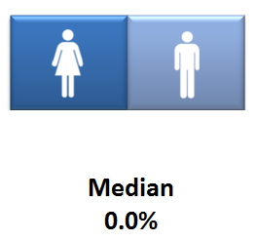

Bonus gender pay gap

The NHSBSA has a performance related bonus paid in only one area of the organisation (NHS Prescription Services) where the bonus is paid for high volume data entry depending on output and accuracy, regardless of gender. The staff roles that qualify for the bonus are in Agenda for Change pay bands 1 and 2 at the lower end of the pay scale.

Proportion of males and females receiving a bonus payment

The chart below demonstrates that 35.3% of total female staff received a bonus in 2016/2017, compared to the 29.6% of total male staff who received a bonus in the same period. This was influenced by the greater proportion of female staff in pay bands 1 and 2, in the roles which qualify for the bonus.

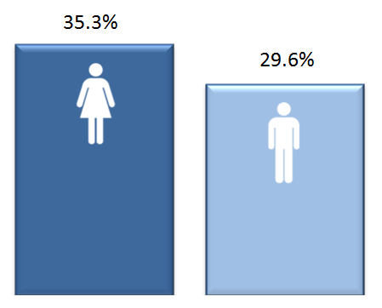

Mean and median bonus gender pay gap

The chart overleaf reveals that there is a 10.5% pay gap between the mean bonus pay of the male and female staff who received the above bonus in the year 2016/17, and a 15.7% bonus pay gap using the median calculation. This shows that although more women than men received a bonus, on average men received a higher bonus amount, which would be linked to achieving higher rates of output and accuracy. The cause of this is not identifiable from the data currently available and therefore we will obtain further insight to explore the reasons for this.

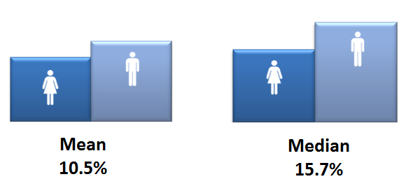

Summary

The table below summarises the various gender pay gap calculations. The NHSBSA does not have a median pay gap. The mean pay gap is 15.4%, as a consequence of a higher proportion of female staff occupying more roles in the lower pay bands, and a greater percentage of male staff occupying more roles in the higher pay bands.

 |  |  | %
Median gender pay gap |  |  | 0%
Mean gender pay gap |  |  | 15.4%
Median bonus gender pay gap |  |  | 15.7%
Mean bonus gender pay gap |  |  | 10.5%
Proportion of male and female employees paid a bonus: |  | Male | 29.6%
 |  | Female | 35.3%
Proportion of male and female employees in each quartile:
Quartile | Female % | Male %
First (lower) quartile | 55% | 45%
Second quartile | 68% | 32%
Third quartile | 61% | 39%
Fourth (upper) quartile | 48% | 52%

Actions to remove the gender pay gap

The NHSBSA is committed to addressing our mean gender pay gap and is undertaking a range of actions to reduce this including:

- Gathering further data and insight to enable us to better understand the causes of the bonus pay gap, and taking action to address this.
- Reviewing our external and internal recruitment and selection process, focusing on attracting more women to apply to more senior roles. We will extend our candidate reach by utilising social media and alternative recruitment platforms to attract a wider and more diverse range of applicants to those roles.
- Identifying and removing any gender bias, including unconscious bias, in the selection methods we use. We will ensure that all interviewers have undergone recruitment training including understanding of unconscious bias, and work towards ensuring that no recruitment panels consist of members of a single gender.
- Supporting all staff to develop their careers and reach their potential through our appraisal and personal development process, promotion of learning and development opportunities and a talent management strategy aimed at retaining staff with potential.
- Implementing a leadership development programme with elements aimed specifically at female staff with potential, to help develop their skills and confidence to progress to senior roles.
- Supporting women returning to work following maternity or adoption leave. We offer shared parental leave and flexible working opportunities for all staff, and are committed to ensuring we have a high return rate from those taking maternity or adoption leave. We will actively encourage flexible working at every level of the organisation to ensure that all our people, irrespective of gender, have the opportunity to work in a way that supports their career aspirations and home life balance.
- Ensuring that gender equality is a key part of our Diversity and Inclusion Strategy, and engaging with staff on these issues through our Diversity and Inclusion Network and Committee, to understand any additional barriers women may face in the workplace.

