**ePACT2 guide**

**Using an analysis to show the ‘top 10’ presentations for each cost centre within a specific Commissioner / Provider based on prescribing or cost**

|  |  |  |  |  |  |  |  |  |  |  |  |  |  |  |  |  |  |  |  |  |  |  |  |  |  |  |  |  |  |  |  |  |  |  |  |  |  |  |  |  |
| --- | --- | --- | --- | --- | --- | --- | --- | --- | --- | --- | --- | --- | --- | --- | --- | --- | --- | --- | --- | --- | --- | --- | --- | --- | --- | --- | --- | --- | --- | --- | --- | --- | --- | --- | --- | --- | --- | --- | --- | --- |
| **Contents**   |  |  |  |  | | --- | --- | --- | --- | | 1. | Getting started |  | page 2 | | 2. | **Create a basic analysis** – to show the number of ‘Items’ and ‘Actual Cost’ for all ‘Cost Centres’ for all months available |  | page 2 | | 3. | **Filtering** – to show the number of ‘Items’ and ‘Actual Cost’ for all ‘Cost Centres’ within a Commissioner / Provider for the ‘Month’ selected |  | page 5 | |  | Limit results to a specific time period |  | page 5 | |  | Limit results to a specific Commissioner / Provider |  | page 8 | | 4. | **Filtering** – to show the top 10 presentation for each ‘Cost Centres’ in the selected Commissioner / Provider for the ‘Month’ selected by ‘Items’. |  | page 9 | |  | Limit results to top 10 presentations by cost |  | page 12 | | 5. | Run the analysis |  | page 12 | | 6. | Save the analysis |  | Page 13 | |  |  |  |  | |

**1. Getting started**

## Log in to ePACT2.

This will open the homepage.

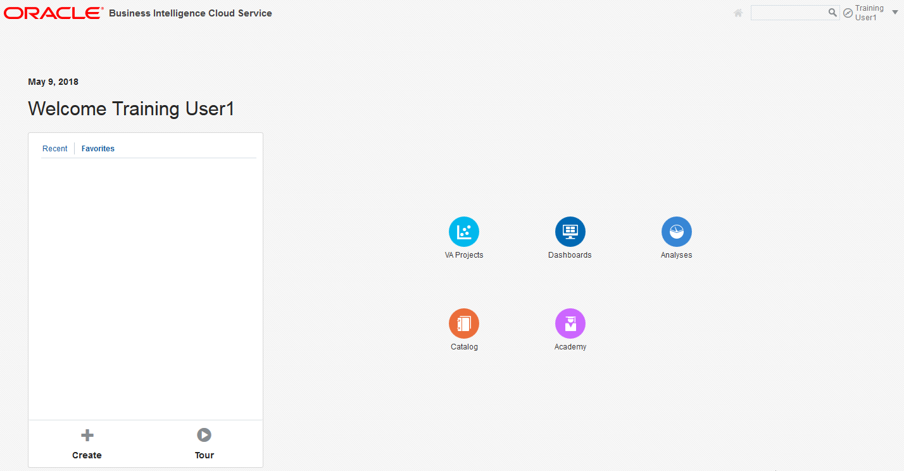

**2. Create a basic analysis**



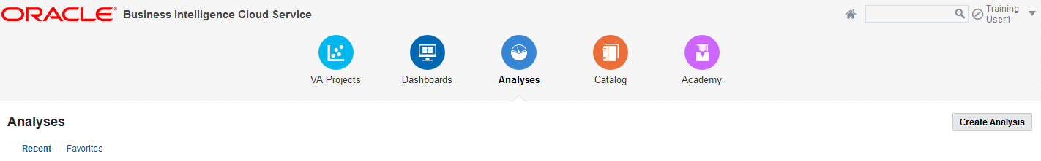

Select ‘New.’

Select ‘Analysis’ from the drop down list.

The ‘Select Subject Area’ pane will appear.

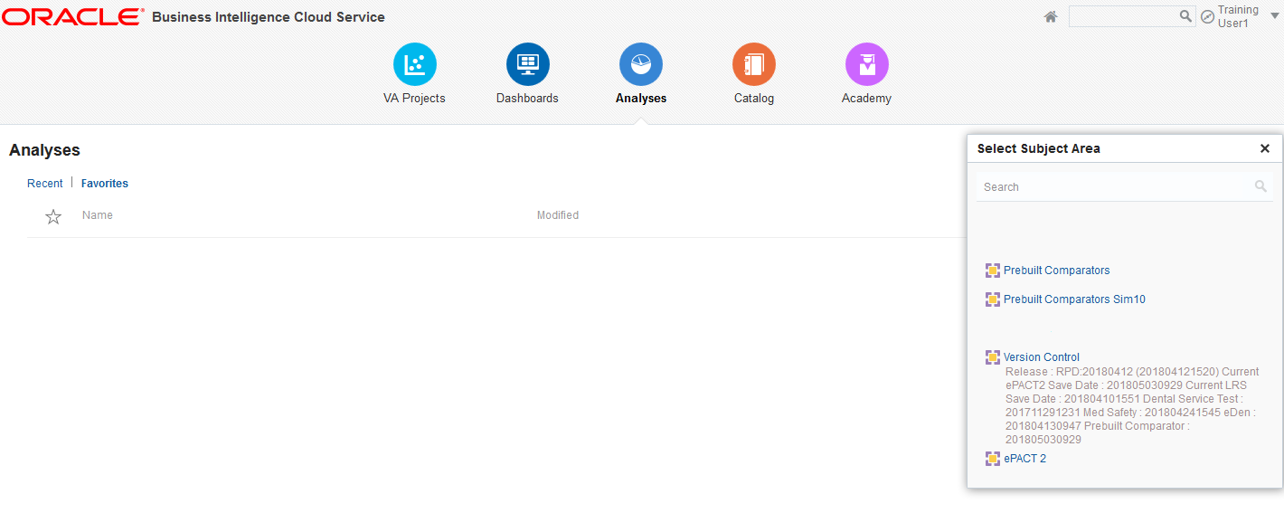

Select your required Subject Area.

The ‘Analysis Builder’ will open.

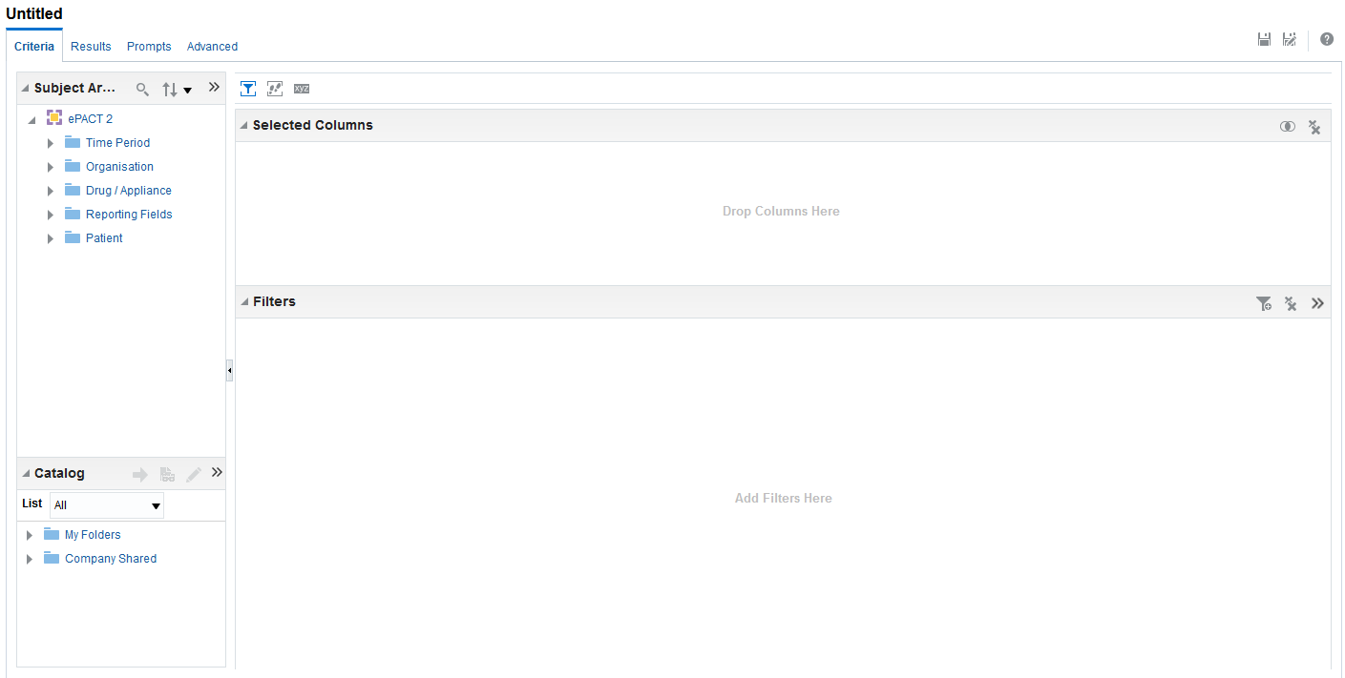

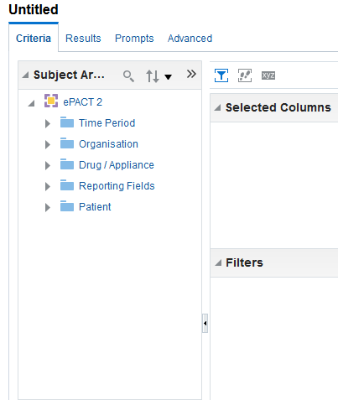 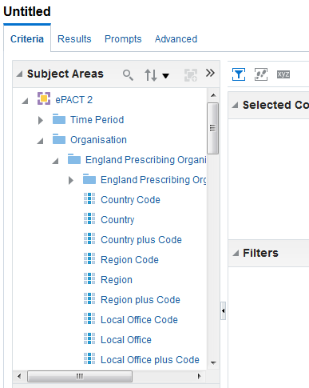

The available dimensions/facts are listed in the ‘Subject Areas’ pane.

Expand any dimension/fact by clicking the arrow icon next to it.

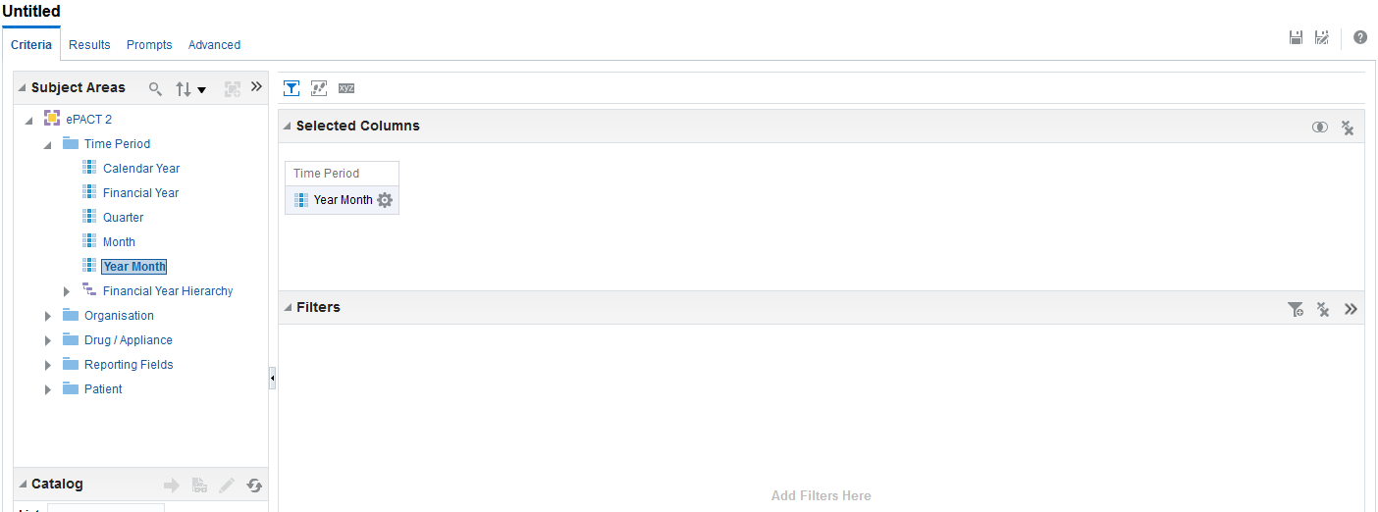

To select a field, either ‘double click’ on the required field or ‘click and drag’ the field into the ‘Selected Columns’ pane.

Once selected the fields will appear in the ‘Selected Columns’ pane.

You should then select the fields for ‘Time Period’, ‘Organisation’ and ‘Reporting Fields’.

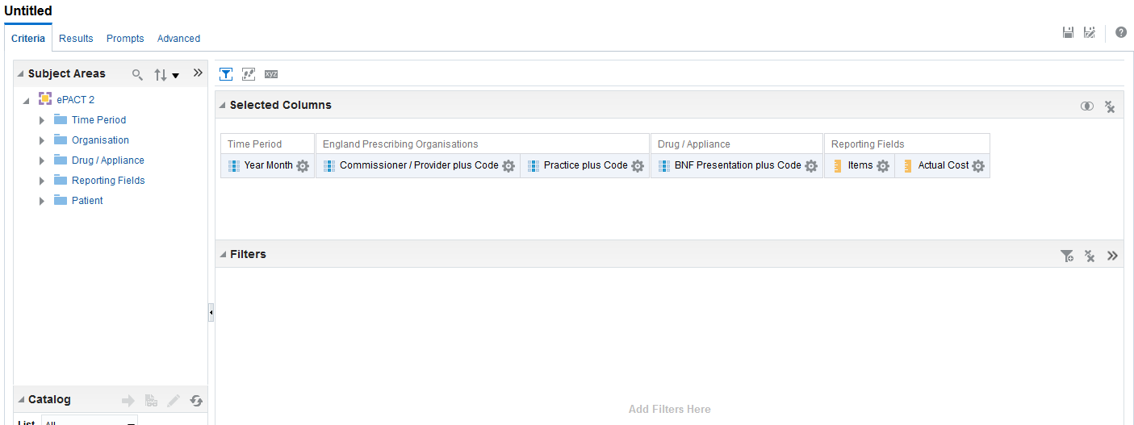

**3. Filtering – to show the number of ‘Items’ and ‘Actual Cost’ for all ‘Cost Centres’ in the selected Commissioner / Provider for the ‘Month’ selected**

This section shows how to apply filters to a basic analysis.

**Add filter – to limit the results to a specific time period**

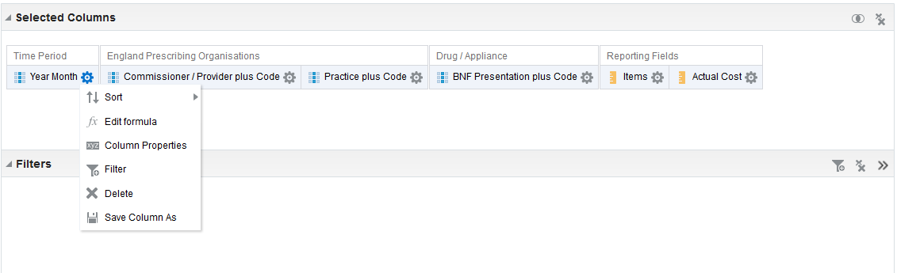

In the ‘Selected Columns’ pane, click on the cog icon under ‘Time Period’.

Select ‘Filter’ from the drop down list.

The ‘New Filter’ pane will appear.

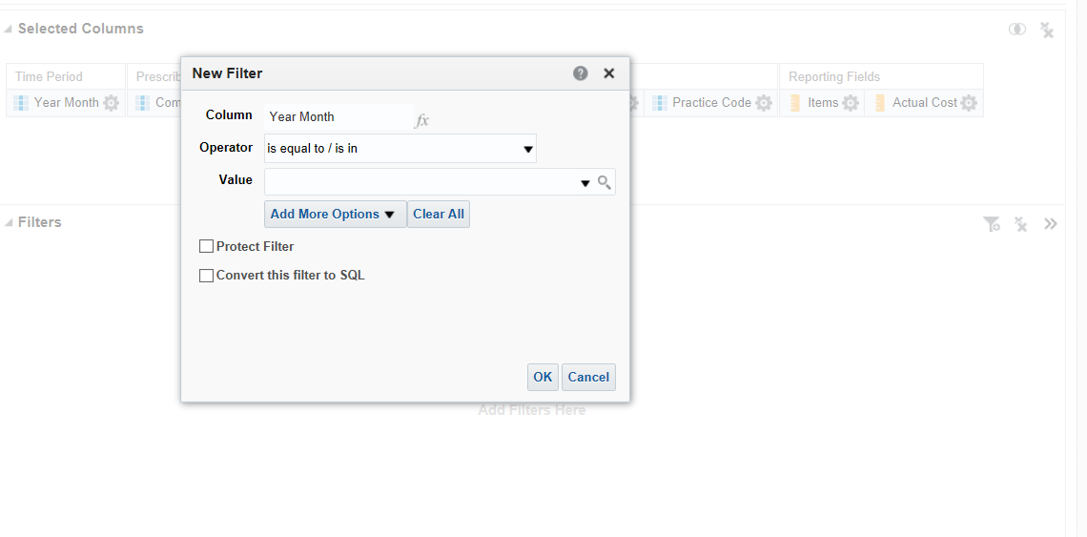

‘Operator’ will default to ‘is equal to / is in’.

Click the search icon to show the ‘Values’ available to filter by.

A ‘Select Values’ pane will appear.

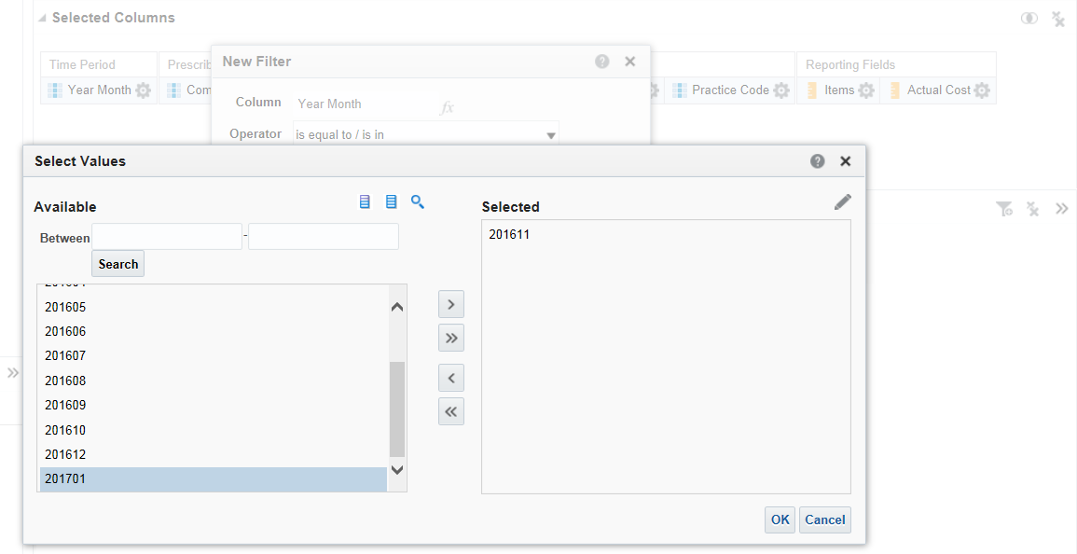

Highlight the values required, multiple values can be selected by holding the ‘Ctrl’ button while selecting.

Once the values required have been selected use the > arrow icon to select the value.

The value will appear in the ‘Selected’ pane.

Click ‘OK’ to confirm the selection.

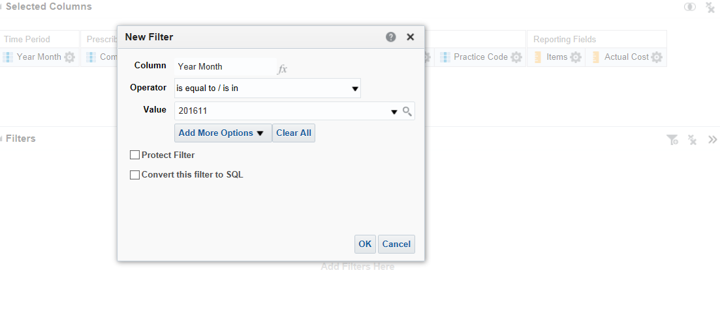

The ‘Value’ will display the month selected.

Select ‘OK’ to confirm the selection.

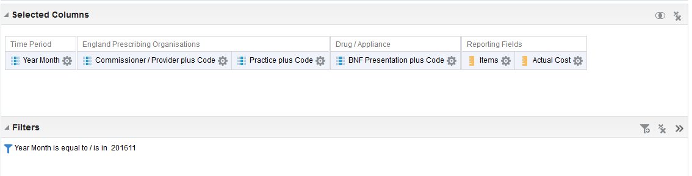

The filter will now appear in the ‘Filter’ pane.

**Add filter – to limit the results to a specific Commissioner / Provider**

To add a ‘Commissioner / Provider’ filter, repeat the same process as for ‘Time Period’.

This time select ‘Organisation’ by clicking the arrow icon next to it. Make your selection within ‘England Prescribing Organisations’.

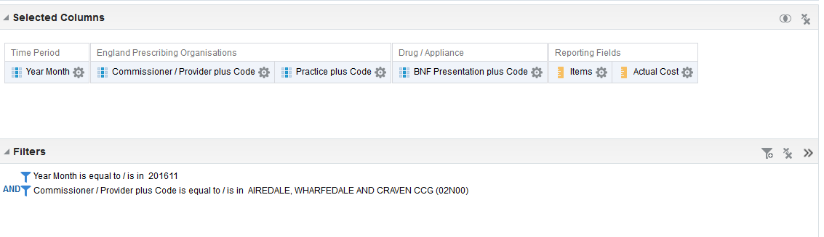

The additional filter will be shown within the ‘Filter’ pane.

|  |
| --- |
| When generated this report will now show the number of ‘Items’ and ‘Actual Cost’ for all ‘Cost Centres’ in the selected Commissioner / Provider for the ‘Month’ selected. |

**4. Filtering – to show the top 10 presentations by number of ‘Items’ and ‘Actual Cost’ for each ‘Cost Centres’ in the selected Commissioner / Provider for the ‘Month’ selected**

Create a basic analysis (see page 2) then add an extra filter to show the top 10 cost centres for either ‘Items’ or ‘Cost’ for each cost centre.

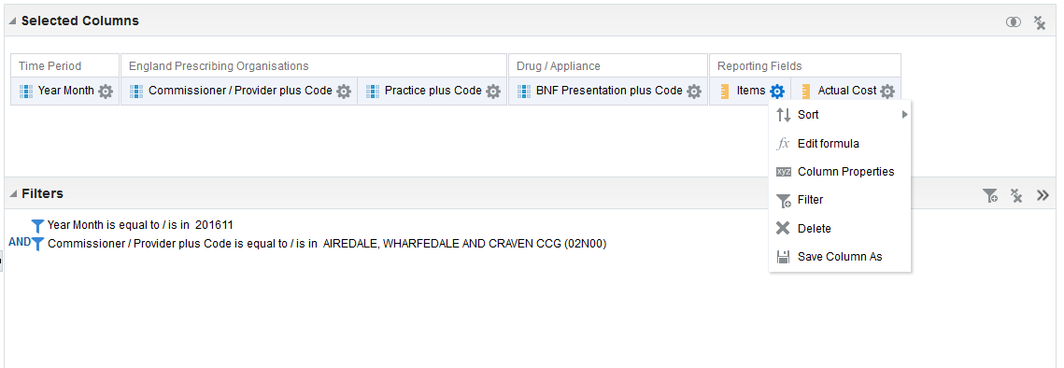

In the ‘Selected Columns’ pane, click on the cog icon below ‘Reporting Fields’.

Select ‘Filter’ from the drop down list.

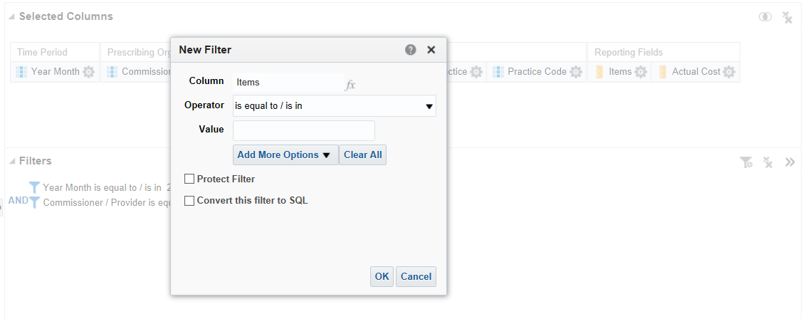

‘Operator’ will default to ‘is equal to / is in’. The value can be changed.

Click the down arrow to expand the ‘Operator’ pane.

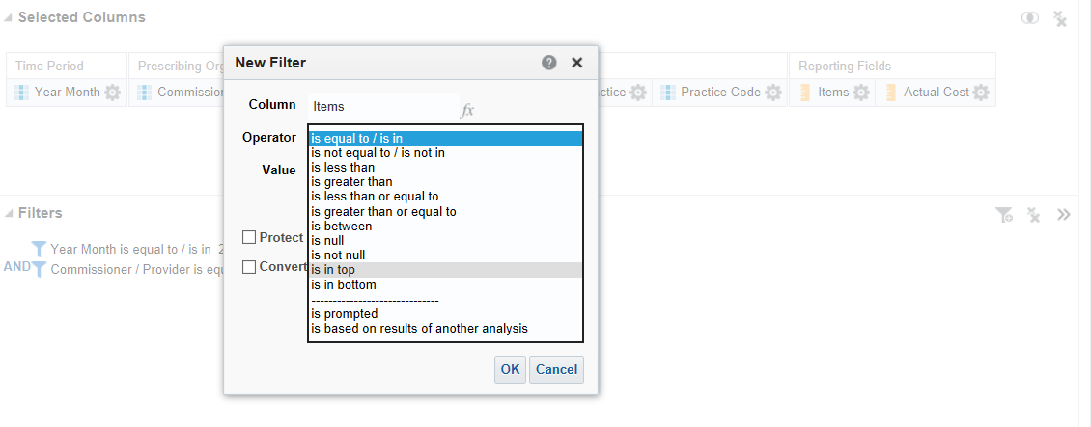

‘Operator’ will expand to show all available options.

Select ‘Operator’ as ‘is in top’.

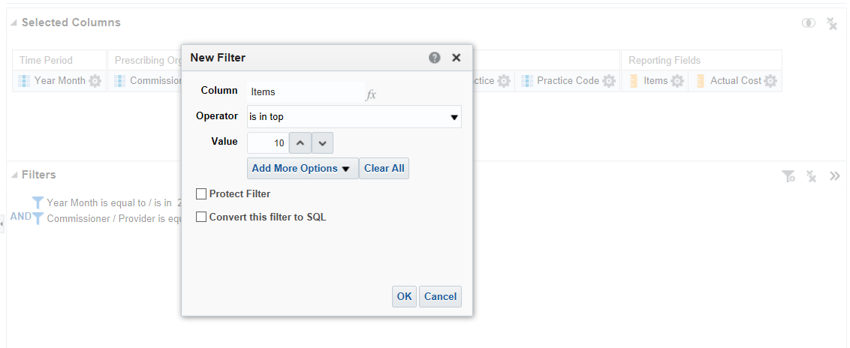

‘Operator’ will now show as ‘is in top’.

‘Value’ field will default to ‘10’. The value can be changed by either typing a new value or by using the arrow icons to the right of the ‘Value’ pane.

Check the box for ‘Convert this filter to SQL’

Select ‘OK’ to confirm selection.

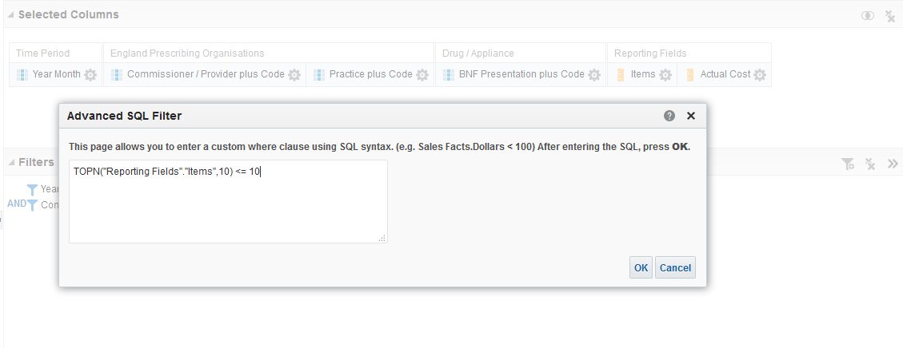

The ‘Advanced SQL Filter’ pane will be displayed.

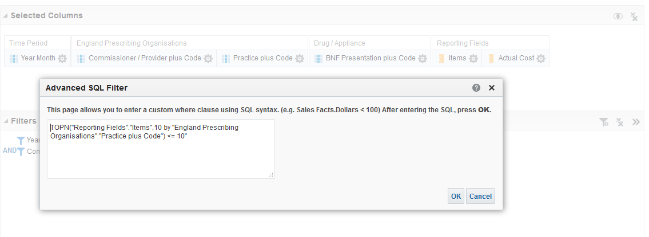

Amend the SQL shown to include a ‘By Clause’, an example of the by clause is provided below.

*TOPN("Reporting Fields"."Items",10 by "England Prescribing Organisations"."Practice plus Code") <= 10*

Click ‘Ok’ to confirm selection.

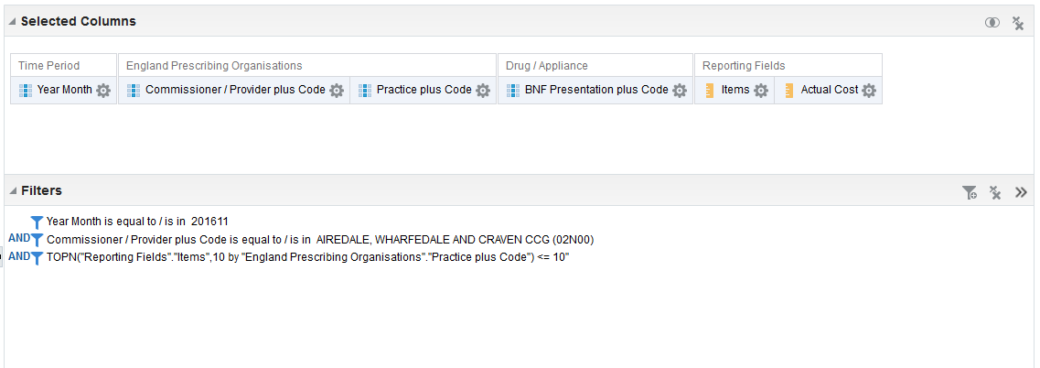

The filter will now appear in the ‘Filter’ pane.

|  |
| --- |
| When generated this report will now show the top 10 presentations by number of ‘Items’ or ‘Actual Cost’ for the ‘Month’ selected for each cost centre within the Commissioner / Provider selected. |

**Add filter – to limit results to top 10 presentations for each cost centres by ‘Cost’**

To show the top 10 cost centres by ‘Cost’, the ‘is in top’ filter should be added to the ‘Actual Cost’ field rather than the ‘Items’ field.

**5. Run the analysis**

Once the criteria selection has been completed the results can be checked by selecting the ‘Results’ tab.

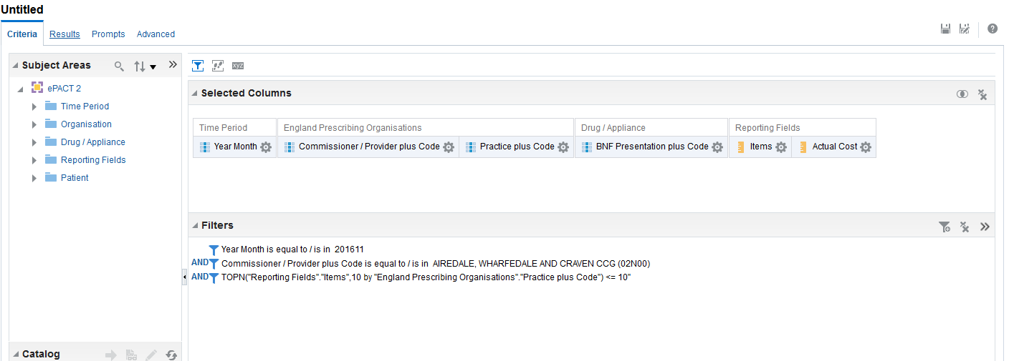

Select the ‘Results’ tab to run the analysis.

The results will be displayed in the default Table view.

**6. Save the analysis**



To save the analysis click the ‘Save As’ icon.

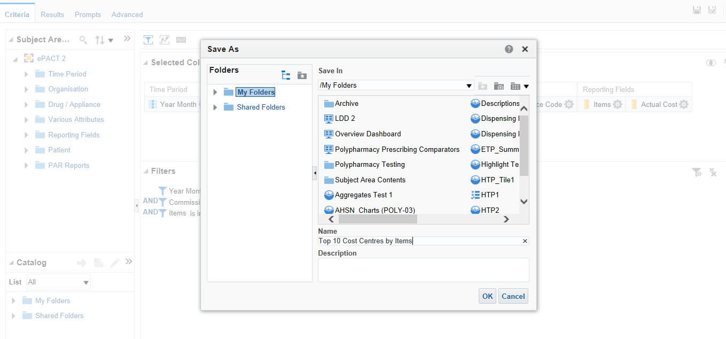

Select the ‘Folder’ the analysis is to be saved in.

Give the analysis an appropriate name.

Select ‘OK’ to save the analysis.