ePACT2 Guide
Aggregating Actual Cost to CCG or National Level

How To

If you would like to get the aggregated figure for Actual Cost for your CCG use this formula –

AGGREGATE("Reporting Fields"."Actual Cost" AT "England Prescribing Organisations"."Prescribing Organisation"."Commissioner / Provider Level")

If you would like to get the aggregated figure for Actual Cost to a National level use this formula -

AGGREGATE("Reporting Fields"."Actual Cost" AT "England Prescribing Organisations"."Prescribing Organisation"."Country Level")

If you would like to include this data in your analysis you first need to include an additional Actual Cost Column in you analysis, and follow the below steps:

Step 1: Hover over the Cog Icon on the column and select the Edit formula option
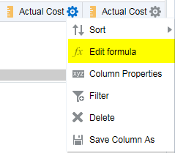

Step 2: Delete the current formula.
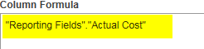
Step 3: Copy the formula from this document and paste into the Column Formula pane.
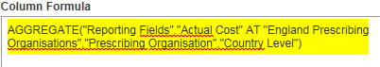
Step 4: Give the column an appropriate name by selecting the ‘Custom Heading’ box and editing the ‘Column Heading’.
An example of what you could create can be seen below:
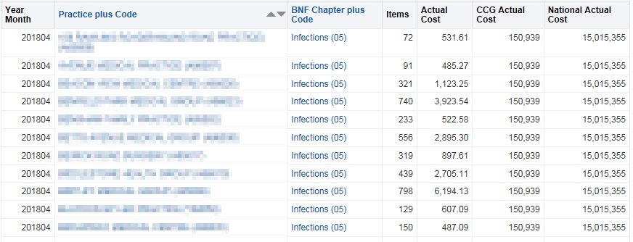

Getting Help

Additional training material and user guides
The NHSBSA has developed a number of how to guides to help you get the best out of ePACT2. These can be found at https://www.nhsbsa.nhs.uk/epact/epact2.
WebEx sessions
WebEx will be provided on a number of different topics and features. More information about these can be found here https://www.nhsbsa.nhs.uk/epact/epact2.

