**ePACT2**

Participants Guide



Contents

Session 1 1

Practice 1: Logging into ePACT2, exploring the home page and accessing and navigating dashboards 1

Session 2 – Creating Analysis – Part 1 5

Practice 1: Creating a basic analysis 5

Practice 2: Creating an analysis to show Ibuprofen & Naproxen as a percentage of all NSAIDs 8

Session 2 – Creating Analysis – Part 2 19

Practice 1: Creating an analysis to show the number of identified patients split by age band receiving an item under a BNF Chemical Substance 19

Practice 2: Creating an analysis to show Actual Cost per ASTRO PU for the practices within a CCG. 22

Practice 3: Using ‘Selection Steps’ to show the number of items and actual cost for a CCG, the practices registered under the CCG and groups of selected practices. 32

Session - 3 - Creating, saving and using saved filters 40

Practice 1: Creating and using saved filters 40

Practice 2: Re-creating ePACT tags as a saved filter 43

Session 4 - Adding data visualisations to an analysis 49

Practice 1: Adding data visualisations to an analysis 49

Getting Help 53

# Session 1

### Practice 1: Logging into ePACT2, exploring the home page and accessing and navigating dashboards

**Goal**

In this scenario you will learn how to access ePACT2, explore the various elements of the home page and access and navigate a dashboard.

**Time**

0 -15 minutes

**Task**

You will learn how to access ePACT2 from the NHSBSA website and how to login to the system. You will then explore the various elements of the home page before accessing and navigating a dashboard created by the NHSBSA.

**1. Accessing ePACT2 and logging**

1. Access the ePACT2 login page here <https://bi2-a437212.analytics.em3.oraclecloud.com/analytics/>
2. On the sign in screen for ePACT2, enter your user ID and password and click ‘Sign In’.
3. Under the ‘My Oracle Services’ heading select ‘Oracle Business Intelligence Cloud Service’. The home page will be displayed.

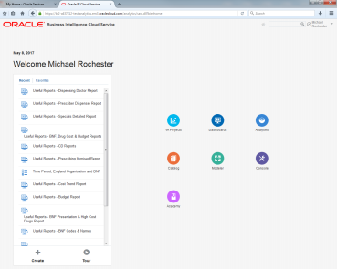

**2. Explore the ePACT2 home page**

1. Click the dashboards bubble to view a list of available dashboards.
2. Pick a dashboard to favourite by clicking the star next to it. We’ll look at how to access favourites later 
3. Click the home button in the top right hand corner to go back to the home page 
4. Click the catalogue bubble to explore the whole ePACT2 catalogue. The ePACT2 catalogue behaves like a file manager and is where content can be moved, renamed and deleted (depending on access privileges). All users will have access to ‘My Folders’ and is where you can save content for your own use. All users can see the contents of the ‘Company Shared’ folder but only some users can edit the contents of these folders. ePACT2 master users will be able to save content in the ‘ePACT2 Customer Templates’ folder. This allows master users to create analyses, dashboards and filters that all staff can then access and use. Users can copy content from the shared folder and save it in their own personal folder if they wish to edit it. After exploring the available folders, click the home button to return to the home page.
5. The ‘Academy’ bubble will direct you to an online learning environment where you can view Oracle made training materials (YouTube videos). Click the home button to return to the home page.
6. Your most recently accessed content can be seen under the ‘Recent’ heading on the left hand pane. Click ‘Favourites’ to see the dashboard you had previously added to your favourites list

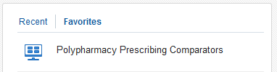

1. Click the down arrow next to your login name in the top right hand corner and select ‘My Account’. Explore the ‘My Account’ settings. Note that you can set a particular dashboard to be your starting page when you first login to the system. Close the ‘My Account’ window once done.
2. Click the down arrow next to your login name and select ‘Sign Out’ to log out of ePACT2. Click ‘Confirm’ to sign out. You will be taken back to the sign in screen, sign back into the system.

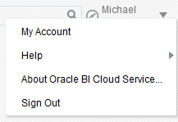

**3. Accessing and navigating the Polypharmacy Prescribing Comparators**

1. Click the dashboards menu from the ePACT2 home page and select ‘Polypharmacy Prescribing Comparators’. The comparators will open to the first page.
2. Dashboards are navigated by means of pages. The various pages can be accessed by using the menu along the top of the dashboard.

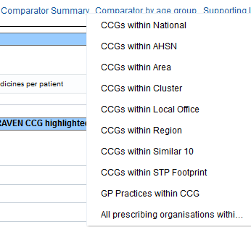

1. Dashboards can also include prompts which permit the user to make selections for a number of pre-defined parameters. Selections made in those prompts will determine the data that is displayed. After making a selection, click the ‘Apply’ button to apply the selections made to the dashboard page.



1. Using the prompts on the Polypharmacy Prescribing Comparators: Comparator Summary – (CCG v National) page, find out the average number of unique medicines per patient for the latest month for your CCG (or a selected CCG).
2. Using the same page, find the percentage of patients with an anticholinergic burden score of 12 or more aged 85 or over in your CCG in February 2017.
3. Open the ‘CCGs within Area’ page from the ‘Comparator by age group’ option in the dashboard menu bar.
4. View the average number of unique medicines per patient in your CCG in November 2016 for each of the patient age groupings and see how this compares to other CCGs within the same NHS England Area.
5. Spend some time to explore the other dashboard pages using the prompts to make different selections.

# Session 2 – Creating Analysis – Part 1

### Practice 1: Creating a basic analysis

**Goal**

In this scenario you will learn how to create a basic analysis to view the number of items and actual cost for practices within your organisation for a specified BNF chemical substance.

**Time**

15-30 minutes

**Task**

You will learn how to create a basic analysis by adding columns to a report and applying filters to narrow the data down to what is required. You will then view the data in tabular format.

1. **Create a new analysis using ePACT2 as the subject area**
2. Login to ePACT2 using your supplied login credentials.
3. From the home page, click ‘+ Create’ followed by ‘Analysis’. Select ePACT 2 as your subject area.

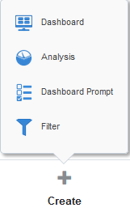**🡪**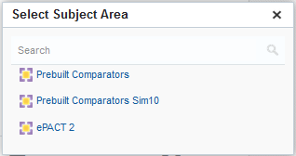

1. The analysis editor will be displayed. From the ePACT 2 subject area, expand the time period tree and double click the ‘Year Month’ column. You will notice that the ‘Year Month’ column appears in the selected columns pane.

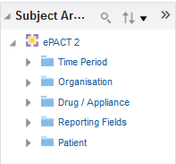

1. Add the following additional columns to your analysis:



1. At this point, if you click the ‘Results’ tab, the results returned would be for all time periods and all organisations within the system, which would be a very large amount of data. As such, before viewing the results continue to the next step to filter the data
2. **Filter the analysis to show data for a specific time period, organisation and BNF chemical substance**
3. To show data for specific criteria, filters need to be applied to narrow down the results returned.
4. Click the cog icon on the ‘Year Month’ column and select ‘Filter’.

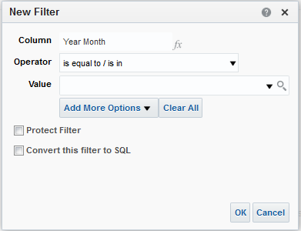

1. Notice the different operators available. Leave the selection as ‘is equal to/is in’.
2. Click the down arrow in the value field and select the latest month available. Click OK to dismiss the ‘New Filter’ window.
3. Click the cog icon on the ‘BNF Chemical Substance plus Code’ column and select ‘Filter’. Click the magnifying glass icon to bring up the search window:

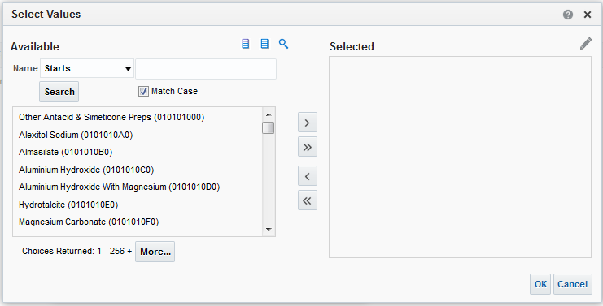

1. For this analysis we want to know the number of items and actual cost for items at BNF chemical substance level with ‘Paracetamol’ in the name. Change the ‘Starts’ drop-down box to ‘Contains’. Type ‘Paracetamol’ in the search box and untick the ‘Match Case’ box. Click ‘Search’. A list of BNF chemical substances with ‘Paracetamol’ in the name will be displayed:

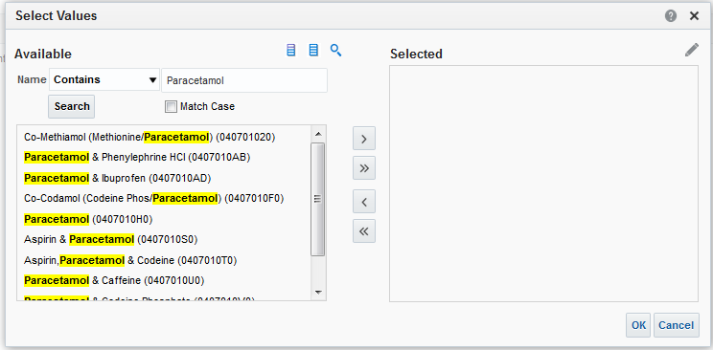

1. Click the double right arrows to move all items into the ‘Selected’ section. Click ‘OK’ followed by ‘OK’ again.
2. We now need to add a filter so that only data for your organisation’s practices is returned. You will note that because we have not included the ‘Commissioner/Provider’ column in our analysis, there is no cog icon to click to add this filter. Instead, click the ‘Create a filter for the current Subject Area’ icon to the right of the ‘Filters’ heading:



1. Click ‘More Columns…’ and then from the ‘Organisation – England Prescribing Organisations’ hierarchy, select the ‘Commissioner/Provider plus Code’ column and click ‘OK’.
2. Using the magnifying glass option as detailed above when searching for BNF chemical substances, search for and select your CCG. Click ‘OK’ twice to add your organisation filter. Your analysis builder should look something like this:

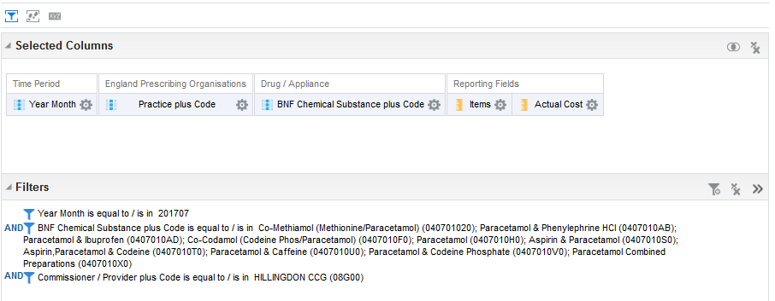

1. Click the ‘Results’ tab. Your data will be displayed

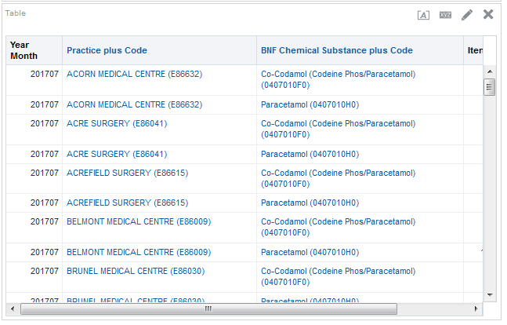

1. Save your analysis as ‘Paracetamol Items and Actual Cost by Practice’ by clicking the ‘Save As’ icon near the top right hand side of the screen. Make sure you save your analysis in your own folder.



### Practice 2: Creating an analysis to show Ibuprofen & Naproxen as a percentage of all NSAIDs

**Goal**

In this scenario you will learn how to create an analysis to show Ibuprofen & Naproxen items as a percentage of all NSAID items at practice level within your organisation.

**Time**

15-30 minutes

**Task**

You will learn how to create an analysis by adding columns to a report, apply filters to narrow the data down to what is required and to edit the columns selected to show information for selected items and include calculations. You will then view the data in tabular format.

1. **Create a new analysis using ePACT2 as the subject area**
2. Login to ePACT2 using your supplied login credentials.
3. From the home page, click ‘+ Create’ followed by ‘Analysis’. Select ePACT 2 as your subject area.

🡪

1. Add the following additional columns to your analysis: Please note the ‘Items’ column should be included 3 times.

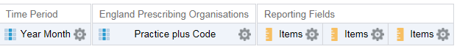

1. Filter the analysis to show data for a specific time period.
2. To show data for specific criteria, filters need to be applied to narrow down the results returned.
3. Click the cog icon on the ‘Year Month’ column and select ‘Filter’.
4. Leave the operator selection as ‘is equal to/is in’.
5. Click the down arrow in the value field and select the latest month available. Click OK to dismiss the ‘New Filter’ window.
6. Filter the analysis using a column not shown in the analysis
7. In the filters pane, click the ‘Create a filter for the current Subject Area
8. Select ‘More Columns…’ and browse to and select ‘Commissioner / Provider plus code’ from the tree and click OK. Leave the operator as ‘is equal to/is in’ and set the value to your CCG. Click OK.
9. Check your work, the CCG shown will vary depending on the CCG selected.

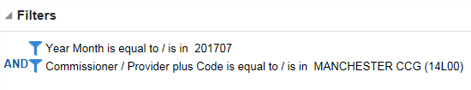

1. Save your analysis as ‘Ibuprofen & Naproxen as a % of all NSAIDs’ in ‘My Folders’ using the ‘Save Analysis’ or ‘Save As’ buttons .
2. **Editing a column to show results for a specific set of drugs.**
3. Click the cog icon on the first ‘Item’ column and select ‘Edit Formula’.
4. The ‘Edit Column Formula’ pane will be displayed.

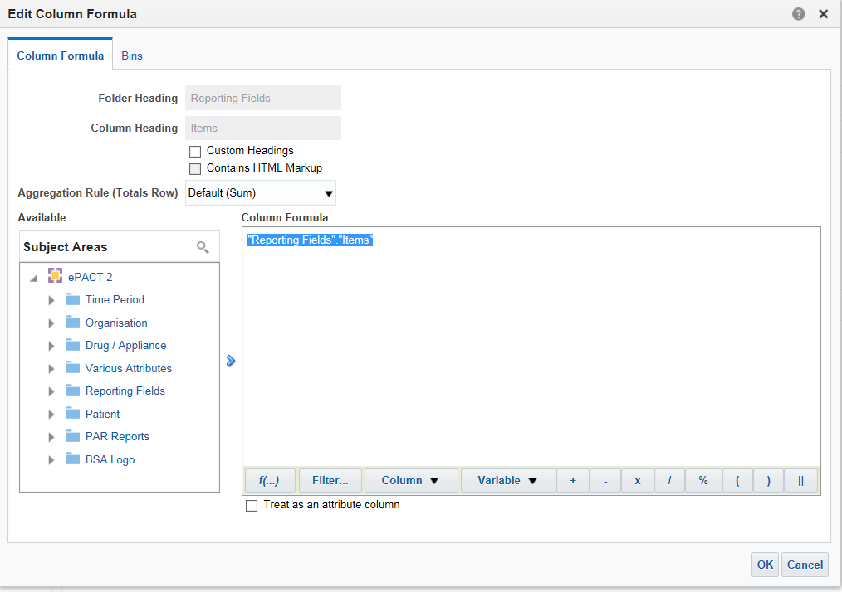

1. Ensuring that all the text within the ‘Column Formula’ box is highlighted, select ‘Filter’ from the task bar at the bottom of the ‘Column Formula’ pane. The ‘Insert Filter’ pane will appear.

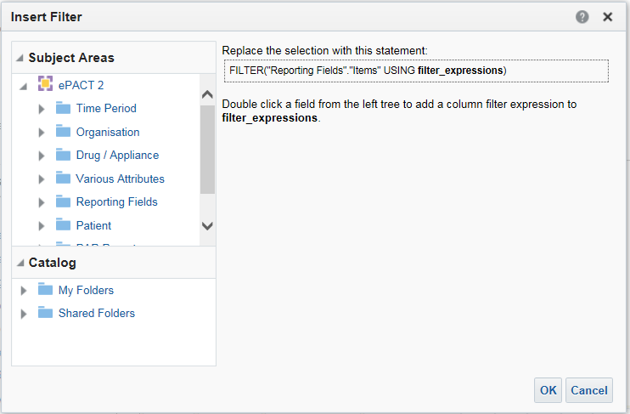

1. Expand the ‘Drug /Appliance’ folder in the ‘Subject Area’ tree and double click ‘BNF Chemical Substance plus code’. The ‘New Filter’ pane will be displayed.

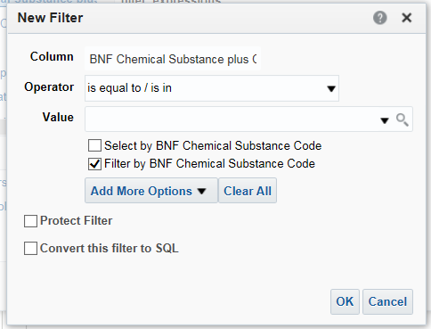

1. Click the magnifying glass icon to bring up the search window. Ensuring the ‘Match Case’ option is not selected and the operator is changed to ‘Contains’ search for and select the items shown below. Click ‘OK’ followed by ‘OK’ again.

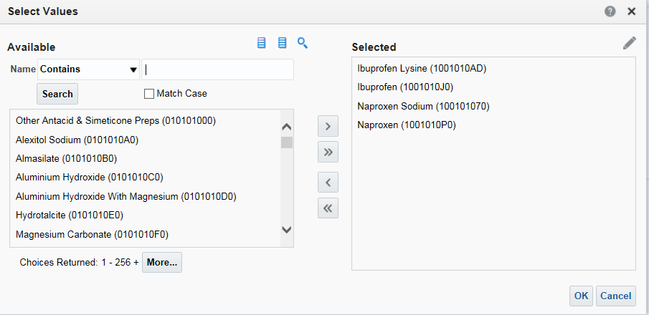

1. The ‘Insert Filter’ pane will now be populated with the items selected as below. Click ‘OK’.

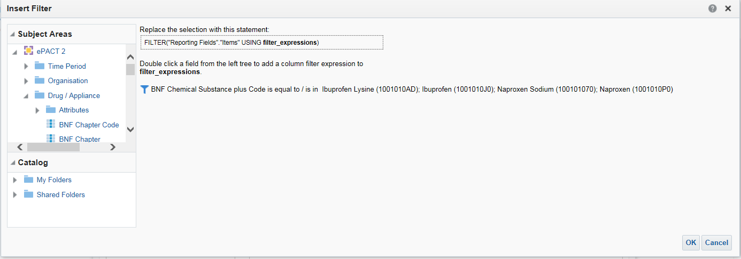

1. The ‘Column Formula’ will be updated to include the filter added as below.

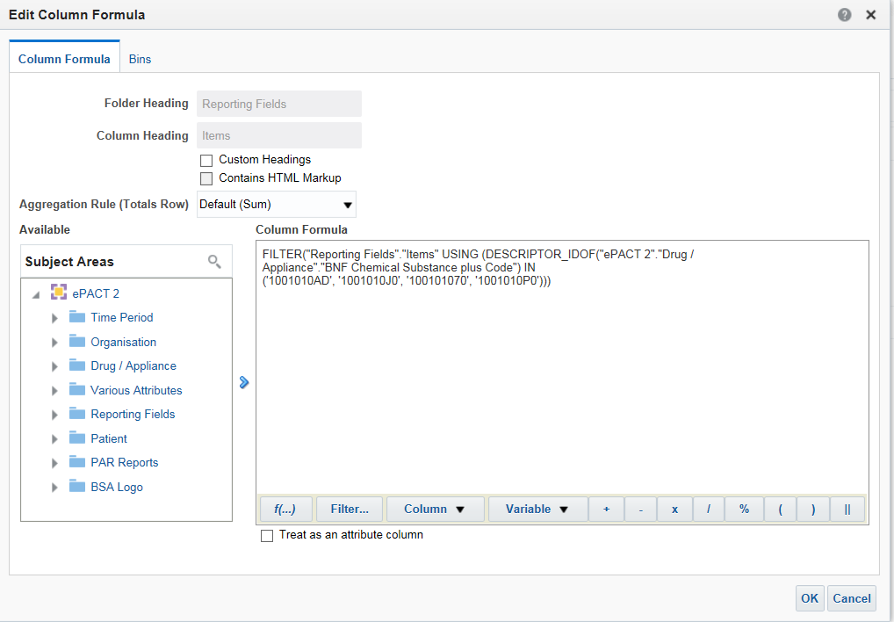

1. Tick the option for ‘Custom Headings’ and amend the name of the column to ‘Ibuprofen & Naproxen Items’ as below. Click ‘OK’.

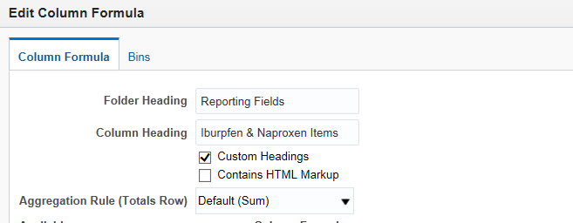

1. The columns displayed in the ‘Selected Columns’ pane will be updated to show the amended column as below.

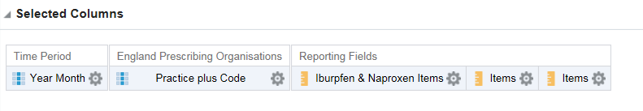

1. Following the process above edit the formula for the second ‘Items’ column to filter the column by ‘BNF Paragraph plus code’ for the BNF Paragraph – Non-Steroidal Anti-Inflammatory Drugs (100101). Amend the column heading to ‘NSAID Items’ and click ‘OK’. The results should match the example shown below.

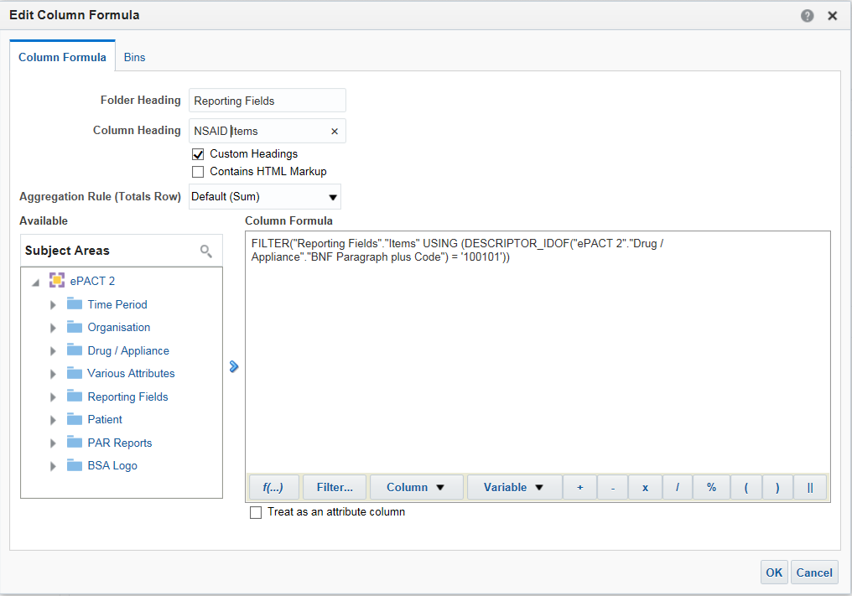

1. Click ‘OK’. Your selected criteria should look as below:

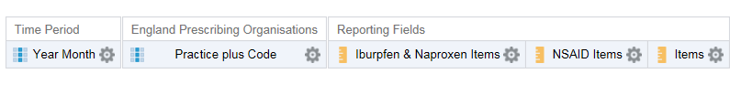

1. Save your analysis using the ‘Save Analysis’ button, overwriting the previous saved analysis.
2. **Editing a column to include a calculation.**
3. Click the cog icon on the third ‘Item’ column and select ‘Edit Formula’.
4. The ‘Edit Column Formula’ pane will be displayed.
5. Delete the contents of the ‘Column Formula’ pane and then click ‘Column’ followed by ‘Ibuprofen & Naproxen Items’. Note the formula used to create the Ibuprofen & Naproxen Items column is pasted into the column formula section.

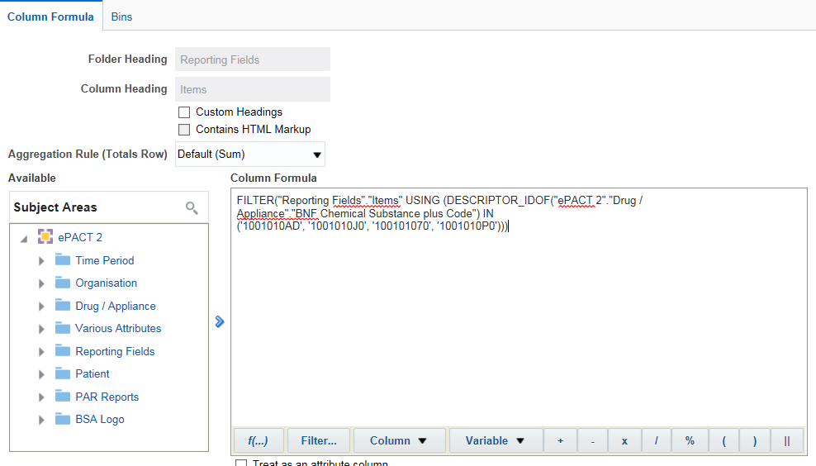

1. Place your cursor at the end of the text in the ‘Column Formula’ pane and select the divide symbol (/) from the task bar at the bottom of the ‘Column Formula’ pane. Alternatively, you can simply type the symbol yourself.

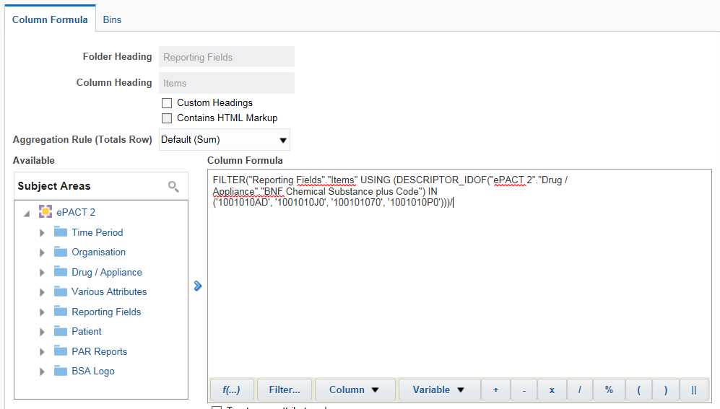

1. Place your cursor at the end of the text in the ‘Column Formula’ pane and click ‘Column’ followed by ‘NSAID Items’. This value will be used as the second part of our calculation.

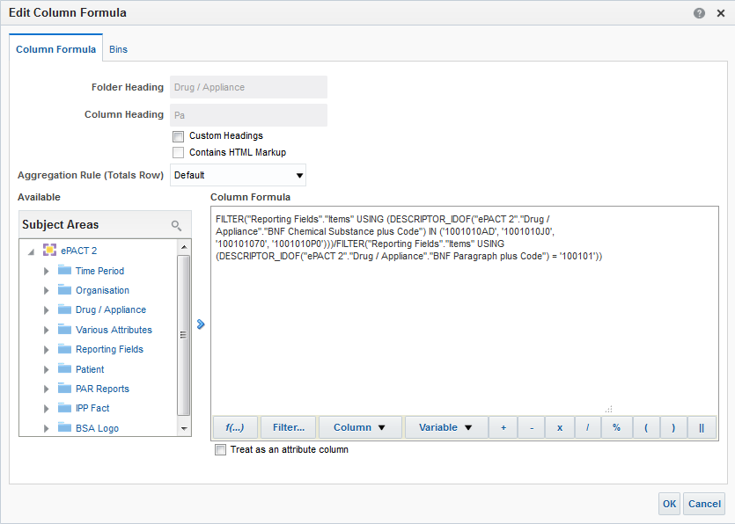

1. Place your cursor at the end of the text in the ‘Column Formula’ pane and select the multiply symbol (x) from the task bar at the bottom of the ‘Column Formula’ pane. Alternatively, you can simply type the multiply (*) symbol yourself. Again, ensuring your cursor is at the end of the text displayed, type 100.

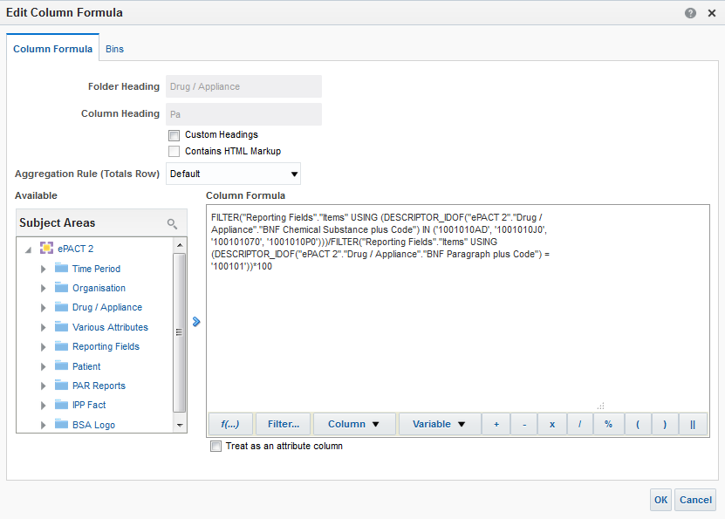

1. At this point, we have taken the number of Ibuprofen & Naproxen items, divided this by the number of NSAID items and multiplied this by 100 to give a percentage. This is known as a calculated column.
2. As in the previous steps select the ‘Custom Headings’ option and amend the ‘Column Heading’ to ‘NSAID: Ibuprofen & Naproxen % Items’. Click ‘OK’ to close the column formula window.

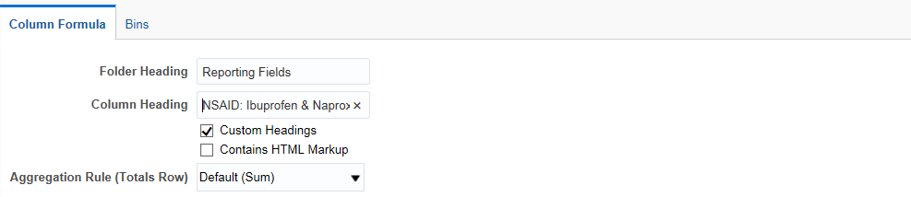

1. The criteria should now show as below.

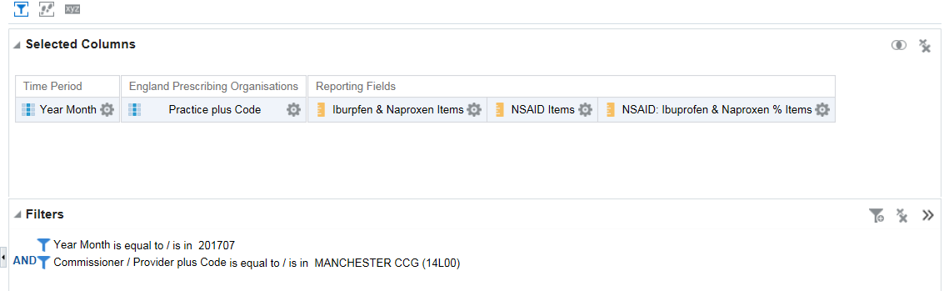

1. Save your analysis using the ‘Save Analysis’ button.
2. **Changing the ‘Data Format’ of a column.**
3. We now want to show our calculated item as a percentage with 2 decimal places. To do that, we can edit the data format of the column. Click the cog icon on the ‘NSAID: Ibuprofen & Naproxen % Items’ column and select ‘Column Properties’. The ‘Column Properties’ pane will be displayed.

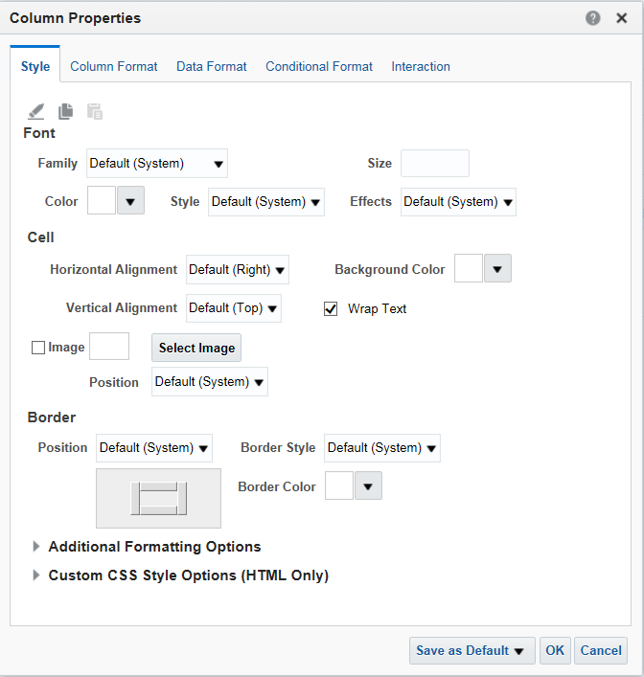

1. Select the ‘Data Format’ tab.

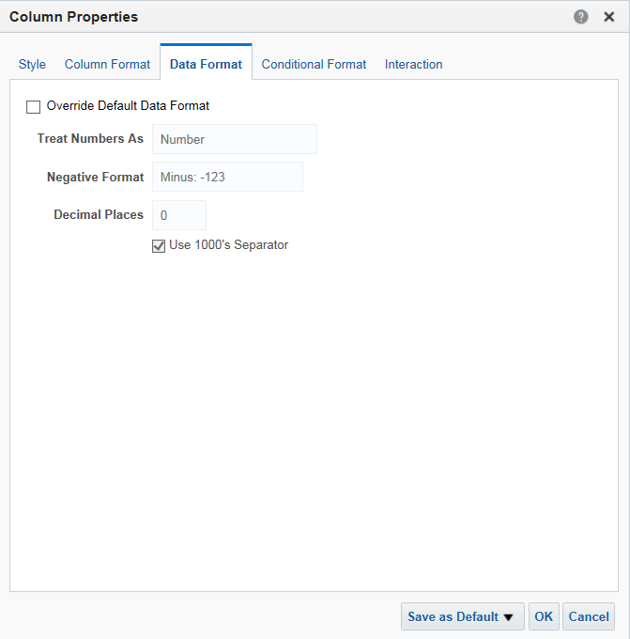

1. Select the ‘Override Default Data Format’ option and select ‘Percentage’ from the ‘Treat Number As’ drop down list, then set the number of ‘Decimal Places’ to ‘2’, as below, and click ‘OK’.

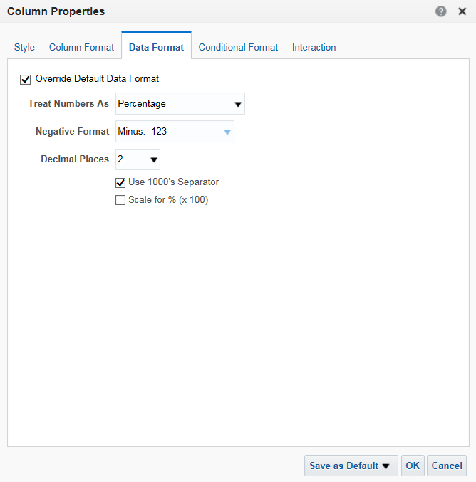

1. Save your analysis using the ‘Save Analysis’ button.
2. Select the ‘Results’ tab to display the results of the analysis. They should appear in the default table view as below.

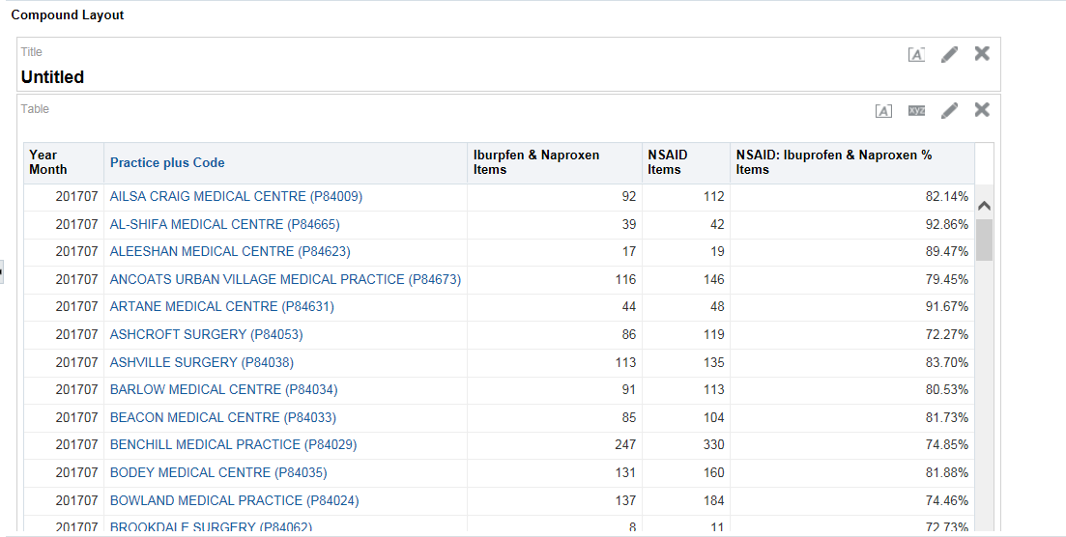

1. Save your analysis using the ‘Save Analysis’ button. This analysis will be used in Session 4 so please ensure this copy is not altered.

# Session 2 – Creating Analysis – Part 2

### Practice 1: Creating an analysis to show the number of identified patients split by age band receiving an item under a BNF Chemical Substance

**Goal**

In this scenario you will learn how to create an analysis to show the number of unique patients split by age band which have received an item under a particular BNF level at practice level within your organisation.

**Time**

45-60 minutes

**Task**

You will learn how to create an analysis by adding columns to a report; apply filters to narrow the data down to what is required. You will then view the data in tabular format.

1. **Create a new analysis using ePACT2 as the subject area**
2. Login to ePACT2 using your supplied login credentials.
3. From the home page, click ‘+ Create’ followed by ‘Analysis’. Select ePACT 2 as your subject area.

🡪

1. Add the following additional columns to your analysis:

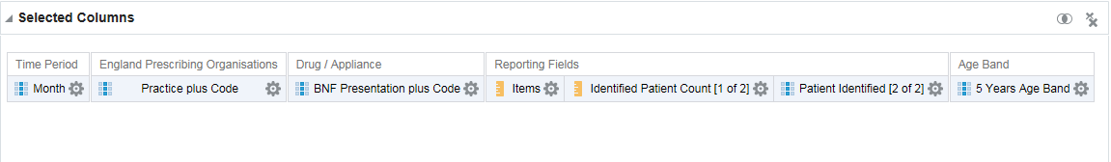

1. **Filter the analysis to show data for a specific time period and Chemical Substance.**
2. To show data for specific criteria, filters need to be applied to narrow down the results returned.
3. Click the cog icon on the ‘Month’ column and select ‘Filter’.
4. Leave the operator selection as ‘is equal to/is in’.
5. Click the down arrow in the value field and select the latest month available. Click OK to dismiss the ‘New Filter’ window.
6. **Filter the analysis using a column not shown in the analysis**
7. In the filters pane, click the ‘Create a filter for the current Subject Area’ 
8. Select ‘More Columns…’ and browse to and select ‘Commissioner / Provider plus code’ from the tree and click OK. Leave the operator as ‘is equal to/is in’ and set the value to your CCG. Click OK.
9. In the filters pane, click the ‘Create a filter for the current Subject Area’
10. Select ‘More Columns…’ and browse to and select ‘BNF Chemical Substance’ from the tree and click OK. Leave the operator as ‘is equal to/is in’ and set the value to the BNF Chemical Substance - Trimethoprim. Click Ok.
11. Check your work, the CCG shown will vary depending on the CCG selected.

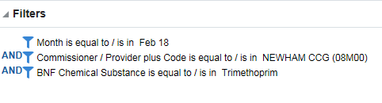

1. Save your analysis as ‘Identified Patients for Trimethoprim’ in ‘My Folders’ using the ‘Save Analysis’ or ‘Save As’ buttons.
2. Select the ‘Results’ tab to display the results of the analysis. They should appear in the default table view as below.

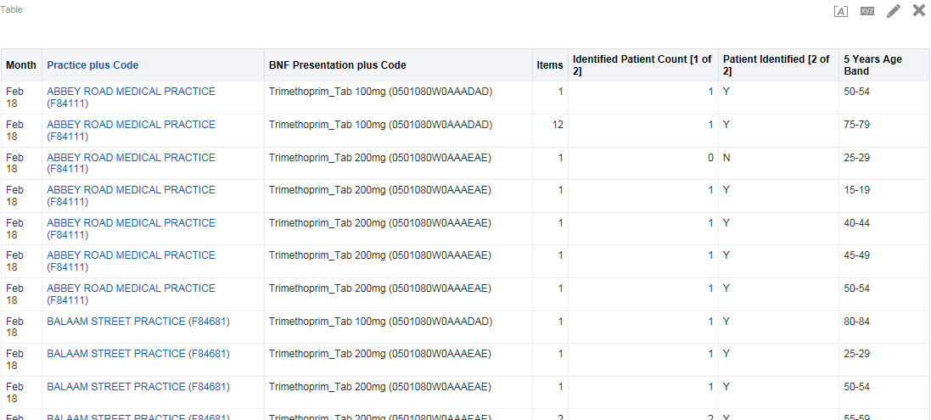

### Practice 2: Creating an analysis to show Actual Cost per ASTRO PU for the practices within a CCG.

**Goal**

In this scenario you will learn how to create an analysis to view the actual cost per ASTRO PU for the practices within a CCG.

**Time**

15-30 minutes

**Task**

You will learn how to create the analysis by adding columns to a report, applying filters to limit the organisations/time period the data is returned for, filtering individual columns to return specific data and including calculations within the system. You will then view the data in tabular format.

1. **Create a new analysis using ePACT2 as the subject area**
2. Login to ePACT2 using your supplied login credentials.
3. From the home page, click ‘+ Create’ followed by ‘Analysis’. Select ePACT 2 as your subject area.

🡪

1. The analysis editor will be displayed. From the ePACT 2 subject area, expand the time period tree and double click the ‘Year Month’ column. You will notice that the ‘Year Month’ column appears in the selected columns pane.



1. Add the following additional columns to your analysis:

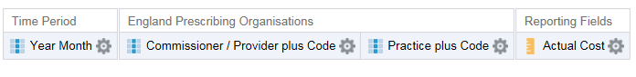

1. At this point, if you click the ‘Results’ tab, the results returned would be for all time periods and all organisations within the system, which would be a very large amount of data. As such, before viewing the results continue to the next step to filter the data.
2. Filter the analysis to show data for a specific time period and organisation
3. To show data for specific criteria, filters need to be applied to narrow down the results returned.
4. Click the cog icon on the ‘Year Month’ column and select ‘Filter’.



1. Click the down arrow in the value field and select the latest month available. Click OK to dismiss the ‘New Filter’ window.
2. Repeat the process using the ‘Commissioner/Provider plus Code’ column to select the CCG required.

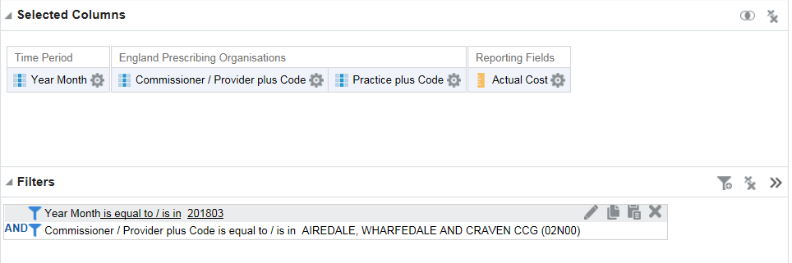

1. Click the ‘Results’ tab. Your data will be displayed

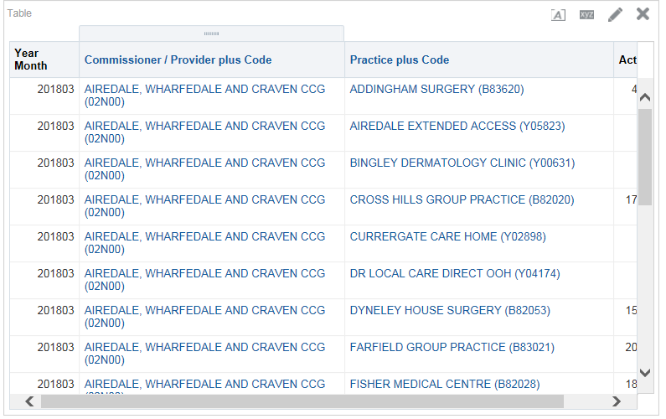

1. Save your analysis as ‘Actual Cost per ASTRO PU by Practice’ by clicking the ‘Save As’ icon near the top right hand side of the screen. Make sure you save your analysis in your own folder.



1. **Filter the ‘Standard PU, Astro PU and STAR PU’ column to show a selected PU measure.**
2. Select the ‘Criteria’ tab to return to the criteria pane.
3. Expand the ‘Patient’ folder within the Subject Area followed by the ‘List Size’ sub folder and add the ‘Standard PU, Astro PU and STAR PU’ column to the selected columns.

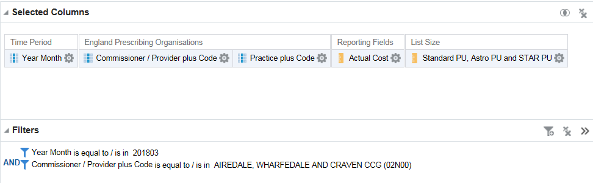

1. Select the ‘cog’ icon for the ‘Standard PU, Astro PU and STAR PU’ column, from the drop down list select the option for ‘Edit Formula’.
2. The ‘Edit Column Formula’ pane will be displayed; ensuring everything within the ‘Column Formula’ box is highlighted select the ‘Filter’ tab from the task bar at the bottom of the pane. The ‘Insert Filter’ pane will be displayed.

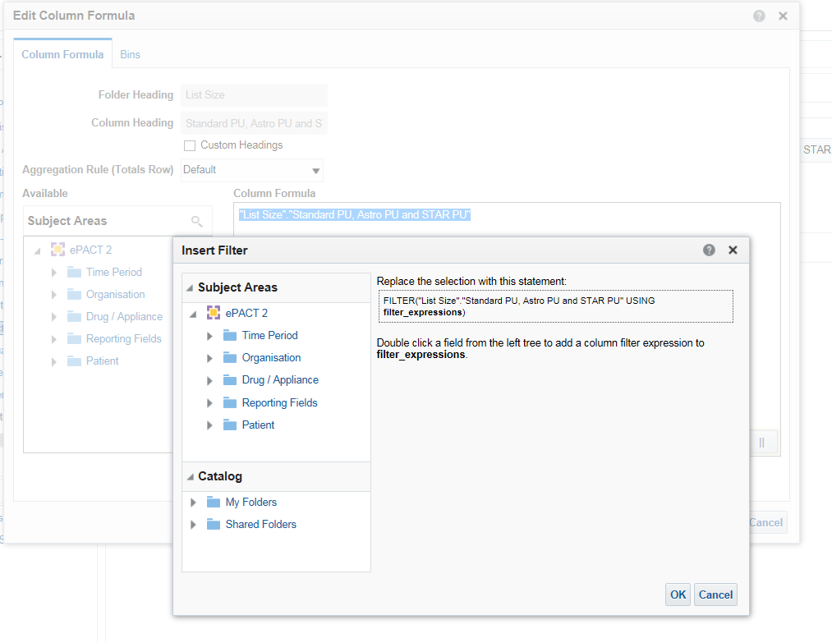

1. Expand the ‘Patient’ folder within the Subject Area followed by the ‘List Size’ sub folder and double click the ‘Patient Unit Name’ column.
2. The ‘New Filter’ pane will be displayed, expand the ‘Value’ drop down list and select the option for ‘ASTRO PU 2013 (COST) (2013)’.

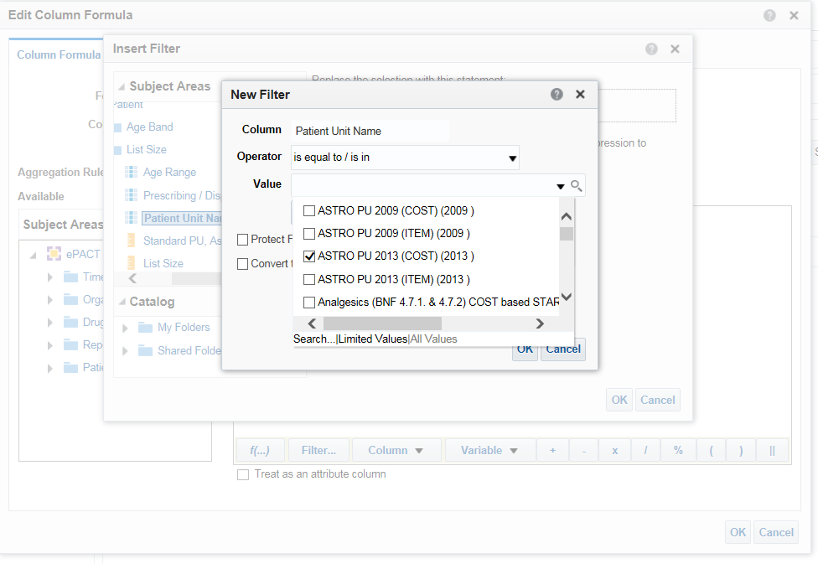

1. Select ‘Ok’ within the ‘New Filter pane, the ‘Insert Filter’ pane will be updated to show the filter created.

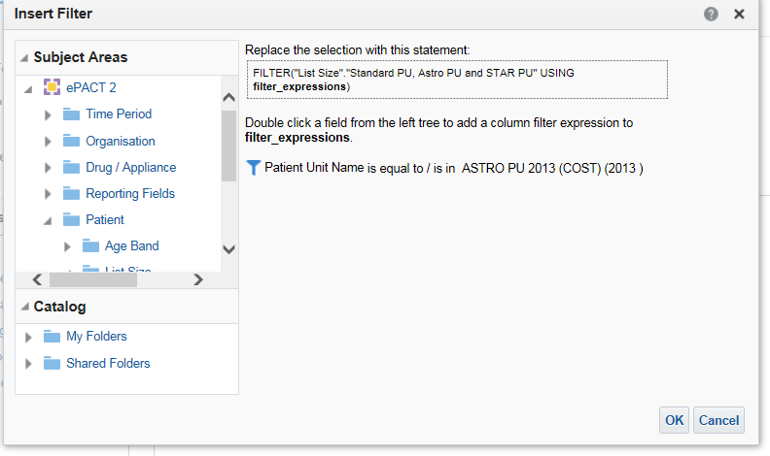

1. Select ‘Ok’ to return the ‘Edit Column Formula’ pane. The column formula displayed will have been updated to include the filter created. The data returned in this column will now be limited to the PU measure selected.

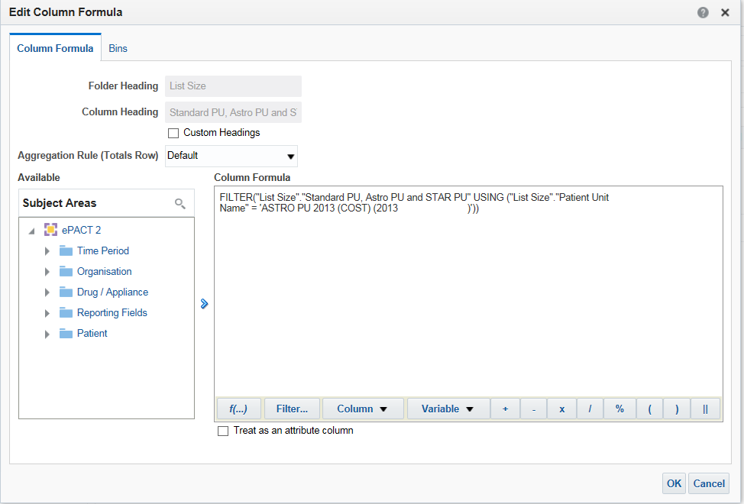

1. Select the ‘Custom Headings’ check box to allow the editing of the ‘Column Heading’, amend the column name displayed to ‘Cost based Astro PUs’.

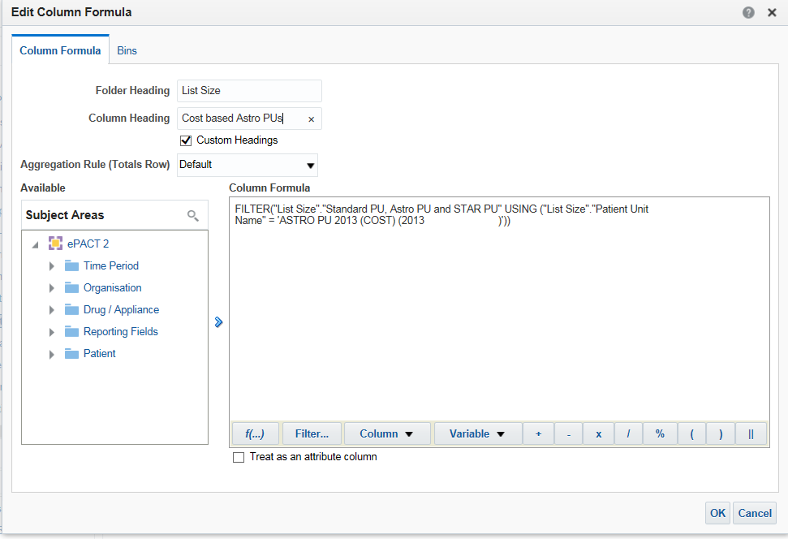

1. Select ‘Ok’ to confirm the changes to the column, the updated column will now be displayed within the selected columns pane.

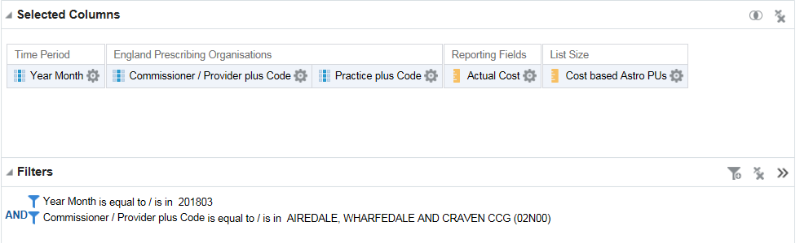

1. Save your analysis using the ‘Save Analysis’ button, overwriting the previous saved analysis.
2. **Editing a column to include a calculation within to show actual cost per Astro PU.**
3. Expand the ‘Reporting Fields’ folder within the Subject Area and add an additional ‘Actual Cost’ column to the ‘Selected Columns’.
4. Select the ‘cog’ icon for the additional ‘Actual Cost’ column, from the drop down list presented select ‘Edit Formula’. The ‘Edit Formula’ pane will be displayed.

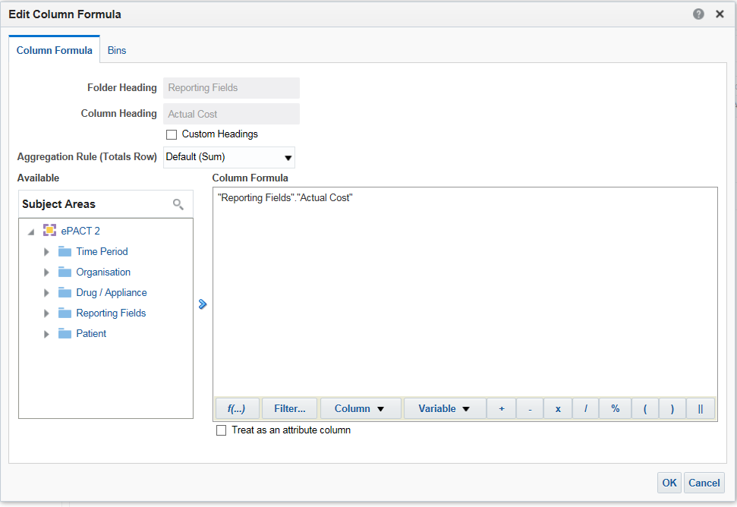

1. Place your cursor at the end of the text in the ‘Column Formula’ pane and select the divide symbol (/) from the task bar at the bottom of the ‘Column Formula’ pane. Alternatively, you can simply type the symbol yourself.
2. The ‘Divide’ symbol will be displayed within the ‘Column Formula’ pane. Any content added to the ‘Column Formula’ pane will be highlighted, before proceeding ensure that nothing in the ‘Column Formula’ pane is highlighted.
3. Place your cursor at the end of the text in the ‘Column Formula’ pane and click ‘Column’ followed by ‘Cost based Astro PUs’. This value will be used as the second part of our calculation.

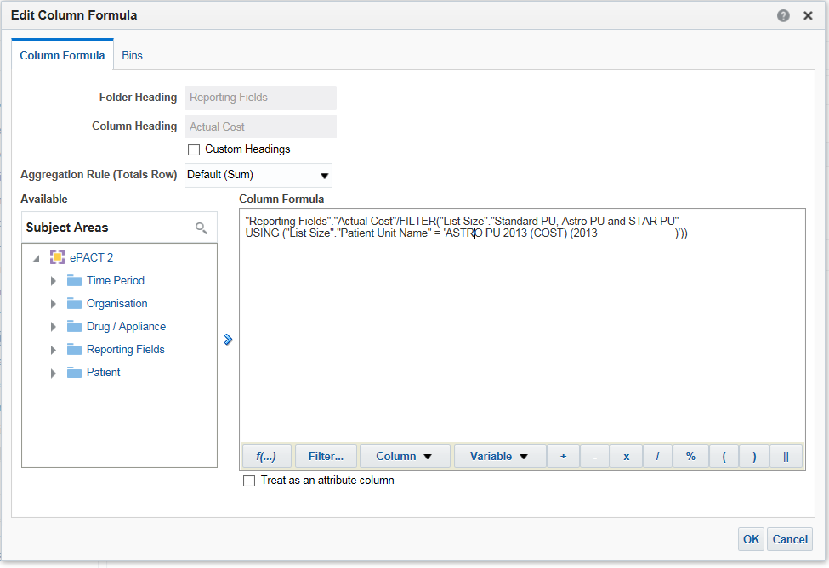

1. At this point, we have taken the actual cost and divided this by the number of cost based Astro PUs. This is now a calculated column.
2. As in the previous steps select the ‘Custom Headings’ option and amend the ‘Column Heading’ to ‘Actual Cost per Cost based Astro PU’. Click ‘OK’ to close the column formula window.

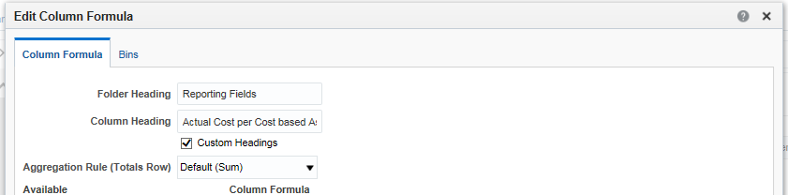

1. The criteria should now show as below.

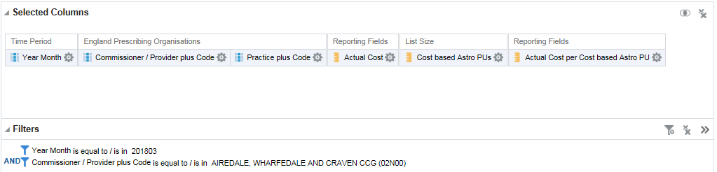

1. Save your analysis using the ‘Save Analysis’ button.
2. **Changing the ‘Data Format’ of a column.**
3. We now want to show our calculated item to show with 2 decimal places. To do that, we can edit the data format of the column. Click the cog icon on the ‘Actual Cost per Cost based Astro PU’ column and select ‘Column Properties’. The ‘Column Properties’ pane will be displayed.



1. Select the ‘Data Format’ tab.

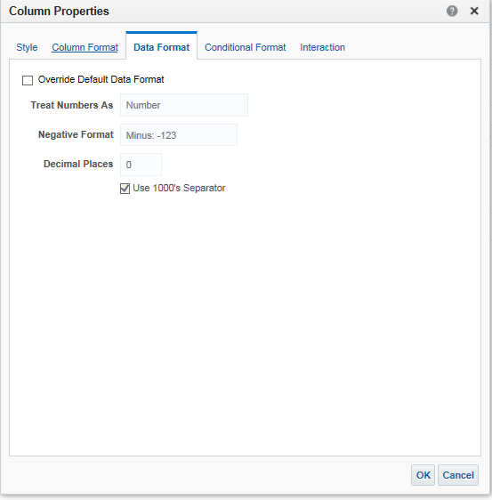

1. Select the ‘Override Default Data Format’ option and set the number of ‘Decimal Places’ to ‘2’, as below, and click ‘OK’.

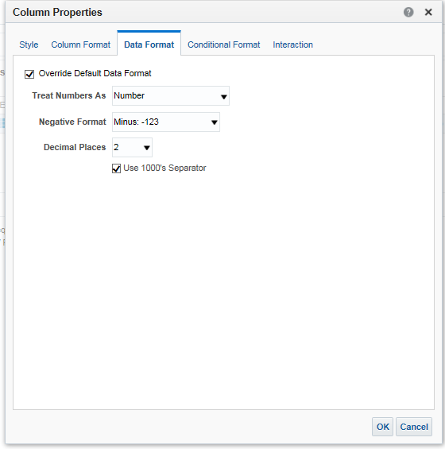

1. Save your analysis using the ‘Save Analysis’ button.
2. Select the ‘Results’ tab to display the results of the analysis. They should appear in the default table view as below.

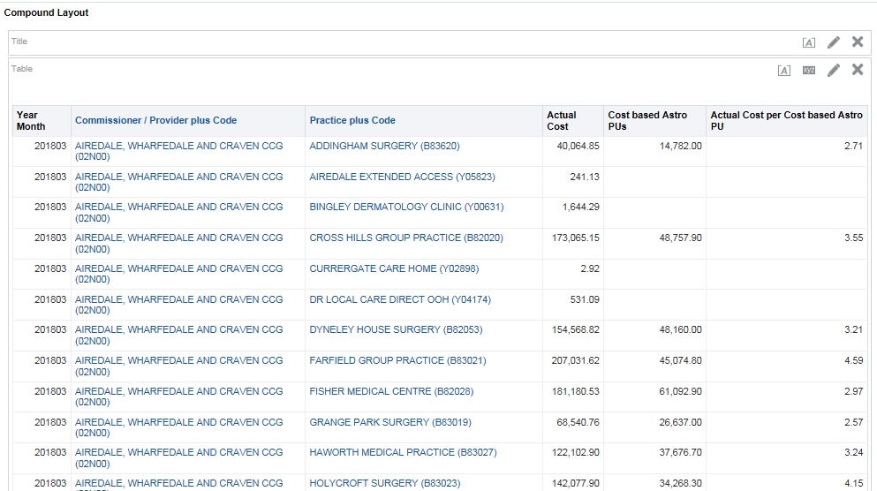

1. Save your analysis using the ‘Save Analysis’ button.

### Practice 3: Using ‘Selection Steps’ to show the number of items and actual cost for a CCG, the practices registered under the CCG and groups of selected practices.

**Goal**

In this scenario you will learn how to create an analysis to show information at multiple organisational levels within a single analysis and how to show information for groups of organisations.

**Time**

30-45 minutes

**Task**

You will learn how to create an analysis by adding columns to a report, apply filters to narrow the data down to what is required and to use selection steps to show the information at multiple organisational levels and to show information for groups of organisations. You will then view the data in tabular format.

1. **Create a new analysis using ePACT2 as the subject area**
2. Login to ePACT2 using your supplied login credentials.
3. From the home page, click ‘+ Create’ followed by ‘Analysis’. Select ePACT 2 as your subject area.

🡪

1. Add the following additional columns to your analysis:

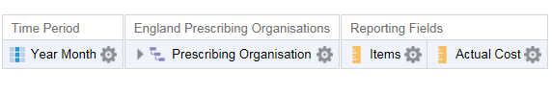

1. Filter the analysis to show data for a specific time period
2. To show data for specific criteria, filters need to be applied to narrow down the results returned.
3. Click the cog icon on the ‘Year Month’ column and select ‘Filter’.



1. Leave the operator selection as ‘is equal to/is in’.
2. Click the down arrow in the value field and select the latest month available. Click OK to dismiss the ‘New Filter’ window.

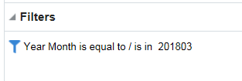

1. Save your analysis as ‘CCG, Practices & Localities’ in ‘My Folders’ using the ‘Save Analysis’ or ‘Save As’ buttons .
2. Select the ‘Results’ tab to display the results of the analysis. They should appear in the default table view as below.

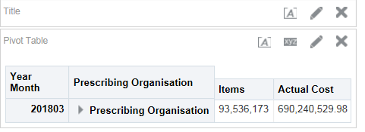

1. Save your analysis using the ‘Save Analysis’ button.
2. **Using Selection Steps to limit the data displayed**
3. Expand the ‘Selection Steps’ option at the bottom of the ‘Compound Layout’.

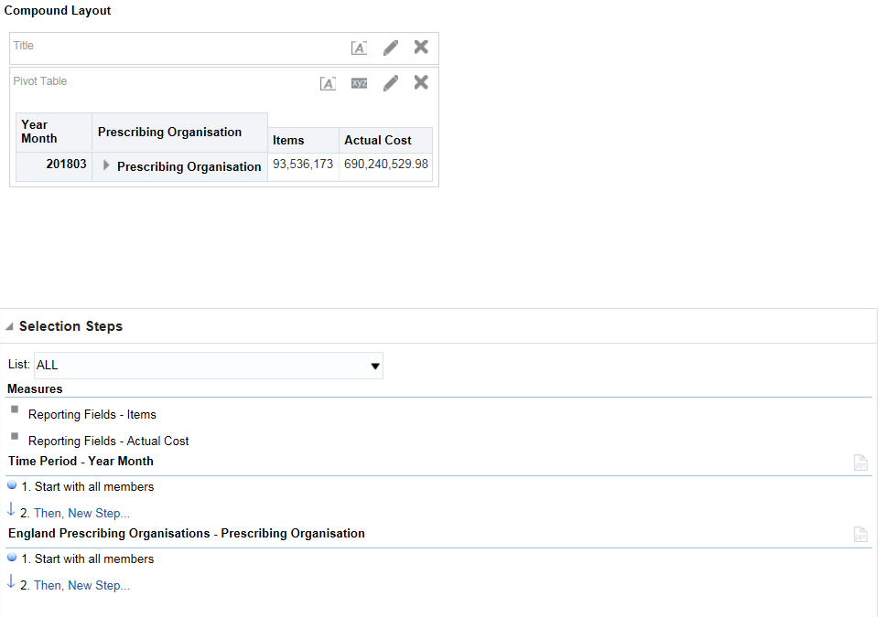

1. Hover over ‘Starts with all members’ under the ‘England Prescribing Organisations – Prescribing Organisation’ section and select the pencil icon.
2. The ‘Edit Member Step’ will be displayed.

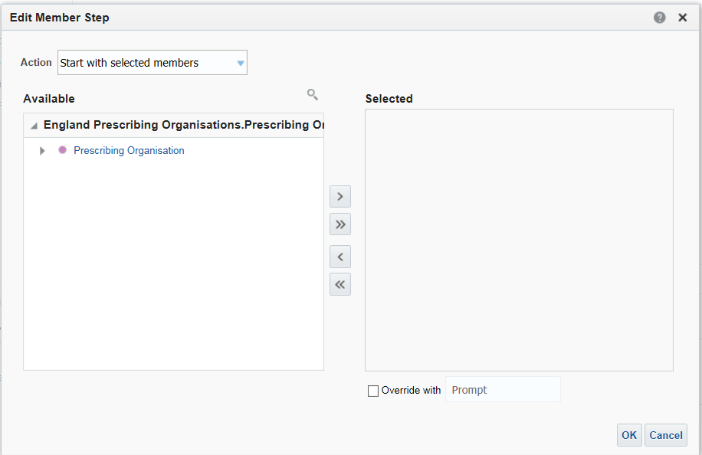

1. Use the ‘Search’ facility to locate the CCG required. Highlight the selected CCG within the ‘Available’ pane and use the ‘arrow’ icon to move the organisation into the ‘Selected’ pane.

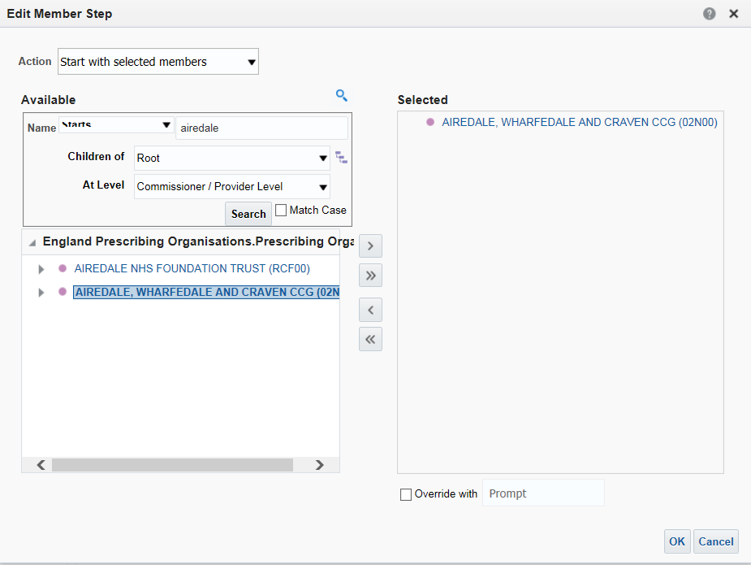

1. Select ‘Ok’ to confirm the selection. The data will now regenerate to show the results for only the CCG selected. The CCG can be expanded by selecting the ‘arrow’ icon to the right of the CCG name to show the practices under the CCG.

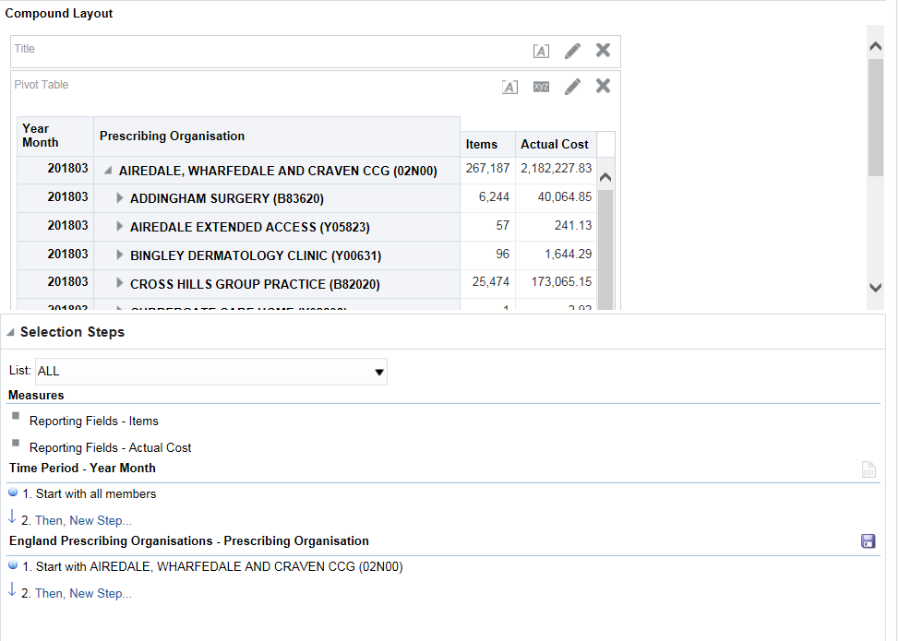

1. Save your analysis using the ‘Save Analysis’ button.
2. **Using Selection Steps to group practices into localities**
3. Within the ‘Selection Steps’ pane select the option for ‘Then, New Step…’. From the drop down list displayed select ‘Add Groups or Calculated Items’ followed by ‘New Group’.

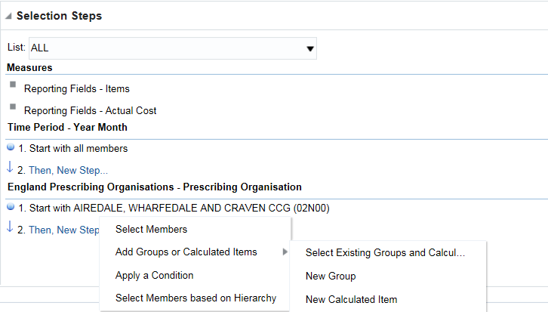

1. The ‘New Group’ pane will be displayed, use the search facility to limit the results shown to the CCG selected earlier.

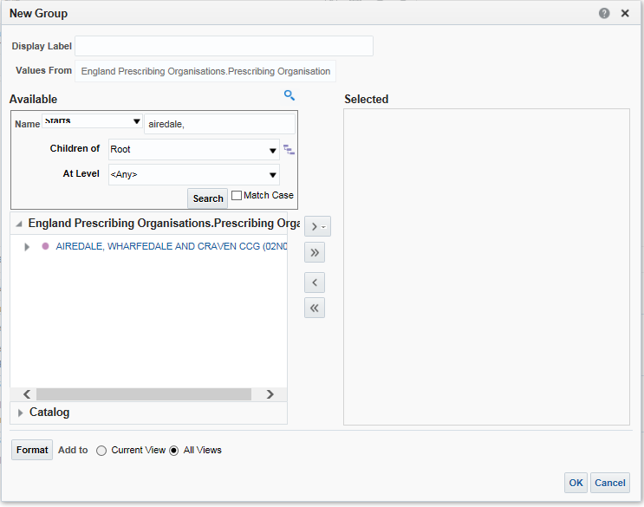

1. Expand the CCG by selecting the ‘arrow’ icon to the right of the CCG name within the organisational hierarchy.
2. Select the first six practices under the CCG by highlighting the practice and using the central single arrow icon to move them into the ‘Selected’ pane.
3. Edit the ‘Display Label’ name to name the group ‘Locality 1’.

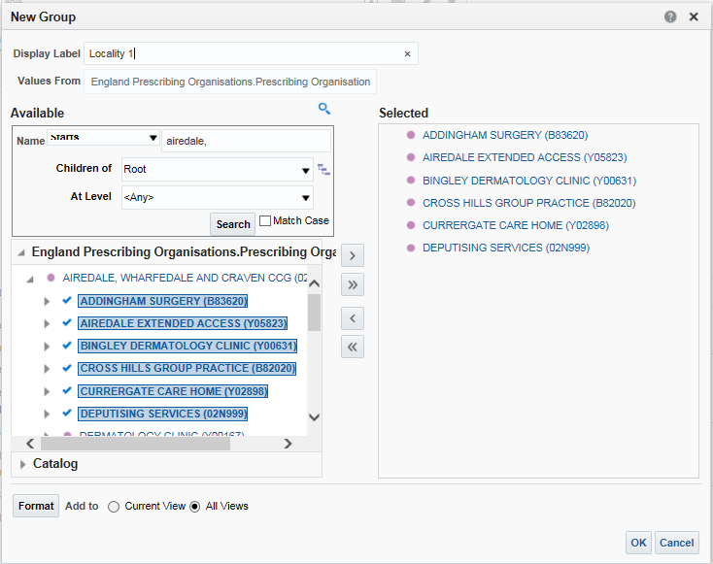

1. Select ‘Ok’ to confirm the selection and create the group. The group will now be displayed in the ‘Selection Steps’ pane.

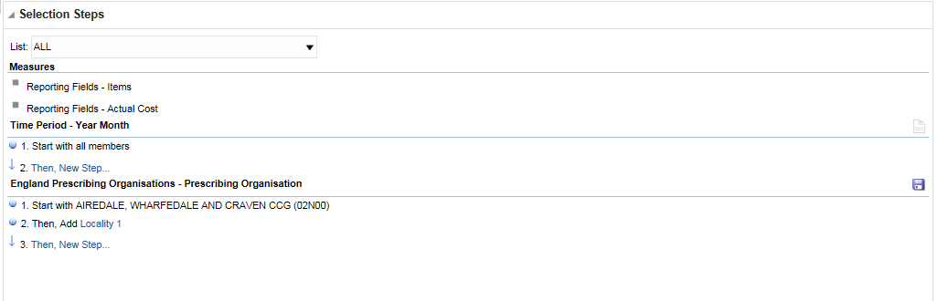

1. The group created will now be displayed within the results.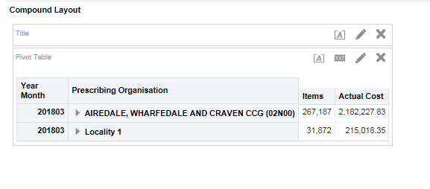
2. Repeat the process above to create a second group using the next six practices under the CCG, name this group Locality 2.
3. Save your analysis using the ‘Save Analysis’ button.
4. **Saving Groups to reuse in future analyses.**
5. Within the ‘Selection Steps’ pane select the hyperlinked group name for Locality 1.
6. From the drop down list presented select the option for ‘Save Group As’.

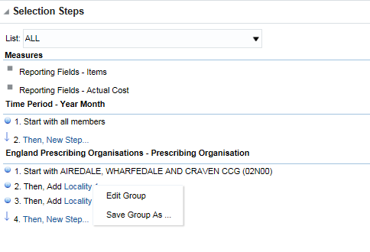

1. The ‘Save As’ box will be displayed, highlight your ‘My Folders’ area and select ‘Ok’ to confirm.

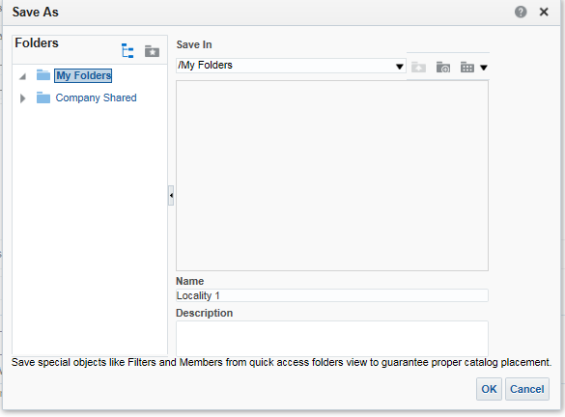

1. The group will now be saved within your ‘My Folder’ area and can be used within any future ‘Selection Steps’ when creating an analysis.
2. Using saved Groups in an analysis.
3. Within the ‘Selection Steps’ pane select the option for ‘Then, New Step…’. From the drop down list displayed select ‘Add Groups or Calculated Items’ followed by ‘Select Existing Groups and Calculated Items’.
4. The ‘New Select Existing Groups and Calculated Items’ pane will be displayed. Expand your ‘My Folders’ to locate the group saved earlier, highlight the group and use the single arrow icon to move the saved group into the ‘Selected’ pane.

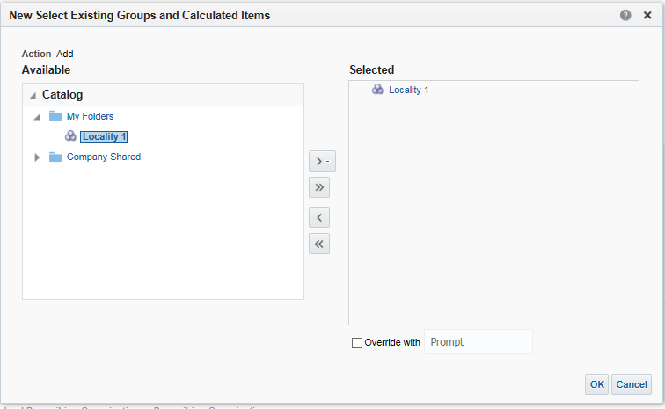

1. The saved group will now be shown within the ‘Selection Steps’ and within the results as below.

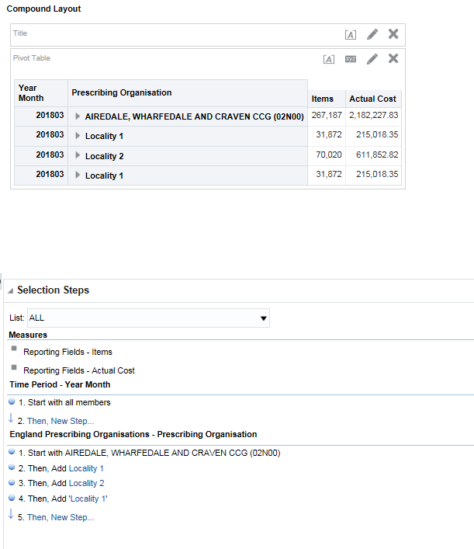

1. Save your analysis using the ‘Save Analysis’ button

# Session - 3 - Creating, saving and using saved filters

### Practice 1: Creating and using saved filters

**Goal**

In this scenario you will create and save filters for use in analyses.

**Time**

0-15 minutes

**Task**

You will learn how to create and save a saved filter and how to use it in an analysis. Saved filters are the equivalent of tags in ePACT.

1. **Create and save a saved filter**
2. From the ePACT2 home page, click ‘+ Create’ followed by ‘Filter’.
3. Select the ePACT 2 subject area. The create filter window will open.
4. Open the Organisation tree and double click ‘Commissioner / Provider plus Code’, from the ‘New Filter’ pane select your CCG.
5. Check your work:

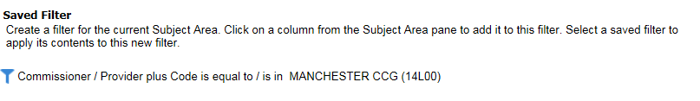

1. Add an additional level to the filter by double clicking ‘Practice plus Code’.
2. In the ‘New Filter’ pane click the magnifying glass icon to bring up the search window.

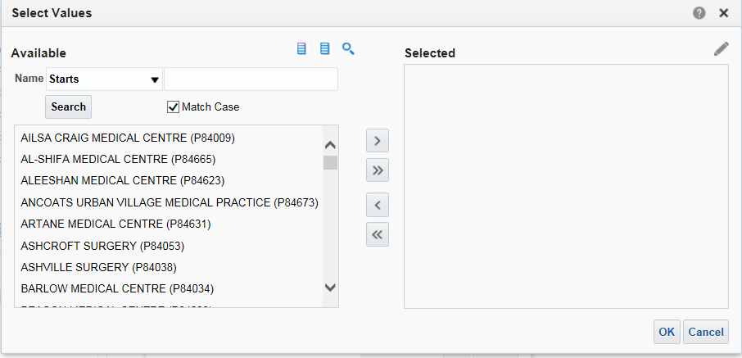

1. Select the ‘Limited Values’ icon  to limit the values shown to the practices under the CCG selected in the earlier level of the filter.
2. Select 5 GP practices from the list.

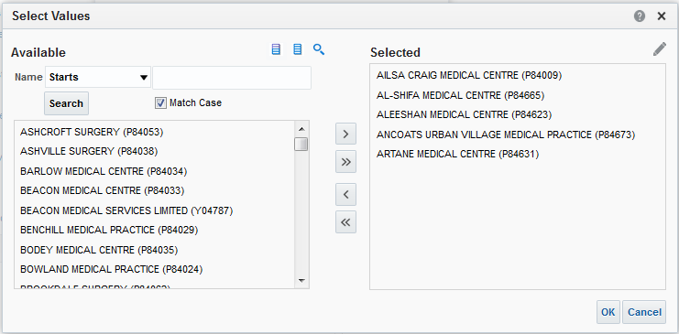

1. Click ‘OK’ and ‘OK’ again, the contents of the filter will be displayed:

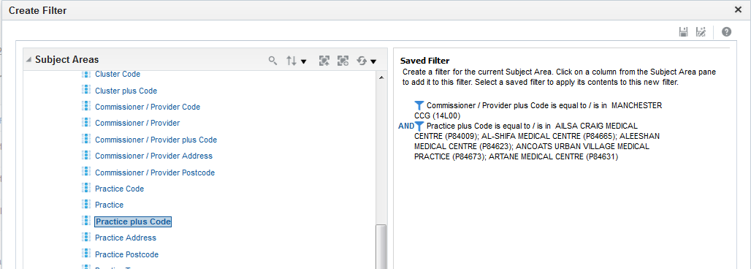

1. Save the filter in ‘My Folders’ and name it ‘(your CCG) Practice Group 1’. Confirm the save location as ‘My Folders’ if asked. Close the new filter window.
2. Locate the ‘Ibuprofen & Naproxen as a % of all NSAIDs’ analysis created in Practice 2 in the catalogue, click ‘Edit’ and then select the ‘Criteria’ tab.
3. Under the ‘Catalogue’ pane, browse to ‘My Folders’ and double click the (your CCG) GP Practices’ filter you have just created. Note the filter options that are available. Leave both options deselected and click ‘OK’.
4. Check your work:

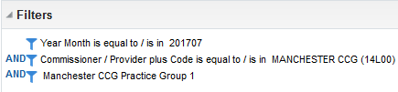

1. Click the ‘Results’ tab and note the results are based on the practices in your saved filter. If/when you update the ‘Manchester CCG Practice Group 1’ filter; your analysis will automatically be updated to include the revised practice list meaning you don’t need to edit your analysis once set up.
2. Save the analysis as ‘Ibuprofen & Naproxen as a % of all NSAIDs Practice Group 1’ in ‘My Folders’ and return to the home page.
3. **Including an NHSBSA Filter.**
4. Browse to the ePACT2 catalogue and locate the ‘Ibuprofen & Naproxen as a % of all NSAIDs GP Practices’ analysis in ‘My Folders’ and select Edit.
5. Select the ‘Criteria’ tab.
6. Under the ‘Catalogue’ pane, browse to ‘Company Shared’ – ‘epact2’ – ‘Filters’ – ‘Time Periods’ and double click the ‘Latest Three Months’ filter. Note the other filter options that are available. Leave both options deselected and click ‘OK’.
7. In the ‘Filter’ pane hover over the filter for ‘Year Month’ and select delete to remove this filter.

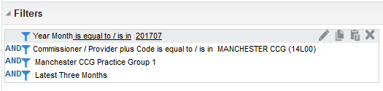

1. Check your work:

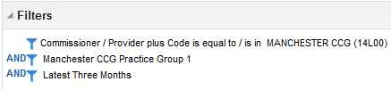

1. Click the ‘Results’ tab and observe the results are now filtered by both the GP practices filter and for the latest 3 months available.

### Practice 2: Re-creating ePACT tags as a saved filter

**Goal**

In this scenario you will create and save filters for use in analyses.

**Time**

0-15 minutes

**Task**

You will learn how to re-create an ePACT tag as a saved filter and how to use it in an analysis. Saved filters are the equivalent of tags in ePACT.

1. **Using the ePACT Tag Tool**
2. From the home page, click ‘+ Create’ followed by ‘Analysis’. Select ePACT 2 as your subject area.

🡪

1. Add the following column to your analysis:

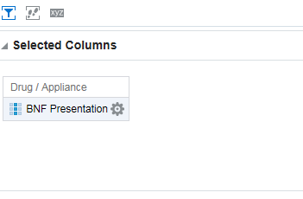

1. In the filter pane select the following icon  and then select ‘More Columns

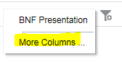

1. Navigate to ‘Drug/ Appliance and select ‘BNF Chemical Substance plus Code

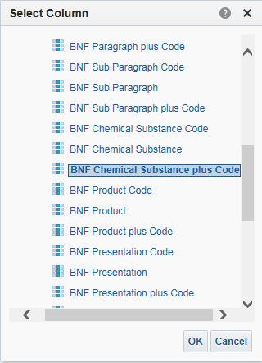

1. Select ‘OK’
2. In the ‘Value box select the search icon
3. Search for Tramadol Hydrochloride

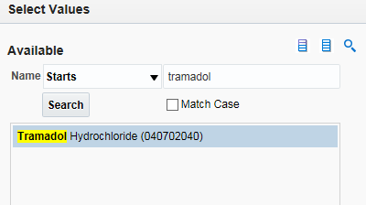

1. Select the single arrow icon and then select ‘OK’ select ‘OK’ again
2. Your analysis should now look like this

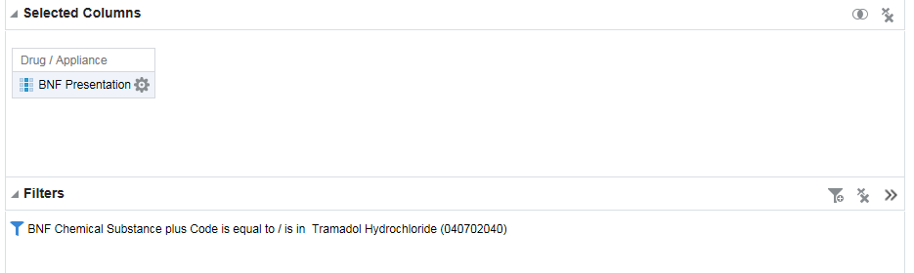

1. Select ‘Results’ to generate your analysis, this will bring back a list of all presentations that fall under Chemical Substance ‘Tramadol Hydrochloride’.
2. Select the ‘Export this analysis’ icon select ‘Data’ then select ‘CSV Format’

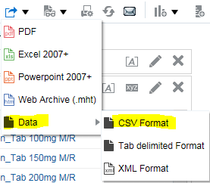

1. **Using the ePACT Tag Tool.**
2. Access the ePACT2 User Guide page on the NHSBSA website at <https://www.nhsbsa.nhs.uk/epact2/epact2-user-guides>.
3. Expand the ‘Creating and using filters’ section.
4. Open the ‘Recreating ePACT tags within ePACT2’ user guide.
5. Scroll to section 2 of the guide and select the link for the ‘ePACT Tag Tool’.

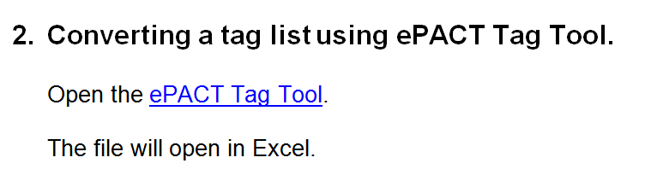

1. Once the spreadsheet opens select ‘Enable Editing’ followed by ‘Enable Content’ and then copy & paste the above list of BNF codes into the ePACT Tag Tool.

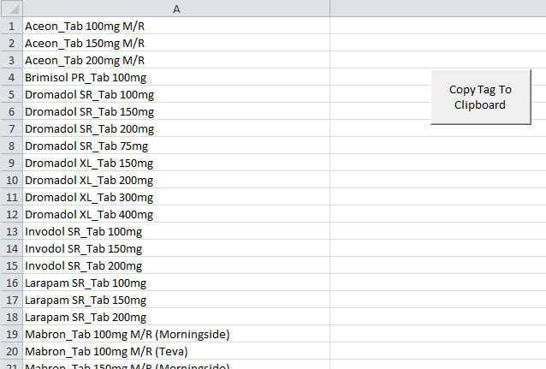

1. Select the ‘Copy Tag To Clipboard’ button.
2. **Creating a saved filter.**
3. From the ePACT2 home page, click ‘+ Create’ followed by ‘Filter’.
4. Select the ePACT 2 subject area. The create filter window will open.
5. Open the Organisation tree and double click ‘BNF Presentation’.
6. Click into the ‘Values’ section of the ‘New Filter’ pane and paste the contents of the ePACT Tag Tool spreadsheet.

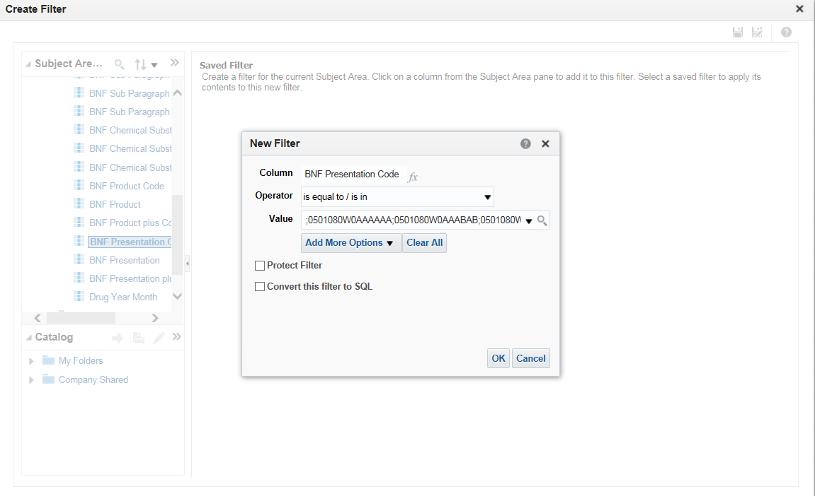

1. Select the drop down arrow to the right of the ‘Values’ pane to confirm the selections. The system will select all of the values copied into the ‘Values’ pane. Note that if the drop down list is not selected the values will not be included in the filter. Select ‘Ok’.

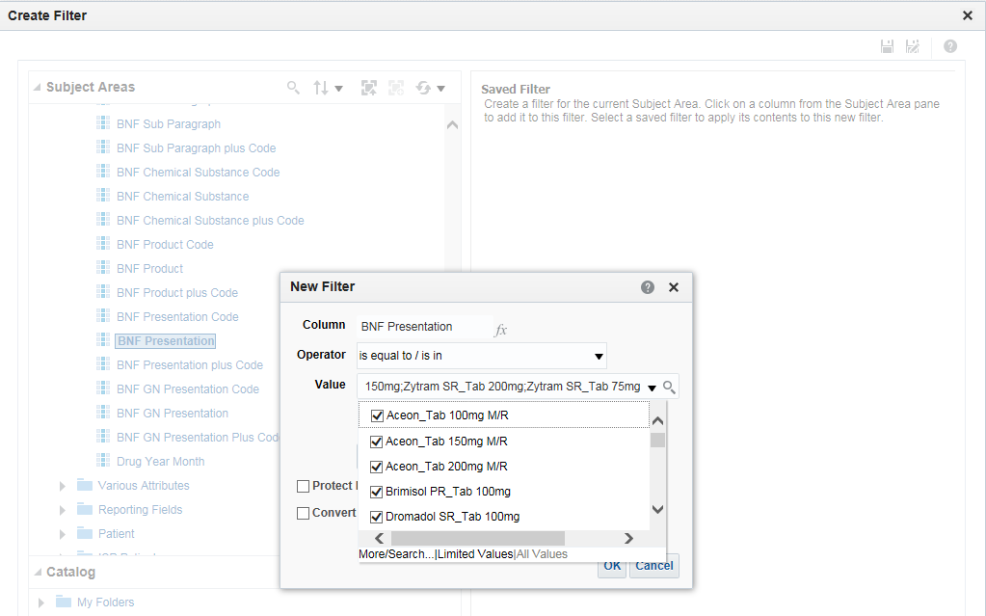

1. The values included in the filter will now be displayed in the ‘Create Filter’ pane.

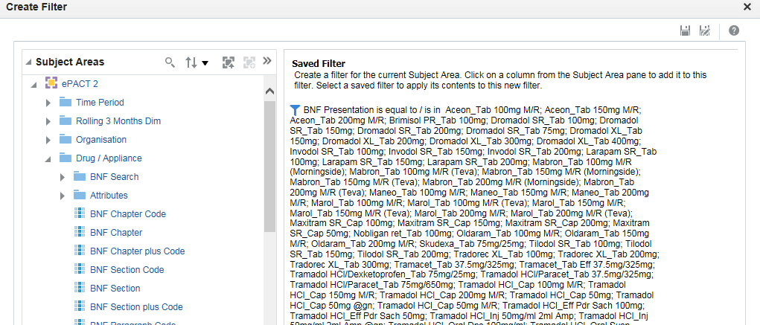

1. Save the filter in ‘My Folders’ and name it ‘Tramadol’. Confirm the save location as ‘My Folders’ if asked. Close the new filter window.

# Session 4 - Adding data visualisations to an analysis

### Practice 1: Adding data visualisations to an analysis

**Goal**

In this scenario you will add data visualisations to the ‘NSAID: Ibuprofen & Naproxen % Items’ analysis created in Session 2 - Practice 2 and edit those views.

**Time**

15-30 minutes

**Task**

You will learn how to add additional views to your analysis to visualise your data in different ways. You will also learn how to edit and format those views.

1. **Adding different views to an analysis**
2. Locate the ‘NSAID: Ibuprofen & Naproxen % Items’ analysis in the ‘Catalogue’ and select ‘Edit’.
3. Click the ‘Criteria’ tab.
4. Edit the ‘Year Month’ filter by hovering your mouse over the filter and clicking the ‘Edit Filter’ button 
5. Add the five successive months to the filter so that you have selected the latest 6 months.
6. Check your work:

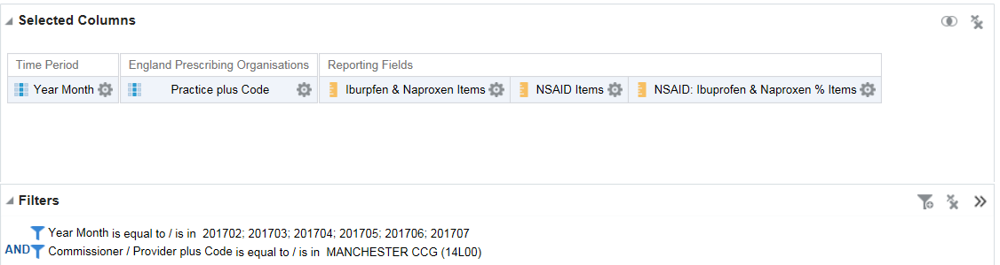

1. Click the ‘Results’ tab.
2. Click ‘New View’ in the menu bar near the top of the screen and note the various views that are available.



1. Select the ‘Graph’ option followed by ‘Bar’ followed by ‘Vertical’. The selected vertical bar graph will appear. Note that the graph shows the practice name plus code as a selection prompt above the bar graph.
2. Click the ‘Remove View from Compound Layout’ button on the table view 
3. The table view will no longer be shown. However note that under the ‘Views’ pane in the left hand bottom corner, the table can be selected and re-added to the view by clicking and dragging it into the Compound Layout wherever a dark blue line shows:

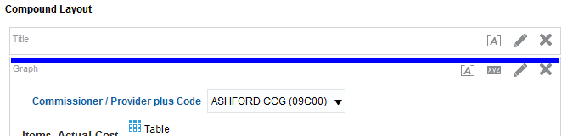

1. Ensure the table view is not showing before continuing.
2. **Editing analysis views**
3. Click the ‘Edit View’ button on the bar chart  . The layout pane will open. Enlarge the layout pane by clicking and dragging the size slider in the layout pane title bar.
4. Click and drag the ‘Ibuprofen & Naproxen Items’ and ‘NSAID Items’ Columns from the ‘Measures’ box to the ‘Excluded’ box.
5. Click and drag the ‘Practice Plus Code’ column to the ‘Bars – Group By (Horizontal Axis)’ section and click and drag the ‘Year Month’ column to the ‘Graph Prompts’ section. Your layout pane should look as below:

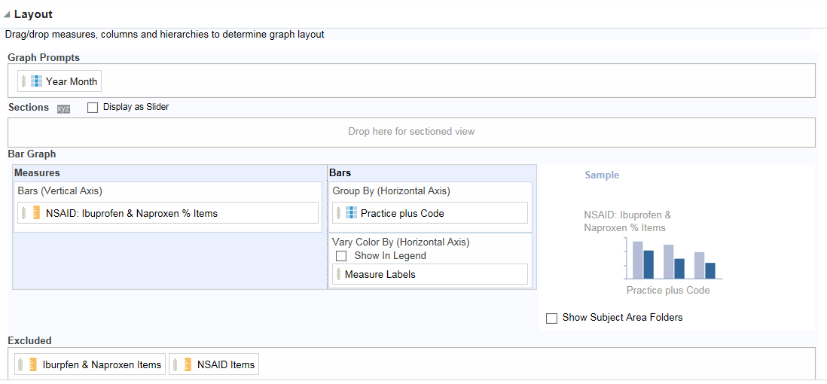

1. Click ‘Done’ in the top right.
2. Note that the bar graph now shows ‘NSAID: Ibuprofen & Naproxen % Items’ for each practice with a Graph Prompt which can be used to select the required month.

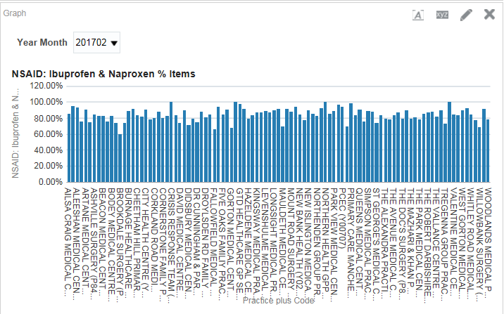

1. Save your analysis as ‘Ibuprofen & Naproxen as a % of all NSAIDs Views’ in ‘My Folders’ using the ‘Save As’ button.
2. We now want to view the trend of Ibuprofen and Naproxen and NSAID prescribing over a period of time per practice. Click ‘New View’ in the menu bar and add a new line chart view. Edit the line chart to exclude the ‘NSAID: Ibuprofen & Naproxen % Items’.

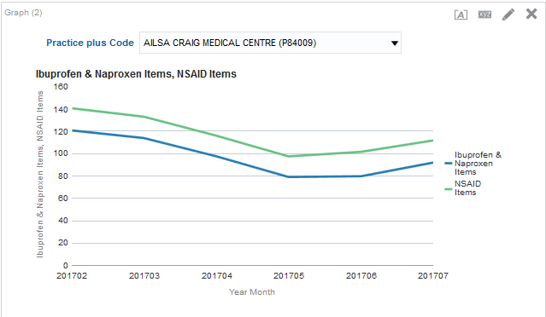

1. View and compare the Ibuprofen & Naproxen items and NSAID items for your practices over the 6 months using the graph prompt.
2. Click ‘View Properties’ on the bar chart and explore the various options available. Click OK when you have finished.
3. Save your analysis using the ‘Save Analysis’ button.

# Getting Help



**Additional training material and user guides**

The NHSBSA has developed a number of how to guides to help you get the best out of ePACT2. These can be found at <https://www.nhsbsa.nhs.uk/epact/epact2>.

**WebEx sessions**

WebEx will be provided on a number of different topics and features. More information about these can be found here <https://www.nhsbsa.nhs.uk/epact/epact2>.