Welcome to the December edition of the NHS Jobs newsletter.

This month we’re sharing an update on the NHS Jobs project along with information on two campaigns that NHS Jobs are proud to be supporting.

Did you know?

Last year Santa may not have brought you a new job but he may have brought you a new iPhone…

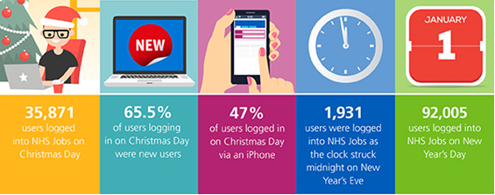

Enhancements to the current service

Last month we released the electronic offer letter which allows you to generate and issue offer letters and contracts through the site.

We can see that some of you are already using this functionality and we’d love your feedback. If you’d like to offer your thoughts drop us a line at: nhsbsa.nhsjobs@nhs.net

Please keep an eye on the latest news section of the NHS Jobs website for news of all new releases.

The future service – more than a project

We’ve mainly updated you on the project so far; however there is more to the future service of NHS Jobs than the project to build the new system.

A key focus for our current and future service teams is to ensure that NHS Jobs is aligned to the wider NHS and is working with key organisations. Two groups have recently been set up to ensure that we can engage with our stakeholders and key contacts regularly, ensuring NHS Jobs and the wider workforce direction are joined up.

NHS Jobs Strategy Group - The members of the group are from a wide range of areas within the NHS, such as DHSC, NHS England, NHS Employers, NHS Improvement, Health Education England and local authorities

Their aims are to work together to ensure that the NHS Jobs service aligns to the wider strategic workforce agenda across NHS organisations.

The group will also support the implementation of the new service and how this can be done effectively.

Workforce Steering Group - The Workforce Steering Group is aimed at wider workforce services such as ESR, Pensions and NHS Jobs to ‘provide strategic direction and support for the development and implementation of existing and future NHS workforce services’.

This group is chaired by Gavin Larner (Director of Workforce for DHSC) and has representation from NHSBSA as well as other key stakeholder organisations.

Both groups had their first meetings in the last month and feedback has been really positive in terms of joining up NHS Jobs and other workforce services. Both groups will evolve but will provide good platforms to take opportunities forward.

We’ll keep you updated in future newsletters about how both of the groups continue to progress, as well as news about the project but if there’s anything specific you would like to know, contact the team who will be happy to help – just email nhsbsa.jobs3@nhs.net.

Engagement

We are the NHS
We are currently working with NHS England to identify ways in which NHS Jobs can support the ‘We are the NHS’ campaign. The next phase of the campaign will launch on 21 January and will highlight the volumes and types of clerical and administration roles as well as IT roles available within the NHS. As part of the campaign, potential candidates will be signposted to NHS Jobs in order to search for and apply to suitable roles.

Step into Health
The Step into Health programme provides support to ex-military personnel who are seeking to find new employment. A number of recruiting organisations are signing up to the Step into Health programme to show their support and we are now looking at how we can further support the programme and how we can help those of you that have already pledged your support to enable easy identification of candidates with a military background.

Keep in touch
We’re keen to engage with you, hear of your experience in using NHS Jobs and identify how we can assist in making the recruitment journey as seamless as possible. If you would like us to talk to your regional streamlining group please drop us an email at nhsbsa.nhsjobs@nhs.net

Merry Christmas

From all of the NHS Jobs team, we would like to wish you a fantastic festive period and a very happy new year.

Thanks for reading
Do you know someone who would like to subscribe to this newsletter? They can join our mailing list here.

Don’t forget to follow us on Twitter – search for @NHS_Jobs today.

