Setting up Nominated Pharmacy alert

Create a Concept
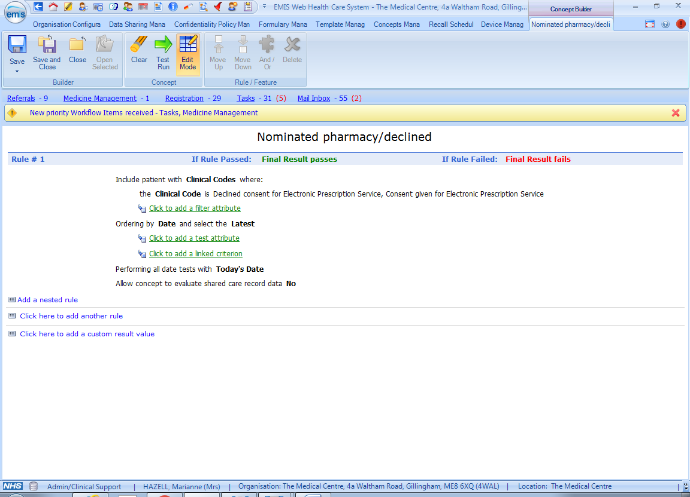

Use Concept to Create a Protocol Alert
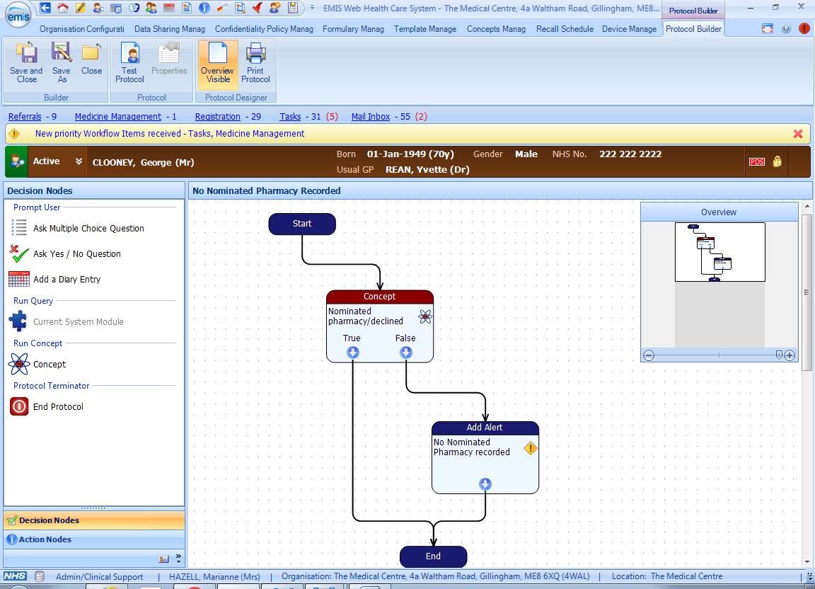

Patient Alert Box shows No Nominate Pharmacy recorded
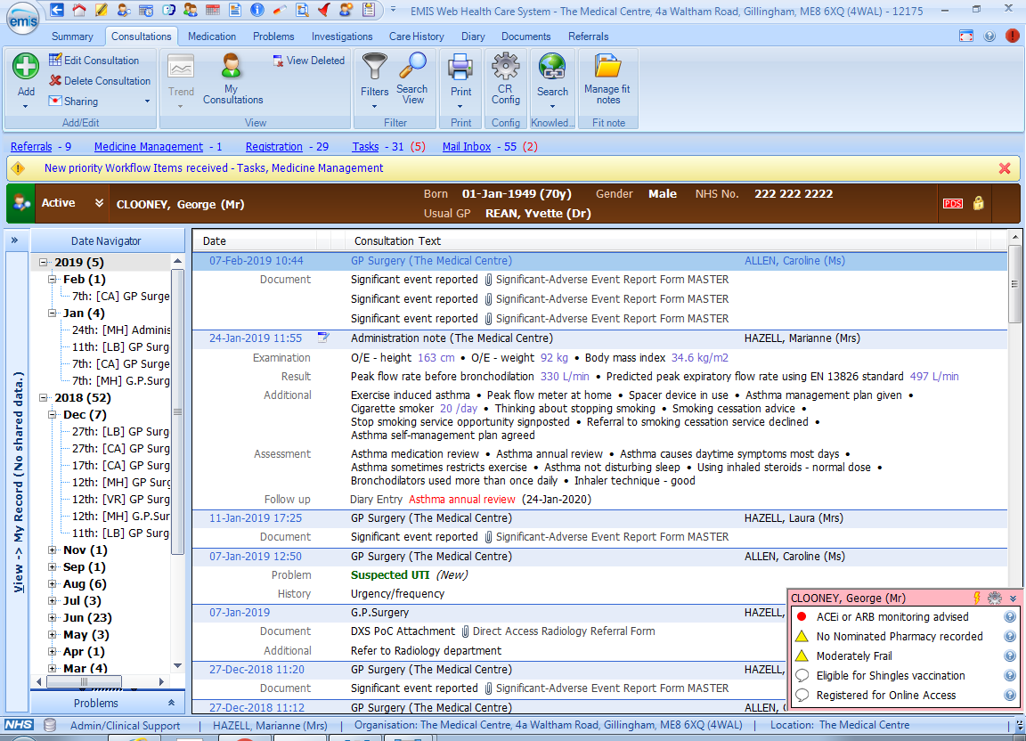

Protocol launcher (F12 button) for staff
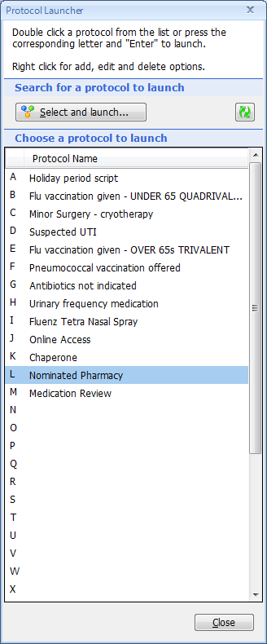

Create a Template to accurately record read code
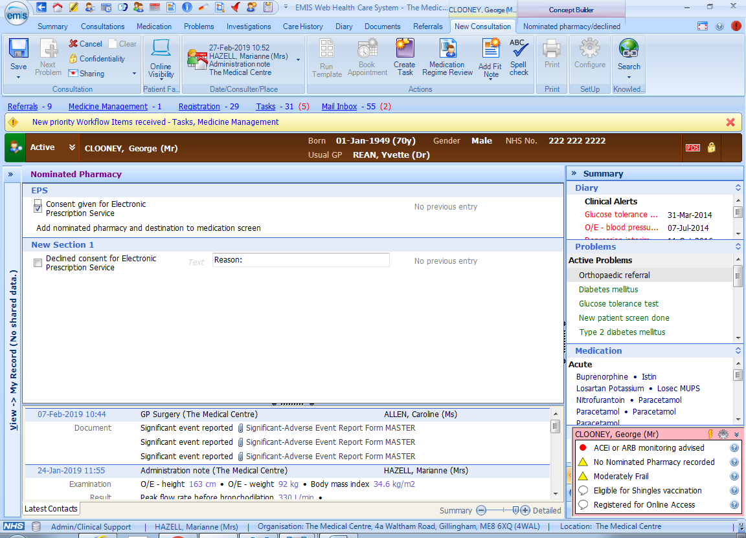

Once template is updated and saved, the alert will no longer appear.

