eDEN User Guide
Dashboard Guidance
Content
NHSBSA eDEN Dashboard Guidance 1
Dashboard Name 1
About this document 1
General Notes 1
Dashboard Tab – Commissioner overview 2
Sub Tab – General services 2
Sub Tab – Orthodontic services 6
Dashboard Tab – Contract Overview 9
Sub Tab – Contract Profile 9
Sub Tab – Activity Summary 13
Sub Tab – Activity Analysis 15
Sub Tab – Clinical Data Set 18
Sub Tab – Orthodontic Data 20
Sub Tab – Patient Access 22
Sub Tab – Patient Profile 24
Sub Tab – Performer Profile 25
Sub Tab – Monitoring 26

NHSBSA eDEN Dashboard Guidance
Dashboard Name
Dentistry Dashboard

About this document
This document is designed to sit alongside the NHSBSA eDEN Dashboard content to provide some context around the different types of analyses and information presented.

General Notes
- Data extracted from FP17s scheduled each month of the reporting year in accordance with year-end methodology.
- Each FP17 scheduled between April and June is allocated to a Reporting Year based on the treatment completion date.
- Delivery is measured against contracted values and activity as entered on CoMPASS, for each Reporting year, by commissioners.
- Current year to date is the latest reporting Time period and the comparators are previous full reporting years.

Dashboard Tab – Commissioner overview

Sub Tab – General services
Analysis Name | Description | Image
% of UDA/UOA or COT Services Provided | Delivered measure expressed as a percentage of measure contracted. For example: (UDA Achieved - Carry Forward UDA) / Contracted UDA) x 100 | 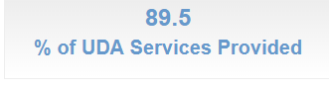
No. of General Contracts | The number of contracts paid by the NHSBSA with at least 1 UDA scheduled during the reporting period. | 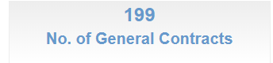
Value of UDA Services | The total contracted value for general commissioned services for all contracts paid by the NHSBSA. | 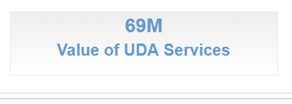
Data for Area Teams within Selected Region | Bar Graph with UDA delivery percentage by Area Team of the selected region.  Red indicates delivery under 96% and Green is 96% or over. | 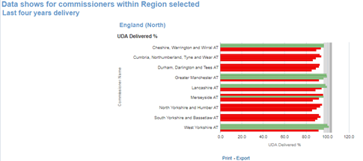
UDA Services Delivered time series | Table illustrating annual UDA delivered expressed as a percentage of UDA contracted | 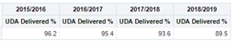
Contract UDA Service Delivery Comparison (Paid by NSBSA) | Bubble chart with amount and percentage of UDA delivered percentage by contract.  Bubble size illustrates contract value commissioned. | 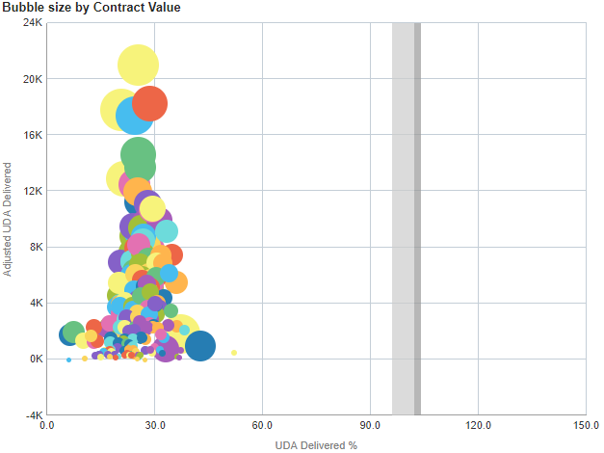
Contract UDA Service Delivery Comparison (Paid by NSBSA) | Bar Chart - | 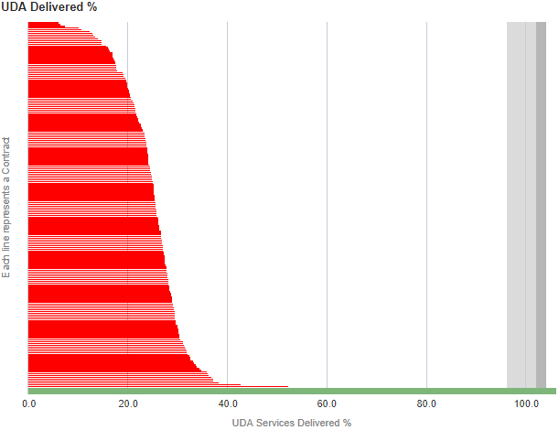
Contract UDA Service Delivery Comparison | Bubble chart with amount and percentage of UDA delivered percentage by contract.  Bubble size illustrates contract value commissioned. | 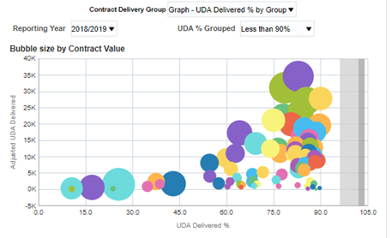
Contracts grouped by % service delivered | Graphic of Number of contracts grouped by percentage of UDA delivered. | 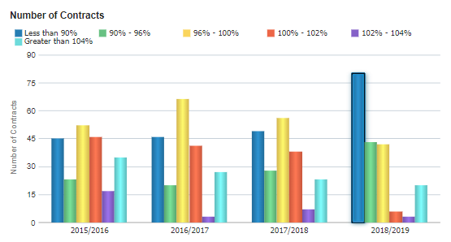
Contracts grouped by % service delivered | Bubble chart with amount and percentage of UDA delivered percentage by contract.  Bubble size illustrates contract value commissioned. | 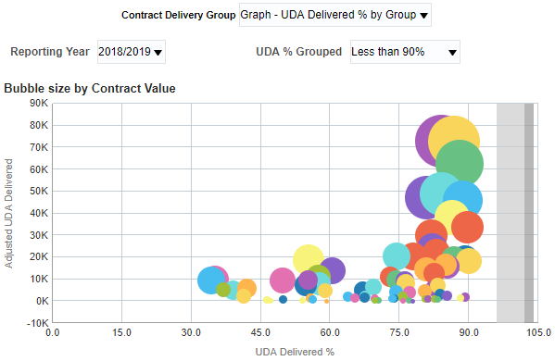
Individual Contract UDA Services - Delivery by Reporting Year | Table of data – showing % of UDA delivered for selected contract number and name. | 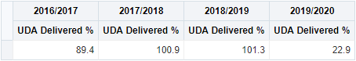
Individual Contract UDA Services - Delivery by Reporting Year | Bar chart - showing % of UDA delivered for selected contract number and name. | 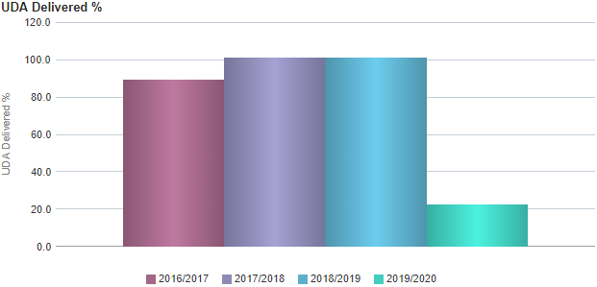
Map to show where UDA services are contracted 2019/2020 | Map Graphic – showing where UDA services are contracted in the selected region. | 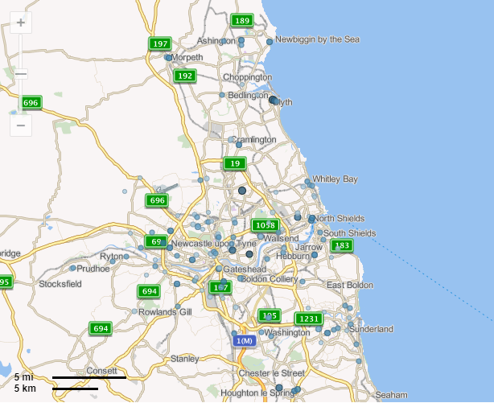

Sub Tab – Orthodontic services

Analysis Name | Description | Image
% of UOA Services Provided | Performance Tile – Showing percentage of UOA Services Provided for the selected Commissioner | 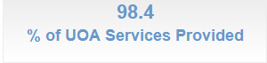
No. of Orthodontic Contracts | Performance Tile - Showing No. of Orthodontic Contracts for the selected Commissioner | 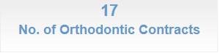
Value of UOA Services | Performance Tile - Showing Value of UOA Services for the selected Commissioner | 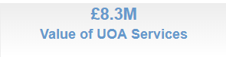
UOA Services Delivered % | Horizontal Bar chart – showing all Commissioners under the region, green bars represent commissioner achieving the 96% threshold for the retrospective time period, red indicates they fall under the threshold | 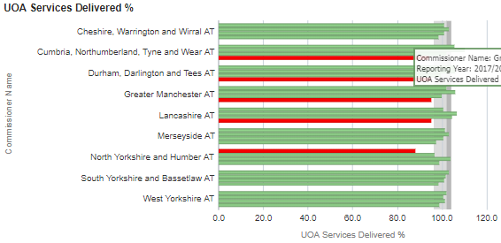
UOA Services – Delivery by Reporting Year | Table of data – showing % of UOA delivered for the selected Commissioner for the latest 4 years | 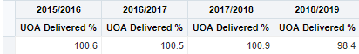
Contracts UOA Services Delivery Comparison (Paid by NHSBSA) 2018/2019 | Bubble chart – showing bubble for each contract under the selected commissioner, higher up the chart the more ‘Adjusted Scheduled UOA’ provided, further to the right higher % of UOA Delivered, bubble sized by the UOA Financial Value i.e. bigger the bubble bigger the value | 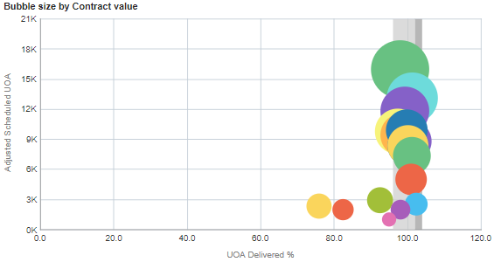
Contracts UOA Services Delivery Comparison (Paid by NHSBSA) 2018/2019 | Horizontal bar chart – showing all contracts under the selected commissioner, green bars represent commissioner achieving the 96% threshold for the retrospective time period, red indicates they fall under the threshold. | 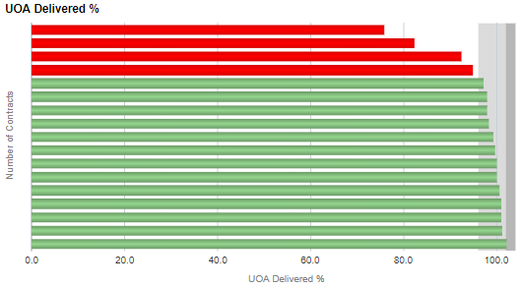
Contracts grouped (Paid by NHSBSA) by % services delivered | Vertical bar chart – showing the number of contracts grouped by % of UOA delivered for each of the latest 4 financial years. | 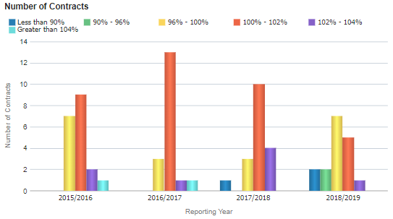
Contracts grouped (Paid by NHSBSA) by % services delivered | Bubble chart - showing bubble for each contract in the selected grouping and time period, higher up the chart the more ‘Adjusted Scheduled UOA’ provided, further to the right higher % of UOA Delivered, bubble sized by the UOA Financial Value i.e. bigger the bubble bigger the value | 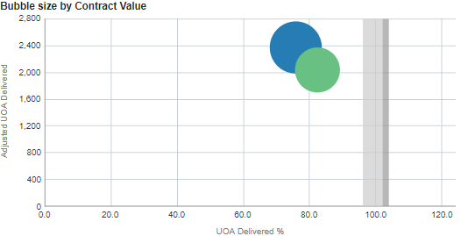
Individual Contract UOA Services – Delivery by reporting year | Table of data - showing % of UOA delivered for the selected contract for the latest 4 years | 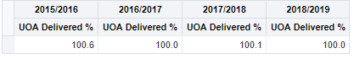
Individual Contract UOA Services – Delivery by reporting year | Bar chart - showing % of UOA delivered for the selected contract for the latest 4 years | 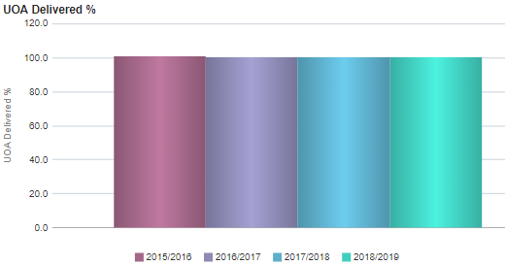
Map to show where UOA services are contracted | Map Graphic - where UOA services are contracted in the selected regin | 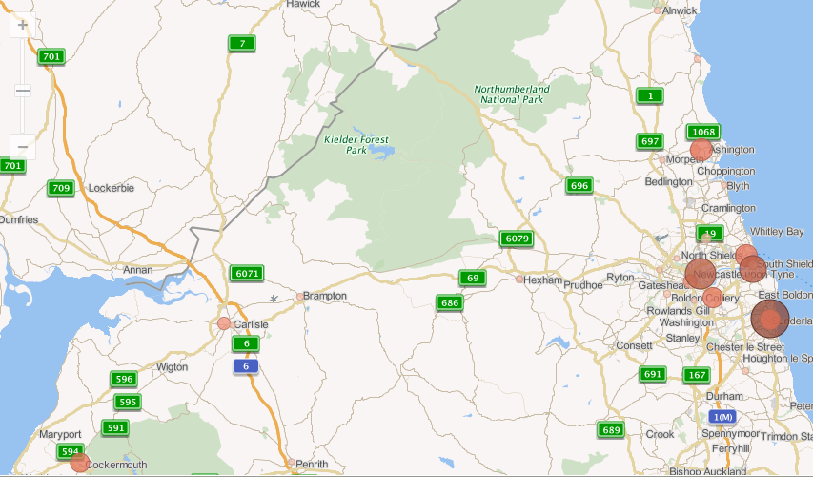

Dashboard Tab – Contract Overview

Sub Tab – Contract Profile

Re-attendance data Includes all FP17s in the reporting period, regardless of treatment dates, also urgent, orthodontic & foundation dentist FP17s.
Re-attendance intervals are the number of days between the date of acceptance and the most recent date of completion from the two most recent FP17s scheduled in the same or a previous schedule month for FP17s for the same patient identity (surname, initial, gender and date of birth) with a previous course of treatment for that patient identity at the same contract . Expressed as a percentage of total FP17s by Adult/Child and by Patient charge status (Child/Exempt Adult/Non-Exempt Adult) with National and Regional comparators.
Analysis Name | Description | Image
Contract Information | Details of contract - Contract details as entered by commissioners on CoMPASS.
% Annual UDA Services Delivered | Performance Tile – Showing percentage of annual UDA services delivered for the selected time period and contract. | 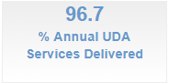
% Annual UOA Services Delivered | Performance Tile – Showing percentage of annual UOA services delivered for the selected time period and contract. | 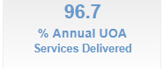
% Annual COT Services Delivered | Performance Tile – Showing percentage of annual COT services delivered for the selected time period and contract. | 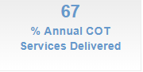
Delivery of UDA and UOA Services Contracted – UDA Services Delivered % | Line chart – showing line for % of UDA services delivered for each financial year, grey bar represents delivery threshold, grey lines represent quarterly thresholds | 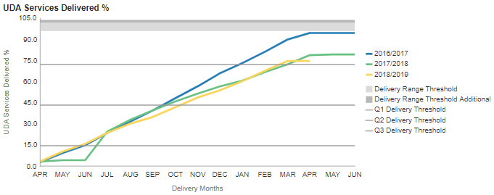
Delivery of UDA and UOA Services Contracted – UOA Services Delivered % | Line chart – showing line for % of UOA services delivered for each financial year, grey bar represents delivery threshold, grey lines represent quarterly thresholds | 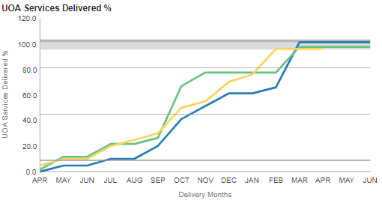
Patient Access – Adult Patient Count – 24 Months | Line chart - snapshot at end of each month with a count of unique adults patients over previous 24 months for last 3 years. | 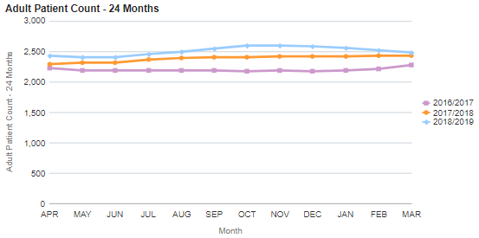
Patient Access – Child Patient Count – 12 Months | Line chart - snapshot at end of each month with a count of unique child patients over previous 12 months for last 3 years. | 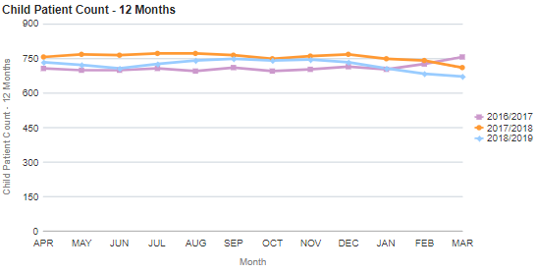
FP17 forms for the same Patient ID (Re-attendance) Adult/Child  Forms processed between selected time period | Stacked horizontal bar chart – for the selected contractor broken down by age group | 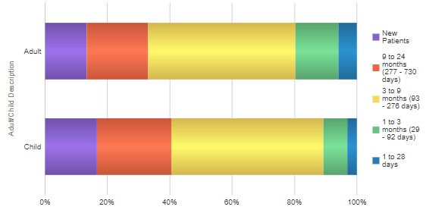
FP17 forms for the same Patient ID (Re-attendance) Adult/Child  Forms processed between selected time period | Stacked horizontal bar chart – for the selected contractor broken down by age group | 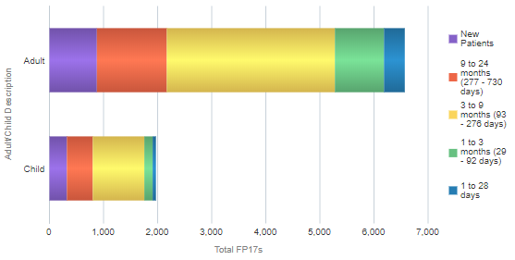
England | Stacked horizontal bar chart – for the Country broken down by age group | 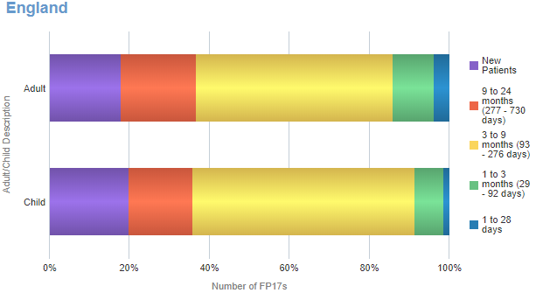
England region (i.e. North) | Stacked horizontal bar chart – for the region  broken down by age group | 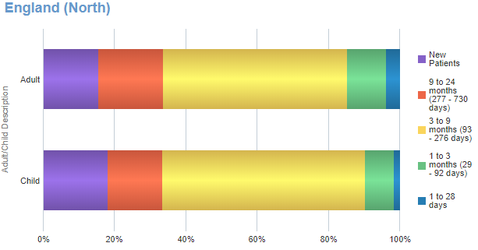
FP17 forms for the same Patient ID (Re-attendance) by Adult Patient Charge Status | Stacked horizontal bar chart – for the selected contract  broken down by age group | 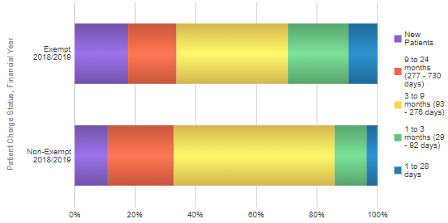
FP17 forms for the same Patient ID (Re-attendance) by Adult Patient Charge Status | Stacked horizontal bar chart – for the selected contract  broken down by age group | 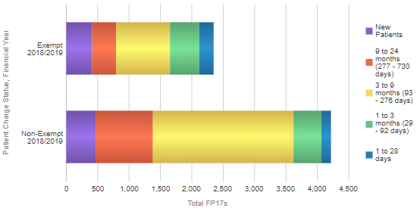
England | Stacked horizontal bar chart – for the country  broken down by age group | 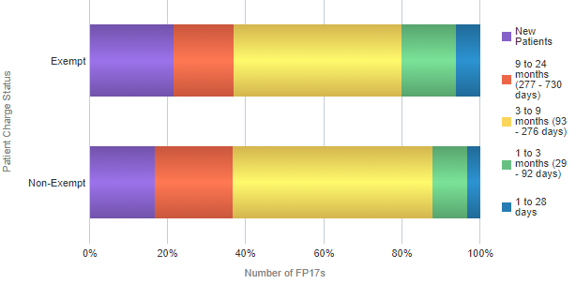
England region (i.e. North) | Stacked horizontal bar chart – for the region  broken down by age group | 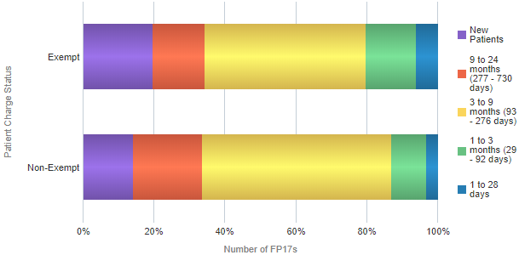

Sub Tab – Activity Summary

Analysis Name | Description | Image
Contract UDA Service Delivery Comparison | Vertical bar chart – showing the percentage of UDA services delivered | 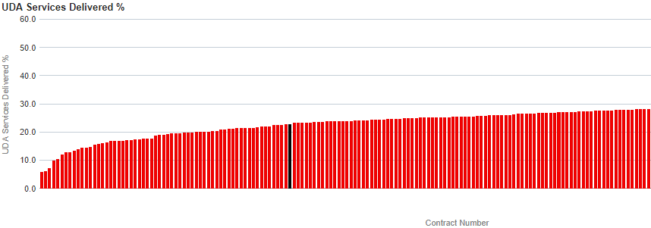
Dental Services - General | Table of data – showing Reporting Year Contract Number, UDA financial value, UDA services Contracted, UDA carry forwards, UDA provided to date, Balance of UDA, % of UDA Services Provided. | 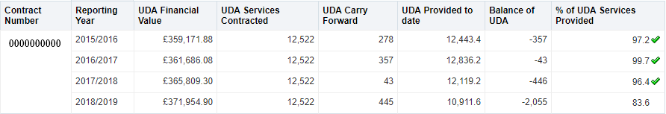
Dental Services - Orthodontic | Table of data - showing Reporting Year Contract Number, UOA financial value, UOA services Contracted, UOA carry forwards, UOA provided to date, Balance of UOA, % of UOA Services Provided. | 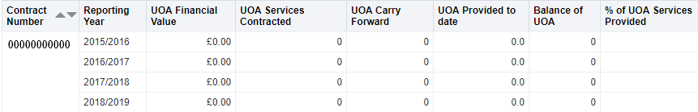
Dental Services - Courses of Treatment | Table of data - showing Reporting Year Contract Number, COT financial value, COT services Contracted, COT carry forwards, COT provided to date, Balance of COT, % of COT Services Provided. | 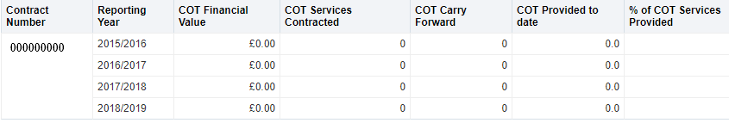
Dental Services - Other | Table of data – showing Contract Number, Reporting Year, Other Financial Value, Other Services Contracted | 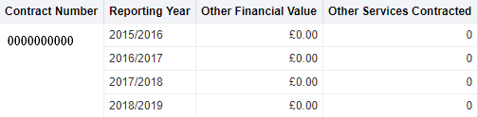

Sub Tab – Activity Analysis

Analysis Name | Description | Image
General Activity | Stacked bar chart – showing data for selected time period and contract number. Graph shows UDA’s delivered by band, urgent treatment and others represented by the green bars, the blue bar shows the total UDA’s delivered. | 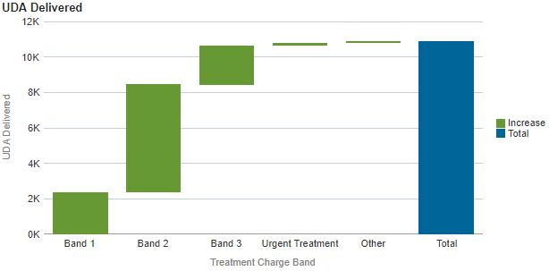
General Activity | Stacked bar chart – showing data for selected time period and contract number. Graph shows Number of FP17’s provided by band, urgent treatment and others represented by the green bars, the blue bar shows the total FP17’s provided. | 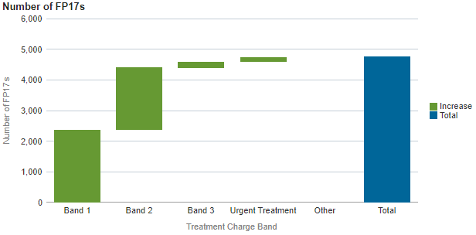
UDA by Patient Charge Status | Pie chart – showing breakdown of patient charge status for the selected time period and contract number. Pie chart is broken into three slices, Blue = Child, Green = Exempt and Yellow = Non-Exempt | 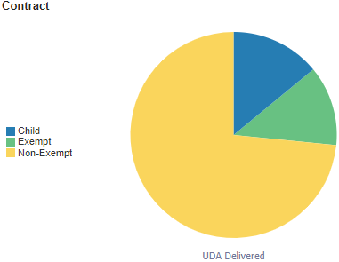
UDA by Patient Charge Status | Pie chart – showing breakdown of patient charge status for the selected time period for England. Pie chart is broken into three slices, Blue = Child, Green = Exempt and Yellow = Non-Exempt | 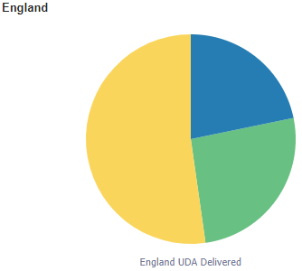
UDA by Patient Charge Status | Pie chart – showing breakdown of patient charge status for the selected period and Commissioner. Pie chart is broken into three slices, Blue = Child, Green = Exempt and Yellow = Non-Exempt | 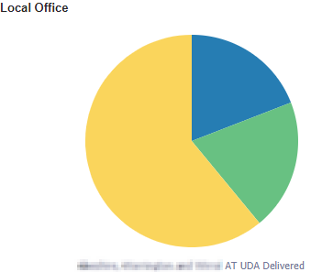
UDA by Patient Charge Status and Band | Pie chart – showing breakdown of patient charge status for the selected charge band, time period and contract number. Pie chart is broken into three slices, Blue = Child, Green = Exempt and Yellow = Non-Exempt | 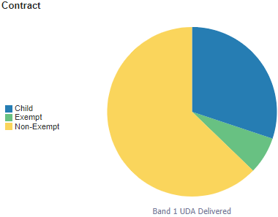
UDA by Patient Charge Status and Band | Pie chart – showing breakdown of patient charge status for the selected charge band and time period for England. Pie chart is broken into three slices, Blue = Child, Green = Exempt and Yellow = Non-Exempt | 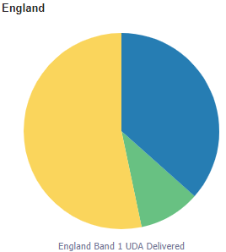
UDA by Patient Charge Status and Band | Pie chart – showing breakdown of patient charge status for the selected charge band, Commissioner and time period. Pie chart is broken into three slices, Blue = Child, Green = Exempt and Yellow = Non-Exempt | 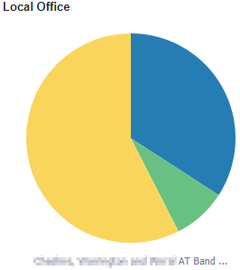

Sub Tab – Clinical Data Set

Analysis Name | Description | Image
Clinical Data Set | Horizontal bar chart – showing the overall clinical data set treatment rates per 100 FP17’s, for the selected time period and contract | 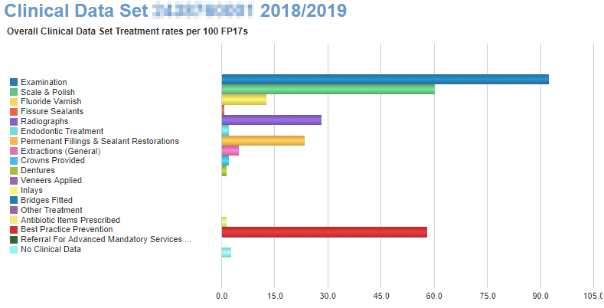
Clinical Data Set Band and Patient Adult/Child | Vertical bar chart – showing clinical data set treatment rates per 100 FP17’s, for the selected time period, adult/child description, treatment charge band and contract | 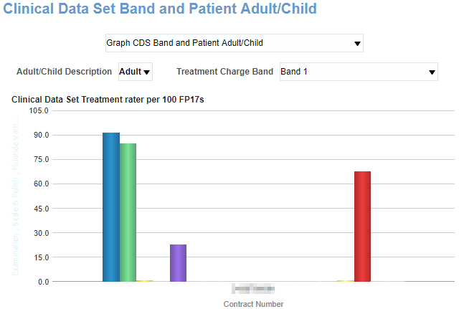
Clinical Data Set Adult Patient Charge Status and Band | Vertical bar chart – showing clinical data set treatment rates per 100 FP17’s, for the selected time period, patient charge status, treatment charge band and contract | 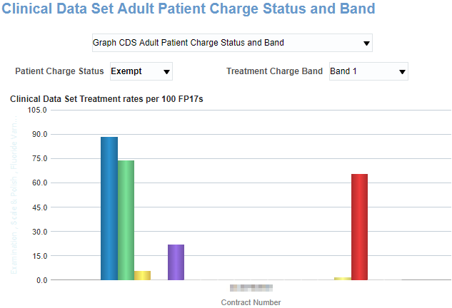
CDS Rates per 100 FP17s over time | Line chart – showing CDS Rates per 100 FP17s over time for the latest 15 months by month. Three views to choose from: Scale and Polish, Radio Graph or Fluoride Varnish rates. | 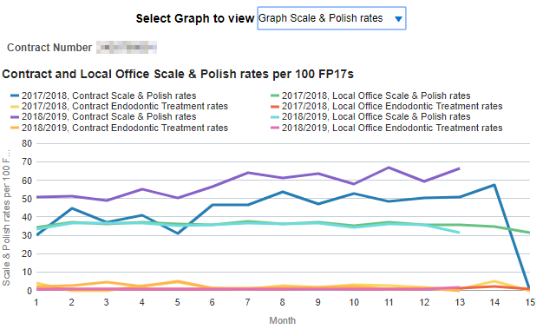

Sub Tab – Orthodontic Data

Analysis Name | Description | Image
Orthodontic FP17s | Stacked bar chart – showing number of FP17s for the selected contractor and time period. Green bars represent assessment type blue bar shows the total. | 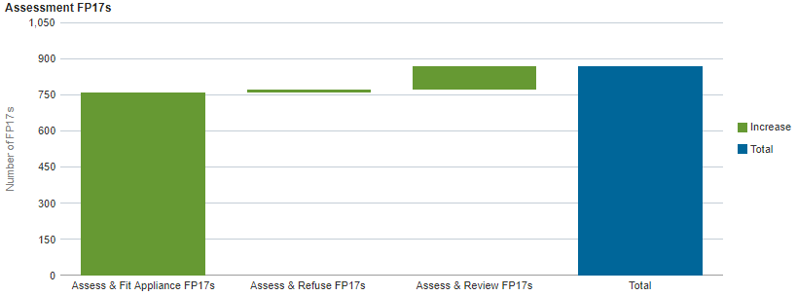
Orthodontic FP17s | Table of data – showing Assessment FP17s, % of all assessments that were assess and fit appliance (case starts), % of all assessments that were assess and review, % of all assessments that were assess and refuse.
Concluded treatment FP17s | Bar chart showing the number of concluded treatment FP17s, green bars represent the concluded treatment categories, blue bar shows total. | 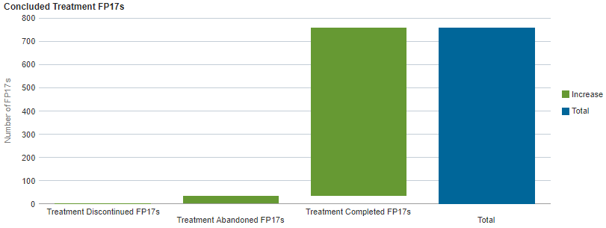
Concluded treatment FP17s | Table of data – showing: Concluded treatment FP17s, Completed treatment FP17s, % concluded treatment where treatment was completed, Concluded courses abandoned or discontinued, % concluded treatment where treatment was completed
Concluded treatment FP17s | Table of data – showing Forms With Orthodontic Regulation 11 Replacement Appliance, Forms With Repair to Appliance Fitted By Another Dentist

Sub Tab – Patient Access

During the last 12 or 24 months. Patients have been identified by using surname, first initial, gender and date of birth. No other identifiers have been used. This is a pragmatic compromise between undercounting patients with common identifiers and over-counting where there are slight differences in recorded details.
Each unique patient ID is counted against the dentist contract against which the most recent claim was recorded in the 12 or 24 month period, with the following exceptions. If the most recent claim is for urgent treatment, orthodontic treatment, free treatment or treatment on referral the ID remains with the previous contract, if there is one within the 12 or 24 month period. If the claim for the previous contract occurred before the 12 or 24 month period the ID is allocated to the most recent contract.
Analysis Name | Description | Image
Patient Access | Table – Showing 12 month and 24 month patient counts by adult/child. For the selected contract. | 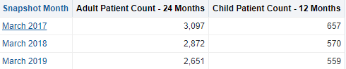
Patient Access | Vertical bar chart – Showing 24 month adult patient count up to the time period indicated, i.e. Yellow indicates the adult patient count for the 24 months up to March 2019. | 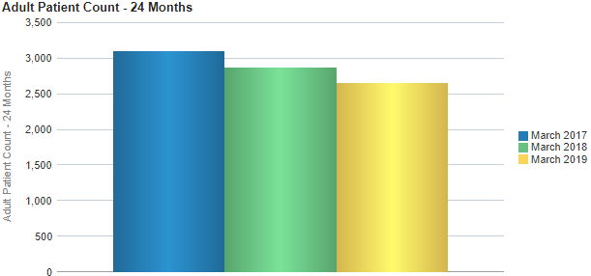
Patient Access | Vertical bar chart – Showing 12 month child patient count up to the time period indicated, i.e. Yellow indicates the child patient count for the 12 months up to March 2019. | 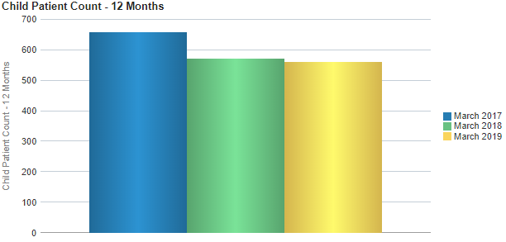
Patient Access - By Age | Vertical bar chart – Showing 24 month adult patient count up to the time period indicated for the selected patient age band, i.e. Yellow indicates the adult patient count for the 24 months up to March 2019. | 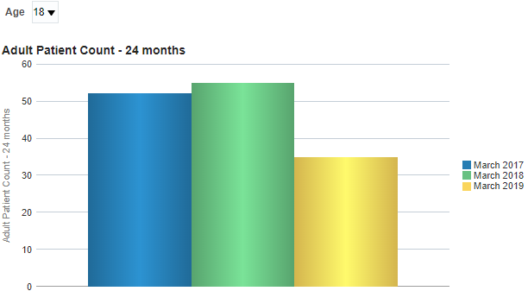
Patient Access - By Age | Vertical bar chart – Showing 12 month child patient count up to the time period indicated for the selected child age band, i.e. Yellow indicates the child patient count for the 12 months up to March 2019. | 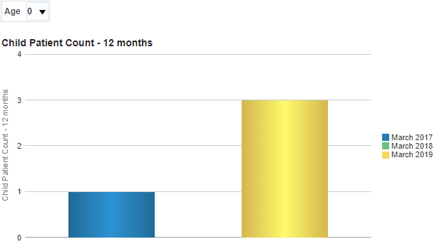

Sub Tab – Patient Profile

Analysis Name | Description | Image
Patient Profile - General | Vertical bar chart – showing Total FP17’s for each age group and sex. | 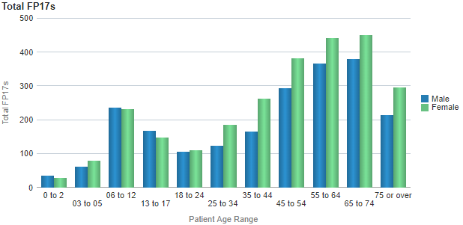
Patient Profile - General | Vertical bar chart – showing UDA delivered for each age group and sex. | 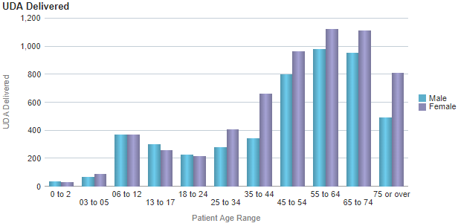
Patient Profile - General | Table of data – showing  Total FP17’s, % FP17s, UDA Delivered, % UDA and Number of patients treated. Split by age group for selected gender. | 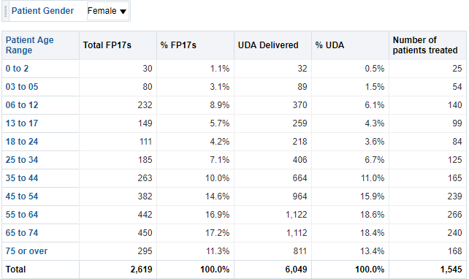

Sub Tab – Performer Profile

Analysis Name | Description | Image
Performer Summary | Table of data- showing data for UDA and UOA for selected contract, broken down to individual performers. | 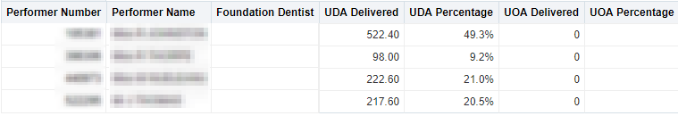
UDA Delivered | Vertical bar chart – showing UDA delivered by performer. | 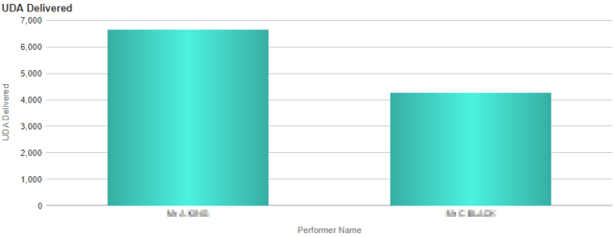
UDA Delivered | Line chart – showing time series of UDA delivered by performer. | 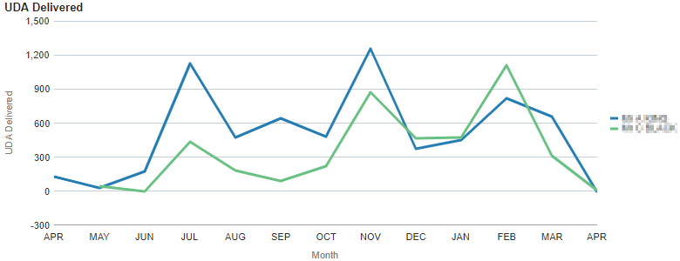
FP17’s by treatment charge band | Stacked bar chart – showing percentage breakdown by charge band from total form count, by performer | 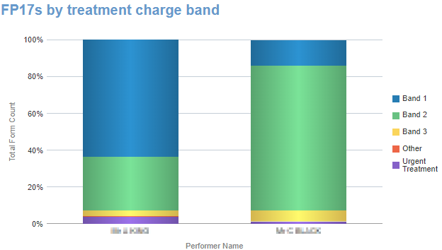
FP17’s by treatment charge band | Stacked bar chart – showing breakdown by charge band from total form count, by performer | 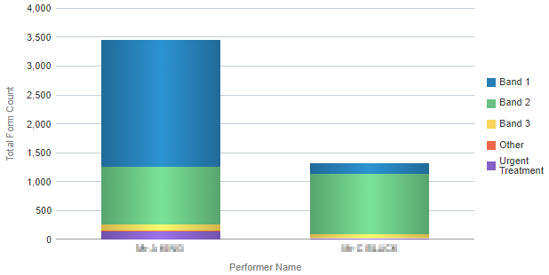

Sub Tab – Monitoring

Analysis Name | Description | Image
FP17s with Other Treatment Categories | Table of data – showing: Total FP17s, Incomplete treatment, treatment on referral, Free repair/replacement, Late submitted FP17, Further Treatment within 2 months, Number of patients with more than 24 UDA, Band 2 or 3 FP17s, Band 2 or 3 FP17s ‘Other treatment’, Band 3 FP17s, Band 3 Same Day FP17s, Band 2 & 3 No clinical data. | 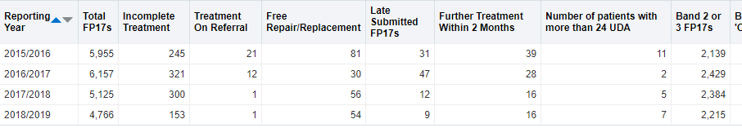
Other categories rate per 100 FP17s | Line chart – showing trend over time for other categories rate per 100 FP17s | 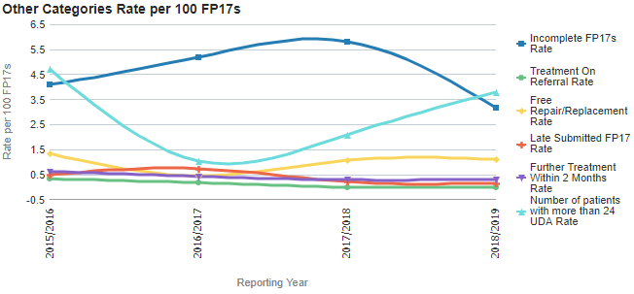
Band 2 and 3 FP17s | Line chart – showing trend over time for band 2 and 3 rate per 100 FP17s | 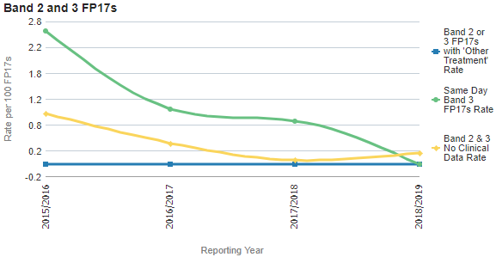
General patient questionnaire satisfaction results 12 months ending to selected time period | Table of data – showing questionnaire results | 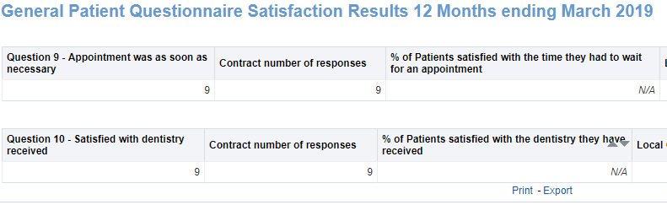
General Patient Questionnaire Satisfaction Results 12 Months | Table of data – showing questionnaire results | 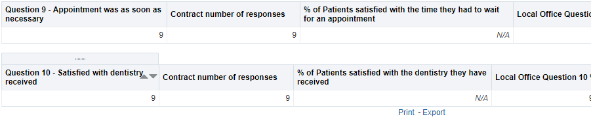
Orthodontic Patient Questionnaire Satisfaction Results 12 Months | Table of data – showing questionnaire results

