eDEN User Guide
Commissioner Overview Reports

Contents
Finding the Commissioner Overview Reports 1
Using the Commissioner Overview reports 2
Commissioner Overview Report – General Services 4
Dental Services – General (Paid by NHS BSA) 4
Commissioners within Region graph 5
UDA Services - Delivery by Reporting Year 5
Contracts grouped by % service delivered 7
Updating data displayed 9
Commissioner Overview: Summary – Orthodontic Services 11
Dental Services - Orthodontic (Paid by NHSBSA) 13
Commissioners within Region graph 14
UOA Services - Delivery by Reporting Year 14
Contract UOA Service Delivery Comparison (Paid by NHSBSA) 14
Contracts grouped by % service delivered 16
Updating data displayed 17

Finding the Commissioner Overview Reports
- From the landing page select the Dentistry Dashboard icon.
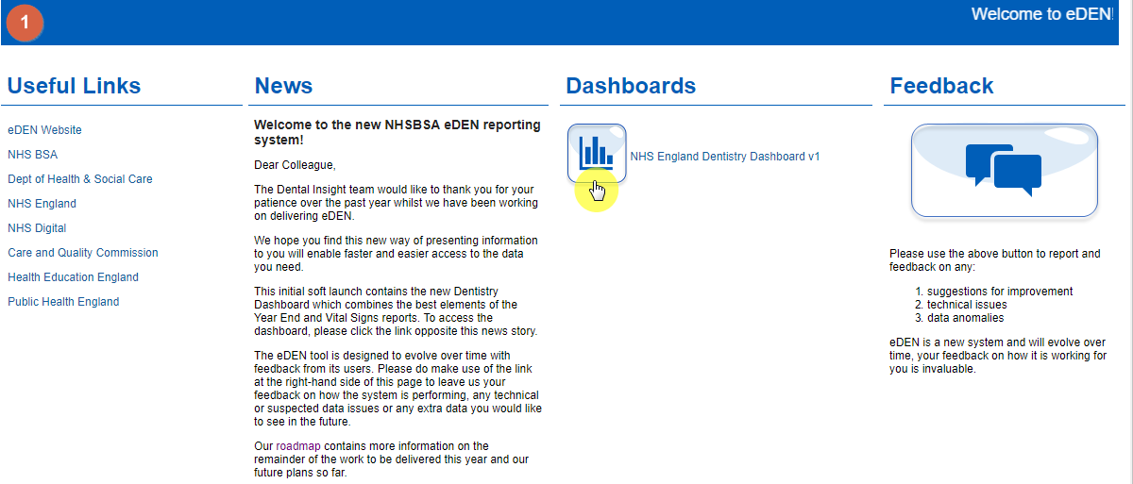
- The Commissioner Overview reports will be displayed
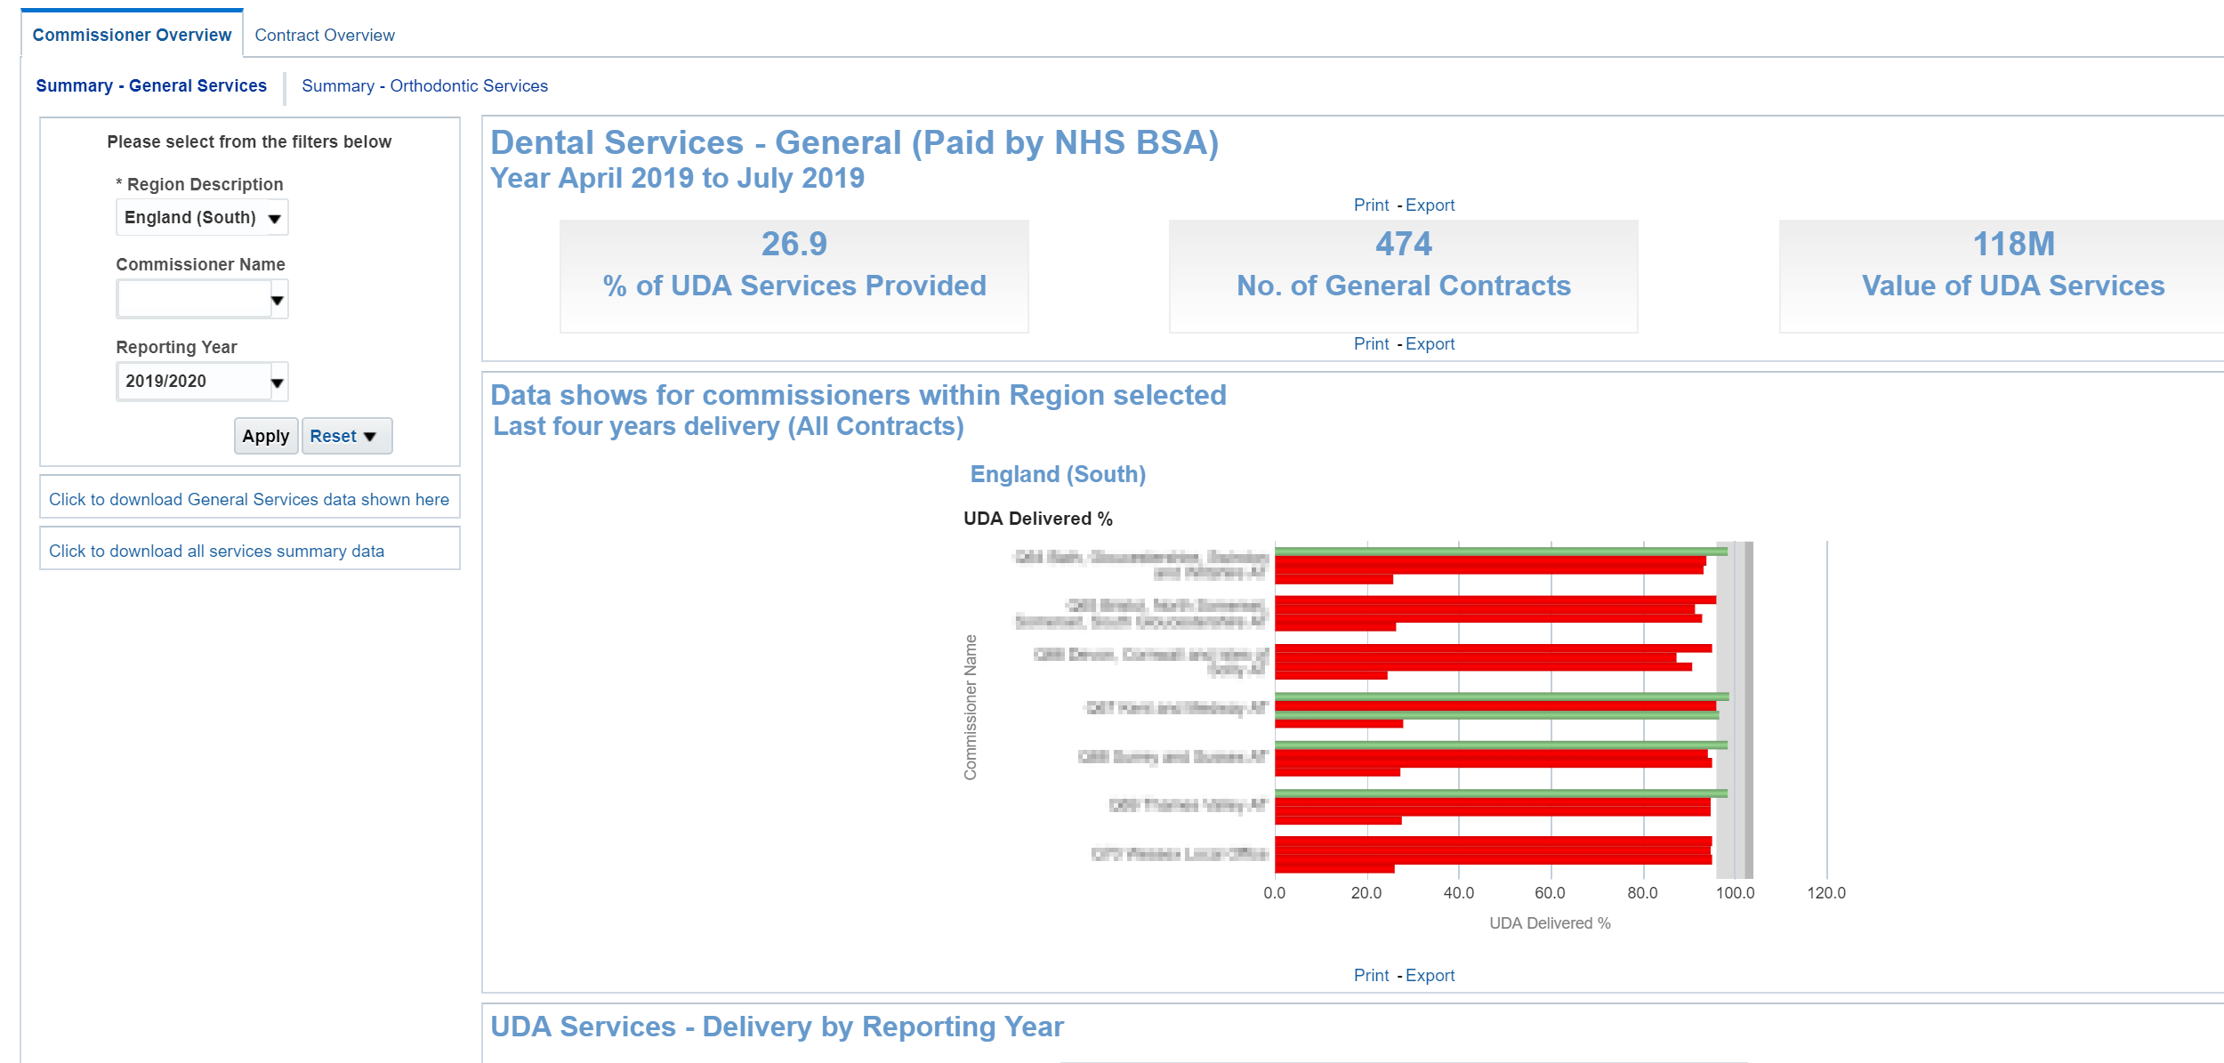

Using the Commissioner Overview reports
The Commissioner Overview report is split into two separate pages – Summary General Services and Summary – Orthodontic Services
To change the data being displayed use the criteria selector prompts and select the organisation and the financial year you wish to view data for.
- Select Region
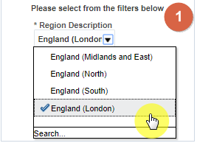
- Select Commissioner Name
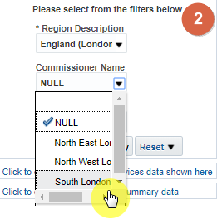
- Select reporting year, by default the latest reporting year will be selected
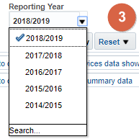
- Click ‘Apply’ the dashboard will update to show your data
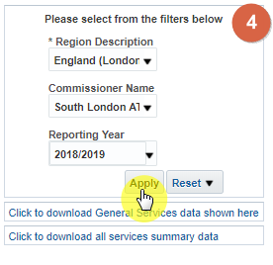

Commissioner Overview Report – General Services
The report is made up of many different views, graphs and data tables based on general dental services. This section of the guide gives more detail on each section of the report.

Dental Services – General (Paid by NHS BSA)
This view displays three tiles that give top level figures for your selected organisation and reporting year:
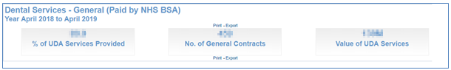

% of UDA Services Provided
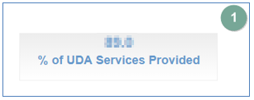
This figure displays the delivered measure expressed as a percentage of measure contracted. For example: (UDA Achieved - Carry Forward UDA) / Contracted UDA) x 100

No. of General Contracts
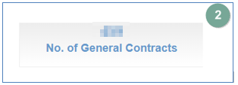
This figure displays the number of contracts paid by the NHSBSA with at least 1 UDA scheduled during the reporting period.

Value of UDA Services
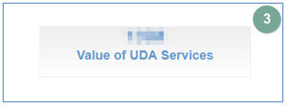
This figure displays the total contracted value for general commissioned services for all contracts paid by the NHSBSA.

Commissioners within Region graph
This bar graph displays the UDA delivery percentage by Area Team of the selected region.
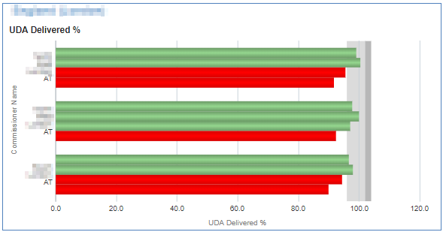
Red = Red indicates delivery under 96%.
Green = Green is 96% or over.
Grey = displays the delivery threshold
Contracts are required to hit over 96% to ensure they are meeting their delivery threshold.

UDA Services - Delivery by Reporting Year
Table displaying annual UDA delivered for the latest four years
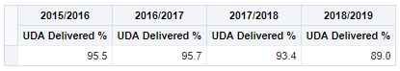
The figure is representing the total for the area team and is expressed as a percentage of the UDA contracted.

Contract UDA Service Delivery Comparison (Paid by NHSBSA)
These charts allow you to compare individual contractors within your selected commissioner organisation

Contract UDA service delivery comparison bubble chart
The chart displays the UDA financial value, the adjusted UDA delivered, and the UDA delivered percentage.
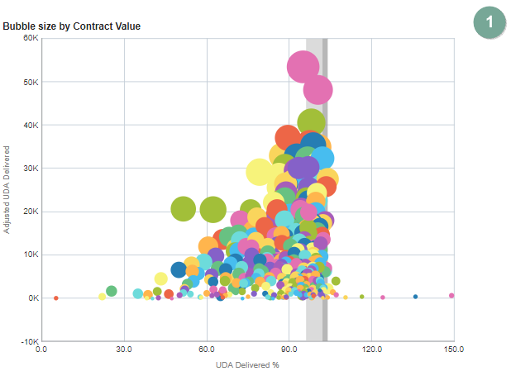
Y axis = adjusted UDA delivered
The higher up the Y axis the higher the amount of Adjusted UDA delivered

X axis = UDA delivered percentage
The further to the right on the X axis the higher percentage of UDA the contractor has delivered.

Bubble size = UDA financial value
The larger the bubble the higher UDA financial value for the contractor

Contract UDA service delivery comparison line chart
Horizontal bar graph highlighting UDA delivery percentage for each Contract
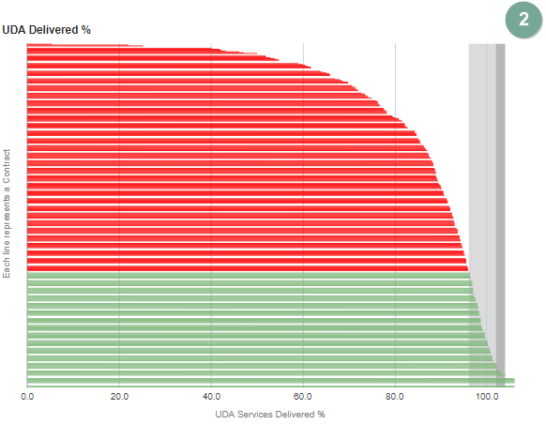
The red bars indicate the contractors that have not met the delivery threshold of 96%, the green bars show the contractors that have exceeded the threshold.

Contracts grouped by % service delivered
- Number of Contracts - Bar chart this view has bars showing number of contractors in each grouping by reporting year.
- Bubble size by Contract Value - Bubble chart this view has bubbles representing individual contractors.
- Individual Contract UDA services – Delivery by Reporting Year - table this view has a table of data showing the % UDA delivered for the selected contractor.
- UDA Delivered %, Bar chart this view has bars representing UDA delivered %.
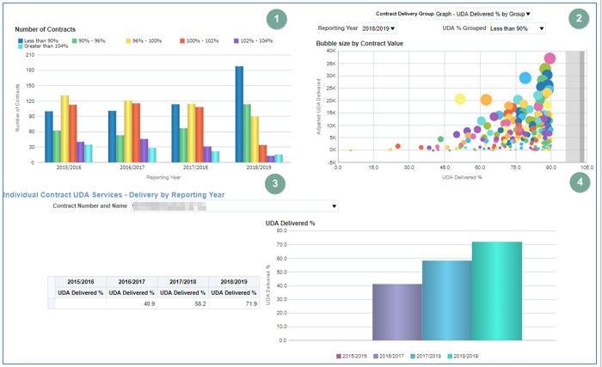

Updating data displayed
- Click on the bar for the grouping you wish to see individual contractors for.
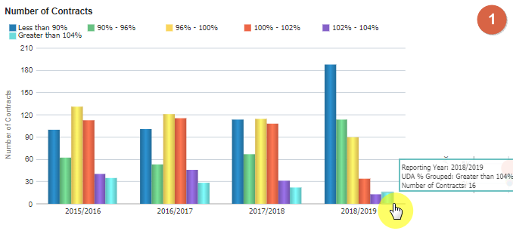
- The bubble chart will now update to show a bubble for each of the individual contracts for the selected time period and % UDA grouping.
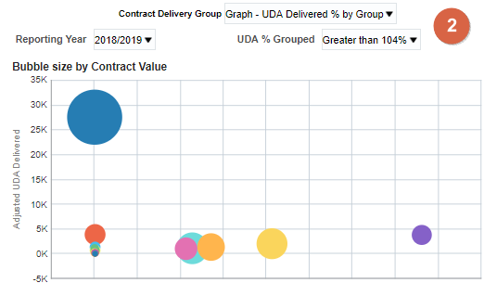
Y axis = adjusted UDA delivered
The higher up the Y axis the higher the amount of Adjusted UDA delivered

X axis = UDA delivered percentage
The further to the right on the X axis the higher percentage of UDA the contractor has delivered.

Bubble size = UDA financial value
The larger the bubble the higher UDA financial value for the contractor

- Select the contract you would like to display individual contract data for
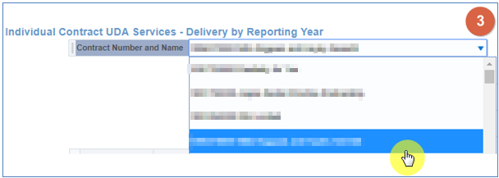
- The individual contractor views will now update.
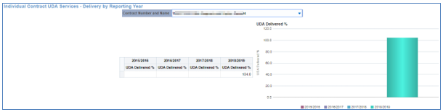

Commissioner Overview: Summary – Orthodontic Services
Select the ‘Summary – Orthodontic Services’ tab to navigate to this report.
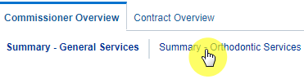
The selection from your previous page will carry though to this report, alternatively if you would like to view data for another organisation and time period:
Use the criteria selector prompts to select the organisation and the financial year you wish to view data for.
- Select Region
- Select Commissioner Name
- Select reporting year, by default the latest reporting year will be selected
- Click ‘Apply’ the dashboard will update to show your data

Dental Services - Orthodontic (Paid by NHSBSA)
This view displays three tiles that give top level figures for your selected organisation and reporting year:
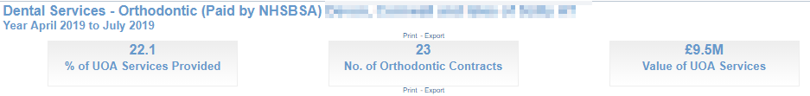

% of UOA Services Provided
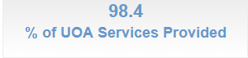
This figure shows the percentage of UOA Services Provided for the selected Commissioner.

No. of Orthodontic Contracts
This figure displays the number of Orthodontic Contracts for the selected Commissioner.

Value of UOA Services
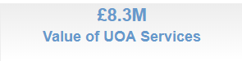
This figure displays the value of UOA Services for the selected Commissioner.

Commissioners within Region graph
This Bar Graph displays the UDA delivery percentage by Area Team of the selected region.
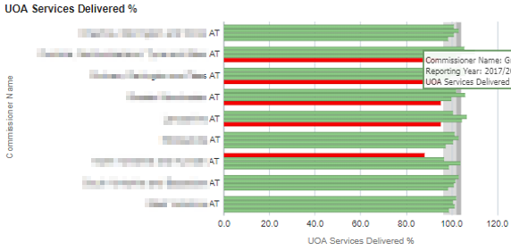
Red = Red indicates delivery under 96%.
Green = Green is 96% or over.
Grey = displays the delivery threshold
Contracts are required to hit over 96% to ensure they are meeting their delivery threshold.

UOA Services - Delivery by Reporting Year
Table displaying annual UOA delivered for the latest four years
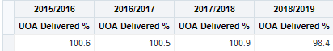
The figure is representing the total for the area team and is expressed as a percentage of the UOA contracted.

Contract UOA Service Delivery Comparison (Paid by NHSBSA)
These charts allow you to compare individual contractors within your selected commissioner organisation.

Contract UOA service delivery comparison bubble chart
The chart displays the UOA financial value, the adjusted UOA delivered, and the UOA delivered percentage.
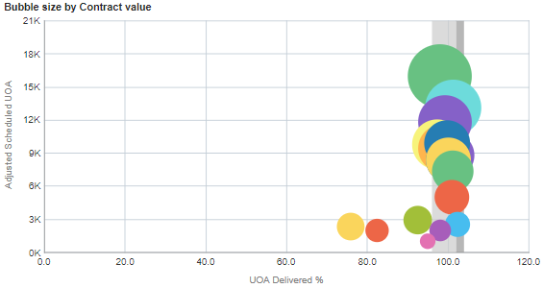
Y axis = adjusted UDA delivered
The higher up the Y axis the higher the amount of Adjusted UOA delivered

X axis = UDA delivered percentage
The further to the right on the X axis the higher percentage of UOA the contractor has delivered.

Bubble size = UDA financial value
The larger the bubble the higher UOA financial value for the contractor

Contract UOA service delivery comparison line chart
Horizontal bar graph highlighting UOA delivery percentage for each Contract
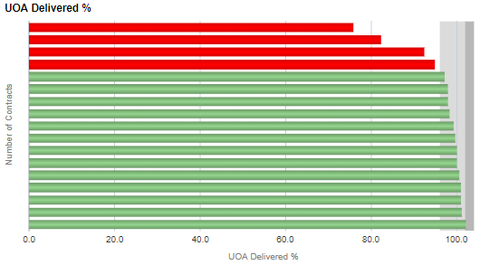
The red bars indicate the contractors that have not met the delivery threshold of 96%, the green bars show the contractors that have exceeded the threshold.

Contracts grouped by % service delivered
- Number of Contracts - Bar chart this view has bars showing number of contractors in each grouping by reporting year.
- Bubble size by Contract Value - Bubble chart this view has bubbles representing individual contractors.
- Individual Contract UOA services – Delivery by Reporting Year - table this view has a table of data showing the % UOA delivered for the selected contractor.
- UOA Delivered %, Bar chart this view has bars representing UDA delivered %.
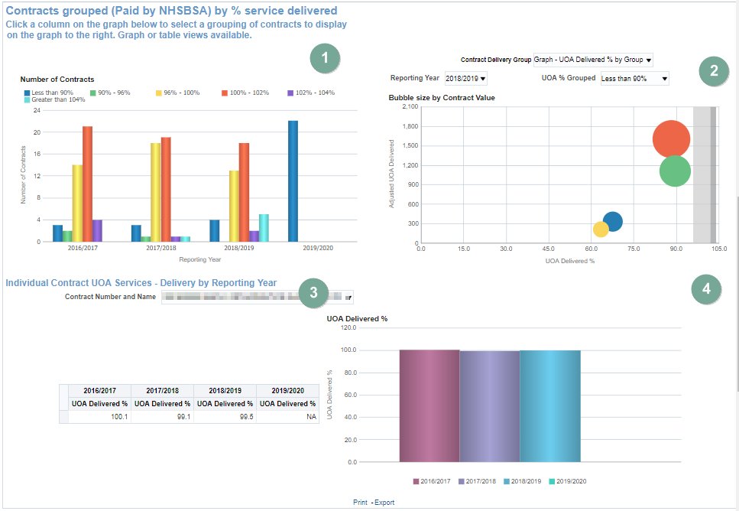

Updating data displayed
- Click on the bar for the grouping you wish to see individual contractors for.
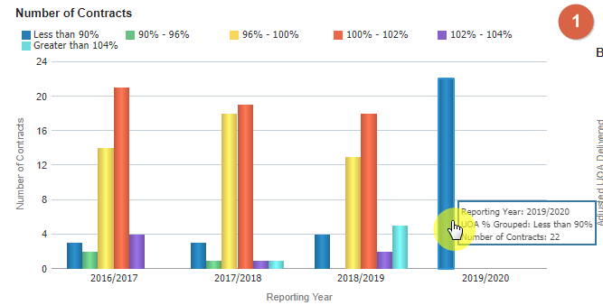
- The bubble chart will now update to show a bubble for each of the individual contracts for the selected time period and % UOA grouping.
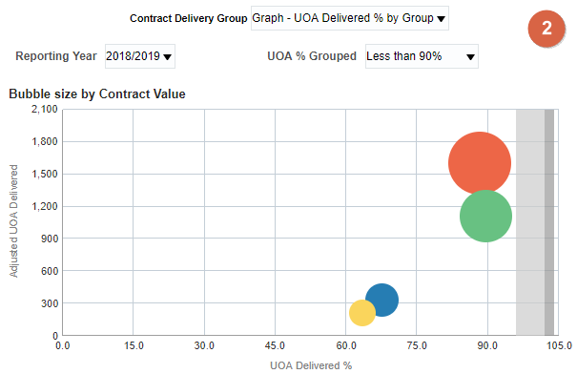
Y axis = adjusted UOA delivered
The higher up the Y axis the higher the amount of Adjusted UOA delivered

X axis = UOA delivered percentage
The further to the right on the X axis the higher percentage of UOA the contractor has delivered.

Bubble size = UOA financial value
The larger the bubble the higher UOA financial value for the contractor

- Use the prompt to select the contract you would like to display individual contract data for In the Individual Contract UOA Services - Delivery by Reporting Year section.
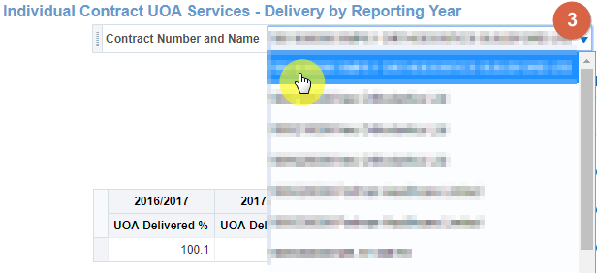
- The individual contractor views will now update.
