eOPS User Guide

Dashboard Guidance

Created Date: | 04/02/2020 | Reviewed On: | 10/02/2020
Author: | Rob Haynes | Reviewed By: | Wilma Harvey-Reid
Department: | Ophthalmic Information Services
Owner: | Jason Harper

Contents
eOPS User Guide 1
Dashboard Guidance 1
NHSBSA eOPS Dashboard General Guidance 2
Dashboard Name 3
Accessing and Navigating 3
Accessing 4
Navigating 4
Dashboard Overview 6
Analysis Guide 10
Sight Tests 10
Vouchers 13
Supplements 16
Repairs, Replacements & Small Glasses 19
Finance 21
Benchmarking 21
Average Contractor 26

NHSBSA eOPS Dashboard General Guidance

Dashboard Name
NHS England Ophthalmic Dashboard v1
This is also referred to as eOPS.
This document is designed to complement the NHSBSA eOPS Dashboard content & Glossary, to provide context on the different types of analyses & information presented.

- The Practice Profile Report (PPR) & Monthly Expenditure Report by Practice (MERP) are extracted once a month from Open Exeter & both are used to drive the content within eOPS.

- Any activity analysis is solely derived from the Practice Profile Report & the Finance data comes from the Monthly Expenditure Report by Practice (MERP) only.

- There is reference to the old Primary Care Trusts (PCTs) in the dashboard tool. The reason for this is because this is how the data is structured currently in Open Exeter. Once the eGOS dataset becomes available, the PCT tab will be retired from the dashboard.

- All reports are currently based on 4 Regional teams & 42 Area Teams (AT), this will update in April 2020, to reflect the transition to Strategy Transformational Partnerships (STPs).

- There are two views available for most of the graphs – a graph view or a table view. Use the drop down immediately above a graph to switch between these views.

- All references to Year refer to Financial Year and NOT Calendar Year.

- Any item labelled with * means that this is a mandatory field & the User must choose a value or no results will be displayed.

- Do make use of the hover text inside of graphs and other analysis. These can be useful to identify exactly each data point.

- This guidance doesn’t display every graphic or analysis available within eOPS, for instance GOS 4 Repairs have been described but additional graphs & tables for GOS 4 Replacements and GOS 4 Small Glasses have been omitted. The logic applied to one can apply to all similar graphs.

For further help and guidance, you can contact the NHSBSA Ophthalmic Insight team at: nhsbsa.ophthalmicinsight@nhs.net

Accessing and Navigating

Accessing

Should you require access to eOPS as part of your day-to-day Ophthalmic commissioning activities, simply send an email to nhsbsa.opthalmicinsight@nhs.net to start the process.
Please include your First Name, Last Name, Job Title & the name of the Regional Commissioning team that you work for, in any email that you send to us.
We will respond and provide an eOPS User Agreement that you must agree & adhere to by return, before any account creation can progress.
Further information about the exact steps will be provided following successful sign-up.
Access is currently limited to the Ophthalmic Commissioning Regional Teams (RT).
Should you be a member of the public, other NHS colleague, an academic institute or any other body that would like, or need some further information on accessing our data in the meantime, please speak to either your Customer Liaison Manager (if you have one) or see our website at www.nhsbsa.nhs.uk, where you’ll find further information & guidance for your query.

Navigating

Welcome to eOPS!
Once you have activated your account, you will login and see the eOPS home page.
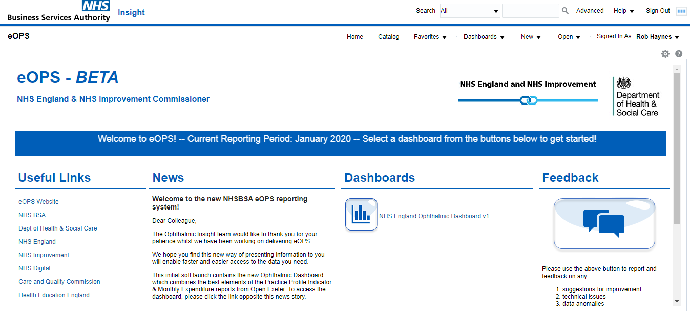
v
iv
ii
i
iii

There are five main areas, labelled i-to-v:
- Useful Links
These will direct you to other areas of the web, including the external NHSBSA website that we feel are useful & relevant to General Ophthalmic Services (GOS), the NHS & the wider Healthcare economy. The NHSBSA does not take any responsibility for the content of external websites, so accessing these is at your own risk.

- News
We will update this with any release date of future updates or, the details of any service announcements such as patching & any associated downtime that may be necessary to keep our product secure, up to date & relevant.

- Dashboards
Click on the graph button or the link ‘NHS England Ophthalmic Dashboard v1’ – see the next image - this will redirect you to the eOPS Dashboard & the underlying Contract data:
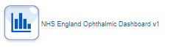

- Feedback
Use this button to send comments, suggestions or technical issues:
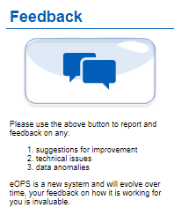
Please feel free to click the button and answer the short survey, hosted by our business partner snapsurveys.com. This link opens the survey in a new window and should take no longer than 2 minutes to complete.

- Current Reporting Period
This can be found in the middle of the home page. This shows the month and year of the latest data available.

Dashboard Overview
When you click on this:

It will take you to this screen:
i
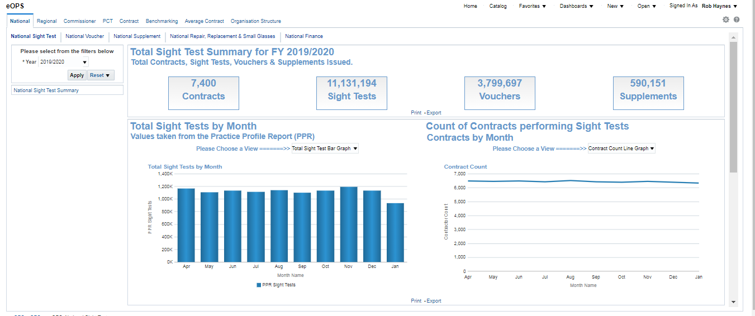
v
iii
iv
ii
Here there are 5 distinct areas:
- Navigation Menu
This area is the navigation menu, there are two levels to choose from:
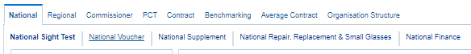

Pointing the mouse at any one of these will underline the word & when this happens, if you click on it, eOPS will load up that part of the dashboard.
Bold Text indicates the currently selected page.
The top level of Dashboard Pages (National, Regional, etc.), will allow you to visualise GOS data at National level or you can drill down to view individual Contract, via RT or AT. It is also here where you can choose to see the available benchmarking or to see the average contract at Regional or Commissioner Level instead.
The lower layer of this menu (Sight Test, National Voucher, etc.) is entirely dependent on which of the upper page is selected.
See the next section for a more in-depth look at the available analysis found on each page, or, see the below table for a quick view of the eOPS Site Map:

 |  | Main Dashboard Pages
 |  | National | Regional | Commissioner |  |  |  | PCT |  | Contract |  |  | Benchmarkg |  | Average Contract |  | Organisation  Structure
 |  | Available Sub Pages
 | Sight Test/  Dom. Visit |  | Sight Test/  Dom. Visit |  | Sight Test/  Dom. Visit |  | Sight Test/  Dom. Visit |  |  |  | Sight Test/  Dom. Visit |  | Regional  Benchmark |  | National Average Contract |  | Organisation  Structure
 | Voucher |  | Voucher |  | Voucher |  | Voucher |  |  |  | Voucher |  | Commissioner  Benchmark |  | Regional  Average Contract
Supplement |  |  | Supplement |  | Supplement |  | Supplement |  |  |  | Supplement |  |  |  | Commissioner Average Contract
 |  | Repairs, Replace  & Small Glasses | Repairs, Replace  & Small Glasses |  | Repairs, Replace  & Small Glasses |  | Repairs, Replace  & Small Glasses |  |  |  | Repairs,  Replace  & Small  Glasses
 |  | Finance | Finance |  | Finance |  | Finance |  |  |  |  | Finance

- Prompt
These are available on most dashboard pages and will look like this:
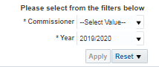

The prompt above allows you to visualise the data based on your preference of Commissioner and the FY. Once you have made your choice, click Apply to confirm and the results will be displayed after a few moments.
Click Reset to return the prompt to the default settings.
- Console Options
Here you can perform additional actions, based on the level of permissions granted to you. Most Commissioners will generally have navigation options available, such as to return home or switch dashboards should you already have access to our sister systems – eDEN for Dental, or ePACT2 for Prescribing.
- Dashboard Page
This is where all the analysis and visualisations for eOPS are displayed.
- Internal Scroll Bar
When eOPS first loads up, not everything may be visible on your screen, to scroll down the content, use this, the inner-most scroll bar. You may also find it useful

Analysis Guide

This section is designed to give you a flavour of the analysis available within eOPS & is by no means a complete guide. Should you ever get stuck or require some clarity, please drop nhsbsa.ophthalmicinsight@nhs.net an email, & we will get back to you as soon as we can.
The analysis presented on the National, Regional, Commissioner, PCT or Contract dashboard page, generally all share the same types of analysis. This means that ‘Total Vouchers’ will be found in the exact same place on each of these pages.
One other clarification is that ‘Commissioner ‘& ‘AT’ are used interchangeably, however both are child organisations of the parent Regional Teams.

Sight Tests

Analysis Name | Analysis Description
Total Contracts | The total count of NHS GOS Contracts where NHS Sight Test count > 0, for the Organisation level and FY selected. | 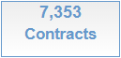
Total Sight Tests | Total count of all NHS Sight Tests, for the Organisation level and FY selected. | 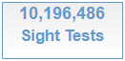
Total Sight Test Bar Graph | A graph showing the count of total NHS Sight Tests by Month, for the FY selected. | 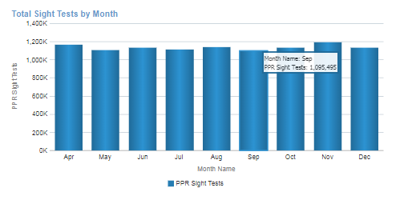
Total Sight Test Pivot Table | A table of values showing the total count of NHS Sight Tests by month, for the FY selected.
Contract Count Line Graph | A line graph showing the count of contracts by month providing NHS Sight Tests by month, for the FY selected. | 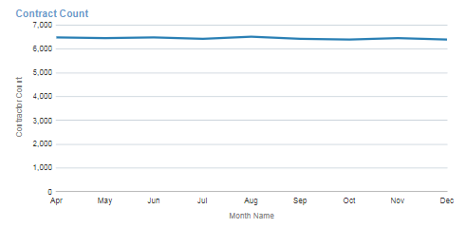
Contract Count Pivot Table | A table of values showing the count of contracts per month, which provided an NHS Sight Test for the FY selected. | 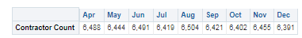
Total Contract Count | Total contract count where at least 1 domiciliary visit has been recorded | 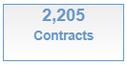
Total Visits | Total count of visits for the FY selected. | 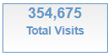
Total Full Visits | Total count of FULL visits, for FY selected. | 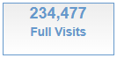
Total Part Visits | Total count of PART visits, for FY selected. | 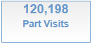
Total Domiciliary Visit Graph | Total count of all Domiciliary Visits by month, for the FY selected. | 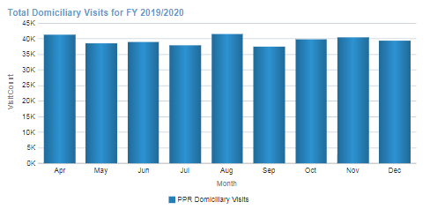
Total Domiciliary Visit Table | Total count of all Domiciliary Visits by month, for the FY selected. | 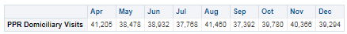
Domiciliary Visit by Type Graph | A line graph which plots the count of visit type by month, for the FY selected. | 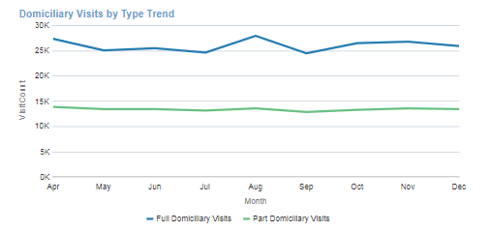
Domiciliary Visit by Type Table | A table showing the values of the visit types by month, for the FY selected. | 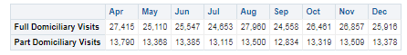

Vouchers

Total Vouchers | Shows the count of ALL vouchers issued for the Organisation level for FY selected. | 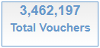
Voucher A-D | Shows the total count of vouchers A-D, for FY selected. | 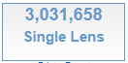
Voucher E-H | Shows the total count of vouchers E-H, for the FY selected. | 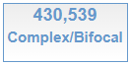
Total Vouchers Graph | A graph showing the total count of ALL vouchers by month, for the FY selected. | 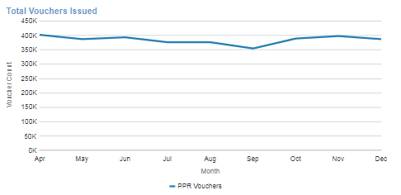
Total Vouchers Table | A table showing the total count of all vouchers, by month for the FY selected.
Voucher A-D Graph | A graph showing the count of vouchers A-D by month for the FY selected. | 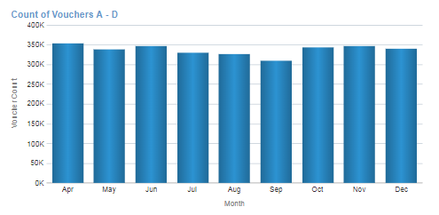
Voucher A-D Table | A table of values detailing the total count of voucher A-D, by month for the FY selected | 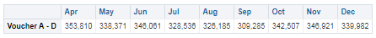
Voucher E-H Graph | A graph showing the total voucher E-H count, for the FY selected. | 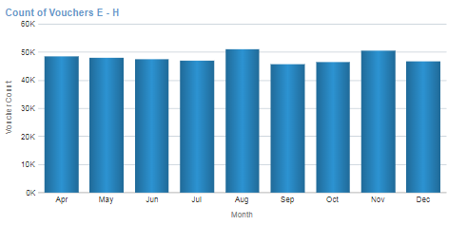
Voucher E-H Table | A table showing the total voucher E-H count, for the FY selected. | 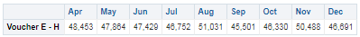
Volume of A Voucher Graph | A graph allowing the user to choose an individual voucher to view the voucher count by month, for the FY selected. | 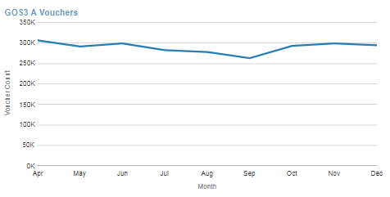
Voucher Table | A table of values that gives a total count by month, for each voucher type for the FY selected. | 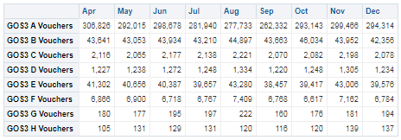
% of Vouchers by Type  Graph | A graph visualising the % of all vouchers issued per month (e.g. 76.27% of Vouchers issued in April, were for A Vouchers). | 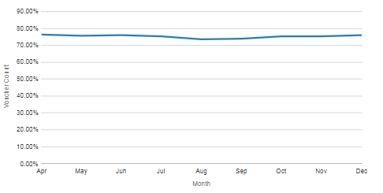
% of Vouchers by Type  Table | A table of values showing the proportion of voucher issues for all voucher types | 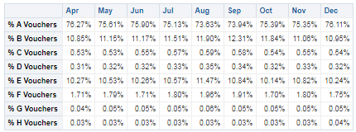
% Sight Test per Voucher Type Graph | A line graph showing the % of total NHS Sight Tests that generated a voucher type (e.g. 26.38% of Sight Tests generated an A Voucher in April). | 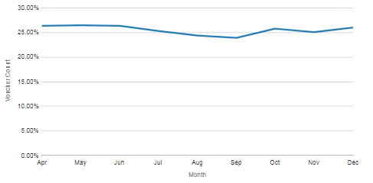
% Sight Test per Voucher Type Table |  | 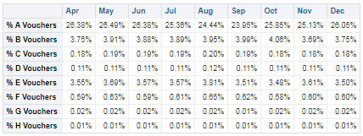

Supplements

Total Supplements | The total count of all supplements, for the Organisation level or FY selected. | 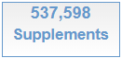
Total Tints | Shows the count of all Tints for the FY selected. | 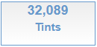
Total Prisms | Shows the count of all Prisms for the FY selected. | 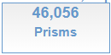
Total Second Pairs | Shows the count of Second Pairs for the FY selected. | 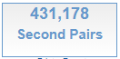
Total Single Complex | Shows the count of Single Complex lenses for the FY selected. | 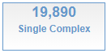
Total Complex Bifocals | Shows the count of Complex Bifocals for the FY selected. | 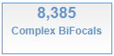
Supplement Quantity Graph | A bar graph (histogram) that shows the total count by supplement for the FY selected. | 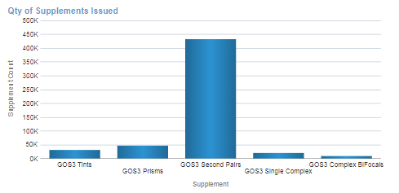
Supplement Qty Table | A table of values that provides the count by supplement, for the FY selected.
Supplement % Graph | A pie chart showing the % of all supplements claimed, for FY selected (e.g. 80.20% of supplements were 2nd pairs in 2019/20). | 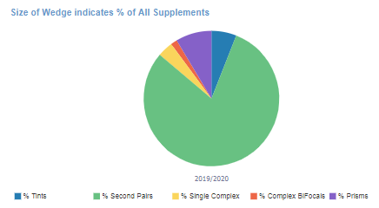
Supplement % Table | A table of values with the supplement % breakdown
Heat Map Tints | A heat map showing the volume of supplement by month – the darker the colour, the greater the volume. | 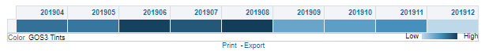
Tint and Prism Graph – Quantity | A graph which visualises the quantity of supplement issued by month | 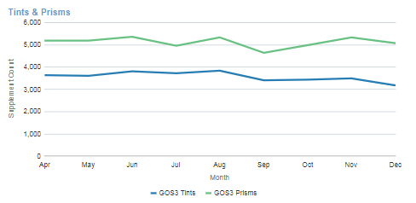
Tint and Prism Table – Quantity | A table of values for the quantity of supplement issued by month for the selected FY. | 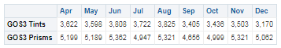
% Supplement to Vouchers Issued Graph | The % of Vouchers where a supplement was issued (e.g. in August, 1.01% of vouchers had a tint supplement). | 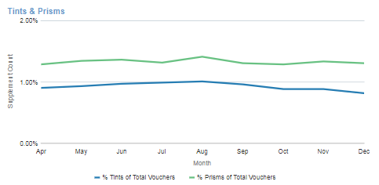
% Supplement to Vouchers Issued Table | The above analysis, but in tabular form | 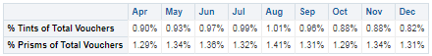

Repairs, Replacements & Small Glasses

Total Repairs | Shows the total count of Repairs claimed. | 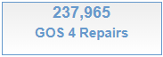
Total Replacements | Shows the total count of Replacements claimed. | 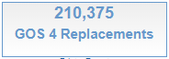
Total Small Glasses | Shows the total count of Small Glasses claimed. | 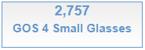
Repair Graph - Quantity | A graph showing the count of chosen supplement, by month for the FY selected. | 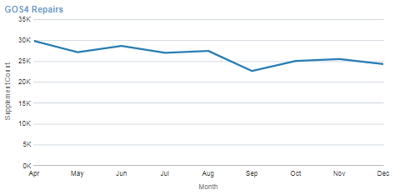
Repair Table – Quantity | A table of values describing the counts of each supplement by month, for the FY selected. | 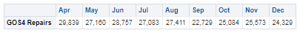
Repairs Graph - % | % of all repairs issued, by month for the FY selected. | 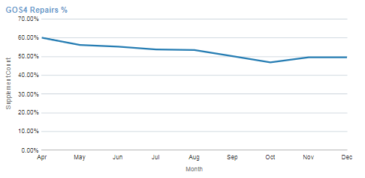
Repair Table - % | A table of values describing the % of all repairs claimed in month, for the FY selected.

Finance
In the case of the table of values presented below, this is only a snapshot of the entire table, meaning more is available within eOPS.

OMP Sight Tests. | A graph showing the value to the Contract for the selected metric. | 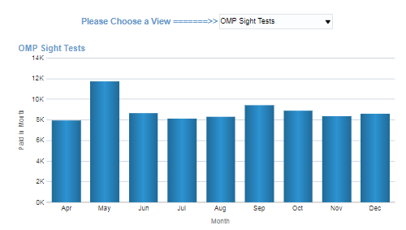
Financial Summary. | A table to reflect the information found in the original MERP report and shows the financial summaries. | 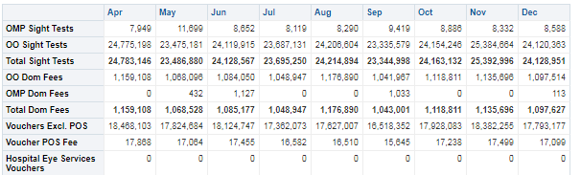

Benchmarking

This section provides some benchmarking at Regional or Commissioner Level depending on the page you select. There’s currently only year-on-year analysis available, there is a future development plan to be able to visualise these by month.

GOS 1
Total NHS Sight Tests Bar Graph | This shows the total count of NHS Sight Tests, by RT/AT or by Year. | 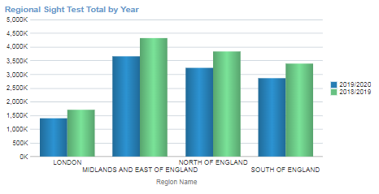
Total Sight Test Bubble Graph | This shows the total NHS Sight Tests by RT/AT & the % of the National Total for each. | 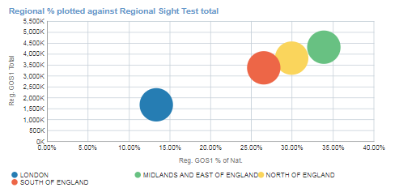
Total Sight Test Table | This provides an at-a-view glance of the above two analysis | 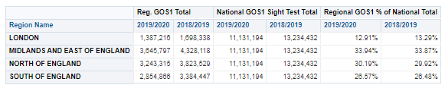
Total Visit Bar Graph | This shows the total count of Domiciliary Visits by RT/AT & by FY. | 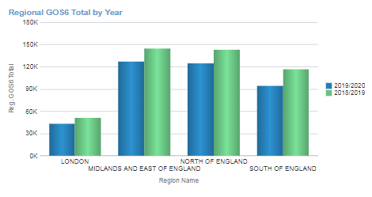
Total Domiciliary Visit Bubble Graph | This shows the total count of Domiciliary Visits by RT, plotted against the % of National Total. | 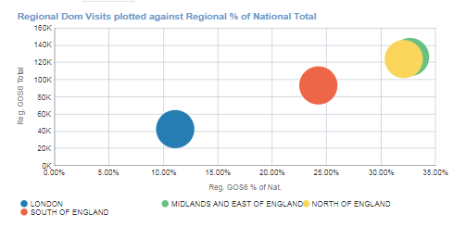
Total Domiciliary Visit Table | This is the table of values for the prior two graphs. | 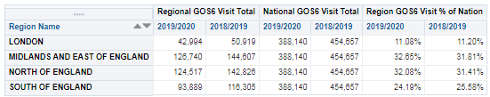
Total Voucher Bar Graph | This shows the total count of Vouchers claimed by RT/AT and Year | 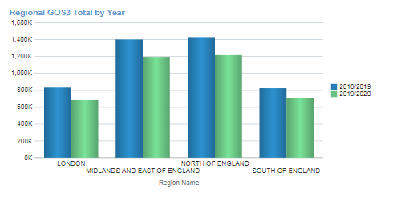
Total Voucher Bubble Graph | This shows the total count of Vouchers claimed by RT/AT by Year, plotted against the % of All Vouchers | 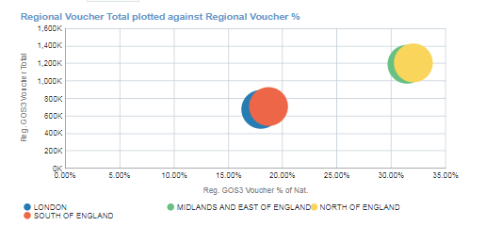
Total Voucher Table | This is the table of values for the preceding two graphs | 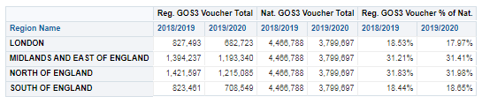
Total Supplements Bar Graph | This shows the total Supplements* by RT/AT & Year. | 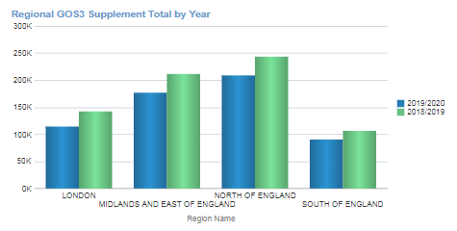
Total Supplements Bubble Graph | This shows the total Supplements* by RT/AT & Year plotted against the % of National Total | 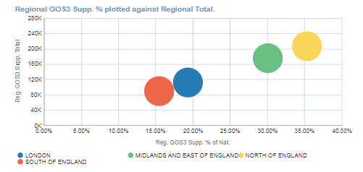
Total Supplements  Table | A table of values for the preceding two graphs. | 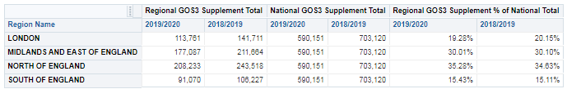
Total Repairs/  Replace & Small Glasses Bar Graph | This shows the total count of all claimed by RT/AT & FY selected. | 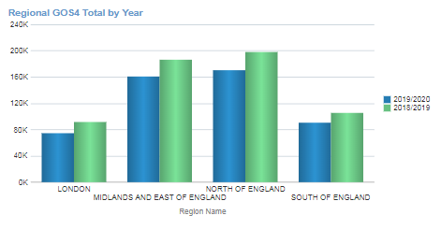
Total Repairs/  Replace & Small Glasses Bubble Graph | This shows the total count of all claimed by RT/AT & FY selected. This also plots each Region/AT against the National Total for GOS 4 Repairs, Replacements etc. | 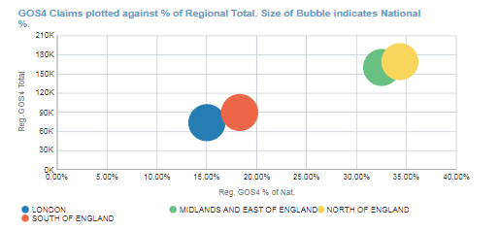
Total Repairs/  Replace & Small Glasses  Table | This is a table of values for the prior two graphs. | 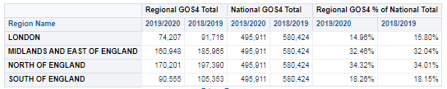

Average Contractor

This section splits out at varying Organisation Levels, however, these are just the mean values for each of the reported indicators. This does tell you useful anecdotal facts about the GOS landscape, such as the average cost of a Sight Test by Region or the Average number of Sight Tests per Voucher.

Average Claim by Contract | This is the average financial claim for a theoretical Contract for the Organisation Level selected. | 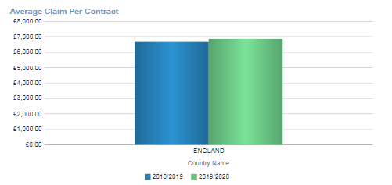
Average Cost Per Sight Test | This is the Average cost of a Sight Test for the Organisation Level selected. | 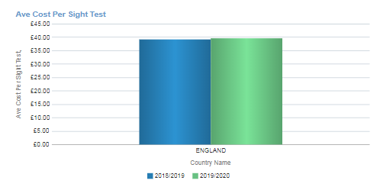
Average Sight Test Count Per Contract | This shows the Average number of NHS Sight Tests claimed by a Contract at the Organisation Level selected. | 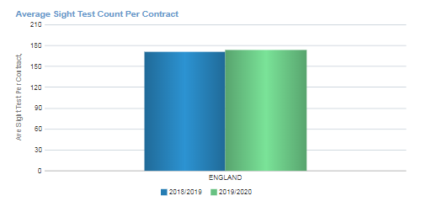
Monthly Average Sight Test Count by Contract | This shows the average number of NHS Sight Tests performed by a Contract at the Organisation Level selected. | 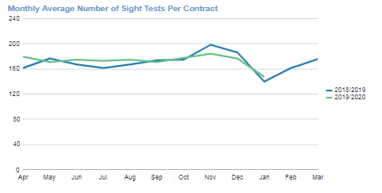
Average number of Sight Tests per Voucher | This shows the average number of NHS Sight Tests performed, before a voucher is issued. | 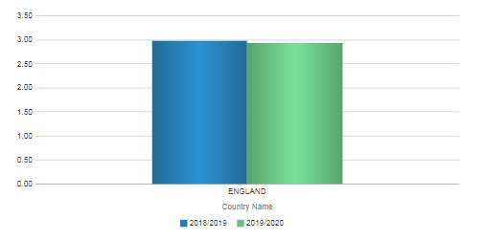
Average number of Sight Tests per Voucher by Month. | This shows the analysis immediately above, but by month | 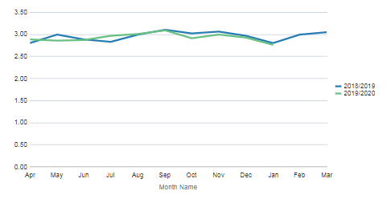

Dashboard Guidance End.

