eOPS User Guide
Accessing & navigating eOPS

Accessing the system

eOPS can be access via the NHS Business Services Authority website at www.nhsbsa.nhs.uk/eOPS
- The main webpage will be displayed.
- Select the ‘Log in to eOPS’ button:
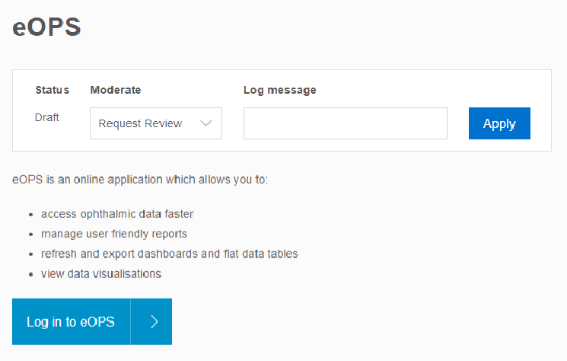
1
2
- The eOPS sign in page will be displayed.
- Enter your User ID for the system, this will the NHS.net email address you registered for access.
- Enter the password for the system. A temporary password is provided for the initial log on. The system will ask the user to change this.
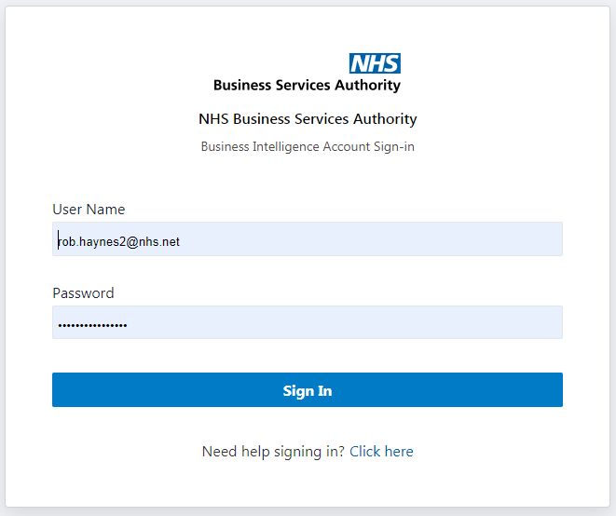
6
5
4
3
- Click the Sign In button to log in to the system.
- The system will default to the landing page:
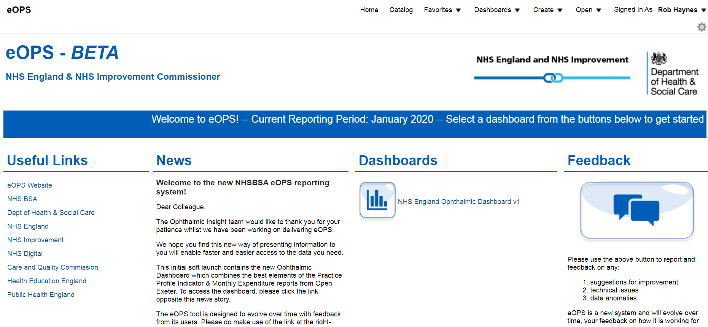
7

- The landing page is split in to 4 main areas:
4
3
2
1

- Useful Links | From here, users can select a hyperlink that will re-direct to an external website from the eOPS system.
- News | Important news, events & updates from the eOPS team
- Dashboards | The ‘Dashboard’ can be accessed here
- Feedback | Feedback allows users to report any bugs or ask for any improvements

Accessing the Dashboard
- Select the icon or click the link to access the dashboard:

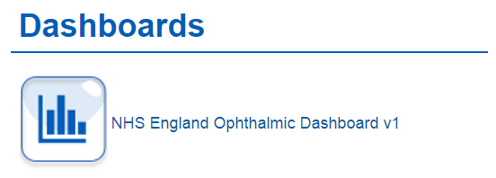

- The Dashboard will open on the National page & Sight Test sub-page:
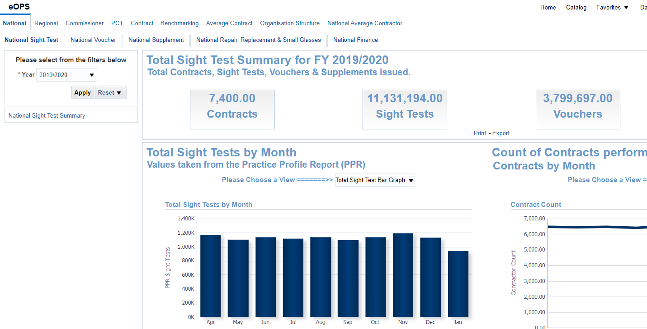

- There are 3 further areas to be aware of:

1
3
2

- Navigation Menu | Use these links to navigate to various areas of the Dashboard
- Prompt | Use this to drive the analysis content (returned values)
- Analysis

To view Regional Data, click on the Regional tab. Similarly, to view the number of vouchers by a particular Contract ID, click on Contract then click on the Voucher sub-page and then finally choose your Contract.

Using the prompts

To use a prompt, click the arrow & it will expand the menu:
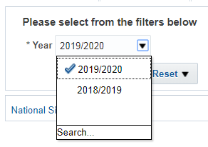
Highlight the option you want, with your mouse & then click to select.
Once all options have been chosen, click Apply to confirm your changes. Click Reset to return all Prompts to their default value (Null).
Fields where a * is present indicates a mandatory field & a value must be chosen by the user.

Exporting Data
This is an under represented area of eOPS – we are desperate to understand how you process this data each month, however there are still a couple of ways you can export data from eOPS & every analysis is available to download.

Export a Single View

To export a Single View based on the values that drives an individual analysis, there are two options available just below the analysis:
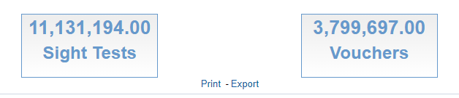
Clicking on Print, will bring up the print options allowing you to choose your printer etc. clicking on Export, will bring up the following menu:

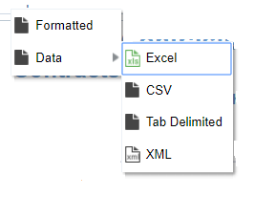

This works in a drop down menu style. Choose Formatted for an output that’s returned in the default Oracle font & colour style, choose Unformatted, should you wish to import this dataset into another system.

Export Full Page View

To access a dataset that underpins every analysis, click the cog in the top left hand corner:
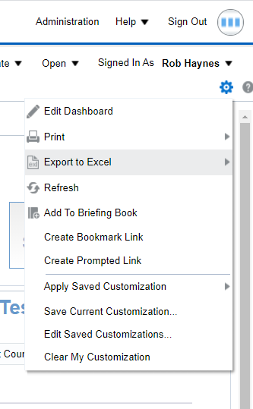

This will bring up a further menu, from which you can choose to print or export.
This is a quick guide to using eOPS, please refer to the additional documentation available on the website should you get stuck. If you would like some official NHSBSA training, then please visit the website for further details. If all else fails, please drop nhsbsa.ophthalmicinsight@nhs.net a line & we’ll be delighted to help.

