NHS Pensions Online (POL) Guide

40. Greenbury guide

Table of contents

Overview 3
- Greenbury screen access ……………………………………………………….3
  - Allocation of Greenbury screen access 3
1.2 Allocating Greenbury access to an existing POL user 5
- Greenbury menu access 8
- The Employee Grid 9
3.1 Status displayed on the Disclosure Request Grid 12
- Member Selection 13
- Employee Detail – add new Disclosure Request 14
  - Pre-populated add Employee Request screen sample 15
  - Amendment of pre-populated data on the Employee Detail screen 17
  - Validation of changes to the pre-populated data entry fields 17
  - Completion of other Employee Detail data entry fields 18
5.5 Marital Status – dropdown list contents 18
5.6 Notification of changes in Working Pattern during the financial year 19
- Existing Disclosure Request screen 21
  - Raise a query 22
  - Recalculate 22
  - Delete 22
  - Cancel 23
  - Compare current year with previous year 23

Overview

Employers will need to nominate a user and allocate Greenbury access to that user before senior manager remuneration disclosures can be requested.

These screens will also be used by the National Health Service Business Services Authority (NHSBSA) to provide the accrued pension, lump sum and Cash Equivalent Transfer Value (CETV) to employers. Benefits in the 2015 Scheme (if applicable) are shown separately to those in the 1995/2008 Scheme.

The factors for calculating a Cash Equivalent Transfer Value (CETV) in the 1995/2008 Scheme and the 2015 Scheme are provided by the Scheme Actuary and have been in force since October 2018.

Employers will only be able to view their own disclosure requests. The function will also support:

- communications between employers and the NHSBSA concerning Greenbury queries
- requests for recalculation of Greenbury disclosures
- comparison of this year’s disclosure figures with last year’s figures.

The following paragraphs give additional information about how the Greenbury access must be switched on by employers and about the Greenbury screens themselves.

Greenbury screen access

Prior to the start of the years disclosure submission as detailed on the NHS Pensions website, a user must be nominated by the employer and their access rights set to allow Greenbury access.

The user could be a new user or an existing Pensions Online (POL) user for whom Greenbury access will be added to their overall access rights. Only one user can have Greenbury access at any time. This is to allow any automated NHSBSA emails generated by the Greenbury process to be directed to a single email contact point.

If a different POL user needs to be given Greenbury access then the previous user must have their Greenbury access switched off first. The new user can then be allocated Greenbury access.

Access rights are set by selecting ‘administer employer access’ from the main menu when logged in as an administrator.
The screenshot below shows the administrator main menu with the relevant selection option highlighted:

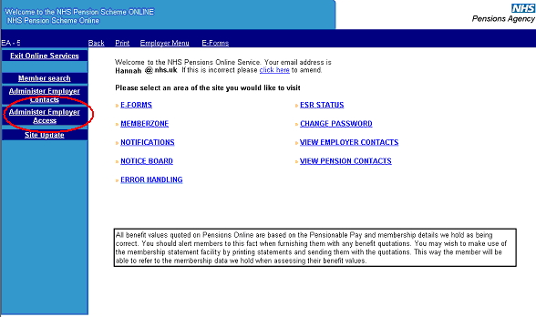

1.1 Allocating Greenbury access to a new POL user

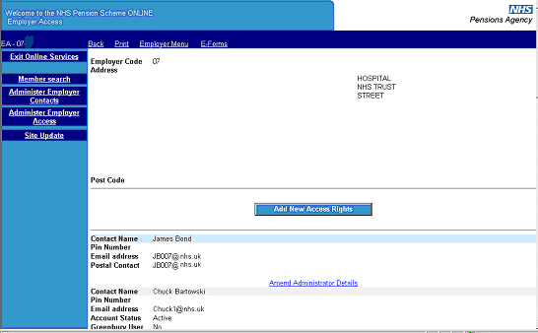

You will then be taken to the employer access screen that shows your POL user accounts. If the nominated user is a new POL user select the ‘add new access rights’ option.

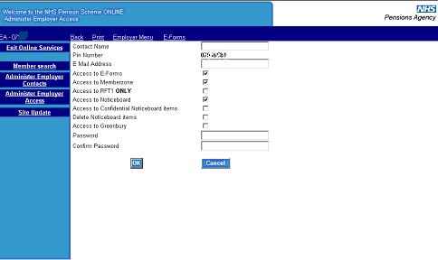

The administer employer access page allows you to add a new user and assign Greenbury access by ticking the ‘access to Greenbury box’. An email address should be inserted to allow any automated Greenbury emails to be directed to the user.

1.2 Allocating Greenbury access to an existing POL user

If the user is an existing POL user click the ‘amend’ button’ next to the user’s access details on the employer access screen. This will take you to the page that allows amendment of user access rights.

The ‘amend’ button should also be used if you want to remove Greenbury access from the user in order to reassign that access.

The next screenshot shows selection of the ‘amend’ button from the employer access screen.

The employer access screen has been amended to display the access status for each POL user, with a ‘Yes’ or ‘No’ for Greenbury access indicated.

If the user is an existing POL user click the ‘amend’ button next to the user’s access details on the employer access screen. This will take you to the page that allows amendment of user access rights.

The ‘amend’ button should also be used if you want to remove Greenbury access from the user in order to reassign that access.

The next screenshot shows selection of the ‘amend’ button from the employer access screen.

The employer access screen has been amended to display the access status for each POL user, with a ‘Yes’ or ‘No’ for Greenbury access indicated.

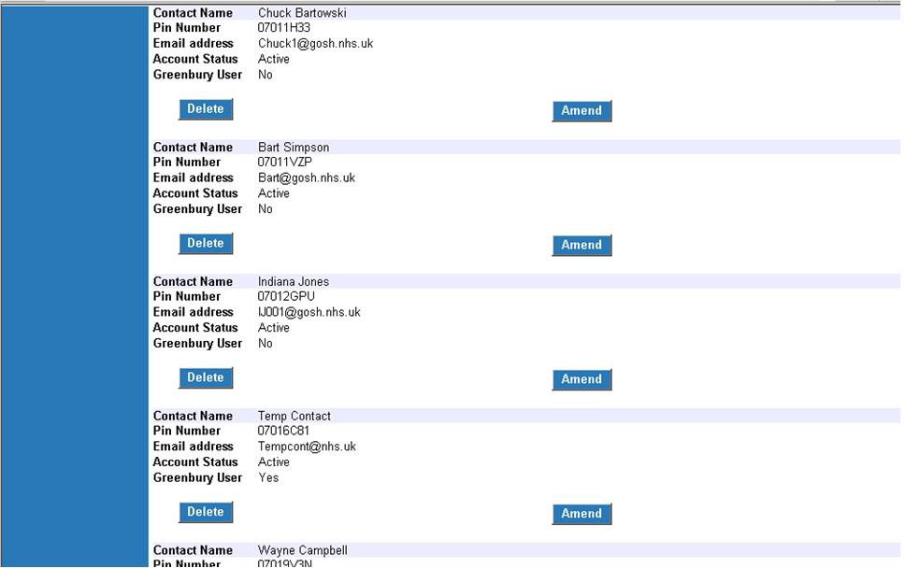

Click the ‘amend’ button and you will be directed to the amend employer contact screen.

The screenshot below shows the amend employer contact screen with the ‘access to Greenbury’ tick box highlighted.

To select Greenbury access, tick this box and press ‘Submit’. An email address must also be supplied so that any automated Greenbury emails from the NHSBSA can be directed to the allocated user.

To remove Greenbury access simply 'untick' the access to Greenbury box and press ‘Submit’.

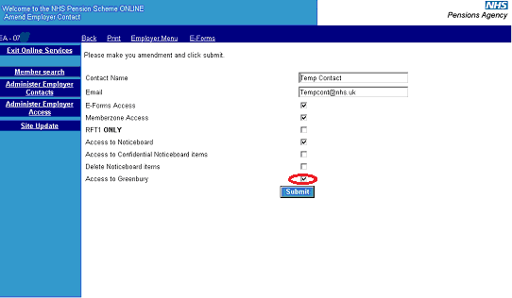

Greenbury menu access

The user has an additional menu option displayed as highlighted below. Other POL users will not be able to view this menu option.

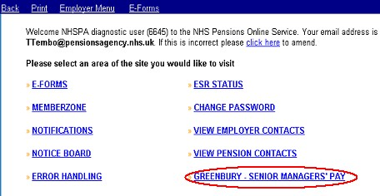

By selecting the Greenbury menu option the user is taken to the ‘Employee Grid’ page first.

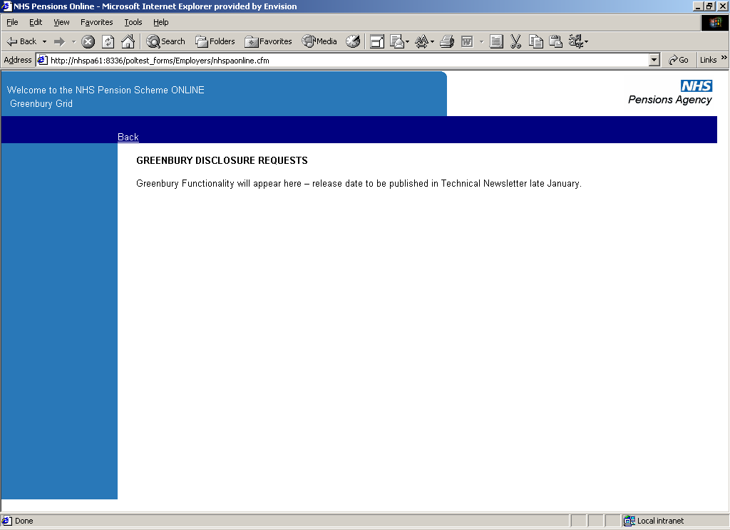

The Employee Grid

The first time the user selects the Greenbury menu option the ‘Employee Grid’ will be blank except for relevant column headings.

Once disclosures begin to be requested, the ‘Employee Grid’ will display:

- The details that the NHSBSA requires to be input for each senior manager.
- The current status for each requested disclosure.
- The calculated pension, lump sum and CETV values returned by the NHSBSA.

The ‘Employee Grid’ has an ‘add new’ option to allow senior manager disclosures to be entered for the first time for this year’s Greenbury exercise.

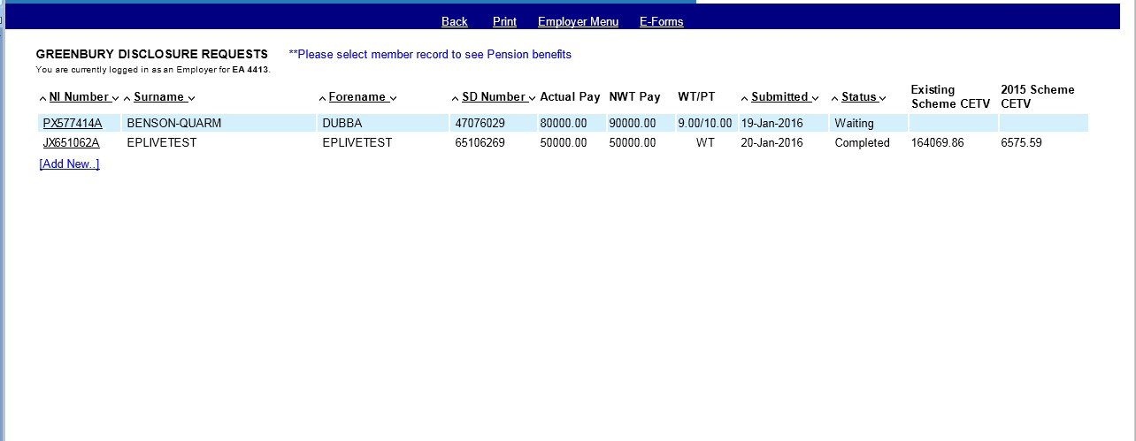

Alternatively, the user can click on a displayed National Insurance (NI) number to enquire on an existing disclosure request for a senior manager.

1995/2008 Scheme and 2015 Scheme CETVs will be shown separately on this screen. Selecting the member record will display the pension benefits.

Calculation of the real increase in pension, lump sum and CETV must be calculated locally. If the senior manager is a transition member we will provide you with separate pension information for the 1995/2008 Scheme and the 2015 Scheme. You will need to add these figures together to calculate the real increases.

3.1 Status displayed on the Disclosure Request Grid

Each disclosure request will have a status displayed. The initial status for a disclosure will be ‘waiting’.

Table 1 Definitions of the Disclosure request statuses
Status | Definition
Waiting | You have added a disclosure request but the accrued pension, lump sum and CETV have not been calculated.
Completed | The accrued pension, lump sum (where applicable) and CETV have been calculated and provided to the employer.
Queried | The user has raised an enquiry with the NHSBSA concerning the senior manager.
Responded | The Greenbury team has responded to the user’s enquiry.

Member Selection

By selecting the ‘add new’ option on the ‘Employee Grid’ the user is shown a member selection screen where they will be asked to input the National Insurance (NI) number – or if known – the membership (SD) number for the senior manager. Press ‘submit’ and the employee detail screen will appear.

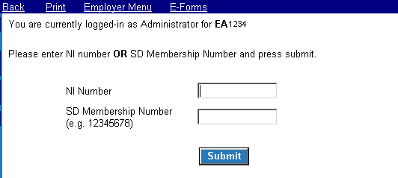

The member selection screen will not allow a user to add the same National Insurance (NI) number or SD membership number twice. If a duplicate is entered the message “This employee has already been requested, please select appropriate NI Number if you wish to recalculate figures or raise a query” will be displayed.

Employers will be able to request disclosure for senior managers who have moved from one employer to another during the financial year.

If the senior manager is:

- not found following the inputting of either the National Insurance (NI) number or SD membership number, or
- is found but there are no employment details to match the Employing Authority (EA) code of the employer.

The message “Details not found, do you want to continue as a manual request case?” will be displayed along with ‘Yes’ and ‘No’ options.

If ‘Yes’ is selected - an unpopulated ‘Employee Detail’ screen is displayed to allow the user to manually enter all the required details for the senior manager.

If ‘No’ is selected – the user will be returned to the ‘Employee Grid’ page.

Employee Detail – add new Disclosure Request

The following fields will be automatically pre-populated using the senior manager’s member database:

- Surname
- Forename
- SD number
- Start date (Note 1)
- End date (Note 2)
- Working pattern at last update (Note 3)
- Actual hours/sessions/programmed activities for part-time senior managers
- Standard hours/sessions/programmed activities for part-time senior managers

Table 2 Pre-population of fields
Note | Field | Comments
1 | Start date | Start date will be pre-populated with the start date of the latest period of employment with the requesting employer or 1 April of the start of the reporting period year if this date is later.
2 | End date | End date will be pre-populated with the end date of the latest period of employment for the requesting employer or 31 March of the end of the reporting period if this end date is earlier or if the employment is still open.
3 | Working pattern | Working pattern is pre-populated based on the latest whole-time / part-time status we hold for the selected senior manager’s employment.

The screenshot below confirms the pre-populated view the user will normally see when they enter the ‘Add New Disclosure Request’ screen.

The user will be able to select the ‘cancel’ button at any time to leave the screen without adding or updating a disclosure request.

The screen will validate whether all the required data has been entered when the user selects the ‘submit’ button. If the required data has not been entered, then the user must take corrective action and re-submit or select ‘cancel’.

If no open employment with the requesting employer is found, a message confirming this will be displayed. The user can then enter the data manually or select ‘cancel’ from the screen. If the user enters the data manually, they will be required to input data in all the required fields, including fields which would normally be pre-populated.

5.1 Pre-populated add Employee Request screen sample

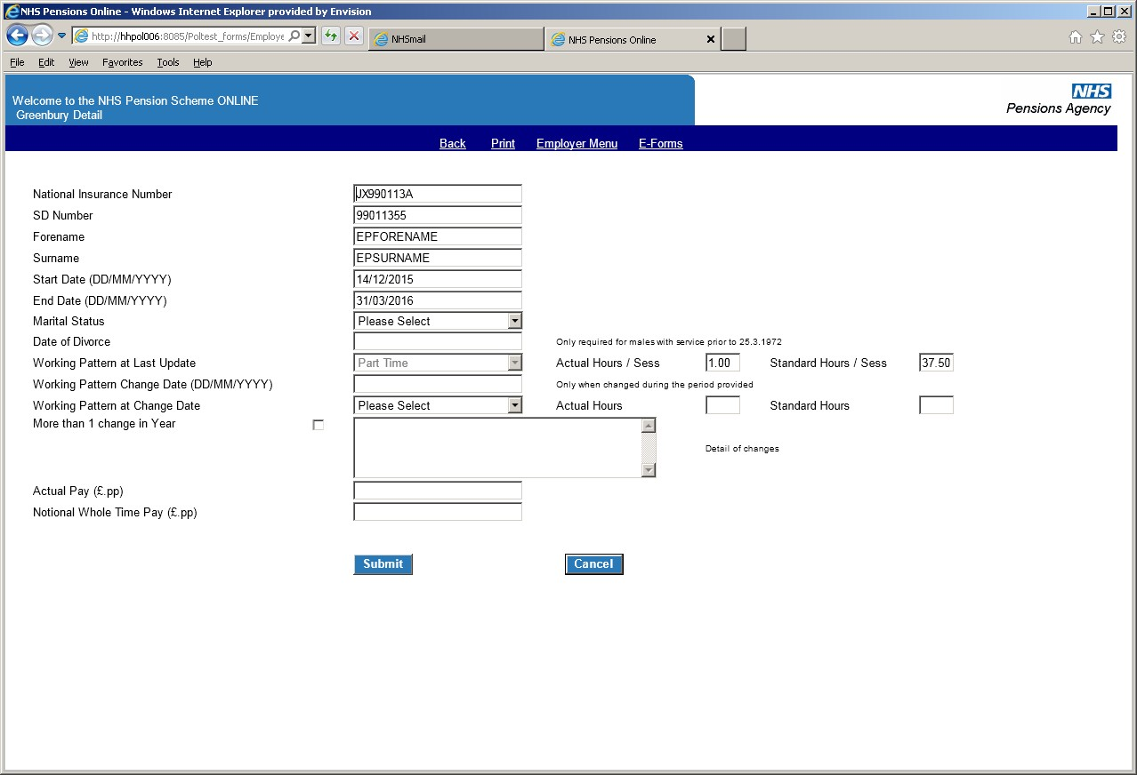

The Actual Pay and Notional Whole Time pensionable pay amounts are now required. Both boxes must be completed even if the member works whole-time. If either box is not completed a warning message will appear (see below).

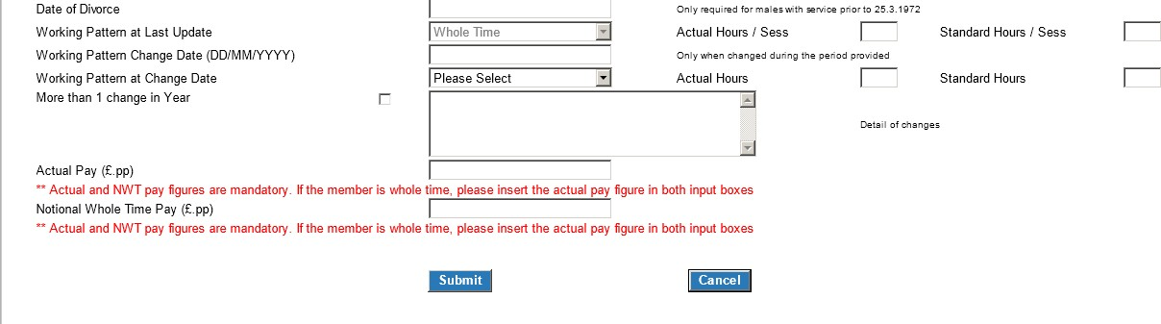

Where a 1995/2008 Scheme member had tapered protection, which ceased during the Greenbury period and has moved to the 2015 Scheme, they will have a final salary link. In addition to the 1995/2008 Scheme pay for this period, we also need pensionable earnings from their start date in the 2015 Scheme to the end of the Greenbury period.

As well as completing the pay boxes for the 1995/2008 Scheme you must provide the 2015 Scheme pensionable earnings in the comment/query box. We will ask you for this information if you have not included it.

5.2 Amendment of pre-populated data on the Employee Detail screen

The user has the option of amending the pre-populated data. This allows the user to tell the NHSBSA of any changes to the senior manager’s membership that has not yet been updated onto their pension record.

These amendments will be treated as being for the purposes of Greenbury calculation only and will not replace the standard updating methods on POL to inform the NHSBSA of changes in member data. Can all employers make sure they make the necessary changes on POL.

5.3 Validation of changes to the pre-populated data entry fields

The following checks are automatically applied during data submission:

- If the pre-populated end date was before 31 March (i.e. a leaver) then the following fields must not be changed by the POL user:

  - ‘Working Pattern at Start Date’
  - ‘Working Pattern Change Date’.

Any contract changes and the worked part-time hours will already be recorded in the NHSBSA database.

- If the pre-populated surname or forename is changed then a warning will be displayed asking the user to complete form SD55G in order to correct the data. This will not prevent a disclosure request from being submitted.

- For all senior managers the working pattern at last update selected must be:

  - whole time
  - part-time, or
  - maximum part-time.

- Self-employed medical practitioner membership (‘practitioner’) is not included in the calculation of the accrued pension, lump sum and Cash Equivalent Transfer Value (CETV). Users should not select the ‘Practitioner’ working pattern at last update for senior managers.

- If the working pattern at last update is part-time or maximum part-time, then:

  - actual hours/sessions/programmed activities must be populated with a value between one and 40

  - standard hours/sessions/programmed activities must be greater than actual hours/sessions/programmed activities and must be greater than or equal to 10 but less than 42.

Completion of other Employee Detail data entry fields

The following fields on the Employee Detail screen must be populated by the user or a value selected from the relevant drop-down list:

- Marital status
- TPP (Total Pensionable Pay)

The Actual Pay and Notional Whole Time Pay amounts are now required. If the member is whole-time the same figures should be entered in both boxes.

Marital Status – dropdown list contents

The user will select the relevant marital status from a drop-down list containing the following values:

- Single
- Married (opposite sex couple)
- Married (same sex couple)
- Divorced (to include Dissolution of a Civil Partnership)
- Civil Partnership
- Unknown

Notifying us of the senior manager’s marital status will enable the system to calculate the correct survivor pension entitlement. This is because a survivor pension for a civil partner or a widow/widower from a same sex couple marriage is aligned with the survivor pension payable to a widower in an opposite sex couple marriage. This is important where the senior manager is male, in the 1995 Section and has membership prior to 6 April 1988.

If the marital status is not known, please do not delay in making your submission.
For calculation purposes ‘Unknown’ will be treated as single.

The following screen item should only be populated subject to the senior manager’s personal circumstance:

- Divorce date

Please complete only where the senior manager is male with membership prior to 25 March 1972.

Notification of changes in working pattern during the financial year

- One change in working pattern:

The following screen items are a mandatory requirement if the senior manager’s working pattern has changed once during the reporting period and differs from the pre-populated information retrieved from the NHSBSA member database:

- Change date
- Working pattern at change date
- Actual hours
- Standard hours

The user will not be allowed to change the working pattern of a session/programme activity post.

A similar validation check, as applied to the working pattern at last update, will be applied to the entered fields.

- More than one change in working pattern:

The ‘more than one change in year’ option should be ticked by the user if the senior manager’s working pattern has changed more than once during the reporting period.

For example, if they have changed from a whole-time employment to a part-time employment and then back to full time.

If the ‘more than one change in year’ option is chosen, then the ‘detail of changes’ box must be updated. The NHSBSA will review the updated information and contact the user if additional data is required.

The screenshot highlights the data entry fields for inputting any changes to the working pattern.

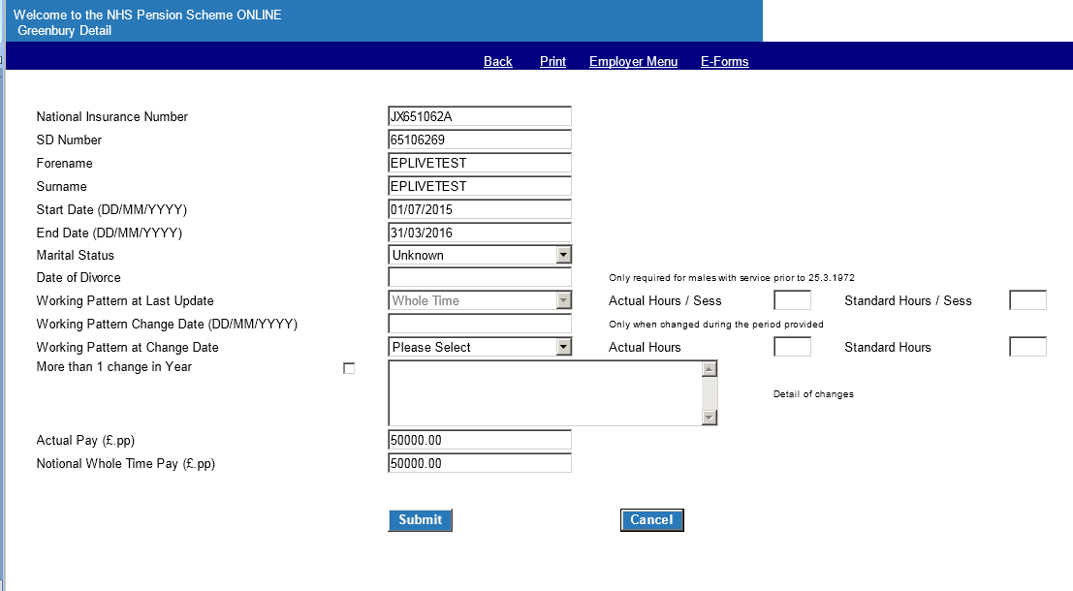
Fields used to record only one change to a working pattern during the reporting period
Fields used to record more than one change to a working pattern during the reporting period

Once all the data has been input the user should click either the:

- ‘Submit’ button - to request disclosure information, or the
- ‘Cancel’ button - to return to the ‘Employee Grid’ without making any changes.

Existing Disclosure Request screen

If the user selects an existing disclosure request from the ‘Employee Grid’ then they will be taken to the screen below. The screen will show the information sent to the NHSBSA and whether the accrued pension, lump sum (where applicable) and CETV have be provided to the employer.

The screen can be used to request a re-calculation of the disclosure information or to raise a query whether the information sent in to the NHSBSA is appropriate. It will confirm any query raised by the user.

The user will be able to compare the current reporting period’s data with the previous period’s data (providing the NHSBSA holds the previous year’s figures).

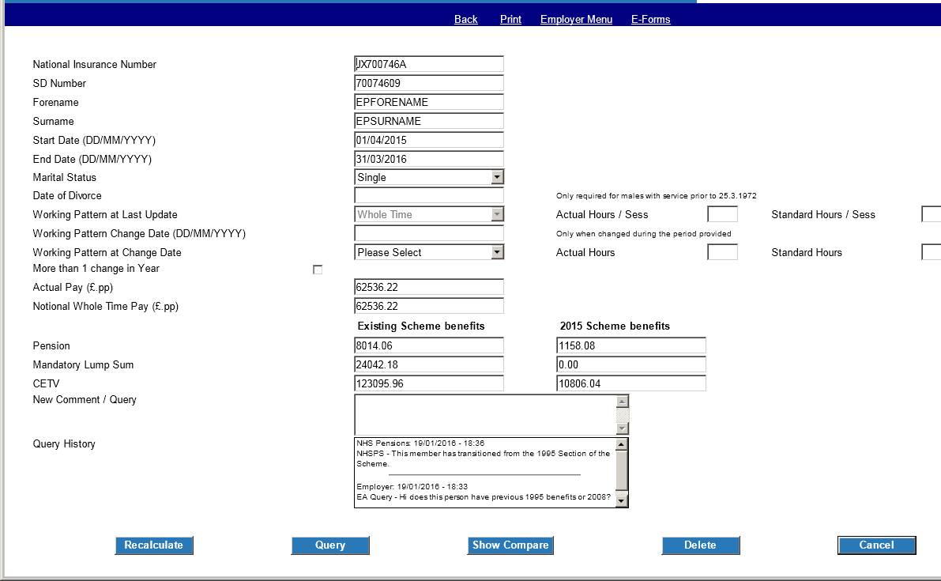
Enter new query here
View Query History between employer and NHSBSA
Click to send a new query

The user will also be able to delete a disclosure request where the wrong senior manager’s details have been inputted.

Raise a query

The employer can raise queries with the Greenbury team using the ‘new comment/query’ free text box and pressing the ‘query’ button.

For each query (and NHS Pension response) the requester, date, time and the wording in the text will be retained and displayed. This will provide the user with a complete history of the dialogue between the employer and the NHSBSA.

Any data input in respect of a multiple change of working pattern when adding the senior manager will also be displayed.

Remember to include any 2015 Scheme pensionable earnings in the comment/query box if the senior manager’s tapered protection of the 1995/2008 Scheme ceased during the Greenbury period.

We will send you a reminder if you do not include it.

Recalculate

The user may want to ask for a recalculation, this may be because information has been incorrectly input.

The user can make any amendments or input additional information before pressing the ‘recalculate’ button. The NHSBSA will be notified of this recalculation request.

A similar validation check to the one applied in the add employee detail screen is applied to the information submitted.

Delete

Clicking the ‘delete’ button will remove the senior manager from the request list. If this is completed in error the senior manager can be reinstated back via the add new employee screen, but the previous history will not be retained.

When the employer presses the ‘delete’ button a confirmation dialog will be displayed:

“Do you really wish to delete this employee request?”

To delete the record click ‘Yes’.

Cancel

This allows the user to leave the screen without making any update.

Compare current year with previous year

The user can compare the current year’s disclosure information with the previous year’s figures, if this was calculated by the NHSBSA.

The comparison information is held at the bottom of the employee detail page and becomes visible once the show compare button is clicked. The comparison information is hidden when the button is clicked again. A detail of what information is available for comparison is shown below.

Both 1995/2008 Scheme and 2015 Scheme benefits (where applicable) will be displayed separately. Calculation of the real increase in pension, lump sum (where applicable) and CETV must be calculated locally. If the senior manager is a transition member we will provide you with separate pension information for the 1995/2008 Scheme and the 2015 Scheme. You will need to add these figures together to calculate the real increases.

Previous year comparison data may have been sourced from more than one employer. In such instances, for the purposes of data protection, all the previous year’s fields will be displayed as blank, except for the relevant accrued pension, lump sum and CETV.

