Compass

Introduction
This guidance provides details of the new Q4 activity report that has been published in Compass.

Accessing your report as a Provider or Performer
The new Q4 report is located in the Activity Folder titled ‘Activity Report for Quarter 4’

Once you have selected the report you will need to enter your contract number and select ‘Execute’

If you are a Provider and Performer your performer version will be titled ‘Activity Report for Quarter 4 (Performer)

Report definitions
The report itself have been developed to meet the details included in the latest Preparedness Letter (Letter 7) , for the dental contract management arrangements for 2020/21 year end reconciliation.

The new Q4 report will include FP17s / FP17Os that meet the following criteria:

- Based on only success fully validated FP17s and FP17Os processed up to close of previous day.
- Based on UDA delivered where the treatment completion date or date of last visit if the patient failed to attend is between 01/01/2021 and 31/03/2021, allowing for two month rule so not based on schedules.
- Based on UOA delivered where;
- the date of assessment for Assess and Review and Refuse the Date of Assessment is between 01/01/21 to 31/03/2021.
- the date of appliance fitted for case starts is between 01/01/21 to 31/03/2021
- the date of completion for appliance repairs is between 01/01/21 to 31/03/2021
- Foundation Dentist activity is included
- The calculation of the 45% and 70% for UDA/UOA respectively is:

UDA
Q4 Target = Annual contracted UDAs / 12 * 3 e.g. for a contract with an annual contracted UDA level of 12,000 UDAs, the Q4 target would be 3,000 UDAs (12,000 / 12 * 3)
Revised Q4 Target = Q4 Target * 45% e.g. for a contract with an annual contracted UDA level of 12,000 UDAs, the Q4 target would be 3,000 UDAs (12,000 / 12 * 3) leading to a revised Q4 target of 1,350 UDAs (12,000 / 12 * 3 *45%).
UOA
Q4 Target = Annual contracted UOAs / 12 * 3 e.g. for a contract with an annual contracted UOA level of 12,000 UOAs, the Q4 target would be 3,000 UOAs (12,000 / 12 * 3)
Revised Q4 Target = Q4 Target * 70% e.g. for a contract with an annual contracted UOA level of 12,000 UOAs, the Q4 target would be 3,000 UOAs (12,000 / 12 * 3) leading to a revised Q4 target of 2,100 UOAs (12,000 / 12 * 3 *70%).

Example Provider Report
An example report has been produced for illustrative purposes. It displays UDA and UOA data, also includes the number of courses of treatment for Sedation and Domiciliary Services, and data at Performer level.
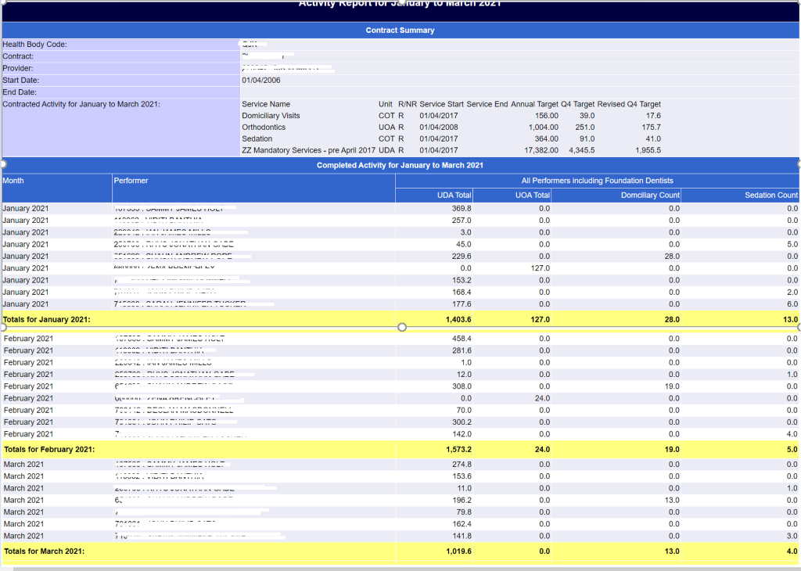

Example Performer Report
An example report has been produced for illustrative purposes. It displays UDA and UOA data, also includes the number of courses of treatment for Sedation and Domiciliary Services. The Performer version of the report does not include targets as these are contract targets only.
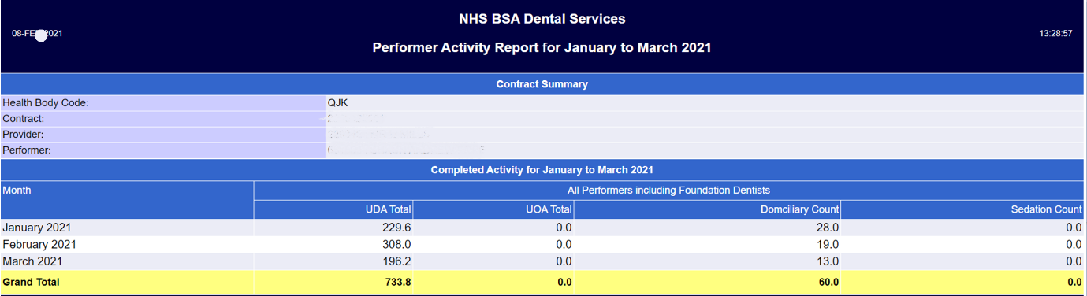

Guidance
Key points to highlight in the report are as follows:
- The report totals will be based on claims successfully processed up to close of previous day. Figures in the report are intended to give a guidance position of contract performance and will not change between morning and afternoon.
- The report is run against an individual contract
- Additional lines will be added for February and March as 1st of each months passes
- As UDAs and UOAs cannot be directly assigned to a specific service line a single UDA / UOA value is allocated to each month. This is the same as the existing Activity Actuals report.

Carry Forward activity
Please note this report currently excludes any Carry Forward activity from 19/20 which may be included in your YE reconciliation for 20/21. This is currently being developed and we will update you shortly.

Why doesn’t the number of UDAs match my monthly statement and other reports in Compass?
The monthly statements, Activity Actuals and Activity Summary screens use the month in which the activity is processed to assign UDA/UOA activity.
The Q4 report uses the date of completion (or last visit for where patients failed to attend) for UDA and the date of Assessment, Appliance Fitted or date of completion for UOA (as described in the definitions section in this document) to assign activity to the month in which in relates to, therefore even if a claim that was competed in January is submitted in March it will still be allocated to the January figures.

