Service Level Agreement (SLA) for
NHS Community Pharmacy Hypertension Case-Finding Pilot

Service level agreement (SLA) for NHS Community Pharmacy and PCN Hypertension Case Finding – a pilot to test the model of care for risk identification and prevention of CVD

This agreement is between
NHS England & NHS Improvement XXXXX Regional Team (NHSE&I) (“the commissioner”)

And the Provider: (“the pharmacy”)

Trading name and address of pharmacy

…………………………………………………………………………………………………

…………………………………………………………………………………………………

…………………………………………………………………………………………………

Contractor ODS code: F……………………………………………………………………

For the provision of NHS Community Pharmacy hypertension case-finding to test the model of care for risk identification and prevention of CVD. The pilot service is a Local Enhanced Service as defined by Part 4 paragraph 14(1)(j) - of the Pharmaceutical Services (Advanced and Enhanced Services) (England) Directions 2013 (as amended).
By signing up to this Service Level Agreement (SLA), you are agreeing that you fully comply with the Terms of Service as outlined in the NHS (Pharmaceutical and Local Pharmaceutical Services) Regulations 2013 and agree to comply with the full terms and conditions as outlined in this Service Level Agreement and service specification. NHSE&I reserves the right to remove you from this pilot if you become unable to meet your terms of service during the pilot period.

Failure to comply with the full terms and conditions as outlined in this SLA and the Service Specification may result in suspension from the pilot. Before any suspension the pharmacy and Commissioner will discuss the reason for the suspension to identify a possible resolution.

Sign up to the service is via the NHS BSA website

By registering to sign up to the service you are agreeing to the terms outlined in this SLA for the Service.

Purpose and scope
The purpose of the NHS Community Pharmacy and PCN Hypertension case finding pilot is to test a model for community pharmacy teams to opportunistically identify people aged 40 years old or over who are likely to have undiagnosed hypertension and promptly refer them to their GP. The pilot is intended to inform the development of the GP contract cardiovascular disease (CVD) Primary Care Network (PCN) specification for 2021/22, helping form the detail of the community pharmacy roles and responsibilities within the specification. The pilot will also inform 2021/22 Community Pharmacy Contractual Framework (CPCF) negotiations. It is intended that the learning resulting from this pilot will inform how GP and community pharmacy services can be delivered as an integrated contracting model through the GP contract and the CPCF.

Timescale
This agreement is for the scheme to be available during all pharmacy opening hours.
This agreement and pilot service delivery covers 1 October 2020 to 31 July 2021.

Termination and Notice period
One month’s notice of termination must be given if the pharmacy wishes to terminate the agreement before the given end date.

If the pharmacy ceases to provide the service before the end of the pilot period, they must arrange for the blood pressure measurement equipment that has been funded by the pilot to be returned if this is required by the Commissioner.

The Commissioner may suspend or terminate this agreement forthwith if there are reasonable grounds for concern including, but not limited to, malpractice, negligence or fraud on the part of the pharmacy.

Obligations
The pharmacy will provide the service in accordance with the service specification and ensure that all substantive and locum pharmacists and pharmacy staff are aware of it. The service can be provided by a pharmacist or a trained competent member of the pharmacy team (the provision of the service remains the responsibility of the pharmacist). The pharmacy, including all staff involved in delivering the pilot, will participate fully in the pilot evaluation, and provide the data set out in the specification in a timely manner (or within the timescales specified).

The Commissioner will manage the service in accordance with the specification.

Standards
The service will be provided in accordance with the standards detailed in the specification (Schedule 1).

Eligibility criteria
Service providers will need to satisfy the following criteria to demonstrate ability to take part in this pilot:
- Compliance with the Essential Services elements of the Community Pharmacy Contractual Framework (CPCF);
- Each pharmacy must have a consultation room that complies with the GPhC standards for such rooms;
- The service may be delivered by agreement with the Commissioner from a suitable location outside a consultation room that complies with infection control requirements for COVID-19 and supports a confidential patient consultation;
- Be located within the agreed PCN pilot footprint;
- Be satisfied that all pharmacists including locum pharmacists and pharmacy staff involved in the provision of the service are competent to do so;
- The service must be available for all the opening hours of the pharmacy
- Be registered to provide the service;
- Be in good standing with NHS England and NHS Improvement;
- Have access to a shared premises NHS mail address and the NHS Summary Care Record.

Confidentiality
Both parties shall adhere to applicable data protection legislation including the General Data Protection Regulation 2018 and to the Freedom of Information Act 2000.

Any approaches by the media for comments or interviews must be referred to the Commissioner.

Indemnity
The pharmacy shall maintain adequate insurance for public liability and professional indemnity against any claims which may arise out of the terms and conditions of this agreement. Any litigation resulting from an accident or negligence on the part of the pharmacy is the responsibility of the pharmacy who will meet the costs and any claims for compensation, at no cost to the Commissioner.

Pharmacy Integration Fund

Service Specification

NHS Community Pharmacy Hypertension Case-Finding Pilot

to

test the model of care for risk identification and prevention of CVD

NHS England and NHS Improvement

Pharmacy Local Enhanced Service
Contents
I. Purpose and scope 2
II. Timescale 2
III. Termination and Notice period 2
IV. Obligations 2
V. Standards 2
VI. Eligibility criteria 2
VII. Confidentiality 3
VIII. Indemnity 3
1. Service background 6
2. Aims and objectives 6
3. Service sign up and self-declaration 6
4. Service description / pathway 7
5. Outcomes of BP measurement and next steps 8
6. Equipment 11
7. Community pharmacy requirements and responsibilities 11
8. Data and information management 13
9. Safety and incident reporting 13
10. Review and evaluation 13
11. Data collection and payments 14
12. Appendices 16

Appendices

A Clinical evidence / national guidance
B Service protocol

Service Specification

Service background
Cardiovascular disease (CVD) is the second most common cause of premature death in England affecting seven million people. The NHS Long Term Plan aims to reduce CVD mortality and morbidity, tackle inequalities and deliver a genuine shift towards prevention. High blood pressure (BP) or hypertension is the single biggest risk factor for CVD (Global Burden of Disease Report, 2017) and there are an estimated 5.6 million people with undiagnosed hypertension across the country (Public Health England).
High BP is a major risk factor for the development of atrial fibrillation (AF) which increases the risk of a stroke by five times. High BP is also a significant contributor to health inequalities; residents of the most deprived areas in England are 30% more likely to have high BP compared to those in the least deprived areas. The risk factors for developing hypertension can be categorised as modifiable or non-modifiable. Modifiable risk factors include lack of physical activity, overweight, high alcohol intake, high salt intake, high cholesterol, smoking and stress. Non-modifiable risk factors include family history, race and age.
The clinical evidence and national guidance on which this service is based are detailed for reference at Appendix A.

Aims and objectives
The aims and objectives of this service are to:
- Test a community pharmacy model that is able to identify people over the age of 40, or at the discretion of the Pharmacy, people under the age of 40 with high blood pressure (who have previously not had a confirmed diagnosis of hypertension or a related condition), and to refer them to general practice to confirm diagnosis and for appropriate management;
- At the request of a General Practice within the PCN, blood pressure monitoring of individuals diagnosed with hypertension;
- Promote healthy behaviours to service users;
- Explore accessibility, engagement and impact in areas of differing demographics and deprivation levels.

Service sign up and self-declaration
Community pharmacy registration for the pilot will be via the NHS BSA website. Only pharmacies within the agreed pilot Primary Care Network areas will be able to sign up.
Registration for the pilot service will involve the responsible pharmacist making a self-declaration of readiness. This self-declaration will require that the responsible pharmacist confirms that they:
- Have read this service specification and can comply with all the elements laid out therein;
- Have completed/will undertake to complete the required training;
- Will ensure that other pharmacists working in the pharmacy and pharmacy team members who will provide the service make the same self-declaration of readiness which will be kept on the pharmacy’s records for the duration of the pilot;
- Have access to the shared NHS Mail account specific to the pharmacy premises;
- Have access to the NHS Summary Care Records;
- Will only provide this pilot service using approved blood pressure monitoring equipment funded by NHS England and Improvement, to be purchased via NHS Supply Chain, unless otherwise agreed by the Commissioner;
- Are aware of the signposting and escalation processes.

Service description / pathway
The pilot service is free of charge to all users. The service process map / pathway is illustrated in Appendix B.
Inclusion criteria
- Adults who are 40 years old or over, who do not have a current diagnosis of hypertension or a related condition
- Any patient under the age of 40 who requests the service because they have a recognised family history of hypertension may be seen under this service (with notes provided on the recording spreadsheet to this effect) if the pharmacist thinks this is appropriate
- Patients between 35 and 39 years old who are approached about or request the service may be tested at the pharmacist’s discretion
- Adults specified by a local GP practice for the measurement of blood pressure
Exclusion criteria
- People who are unable to give consent to participate
- People under the age of 40 years old, unless at the discretion of the pharmacist
- People who have their blood pressure regularly monitored by a healthcare professional, unless at the request of a local GP practice
The pharmacy contractor must ensure the service is accessible, appropriate and sensitive to the needs of all service users. The service must also be delivered ensuring all appropriate infection control and risk management procedures are followed with respect to COVID-19. No eligible service user shall be excluded or experience particular difficulty in accessing this service, with regards to protected characteristics or age.
Any patient who is identified as suitable to be included under the criteria but where the smallest / largest cuff available does not fit and therefore an accurate blood pressure cannot be obtained, should be directed to their GP.
Identification of service users
In order for the service to be a success, the whole community pharmacy team will need to proactively identify potential service users who meet the inclusion criteria. This will include: proactively and sensitively initiating discussions with people who may fall in to the appropriate age range; targeting those collecting prescriptions who fall within the age range but are not already prescribed any antihypertensives; displaying posters within the pharmacy; raising the service with patients already accessing other services at the pharmacy (e.g. NMS, flu vaccination, NHS CPCS, self-care advice).
The COVID-19 pandemic has changed people’s habits and attendance in person at pharmacies. In agreement with the Commissioner, potential service users may be targeted in other settings outside the pharmacy such as areas not designated part of the pharmacy within supermarkets or large stores or in community locations such as (but not limited to) community centres, sports grounds and places of worship.
Pharmacies will be provided with posters for display within the pharmacy / store, and with other materials to support user engagement.

Consultation
The pharmacist, or trained pharmacy team member, will explain the service to the service user and gain their consent.
The pharmacist, or trained pharmacy team member, will then conduct a face to face consultation in the pharmacy consultation room or other suitable location and will take blood pressure measurements using the recommended equipment and following best practice as described in the operational training and toolkit. Personal Protective Equipment (PPE) will be used as recommended by Public Health England (PHE) and infection control procedures followed to manage COVID-19 infection risk.
https://www.england.nhs.uk/coronavirus/publication/standard-operating-procedure-community-pharmacy/

The pharmacist, or trained pharmacy team member, will discuss the results with the service user and complete the appropriate next steps (see section 5 below). A patient leaflet will be provided to the patient as part of the consultation where they can document their blood pressure test results. The information can be completed electronically by the pharmacist and emailed to the patient if this is preferred.

Further information on how to conduct the consultation and on service provision is available within the service toolkit. The toolkit contains guidance detailing the operational delivery of the service in accordance with this service level agreement (SLA) and service specification, and resources/materials for use within the service including the Patient Leaflet.

Patients Already Diagnosed with Hypertension
It is acknowledged that, due to the COVID-19 pandemic, some GP practices may not have up to date blood pressure readings for patients already diagnosed with hypertension. In addition to opportunistically measuring blood pressure for undiagnosed service users, pharmacies participating in the pilot can, at the request of a local GP practice, measure the blood pressure for patients specified by the GP practice and report the measurements to the GP practice. Payments will be made for such readings at £5 for each service user receiving a clinic blood pressure check in the pharmacy (See Section 11).

Outcomes of blood pressure measurement and next steps
5.1 Test outcomes
Please note:
- All blood pressure test results will be sent to the registered GP practices in a weekly summary email. In addition, various test results mean urgent referrals are needed (see details below) and in these cases the pharmacist will telephone the GP practice and send the patient’s blood pressure test results immediately by NHS mail.
- For all measurements below, appropriate action should be taken if either the systolic or the diastolic measurement or both fall outside the normal range.
Once an initial ‘clinic’ blood pressure reading has been taken, there are a number of possible outcomes and actions required from the pharmacist or trained pharmacy team member:
Normal clinic blood pressure – a blood pressure lower than 135/85mmHg and higher than 90/60mmHg. Service users will receive advice on maintaining healthy behaviours (see section 5.4).
High clinic blood pressure – a blood pressure of 135/85mmHg or higher, but lower than 180/120mmHg. Service users will receive advice promoting health behaviours and will be offered Ambulatory Blood Pressure Monitoring (ABPM) either from the pharmacy or through a local diagnostic pathway. Where the pharmacy does not have ABPM equipment available, they must refer appropriate service users to a local provider. Service users will be given a record of their results to show the provider and the results will also be sent to the provider by the pharmacy team using NHS mail or agreed local secure digital process.
Very high clinic blood pressure - a blood pressure of 180/120mmHg or higher. Service users will be urgently referred to see their GP the same day.
During GP Practice hours the pharmacist should call the GP Practice whilst the service user is still in the pharmacy. If the pharmacist is unable to contact the GP Practice or the GP Practice is closed, the pharmacist will advise the patient to take appropriate action as agreed locally, which may include referral to A&E if their GP cannot see them that same day. Service users will be given a record of their results to show their GP or A&E department and the results will also be sent by the pharmacy team using NHS mail or agreed local secure digital process to the patient’s GP and A&E department if applicable.
Low clinic blood pressure – a blood pressure of 90/60mmHg or lower. Although the aim of this service is to identify people with hypertension (high blood pressure), appropriate advice and next steps need to be given to any person with low clinic blood pressure.
Service users with blood pressure lower than 90/60mmHg but who are asymptomatic will receive advice on maintaining healthy behaviours (see section 5.4) and advised to have their blood pressure tested again within a year.
Service users with blood pressure lower than 90/60mmHg that experience dizziness, nausea or fatigue will receive advice promoting healthy behaviours (see section 5.4) and be advised to see their GP within 3 weeks. The pharmacist may ask about any prescribed or non-prescribed drugs or herbal products the patient is taking that might reduce their blood pressure. If the pharmacist believes the service user is at risk (such as of falling) they should support the patient to arrange an urgent GP appointment the same day.
Service users with blood pressure lower than 90/60mmHg that experience regular fainting or falls, or feel like they may faint on a daily/near daily basis will be urgently referred to see their GP the same day. The pharmacist will inform the GP Practice by NHS mail or other locally agreed secure digital process. In addition, during GP Practice hours the pharmacist should call the GP Practice whilst the service user is still in the pharmacy. If the pharmacist is unable to contact the GP Practice or the GP Practice is closed, the pharmacist will advise the patient to take appropriate action as agreed locally which may include referral to A&E.
Irregular pulse - if the blood pressure monitor indicates an irregular pulse then the test should be repeated after five minutes. If the second reading still indicates an irregular pulse, then the service user should be urgently referred to see their GP the same day. The pharmacist will inform the GP Practice by NHS mail or other locally agreed secure digital process.
During GP Practice hours the pharmacist should call the GP Practice whilst the service user is still in the pharmacy. If the pharmacist is unable to contact the GP Practice or the GP Practice is closed, the pharmacist will advise the patient to take appropriate action as agreed locally which may include referral to A&E. The results will also be sent by the pharmacy team using NHS mail or agreed local secure digital process to the patient’s GP and A&E department if applicable.
5.2 Ambulatory Blood Pressure Monitoring (ABPM)
Where the pharmacy has ABPM equipment available and the clinic blood pressure measurements are 135/85mmHg or higher but less than 180/120mmHg then ABPM should be offered to the service user. The ambulatory readings will include diastolic and systolic readings for each of 24 hour average, night time and day time. The recorded data must be documented by the pharmacy team member for each service user. The following next steps will apply depending on the ABPM results obtained:
ABPM indicates a normal blood pressure - where ABPM shows an average blood pressure of lower than 135/85mmHg and higher than 90/60mmHg. The service user will be given a record of their results on the patient leaflet and receive advice on maintaining healthy behaviours
ABPM confirms a high blood pressure - where ABPM shows an average blood pressure of 135/85mmHg or higher but lower than 150/95mmHg. Service users will be referred to see their GP within 3 weeks. The service user will be given a record of their results on the patient leaflet to show the GP and results will also be reported to the GP by the pharmacist using NHS mail or agreed local secure digital process.
ABPM indicates stage 2 hypertension – where ABPM shows average blood pressure of 150/95mmHg or higher. Service users will be urgently referred to see their GP the same day. The service user will be given a record of their results on the patient leaflet to show the GP. During GP Practice hours the pharmacist will call the GP Practice whilst the service user is still in the pharmacy. If the GP Practice is closed the pharmacist will advise the patient to take appropriate action, as agreed locally, which may include referral to A&E. The results will also be sent by the pharmacist using NHS mail or agreed local secure digital process to the patient’s GP and A&E department if applicable.

5.3 Service user non-attendance for ABPM
Collection of equipment for measurement of ABPM
Should a service user fail to attend a scheduled pharmacy appointment as part of this service to be fitted with equipment for ABPM, the pharmacy team should make three attempts, on separate occasions, to contact the service user to rearrange the appointment. In the event of a failure to attend the pharmacist should inform the service user’s GP, providing the initial clinic blood pressure measurements and notify them of the failure to attend to be fitted with equipment for ABPM as indicated by the service user’s initial blood pressure test results.
Receiving results and returning equipment
Should a service user fail to attend a scheduled pharmacy appointment as part of this service to receive the results of ABPM and return equipment, the pharmacy team should make three attempts, on separate occasions, to contact the service user to rearrange the appointment. If despite these attempts to contact the service user does not return to receive ABPM results or return equipment, the pharmacist team should notify the service user’s GP of the failure to attend to receive ABPM results and return the equipment, providing the initial clinic blood pressure measurements. The pharmacist should also email the NHS England and Improvement Pharmacy Integration Team at england.pharmacyintegration@nhs.net and outline the steps taken to recover the equipment. The Pharmacy Integration Team may organise replacement ABPM equipment if appropriate.
5.4 Promoting healthy behaviours
Each participating pharmacy must have achieved HLP-Level 1 with a clear leader responsible for creating an ethos of proactive health and wellbeing within the pharmacy. The leader, jointly with the pharmacy team, should develop an action plan to support the communication of health and wellbeing advice that supports advice during the consultation after the initial clinic BP testing is complete. This should encompass:
- Engaging in a brief discussion about their current behaviours (diet, smoking, physical activity, alcohol, weight);
- Providing general advice on improving behaviours and reducing risk factors in line with the usual advice and information provided;
- Reinforcing this advice where necessary with written information and/or links to online resources. Signposting to support services as required;
- Recording any advice and signposting provided.
Supporting materials should be provided by the pharmacy in hard copy or electronic format. Pharmacies may make use of resources available from the British Heart Foundation and Public Health England. Further details of these resources are set out in Section 5.1 of the toolkit.
Useful links to aid the discussion include:
- Hypertension in adults: diagnosis and management. NICE clinical guidance NG136, August 2019. https://www.nice.org.uk/guidance/ng136
- NICE's guideline on alcohol-use disorders
- NICE's guideline on stop smoking interventions and services
- https://www.nhs.uk/conditions/high-blood-pressure-hypertension/

5.5 New Medicines Service

Those service users who are referred to the GP because they have high blood pressure after ambulatory measurement are likely to return to the community pharmacy with a prescription for antihypertensive medicines. Pharmacists are encouraged to offer the New Medicines Service to these patients.

Equipment
Clinic blood pressure monitors
The Commissioner will arrange for the service equipment to be available and will either provide it to the pharmacy or advise the pharmacy to purchase the equipment and reimburse the cost upon receipt of proof of purchase. Suppliers will provide training and participating pharmacies must complete training (see section 7.1).
If the pharmacy already has a clinic blood pressure monitor which appears on the approved list they should use this in the pilot rather than purchasing a new monitor.
All equipment provided or reimbursed by the commissioner will remain the property of the commissioner on completion of the pilot. The NHSE/I Regional team reserve the right to remove unused equipment from a community pharmacy and redistribute it to other pharmacies in the area.

Infection control measures and cleaning must be carried out by the pharmacy team on clinic blood pressure monitors as per the instructions of the manufacturer or supplier and in line with infection control procedures for COVID-19.

Ambulatory Blood Pressure Monitor (ABPM)
Some (but not all) pharmacies within a PCN will be provided with an ambulatory blood pressure monitor (ABPM) to loan to those service users with a high initial blood pressure reading (equal to or higher than 135/85mmHg). Pharmacies that are providing this service but who do not have ABPM kits must refer service users with high initial blood pressure readings to a place where ABPM kits are available (this may be another community pharmacy, GP Practice or other local arrangement).
When loaning an ABPM, the blood pressure monitor loan form must be completed and the meters re-set for each service user ensuring only readings for that service user will be measured during ABPM.
The pharmacy staff will fit the ABPM, explain how it works and provide instructions on what to do when a reading is being recorded. Importantly they will explain that the monitor cannot become wet and therefore baths and showers must be avoided during the 24-hour monitoring.
The ABPM will record all readings in the device’s internal memory and will calculate an average value. The pharmacist will interpret and explain the results during the service user’s return appointment.
Validation, maintenance and recalibration of both Clinic blood pressure monitors and ABPMs should be carried out periodically according to manufacturers' instructions – teams are advised to contact the supplier if this is required.

Infection control measures and cleaning must be carried out by the pharmacy team on ambulatory blood pressure monitors as per the instructions of the manufacturer or supplier and in line with infection control procedures for COVID-19.
https://www.england.nhs.uk/coronavirus/publication/standard-operating-procedure-community-pharmacy/

Community pharmacy requirements and responsibilities
Prior to commencing provision of the service pharmacy contractors must comply with any service eligibility criteria in the Service Level Agreement.
In addition, they should:
- Develop Standard Operating Procedures (SOP) or adopt those contained within the toolkit; The service toolkit is provided to meet this requirement, and pharmacy versions of SOPs must align with the principles, approaches and procedures.
- Ensure available safe and secure storage systems for confidential service user records;
- Engage with local GP Practices and/or PCN colleagues to make them aware the pharmacy is participating in this service.
7.1 Training requirements
Pharmacists (including locum pharmacists) and pharmacy team members providing the service must:

- Pharmacists must complete the CPPE self-assessment framework and required learning shown on the CPPE Hypertension Case-Finding Pilot web page https://www.cppe.ac.uk/services/hypertension-case-finding Some resources are open to all and others are only available to GPhC registrants, these are clearly marked. The responsible pharmacist is responsible for, and must oversee, the whole service. This involves ensuring the team have access to and have undertaken the required training
- Have read and understood the operational processes to provide the service as described in this Service Specification and Toolkit

In addition, at least one member of staff per participating community pharmacy premise must complete training (e-learning or face-to-face) on how to use the blood pressure monitoring equipment. The trained member of staff will cascade this training to other pharmacists and pharmacy team members who provide this service.

Most of the necessary knowledge and skills to provide the service will already be a core competency for all pharmacists, but pharmacists will want to ensure they have an up to date understanding of the service specification. The professional standards within each pharmacy will ensure that all staff are appropriately trained and competent to provide a high quality and efficient blood pressure screening. Locum pharmacists must also be able to provide or oversee the service.

It is the service provider’s responsibility to maintain competence in line with the details set out below:

Role | Description | Training requirements
Pharmacists (including locum pharmacists) | Oversee and be responsible for the whole service  Oversee service user pathway for abnormal first BP results.  Oversee ABPM measurements and interpretation  Provide clinical advice and judgement  Identify and engage service users and undertake first BP reading  Fit the ABPM equipment and explain its use  Promote healthy behaviours to service users | Understand the rationale for the service  Online CPPE modules as above  Specific training related to equipment  Understand the operational process for delivery of the service (service specification and toolkit)
Pharmacy team members providing the service | Identify and engage service users and undertake first BP reading  Fit the ABPM equipment and explain its use  Promote healthy behaviours to service users | Understand the rationale for the service  Online e-learning for Healthcare modules as above  Specific training related to equipment  Understand the operational process for delivery of the service (service specification and toolkit)
All pharmacy staff | Identify and engage service users | Understand the rationale for the service

Data and information management
All parties shall adhere to applicable data protection legislation including the General Data Protection Regulation 2018 and to the Freedom of Information Act 2000. The requirement for confidentiality will be balanced with the needs of the service user
Before blood pressure measurements are taken, each service user will be required to give verbal consent which will be documented by the pharmacist or pharmacy team member. The consent covers the measurement of the blood pressure and also notifies the service user that their information and results will be shared with their GP practice and stored by the pharmacy in line with ‘Records Management Code of Practice for Health and Social Care.’ It also requests consent for their pseudonymised data to be shared with commissioners and evaluation teams for payment of the service and for service evaluation purposes. In addition, service users will be asked if they consent to being contacted by an evaluation team to complete a service user survey.

Consent forms should be retained for an appropriate period of time. As pharmacy contractors are the data controller, it is for each contractor to determine what the appropriate length of time is. Decisions on this matter must be documented and should be in line with ‘Records Management Code of Practice for Health and Social Care.’

Service users who consent to data collection for provision of the service, but not to the use of their data for evaluation, can access the service, but their data will be omitted from the evaluation.

Safety and incident reporting
The pharmacy team will directly report any incidents relating to the service to the Commissioner (contact details listed in the Service Level Agreement). In response to incidents or near-misses the pharmacy should reflect on current practice and, if appropriate, implement changes to reduce the risk of a similar event and improve the quality of care provided.
The provider will report to the Commissioner within 24 hours any complaints relating to service provision within this specification and/or untoward incidents, including violence and aggression towards staff and customer falls.

Review and evaluation
The Commissioner reserves the right to audit or conduct post payment verification (PPV) on the information and data held at the pharmacy in respect of this service.
As a pilot service, independent evaluation of the service and its outcomes is key to ongoing service development and review of the effectiveness of the pilot.
The service provider and staff providing the service are required to participate in evaluation by ensuring submission of all relevant data and participation in questionnaires/surveys and telephone interviews if requested. The evaluation will also include measurement of time taken to undertake service delivery to inform future service design and implementation.
Service users will be invited to participate in a survey 4-6 weeks after their initial consultation to follow up on the advice given and ask about actions taken by the GP as a result of this consultation.

11. Data collection and payments
The pharmacy will maintain a record of the consultation and blood pressure test results. This will be documented:
- on the pharmacy PMR or other appropriate pharmacy IT system as the clinical record;
- on the patient leaflet (printed copy or electronic copy) and given / emailed to the service user; AND
- on the consent and consultation information form
All blood pressure test results will be sent to the registered GP practices in a weekly summary email. In addition, various test results mean urgent referrals are needed and in these cases the pharmacist will telephone the GP practice and send the patient’s blood pressure test results immediately by NHS mail.
All relevant records must be managed in line with Records Management Code of Practice for Health and Social Care.
The pharmacy should ensure that the consent and consultation information form is correctly completed to ensure accurate payments are made. Pharmacies contracted for this service will be eligible for the following payments:
- £5 for each service user receiving a clinic blood pressure check in the pharmacy (this will incorporate more than one measurement as set out in the toolkit);
- an additional payment of £16 for each appropriate provision of ABPM to a service user
- reimbursement for equipment (or provision of the equipment required by the Commissioner) for delivery of the service
- £120 per pharmacy to support pharmacy team training and set up costs.
There will be no review of fees during the pilot period.

If clinic blood pressure measurements are taken for patients with a diagnosis of hypertension at the request of their GP, their data must be submitted using the same process indicating that they have been referred by their GP to be monitored. £5 will be paid to the community pharmacy for taking and submitting the clinic blood pressure measurements for each of these patients.

The consent and consultation information form must be submitted by the pharmacy contractor to Midlands & Lancashire CSU via the portal. Midlands & Lancashire CSU will send relevant information onwards to:
- the NHSE&I regional team for payments to be processed (aggregate data only)
- the NHSE&I national team and South Central and West CSU for oversight purposes (aggregate data only)
- to the Midlands & Lancashire CSU evaluation team for evaluation purposes
Pharmacies can expect payment within three months of submission through the Local Payment Scheme on their normal NHSBSA payment schedule. Claims submitted which relate to service provisions over 3 calendar months old will not be authorised for payment.

12. Appendices

Appendix A – Clinical evidence and national guidance

The combination of targeted CVD risk assessment, blood pressure readings and pulse checks are in line with the Public Health England (PHE) CVD Prevention Action Plan and consistent with the relevant NICE Clinical Guidelines:
- Cardiovascular disease: risk assessment and reduction, including lipid modification. NICE clinical guidance 181. Updated September 2016. Available at www.nice.org.uk/guidance/cg181
- Hypertension in adults: diagnosis and management. NICE clinical guidance NG136, August 2019. Available at https://www.nice.org.uk/guidance/ng136
The latter guidance states that if a clinic BP is 140/90mmHg or over, ambulatory BP monitoring (ABPM) should be offered to confirm the diagnosis
- Stage 1 hypertension: Clinic blood pressure ranging from 140/90 mmHg to 159/99 mmHg and subsequent ABPM daytime average or HBPM average blood pressure ranging from 135/85 mmHg to 149/94 mmHg.
- Stage 2 hypertension: Clinic blood pressure of 160/100 mmHg or higher but less than 180/120 mmHg and subsequent ABPM daytime average or HBPM average blood pressure of 150/95 mmHg or higher.
- Stage 3 hypertension: Clinic systolic blood pressure of 180 mmHg or higher or clinic diastolic blood pressure of 120 mmHg or higher
- There is limited evidence on the effect of blood pressure measurements being taken in a community pharmacy. Albasri et al (2017) completed a systematic review and meta-analysis comparison of blood pressure in community pharmacies with home, ambulatory and general practitioner office readings. It suggests ambulatory monitoring should be offered to those patients with a clinic blood pressure measured in a pharmacy of 135/85mmHg or over. For the purposes of the pilot this level is being used as advised by the expert task and finish group and will be reviewed throughout the pilot in terms of impact on referral rates and diagnoses.

Appendix B – service protocol

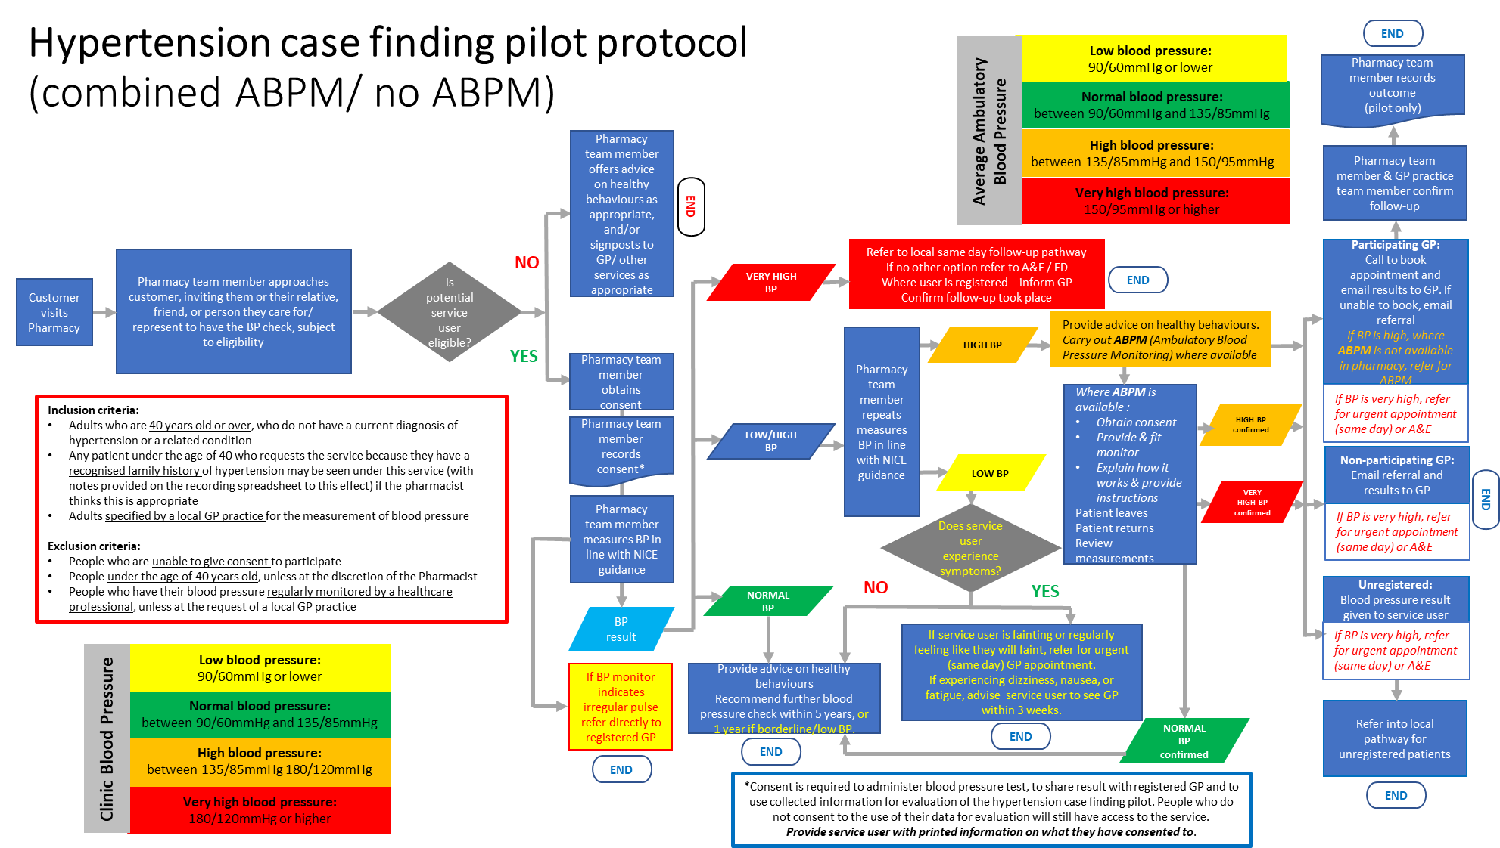
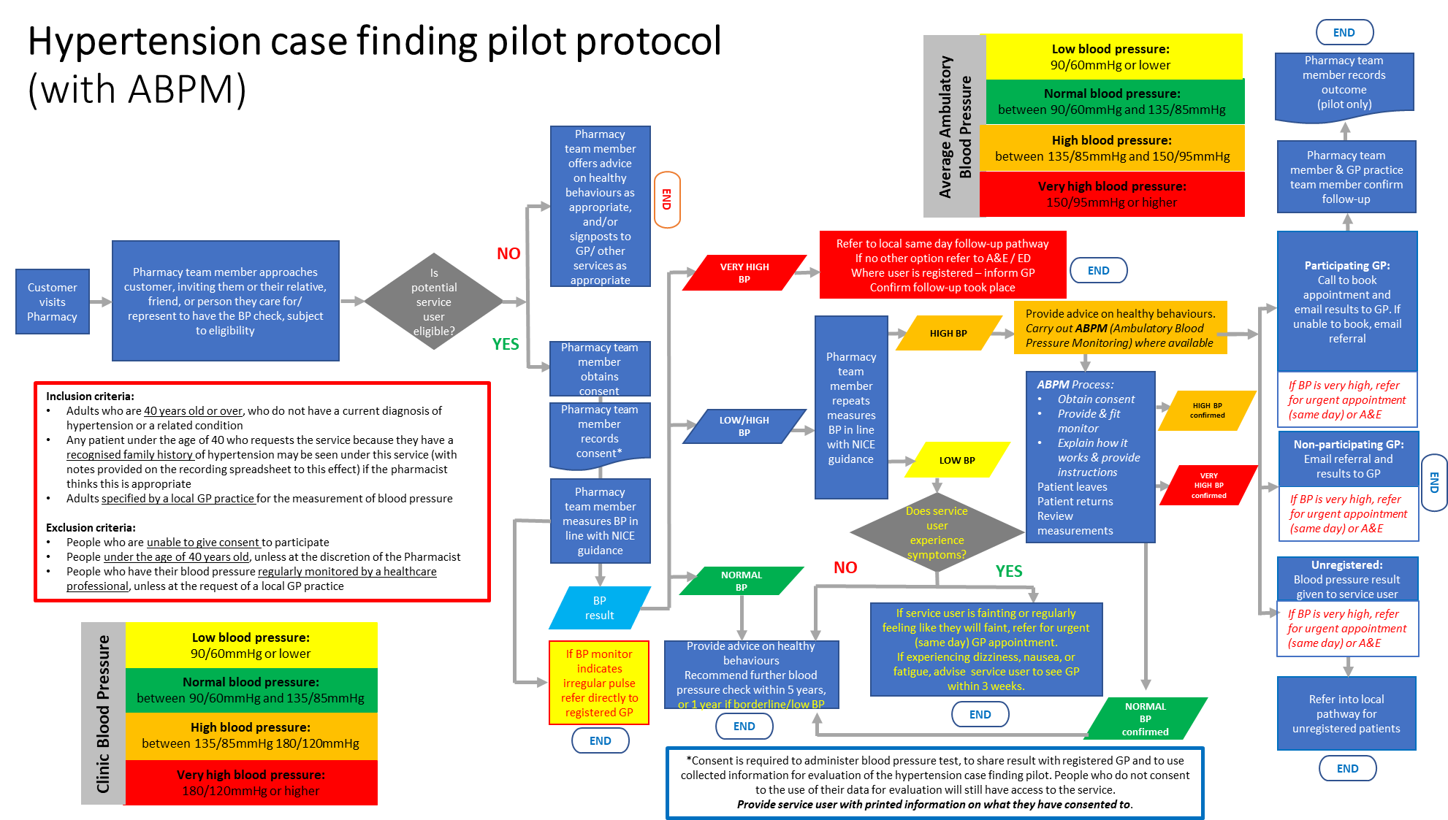
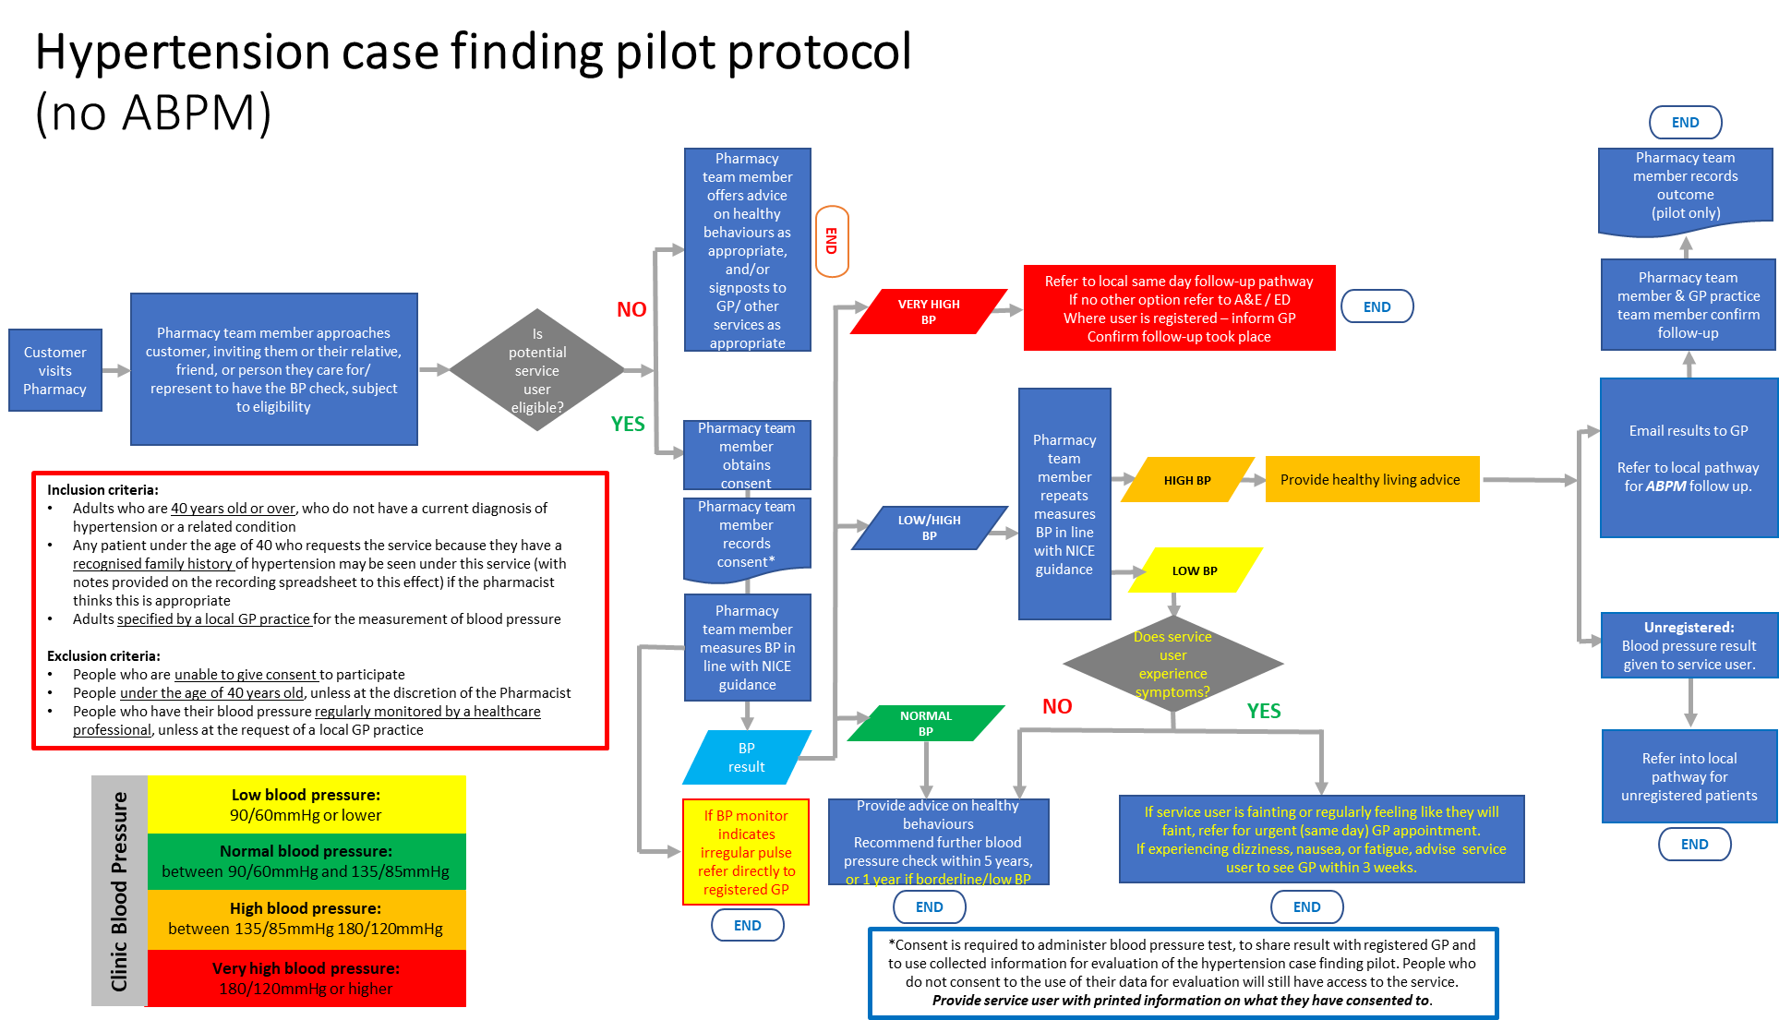

https://www.england.nhs.uk/long-term-plan/
https://www.gov.uk/government/publications/records-management-code-of-practice-for-health-and-social-care
Albasri A, OʼSullivan JW, Roberts NW, Prinjha S, McManus RJ, Sheppard JP. A comparison of blood pressure in community pharmacies with ambulatory, home and general practitioner office readings: systematic review and meta-analysis. J Hypertens. 2017;35(10):1919-1928. doi:10.1097/HJH.0000000000001443

