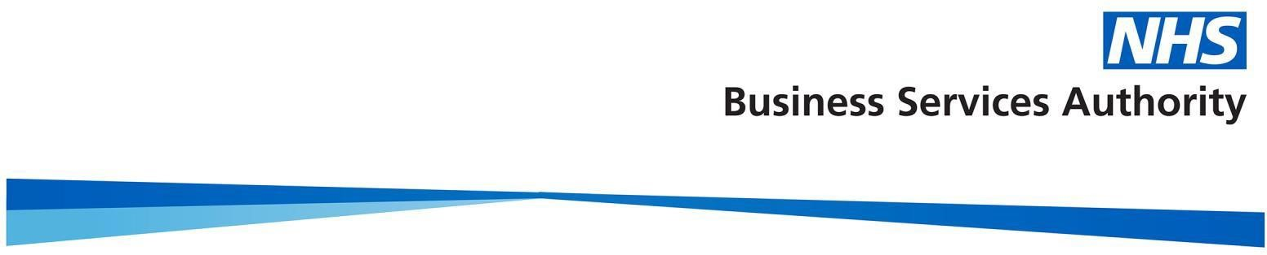
April 2021 NHS Structure

The following will be implemented as part of NHS Structure changes as of 1 April 2021. The changes will apply to April 2021 dispensing data which will be released mid-June and will be implemented across all our reporting systems where applicable. (Information Services Portal (ISP), Open Data Portal (OPD) and ePACT2).

- 135 CCGs reduced to 106 with the merger of 38 CCGs into 9
- Existing 7 regions with updated mapping
- Existing 42 STPs with updated mapping
- Existing 15 AHSNs with updated mapping
- Changes to PCNs with updated CCG and practice mapping
- New organisations assigned a new ODS code; alpha-numeric-alpha (ANANA) format
- Similar 10 refreshed to reflect 106 CCGs

View NHS Digital website https://digital.nhs.uk/services/organisation-data-service/change-summary-reconfiguration-2021-ccg-mergers for more information on structure changes

Users who have built their own analysis and reports will need to understand the new structure and update their analysis or reports appropriately to ensure they continue to run correctly.

If you need any advice or help checking or implementing your changes, please feel free to get in touch with the training team at nhsbsa.ePACT2training@nhs.net

Can I still report under my old structure?

Once the new structure has been introduced in ePACT2 any new data added to the system will only be available in the new NHS organisational structure, although it will still be possible to access historical data in the old structure.

Using the historical structure, you will still be able to run historical data for pre-April 2021 CCGs, however from April 2021 only the CCGs currently available under the April 2021 structure would have data attributed to them, for example any of the new organisations will only have one month of data, therefore any trend analysis will appear with only one data point. It will also mean that any reports that are 3 months rolling etc. will only have one month data until 3 months data is available.

Are their ways I can build my own reports as if my old CCG still existed?

It is not easily possible to replicate the old structure within your own reports as if your old CCG still existed.

However, if information is required for these historical groupings moving forward it is possible for users to create their own groups within the system using either ‘Bins’ or ‘Groups’ to group together the practices previously attributed to these CCGs. This is only possible when building your own analysis and will require you to do on-going maintenance of those reports. If you want to find out more about how to create Bins within ePACT2 then we have a guide https://www.nhsbsa.nhs.uk/sites/default/files/2018-11/ePACT2%20-%20Using%20Bins.pdf

How does it affect my financial reports?
If you are a financial user with access to the Remuneration and IPP reports used to reconcile invoices for your organisation, these reports use the historical structure and will reflect the actual structure of your organisation for the time period you select on the report.
Any reports generated from April 2021 will relate to the new NHS structure with any historical reports prior to April 2021 relating to the historical structure.

