Out of pocket expenses claims

A guide for pharmacy contractors

In 2019 we paid English pharmacies almost £3.5 million in out of pocket (OOP) expenses where the contractor incurred expenses in obtaining eligible products for patients.
In these unprecedented times, we understand the COVID-19 pandemic is putting additional pressure on contractors. This guide is designed to help you claim for OOP expenses and to highlight best practice.

What can be claimed as an OOP expense?

OOP expenses can be claimed in exceptional circumstances, where additional expenses have been incurred in obtaining eligible drugs, appliances or chemical reagents.
As per Part II, Clause 12 of the Drug Tariff, you should only claim for OOP expenses on items you do not supply frequently.
You should take all reasonable steps to avoid claiming for OOP expenses.
OOP expenses can be claimed for items in the following categories:
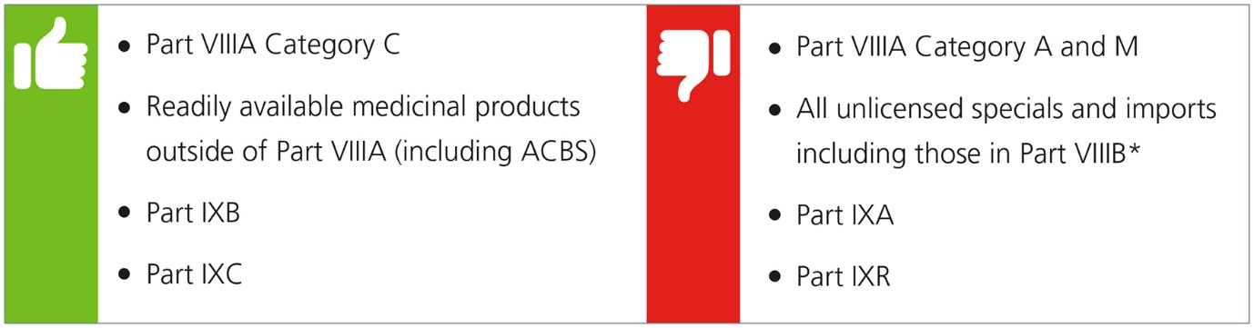
Tip:
You can only claim once for an OOP expense to cover the full pack size. If you need to supply a patient with a quantity smaller than the original pack size, you will not be able to claim again for the remainder of the packet when dispensed in future.

What costs can be claimed?

Claims for OOP expenses must be for 51p or more.
We recommend you keep suitable evidence to validate the costs incurred during the process of obtaining eligible products and that any charges incurred can be linked to an order for a specific product on a specific prescription.
You can only make a claim for the actual costs incurred during the process of obtaining specific items to fulfil specific prescriptions.
Tip:
There is no set fee for OOP expenses - your claim must reflect the actual costs incurred from obtaining a particular drug.

Endorsing the prescription

To ensure payment, you must endorse prescriptions with:
- OOP or XP for paper prescriptions (no alternative endorsements will be accepted)
- XP for electronic prescription submissions (no alternative endorsements will be accepted)
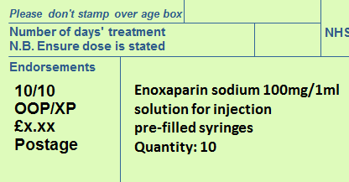

You must also include:
- the total amount being claimed
- details of the claim being made (for example, postage and packaging)
You must endorse the prescription correctly to ensure your claim is valid. We are unable to pay for claims that are incorrectly endorsed.

Tip:
If there are multiple items on the prescription and some or all incurred the same expense, only one OOP expense endorsement is required.
Further guidance on endorsing is available on our website.
For more information on fees and endorsing, please see the PSNC website:
- fees and allowances
- endorsement guidance

Sorting and submission

Paper prescription forms with OOP expense claims need to be separated and placed in the red separator before submission. If you do not do this, your OOP expenses claim might not be paid.
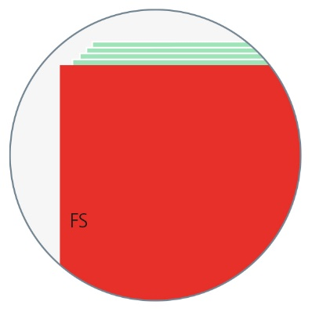
Guidance on how to sort your prescription batch is available on:
- our website
- PSNC website

Record keeping

Analysis has highlighted that a number of contractors are claiming a higher OOP expense value than the average OOP expense claim for the same supplier. We may investigate directly with contractors why their OOP expense claims are higher.
We advise you to keep a record of all OOP expense claims in case of query or investigation.
It is recommended that evidence to support your claim is stored in the pharmacy. For example, you should keep the receipt or invoice relating to your OOP expense claims.
Tip:
We advise you to keep all receipts or invoice records in order to substantiate your OOPE expense claims. Such evidence may also help to support OOP expense claims in cases where some suppliers are charging excessively to obtain drugs.

Schedule of payments

Details of the total OOP expense claims paid by us will appear on your FP34 Schedule of Payment.
You can access your FP34 Schedule of Payments and detailed Prescription Item Report using the Information Services Portal (ISP).
If you need help understanding your FP34 Schedule of Payments, we've published a guidance document on our website.

Unlicensed specials and imports

Where a prescriber considers it appropriate to prescribe an unlicensed medicinal product for a patient, the prescription must be written out accordingly to indicate that a special is required. If a prescription specifies a licensed product which is unavailable due to a shortage or a supply issue, an unlicensed medicinal product cannot be dispensed against such a prescription unless the prescriber has included the appropriate wording to indicate that a special is required.
In EPS, the prescriber must select the correct product listing on their prescribing systems to allow a pharmacy contractor to supply a special and be reimbursed accordingly. In EPS, a prescription for a special could be written as either:
- 'Drug name (Drug Tariff Special Order)' - for a special is listed in Part VIIIB'; or
- 'Drug name (Special Order)' - for a non-Part VIIIB special; or
- 'Drug name (Imported (Country))' - for an unlicensed import
If a prescriber adds supplementary information for example, the words 'Special' or any other free text into a different EPS field for example, as part of the dosage instructions or ‘additional instructions’ (also known as medication specific information or notes to pharmacy), and that changes the prescribed product, this will not be taken into account for reimbursement purposes as this information is not captured by us during processing.
For unlicensed products ordered on FP10 paper prescriptions, the wording '(Special Order)' or similar, should be included in the first line of the prescribed product, ideally following the drug name. Paper prescription forms for any specials need to be separated and sorted into a red separator before submission.

Tip:
For more information about additional product information in the dosage area, visit PSNC’s website.
In addition to the drug reimbursement costs, a fixed fee of £20 is payable for any prescriptions for unlicensed specials or imports endorsed with:
- ‘SP’ (where sourced under a MHRA manufacturer’s specials or importer’s licence) or
- ‘ED’ (where extemporaneously dispensed)
The fixed fee can be claimed for costs incurred in sourcing the item. For example, costs might include:
- postage
- handling
- delivery
Unlicensed specials or imports listed in the Drug Tariff should be endorsed with:
- ‘SP’ only (no alternative endorsements will be accepted)
Unlicensed specials or imports not listed in the Drug Tariff should be endorsed with:
- 'SP' only (no alternative endorsements will be accepted)
- amount dispensed over pack size used
- invoice price per pack size from which the order was supplied less any discount or rebate
- manufacturers’/Importers’ MHRA licence number
- batch number of the product supplied

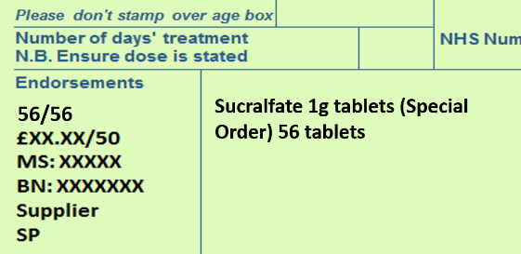

Extemporaneously dispensed unlicensed specials manufactured under the Section 10 exemption from the Medicines Act 1968 (either by the contractor or a third party) should be endorsed with:
- ED for costs incurred in dispensing a product prepared under the Section 10 exemption
- the names, quantities and cost of the ingredients used in preparing the product

Broken Bulk can be claimed on the ingredients used to make the product
For more information on claiming for SP fees, see the PSNC website or the Unlicensed Specials and Imports Dispensing Factsheet.
Tip:
The 'OOP' or 'XP' endorsement cannot be used on prescriptions for unlicensed specials or imports.

Support

For further help and support with claiming for out of pocket expenses, contact us at nhsbsa.pharmacysupport@nhs.net.

