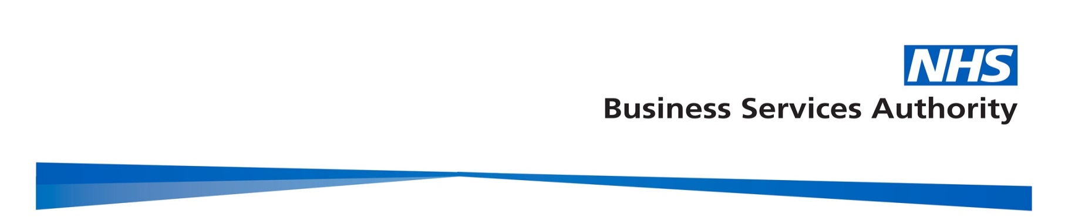
NHSBSA Provider Assurance Dental
Operational Procedure
Abatement 1 April – 7 June 2020

Background

NHSBSA Provider Assurance Dental team on behalf NHS England & NHS Improvement Regional Teams will enact the abatement for the period 1st April – 7th June 2020.

In Issue 3 of the preparedness letter on 25 March 2020, dental contractors were advised:

- All routine, non-urgent dental care including orthodontics should be stopped and deferred until advised otherwise;
- All practices should establish (independently or by collaboration with others) a remote urgent care service, providing telephone triage for their patients with urgent needs during usual working hours, and whenever possible treating with:
• Advice;
• Analgesia;
• Antimicrobial means where appropriate.

In the resumption of dental services letter of 28 May 2020, restrictions around the provision of face-to-face care were lifted for primary care dental services on 8 June 2020.

In Issue 5 of the preparedness letter on 13 July 2020, dental and orthodontic contractors were advised that all practices were to open for face to face by 20 July, and that the following abatements would be applied to GDS contracts & PDS agreements for the appropriate period.

- Non UDC Practices - 16.75% abatement to the total contract value across the period 1 April 2020 – 7 June 2020.

For the avoidance of doubt the following contractors are exempt:

- UDC Contracts or agreements – No abatement
- Orthodontic close down agreements – No abatement.

NHS BSA will apply the abatement to all GDS contracts and PDS agreements (with the exception of the above two commissioning arrangements as defined in the SFE) or where contracts are not paid by the NHS BSA for example Community Dental Services, AQP contracts, or Prison services. Commissioners will be responsible for this at a regional level.

As stated in the Primary Care Dental Services Statement of Financial Entitlement (Coronavirus) (Amendment) Directions 2021 (link to published version upon publication), where an abatement has been calculated this will be recovered by four instalments. This will commence with your scheduled Compass payment on 1 April 2021 (March 2021 schedule) and be completed by 1 July 2021 (June 2021 schedule).

Quality Assurance Process

Quality assurance and measures to ensure data accuracy and integrity will be implemented throughout the process.

The identification of contracts will be established using year-end methodology (contracts with contracted OR processed activity) coded into the Data Warehouse. This will have NHSBSA multi-team scrutiny from NHSBSA PAD and Data Insight.

The abatement calculation (as detailed below) and identification of UDC contracts will be built into the data warehouse at contract level before commissioner and NHSBSA PAD (casework and analyst) oversight will be applied.

PAD Analysts will identify amended contract information by comparing the returned commissioner spreadsheets with the data warehouse, as well as following the detailed instruction, once identified, calculations will be verified by an analyst and peer reviewed from a data specialist.

The “abatement deductions” will then be prepared for import to Compass to create the instalment amounts automatically, following peer review. This process will be tested in advance and a sample checked following the final import.

A programming code has been prepared and tested to create the letters and ready for them to be imported into Compass. These will then be scrutinised by caseworkers to ensure that they reflect the correct data for each contract before upload to Compass. A sample will then be checked within Compass following the upload.

Reports will then be available to commissioners and finance leads across NHS England & NHS Improvement.

Operational Plan

A timeline detailing the operational plans and deadlines/completion dates is found at the end of the procedures.

Abatement Spreadsheets to Regional Teams

NHS BSA PAD will send Regional teams abatement spreadsheets to inform the preparatory work in regard to the abatement process. RTs to confirm UDCs commissioned during the period practices and Orthodontic specific close down agreements and make any required amendments.

If a contract has closed in year and has opened on a new contract number, NHSBSA PAD will combine the data and include only the open contract, RT to indicate this in the spreadsheet. This will be the only occasion where we would need to combine two contracts.

Abatement Spreadsheet Returned to NHSBSA PAD

Regional Teams to return spreadsheet to NHSBSA PAD by 5 March 2021.

NHSBSA PAD will need to check the following:
- review any notes/combined contracts made by Regional teams;
- perform a general sense check on excluded;
- delete any duplicate contracts; and
- Ensure it has been clearly identified where a TCV has been amended.

The returned spreadsheet will be classed as Regional Team sign off for NHSBSA PAD to use information provided to calculate the abatement. This will need dual sign off with person from the team completing the return and the Strategic Dental Lead.

Calculating the Abatement amount

The abatement will be calculated by dividing the contractor’s NACV by 52 to produce a weekly amount of the contractor’s NACV, then multiplying the contractor’s weekly NACV amount by 9 to produce the NACV attributable to the period of closure, 16.75% of this 9 week pro-rated figure is then calculated to form the abatement value.

NHSBSA PAD analysts will calculate the abatements using the above calculation methodology built into the data warehouse. These calculations will be based on the information provided in the returned spreadsheets, accounting for combined contracts and any amendments that have been made to the TCV.

Abatements entered on Compass

NHSBSA PAD will enter abatement deductions in Compass using programming code prior to the 22 March 2021, Compass cut-off date.

Abatements will be recovered in four instalments between Compass payment on 1 April 2021 (March’s schedule) and be completed by 1 July 2021 (June’s schedule)
Compass adjustment code: ABAT1_2021 - Abatements for period 1 April to 7 June 2020
NHSBSA PAD will create a report in Eden, which will allow RTs to run a report to show the total amount of abatement for their region/STP.

Abatement letters published in Compass

NHSBSA PAD will publish abatement letters in Compass during the week commencing 22 March 2021 and prior to the first abatement deduction commencing. A mail chimp notification will be sent to all appropriate business owner email addresses to communicate to Providers when their Abatement letter is ready to be viewed.

Query Management

All queries will form part of the NHSBSA PAD remit. RTs are advised to sign post enquires/queries to NHSBSA. All queries from a Provider will be acknowledged within 5 working days of receipt.

Timeline for delivery

Step of Process | Deadline/ Completion Date | Description
1 | 26/02/2021 | In preparation for the legislation being laid, spreadsheets have been sent to Regional Teams to identify and confirm exempt dental contracts and agreements
2 | 05/03/2021 | Deadline for Regional Teams to return abatements spreadsheets
3 | 8/03/2021 onwards | NHSBSA PAD calculate abatement
4 | 19/03/2021 | Abatement Adjustments to be entered in Compass
5 | Week commencing 22/03/2021 | Publish letters in Compass
6 | 1/04/2021 | Abatements to commence with 4 instalments
7 | 1/04/2021 | Reporting arrangements to be in place for NHS England and NHS Improvement commissioning and finance leads

