ePACT2 user guide
National – Accessing Dashboards and Pre-built Reports

Interactive Contents
Use this interactive contents list to jump straight to the content you want to see. Just click the titles below to go directly to that section:
Contents
Accessing a Dashboard Report 1
Dashboard Selection 1
Navigating the Dashboard 2
Selecting a Dashboard Page 2
Dashboard Criteria Selection 3
Chart/Data Views 4
Exporting and Printing the Data 5
Exporting and Printing Individual Reports 6
Exporting And Printing a Dashboard Page 8
Accessing Pre-built Reports 9
Selecting a Pre-built Report 9
Using a Prescribing Report 10
Getting more help 12

Accessing a Dashboard Report
ePACT2 has a multitude of dashboards available for National users, with their aim to provide high level information for users to be able to easily benchmark their organisation against others within the different structural levels of the NHS (National/STP/Commissioner/Provider/PCN/Practice).
In addition to this, these dashboards help users to monitor prescribing within different areas in order to support medicines optimisation, patient safety, improving patient outcomes and prioritising areas you may wish to focus more resources on.
Detailed information and specification documents for the dashboards are available via the NHSBSA website here: https://www.nhsbsa.nhs.uk/epact2/epact2-dashboardsspecifications

Dashboard Selection
- Select the ‘Dashboards’ link from the ePACT2 Landing page:
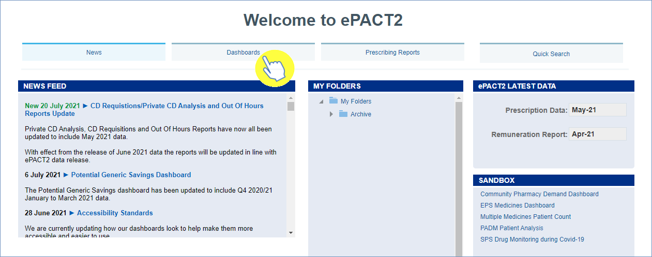
- The dashboard page will open and display all available dashboards. From here click the blue link of the dashboard you want to open:
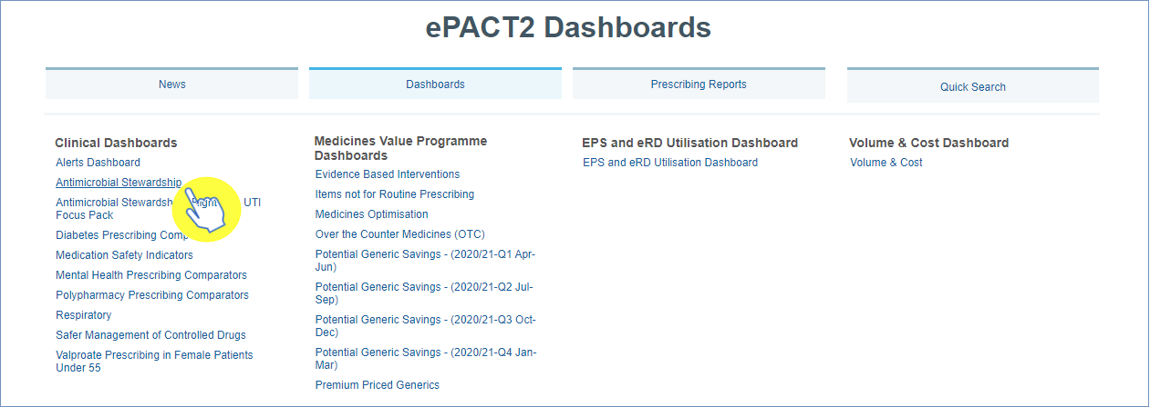

Navigating the Dashboard
For the purposes of this guide we shall use the ‘Antimicrobial Stewardship’ dashboard as an example. With all of the dashboards contained within ePACT2, these dashboards will operate with the same general functionality and ease of use.

Selecting a Dashboard Page
Dashboards are made up of several different pages which allow you to select different sets of information. For example, you can view information at different organisation levels.
- To navigate to a different page, click on the tab of the page you would like to view (the ‘Antimicrobial’ dashboard will default to the ‘National Summary’ tab when first accessed):
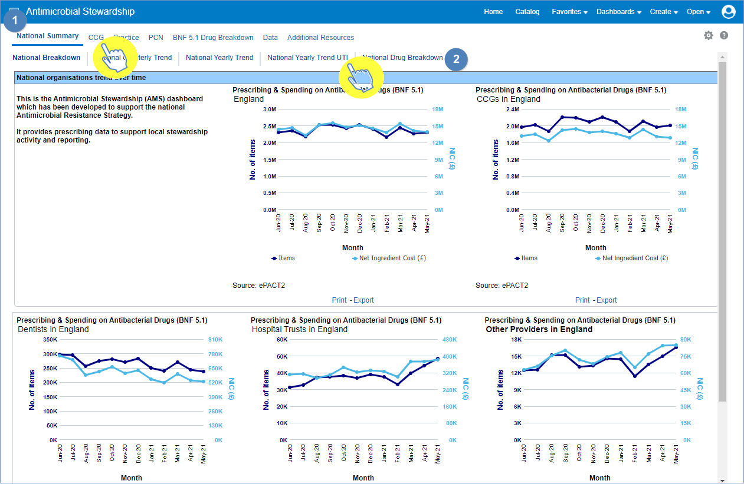
Once the organisation level tab of your choice has been selected, the data displayed on the page will update to reflect the level you have chosen to view it at.
- You can then choose between the different sub-tabs to see, in this case with the ‘National Summary’ tab selected - a ‘National Breakdown’, ‘National Quarterly Trend’, ‘National Yearly Trend’, ‘National Yearly Trend UTI’ or a ‘National Drug Breakdown’.

Dashboard Criteria Selection
Underneath the ‘Tabs’ and Sub-tabs’ you will find the ‘Criteria Selection’. It is here you can select the criteria you want, in order to return the data you wish to see (the CCG tab/CCG Trend sub-tab have now been selected):
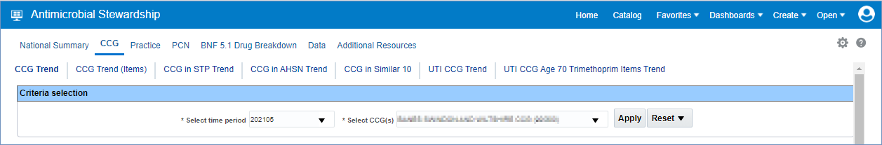
The dashboard will default to show data for the latest time period available. As the data in all dashboards is available at practice level and above you will be able to access the data for any organisation.
The options available in the ‘Criteria Selection’ will change depending on the dashboard you are looking at.
To change the data shown in the dashboard simply select an option from the drop-down boxes in the Criteria Selection
Click on the drop-down arrow to the right of the box you would like to update:
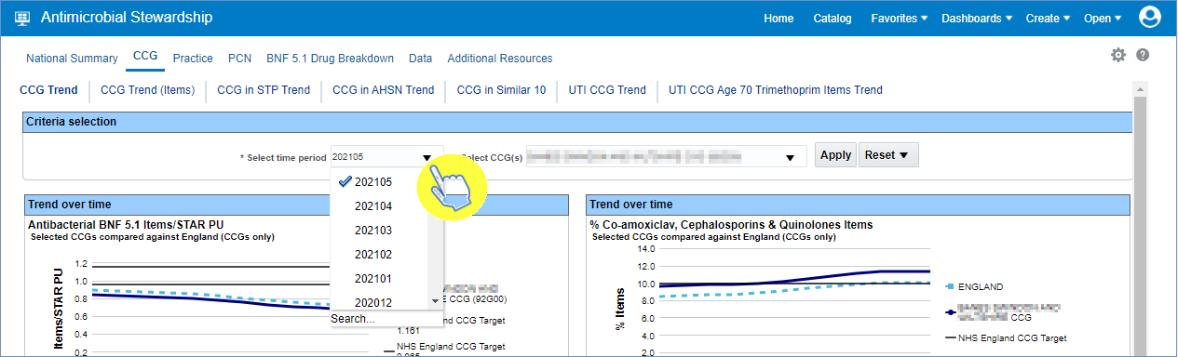

- Select a change to the criteria by clicking on the option in the drop-down box you want to see:
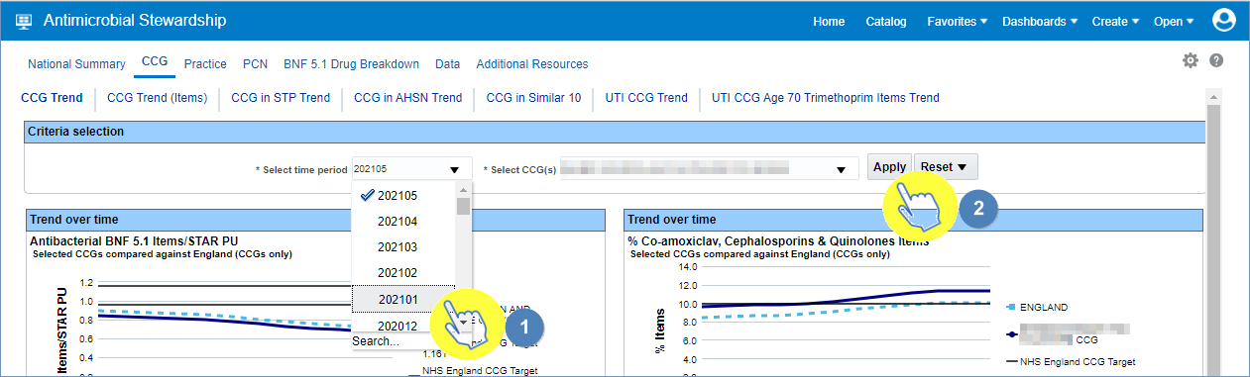
- Once a change to the criteria has been selected in the drop-down box, ensure that the ‘Apply’ button is then clicked to update and display the data required.

N.B. - Not all dashboards have an ‘Apply’ button to change the criteria selection. If you’re using a dashboard that does not have an ‘Apply’ button, then the data will automatically update when the criteria is changed in the drop-down box.

Chart/Data Views
Reports within the system will generally come with 2 different views:
- A ‘Chart’ view, where the system will represent the data returned as a visualisation - such as a Bar chart or a Trend Line graph for example, in order to give the user an easier, visual way of interpreting the data:
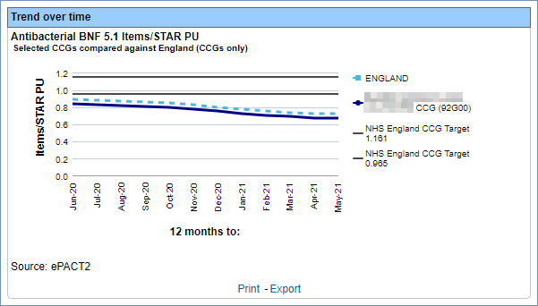

And/or
- A ‘Table’ view, where the data will be represented in numerical form within a table of data:
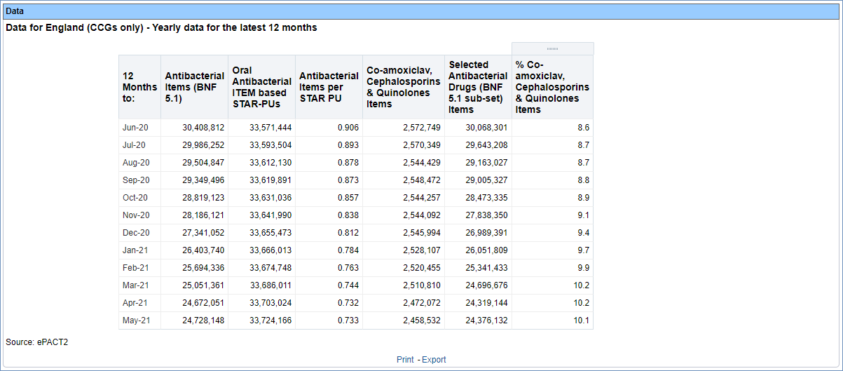

If a report within a dashboard has both views you can switch between these ‘Chart’ and ‘Data’ views by opening the drop-down box above the view and selecting between the two options:

Exporting and Printing the Data
Information can be exported from the dashboard in several ways and in a number of different formats, these formats are standard throughout the system.
Print Formats:
- Printable PDF
- Printable HTML
Export Formats:
Formatted -
- PDF
- Excel
- PowerPoint
- Web Archive
Data -
- Excel
- CSV
- Tab Delimited
- XML

Exporting and Printing Individual Reports
The reports within the dashboard will have options to ‘Print’ or ‘Export’ (highlighted) below each of the reports:

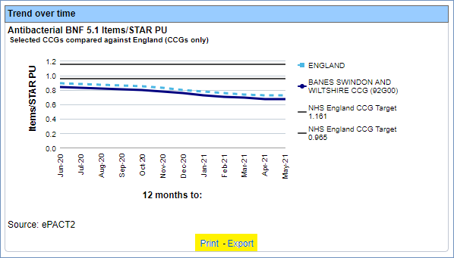

Exporting Individual Reports
- Select the ‘Export’ option below the report required
- A drop-down list with the formats available to export in will be displayed
- Select the format required from the list presented
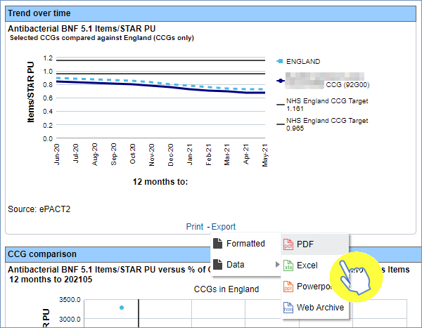

Printing Individual Reports
- Select the ‘Print’ option below the report required
- Select the format required from the list presented
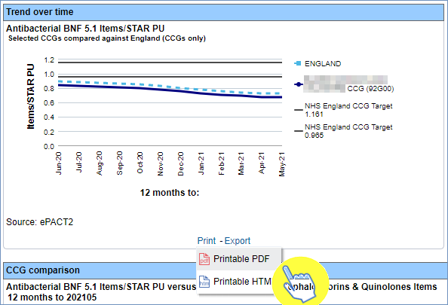

Exporting And Printing a Dashboard Page
You can also export or print the entire page of a dashboard if you find all the views relevant.

Exporting a Dashboard Page
- Select the ‘Cog’ icon in the upper right-hand corner of the page
- From the drop-down list presented select the option ‘Export to Excel’
- Then select ‘Export Current Page’
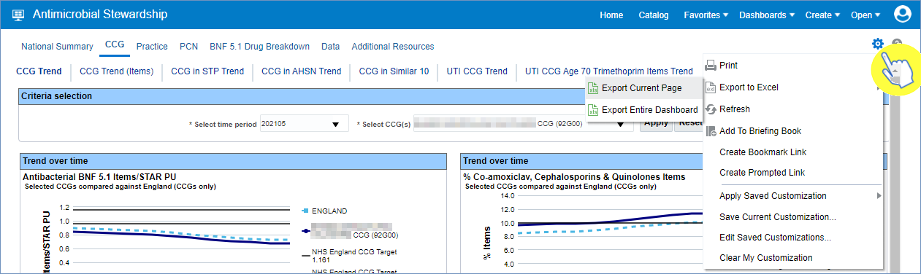

Printing a Dashboard Page
- Select the ‘Cog’ icon in the upper right-hand corner of the page
- From the drop-down list presented select the option to ‘Print’
- Then select the ‘Print’ format you require
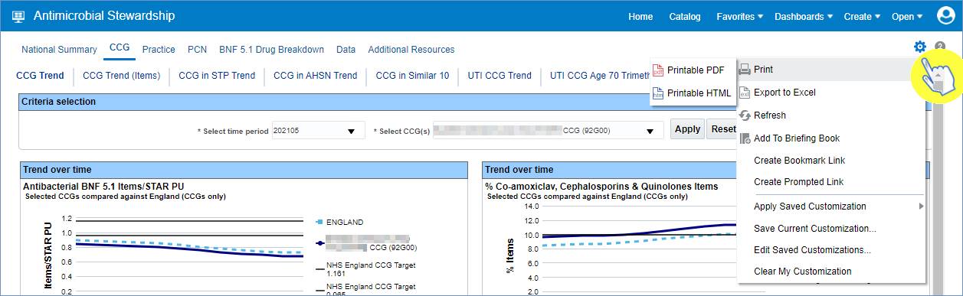

Accessing Pre-built Reports
The pre-built ‘Prescribing Reports’ allow a user to access data to monitor prescribing trends over various, differing areas such as medicines optimisation.

Selecting a Pre-built Report
- To access the ‘Prescribing Reports’ from the Landing page simply select the ‘Prescribing Reports’ tab:
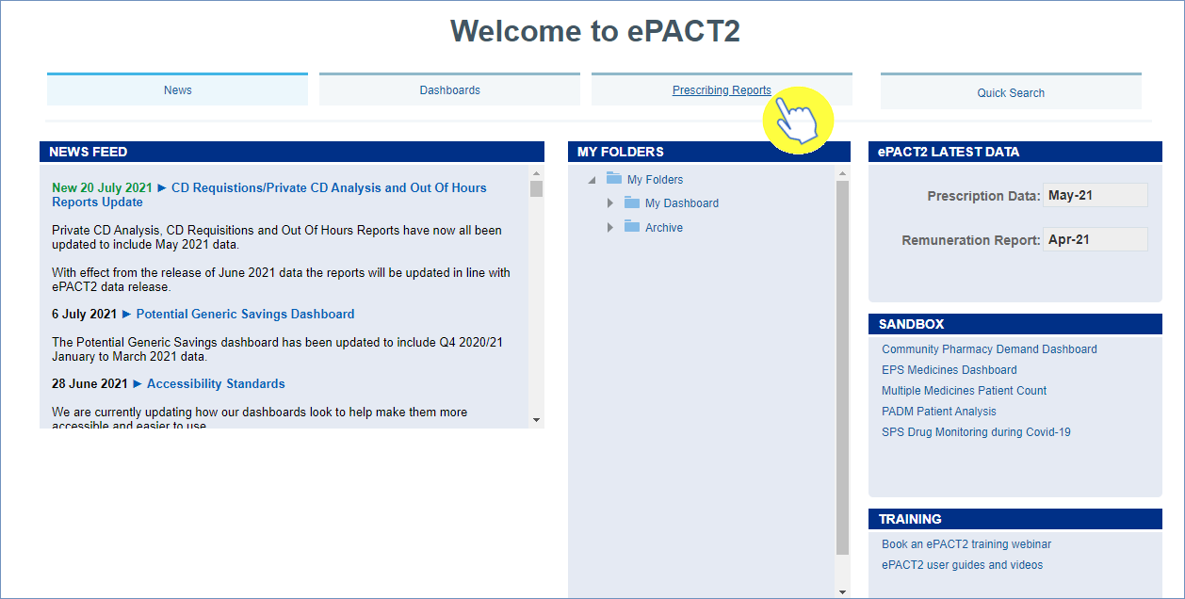

- You will be taken to the ‘Prescribing Reports’ section, all reports are accessed by expanding the report category and selecting the link for the report you wish to view:
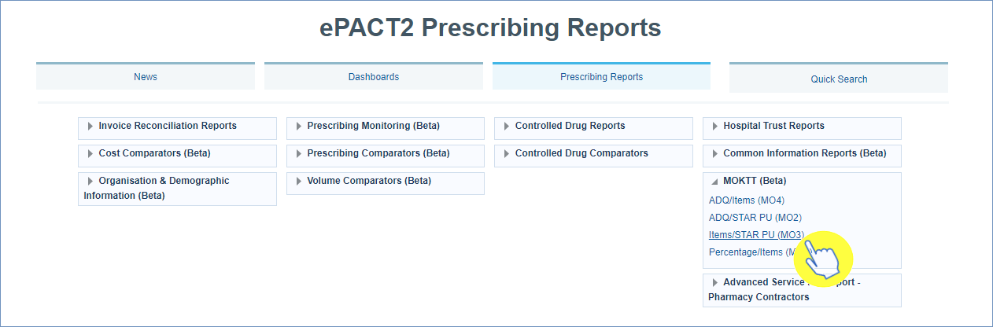

Using a Prescribing Report
With the majority of the ‘Prescribing Reports’ within ePACT2, they visually have a similar appearance to that of the dashboard reports.
The MO KTT Items/Star PU prescribing report is used here as an example.
- Select the main ‘Tab’ ( 1) you wish to view, and then the ‘Sub-Tab’ ( 2):
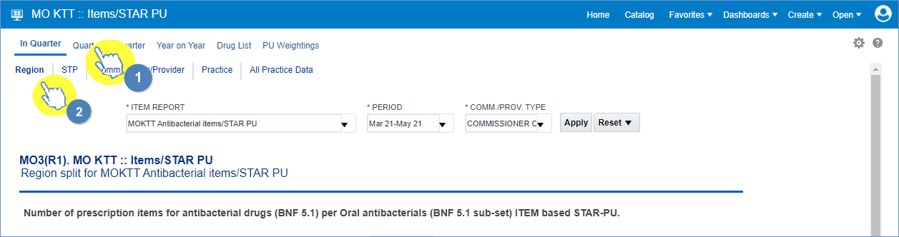

- The ‘Criteria Selection’ can then be used to restrict the report to your chosen criteria. N.B - within this prescribing report the criteria selection has an ‘Apply’ button (highlighted), this means that any change to the criteria must be applied by clicking this ‘Apply’ button to update the report to return the data for the relevant changes made:
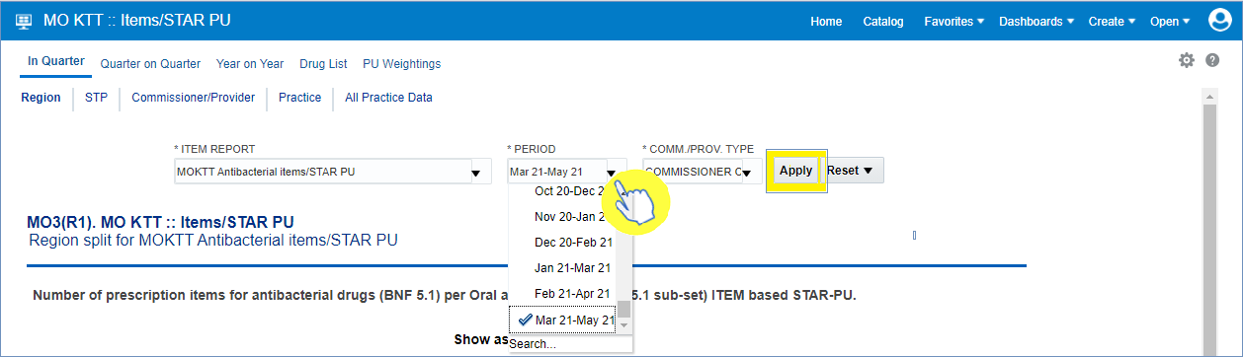

- The report will now return the data for the criteria selected, and beneath the view in the report there is again the options to ‘Export’ or ‘Print’ the data from the report (as highlighted):

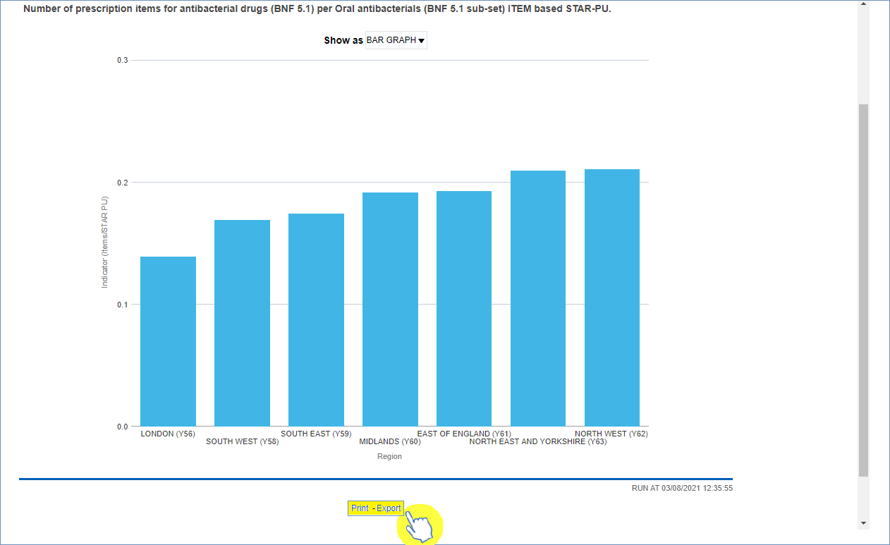

- There is also the option to switch between the ‘Graph’ view to a ‘Table’ view within this MO KTT Items/Star PU report:
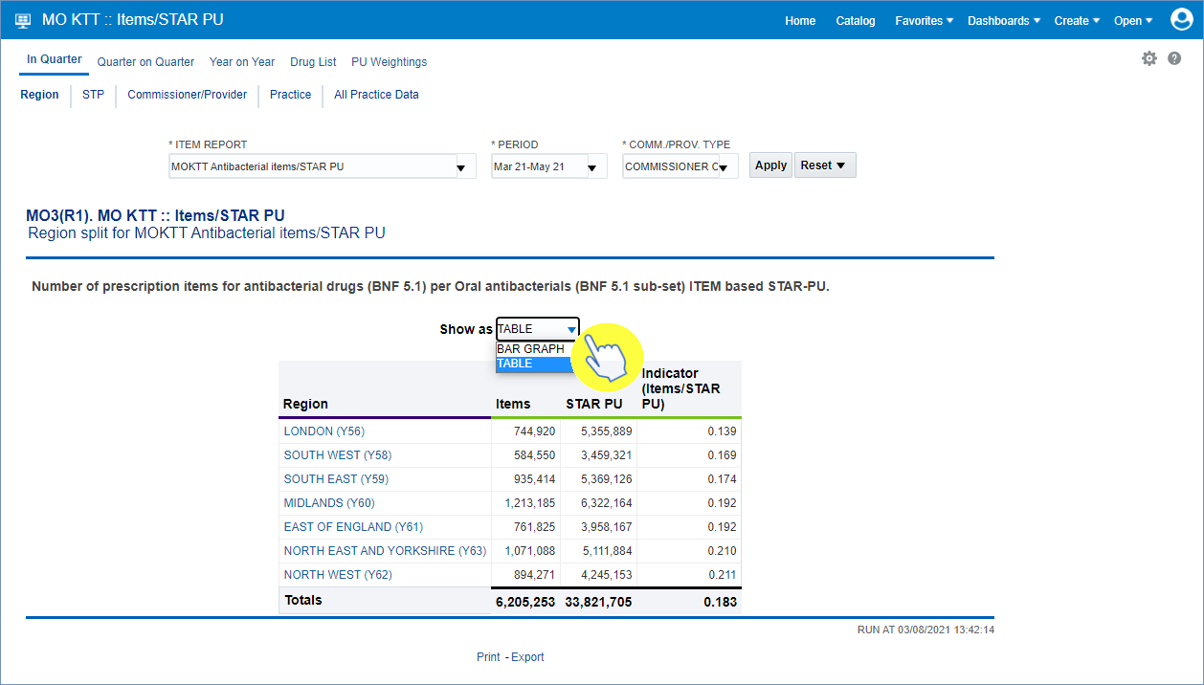

Getting more help

Additional training material and user guides
The ePACT2 training team has developed several how to guides to help you get the best out of ePACT2. These can be found on our ePACT2 user guides page
Webinar sessions
We offer a free, personalised webinar training service to all our users and you can book as many as you need.
You can let us know if you have any specific topics or reports you’d like to cover or if you would prefer an introductory tour. You can take part wherever you are as long as you can get online.
You can find our more and book you webinar by going to our ePACT2 training page

