ePACT2 user guide
STP – Accessing Dashboards and Pre-built Reports

Interactive Contents
Use this interactive contents list to jump straight to the content you want to see.
Just click the titles below to go directly to that section:
Accessing a Dashboard 1
Dashboard Selection 1
Navigating the Dashboard 2
Selecting a Dashboard Page 2
Dashboard Criteria Selection 3
Chart/Data Views 4
External Request Procedure for Patient Identifiable Information 5
Exporting and Printing the Data 6
Exporting and Printing Individual Reports 6
Exporting and Printing a Dashboard Page 8
Accessing a Pre-built Report 9
Selecting a Pre-built Report 9
Using a Standard Report 10
Using a Report Template 11
Getting more help 13

Accessing a Dashboard
ePACT2 has a multitude of dashboards available for STP users, with their aim to provide high level information for users to be able to easily benchmark their organisation against others within the different structural levels of the NHS (National/STP/Commissioner/Provider/PCN/Practice).
In addition to this, these dashboards help users to monitor prescribing within different areas in order to support medicines optimisation, patient safety, improving patient outcomes and prioritising areas you may wish to focus more resources on.
Detailed information and specification documents for the dashboards are available via the NHSBSA website here: https://www.nhsbsa.nhs.uk/epact2/epact2-dashboardsspecifications

Dashboard Selection
- Select the ‘Dashboards’ link from the ePACT2 Landing page:
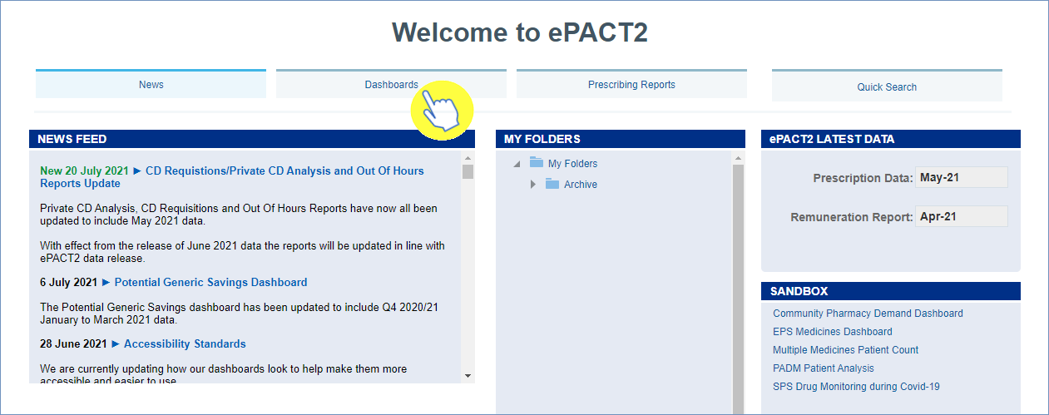
- The dashboard page will open and display all available dashboards. From here click the blue link of the dashboard you want to open:

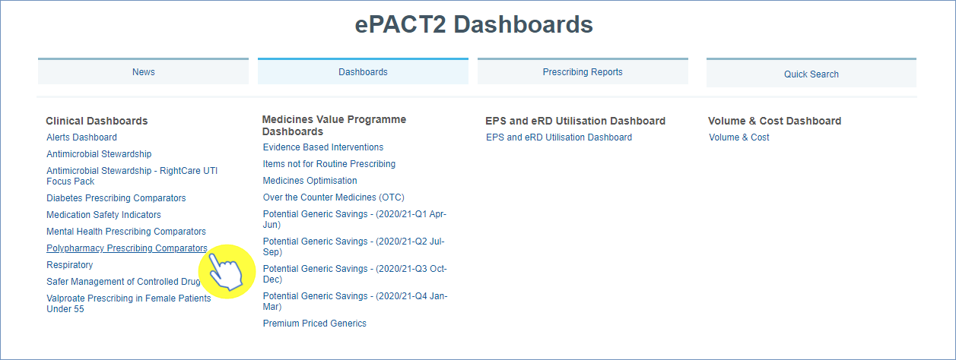

Navigating the Dashboard
For the purposes of this guide we shall use the ‘Polypharmacy’ dashboard as an example. With all of the dashboards contained within ePACT2, these dashboards will operate with the same general functionality and ease of use.

Selecting a Dashboard Page
Dashboards are made up of several different pages which allow you to select different sets of information. For example, you can view information at different organisation levels.
- To navigate to a different page, click on the tab of the page you would like to view (the ‘Polypharmacy’ dashboard will default to the CCG tab when first accessed):
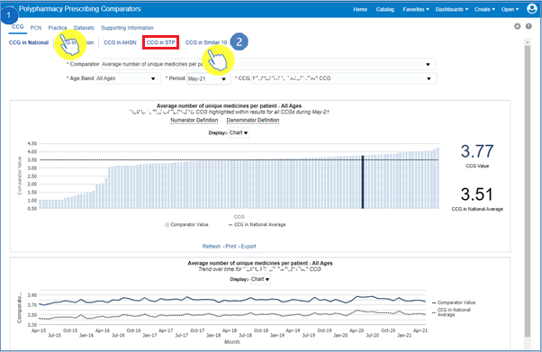
Once the organisation level tab of your choice has been selected, the data displayed on the page will update to reflect the level you have chosen to view it at.

- You can then choose between the different sub-tabs to see, in this case, the chosen CCG compared Nationally, Regionally, within its AHSN, STP or against a ‘Similar10’ (Similar10 developed by NHS RightCare)

Dashboard Criteria Selection
Underneath the ‘Tabs’ and Sub-tabs’ you will find the ‘Criteria Selection’. It is here you can select the criteria you want, in order to return the data you wish to see:
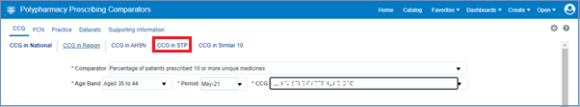
The dashboard will default to show data for the latest time period available and the CCG you are registered under. As the data in all dashboards is available at practice level and above you will be able to access the data for any organisation.
The options available in the ‘Criteria Selection’ will change depending on the dashboard you are looking at.
To change the data shown in the dashboard simply select an option from the drop-down boxes in the Criteria Selection
- Click on the drop-down arrow to the right of the box you would like to update:
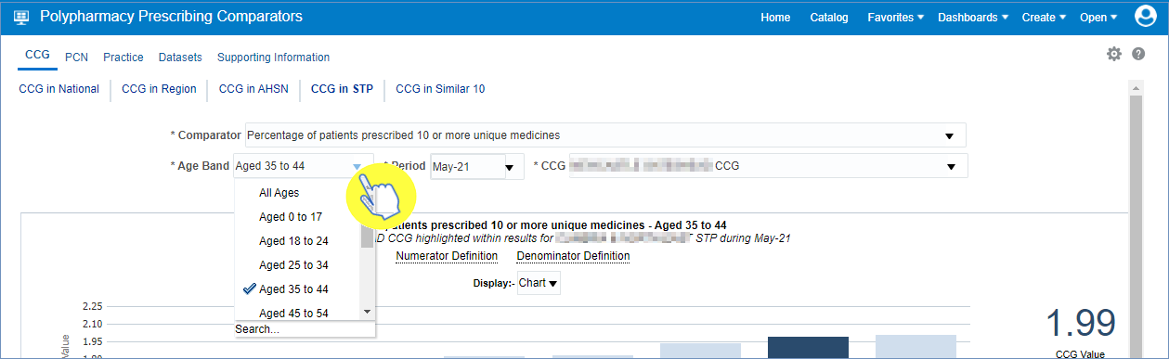
- Select a change to the criteria by clicking on the option in the drop-down box you want to see:
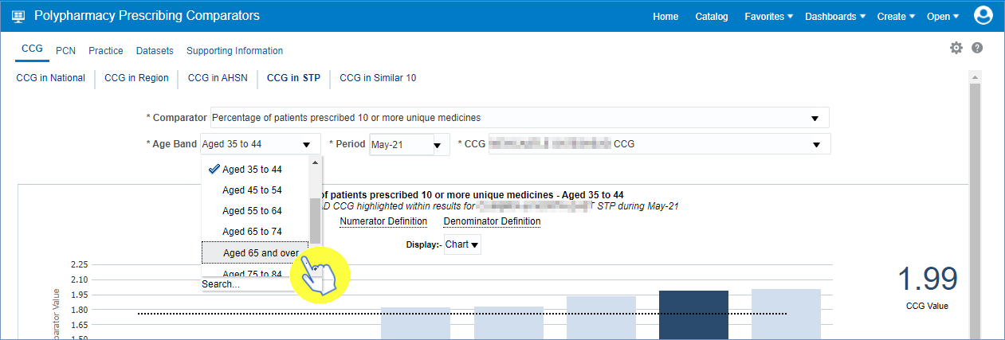
Once selected the dashboard will automatically update and display the required data.

Chart/Data Views
Reports within the system will generally come with 2 different views:
- A ‘Chart’ view, where the system will represent the data returned as a visualisation - such as a Bar chart or a Trend Line graph for example, in order to give the user an easier, visual way of interpreting the data:
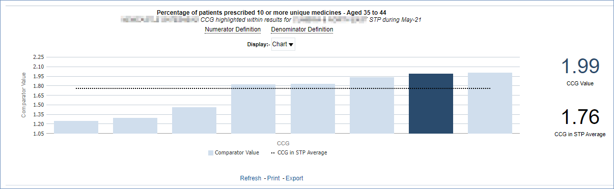
And/or
- A ‘Table’ view, where the data will be represented in numerical form within a table of data:
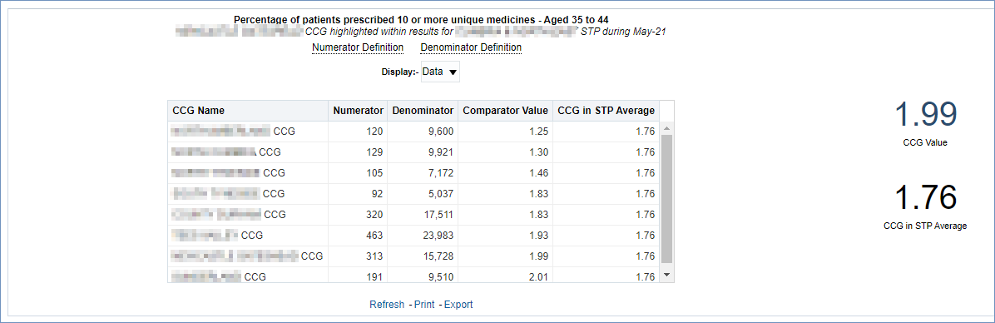
If a report has both views you can switch between these ‘Chart’ and ‘Data’ views by opening the Display drop-down box and selecting between the two options:
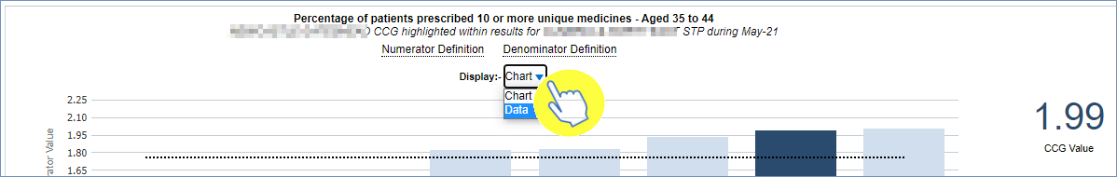

External Request Procedure for Patient Identifiable Information
If the user identifies a patient/group of patients within the results, and they may wish to initiate an investigation/SMR (Structured Medication Review) into them, then there is an external procedure to obtain that patient identifiable information.
Due to patient confidentiality, the actual patient identifiable information cannot be stored within the system itself but can be requested externally using the following process.
Within the ‘Polypharmacy’ dashboard there is a tab titled ‘Supporting Information’, when clicked on this tab has various sub-tabs one of them being ‘Patient Details’.
Select this ‘Patient Details’ sub-tab to then bring up the external request procedure needed to request patient identifiable information (patient identifiable information is usually in the form of a patients’ NHS Number when requested):
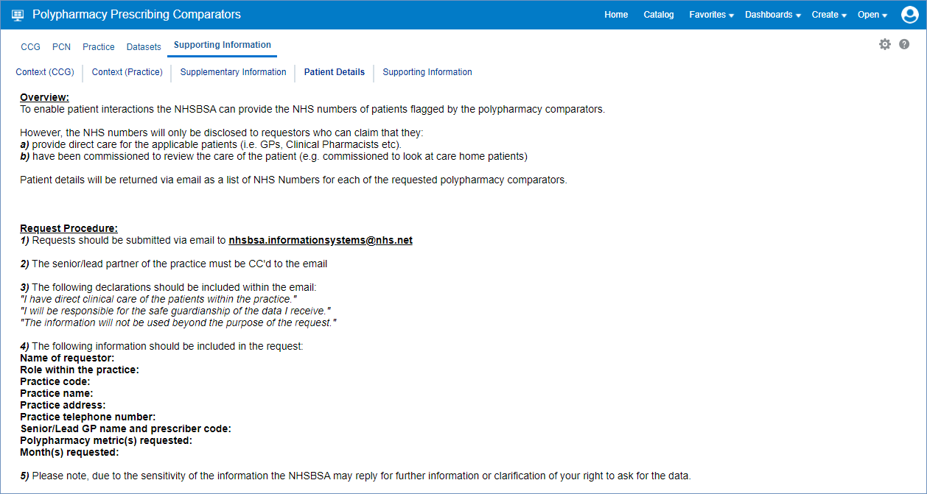

Please note: to identify individual patients, you must first attribute the numbers of patients to each of the practices they received their prescription from. Then those NHS numbers you receive can be used to identify those patients and put in place those possible investigations/SMR’s.

Exporting and Printing the Data
Information can be exported from the dashboard in several ways and in a number of different formats, these formats are standard throughout the system.
Print Formats:
- Printable PDF
- Printable HTML
Export Formats:
Formatted -
- PDF
- Excel
- PowerPoint
- Web Archive
Data -
- Excel
- CSV
- Tab Delimited
- XML

Exporting and Printing Individual Reports
The reports within the dashboard will have options to ‘Print’ or ‘Export’ (highlighted) below each of the reports:
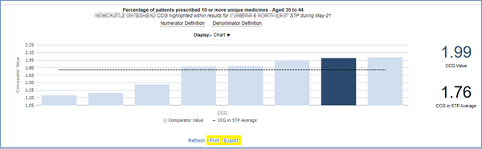

Exporting Individual Reports
- Select the ‘Export’ option below the report required
- A drop-down list with the formats available to export in will be displayed
- Select the format required from the list presented
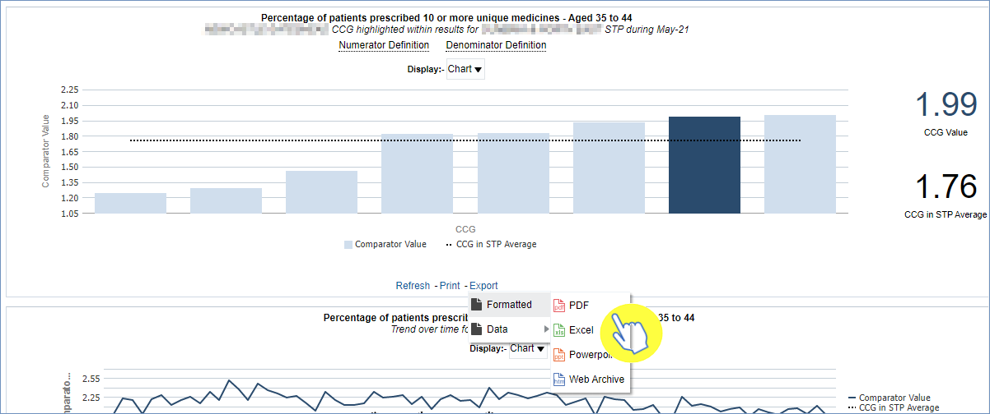

Printing Individual Reports
- Select the ‘Print’ option below the report required
- Select the format required from the list presented
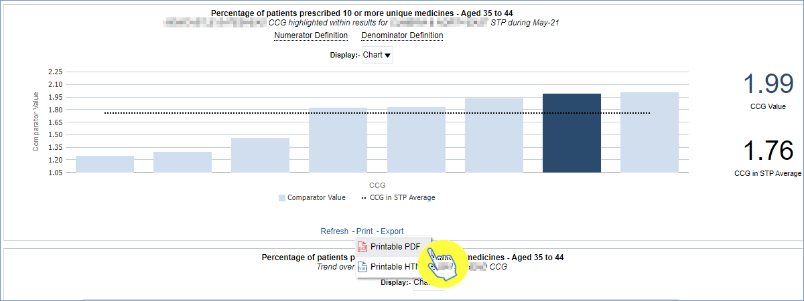

Exporting and Printing a Dashboard Page

Exporting a Dashboard Page
- Select the ‘Cog’ icon in the upper right-hand corner of the page
- From the drop-down list presented select the option ‘Export to Excel’
- Then select ‘Export Current Page’
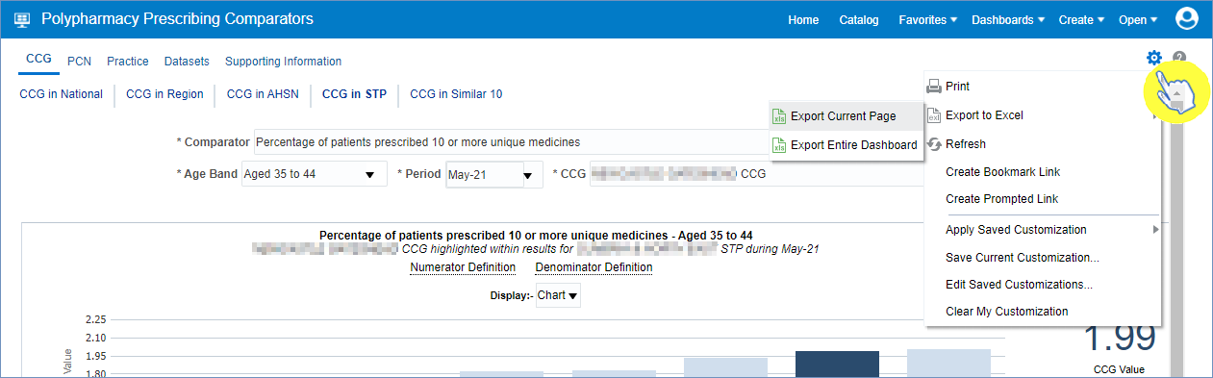

Printing a Dashboard Page
- Select the ‘Cog’ icon in the upper right-hand corner of the page
- From the drop-down list presented select the option to ‘Print’
- Then select the ‘Print’ format you require
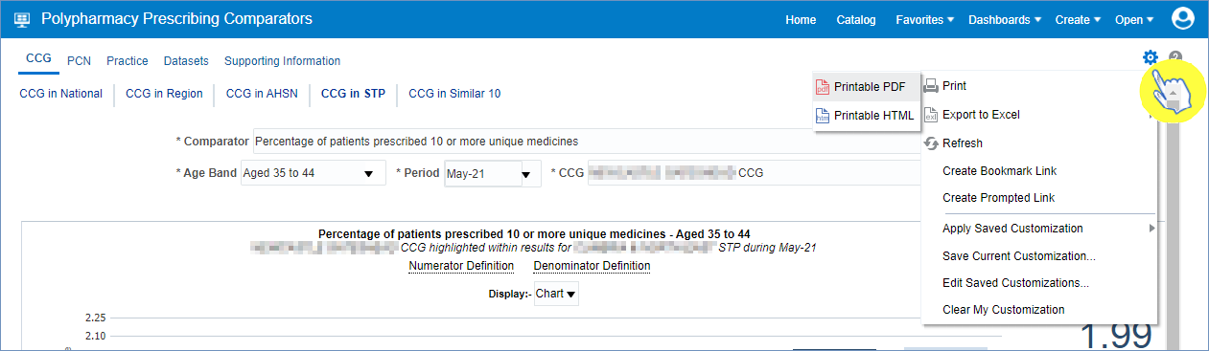

Accessing a Pre-built Report
The pre-built ‘Prescribing Reports’ are available in two different formats. ‘Standard reports’ are available which allow users to access data for a specific prescribing area. There are also some ‘Report Templates’ which allow users to set a more specific, narrowed criteria for the data.

Selecting a Pre-built Report
- To access the ‘Prescribing Reports’ from the Landing page simply select the ‘Prescribing Reports’ tab:
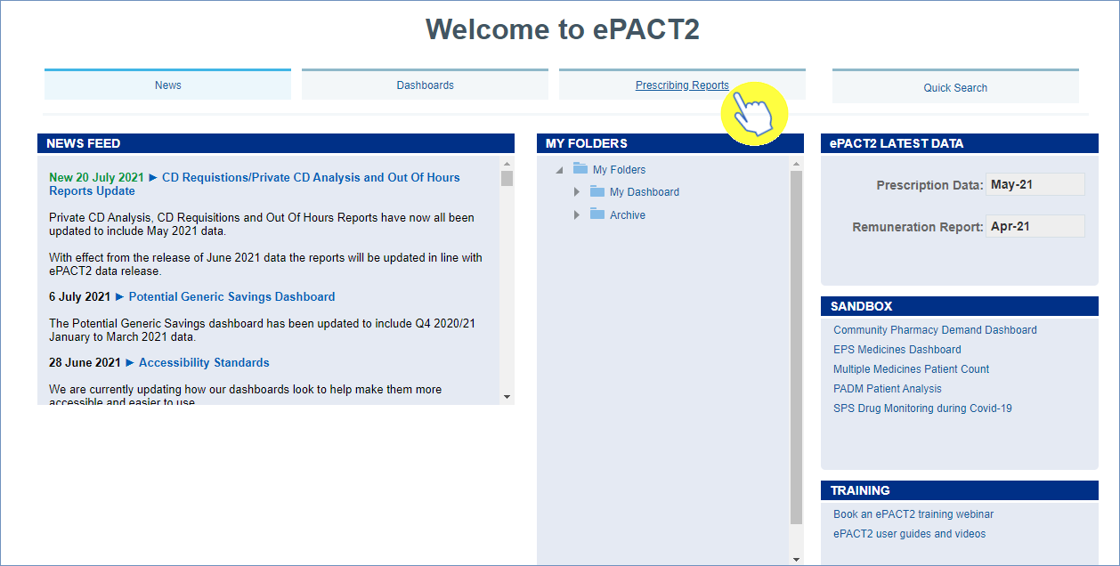

- You will be taken to the ‘Prescribing Reports’ section, all reports are accessed by expanding the report category and selecting the link for the report you wish to view:
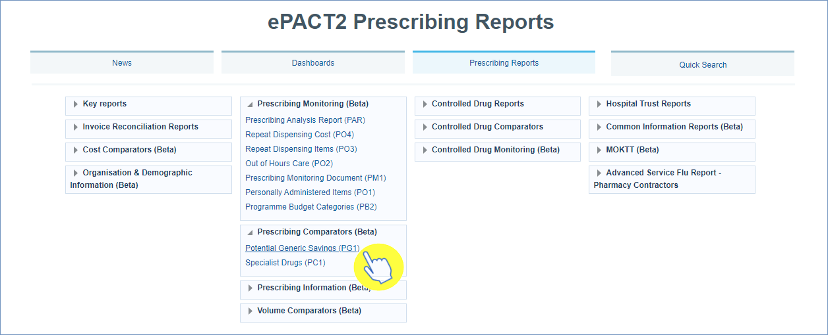

Using a Standard Report
The ‘Standard Reports’ are visually similar to the dashboard reports in style and layout. The ‘Standard Reports’ will be made up of several tabs/pages, that can be accessed in the same manner as the dashboard reports.
With this ‘Standard Reports’ example we are using the ‘Potential Generic Savings’ standard report.
- Select the main Tab/Page you wish to view, and then the Sub-tab:
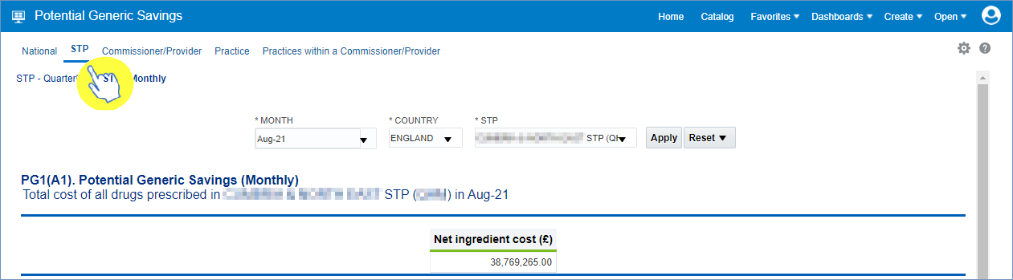

The ‘Criteria Selection’ can then be used to restrict the report to your chosen criteria. N.B - within this Standard Report the selection criteria has an ‘Apply’ button (highlighted red), this means that any change to the selection criteria must be applied by clicking this ‘Apply’ button to update the report to return the data for the relevant changes made:
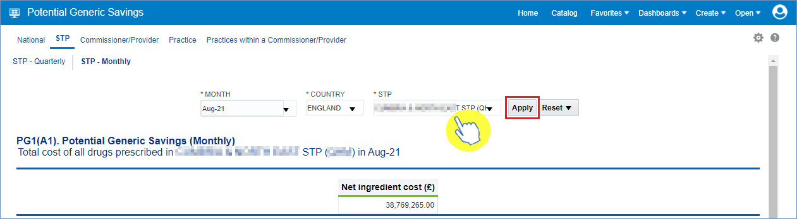

- The report will now return the data for the criteria selected, and beneath each of the views in the report there is again the options to ‘Export’ or ‘Print’ the data from the report (as highlighted):
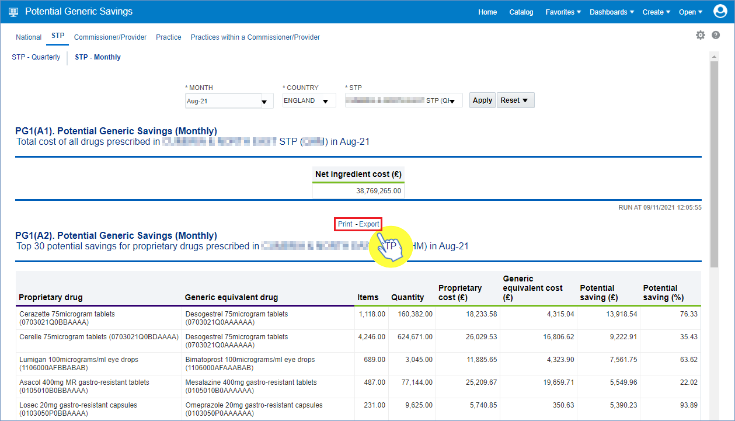

Using a Report Template
The ‘Report Templates’ are the second type of prescribing reports within the system. These reports will be found within the ‘Key Reports’ category in the ‘Prescribing Reports’ section of the system.
We will select the ‘High Cost Drugs’ report template (within the Key reports’ category) as an example.

- When you open the report, you will be prompted to enter your criteria within the selection prompts. N.B. – if these prompts/drop-down lists have an ‘*’ (asterisk) then these will require a selection in order for the report to return the data:
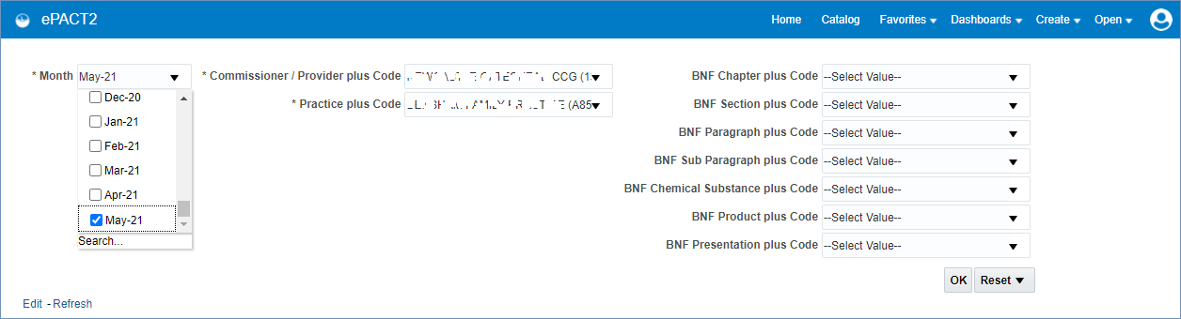

- Once the criteria has been selected then click the ‘OK’ button (beneath the BNF prompts) to generate the report:
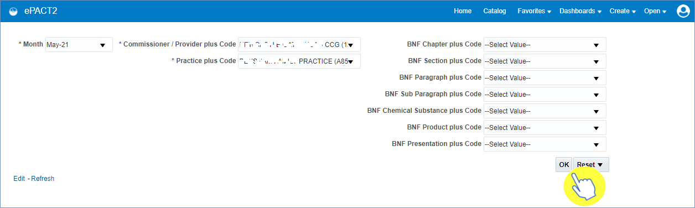

- After the report has been run with the selected criteria, then a table of data will be returned to show the ‘High Cost Drugs’ report. Essentially, this report will show the highest costed drugs prescribed and dispensed within the criteria selected:
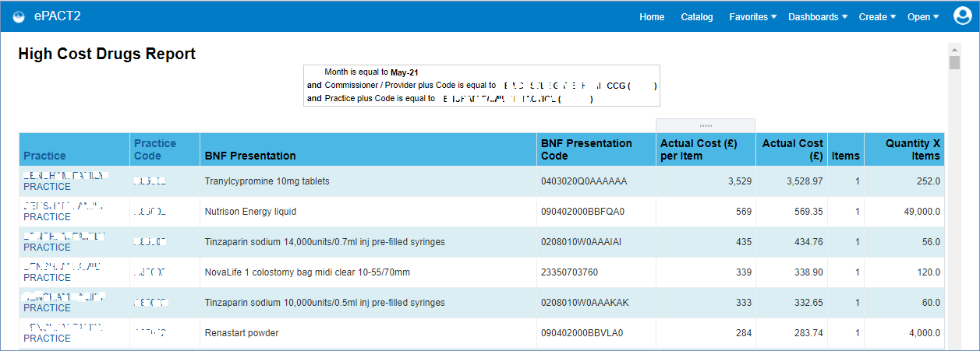

- Once generated, the report results can the be exported or printed using the ‘Export’ or ’Print’ links underneath the report results:
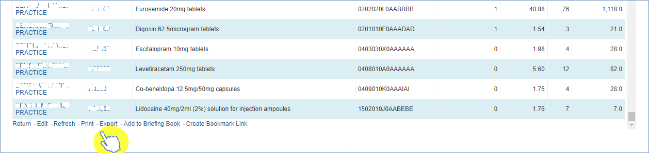

Getting more help

Additional training material and user guides
The ePACT2 training team has developed several how to guides to help you get the best out of ePACT2. These can be found on our ePACT2 user guides page
Webinar sessions
We offer a free, personalised webinar training service to all our users and you can book as many as you need.
You can let us know if you have any specific topics or reports you’d like to cover or if you would prefer an introductory tour. You can take part wherever you are as long as you can get online.
You can find our more and book you webinar by going to our ePACT2 training page

