ePACT2 user guide
STP - Controlled Drug Monitoring Reports

Interactive Contents
Use this interactive contents list to jump straight to the content you want to see. Just click the titles below to go directly to that section:
Contents
Accessing and Using the Controlled Drug Monitoring Reports 1
Accessing the Controlled Drug Monitoring Reports 1
Using the Controlled Drug Monitoring Reports 2
Other Reports Available for CD Accountable Officers 6
Getting more help 7

Accessing and Using the Controlled Drug Monitoring Reports
Within ePACT2 there are various pre-built reports available to aid CD Accountable Officers relating to the aspect of Controlled Drug monitoring and prescribing.
This guide will show you how to access and use these particular reports for the purpose of Controlled Drug monitoring, specifically focusing on the ‘CD Requisitions’ report and the ‘Private CD Analysis’ report.
Please note: these CD reports are run at STP level, if users are accountable for multiple STP’s with regards to Controlled Drug monitoring then each of those STP’s will have to be registered under the users’ ePACT2 account in order to view prescriber level information for each of those organisations.

Accessing the Controlled Drug Monitoring Reports
Once you have logged in to ePACT2 select the ‘Prescribing Reports’ tab
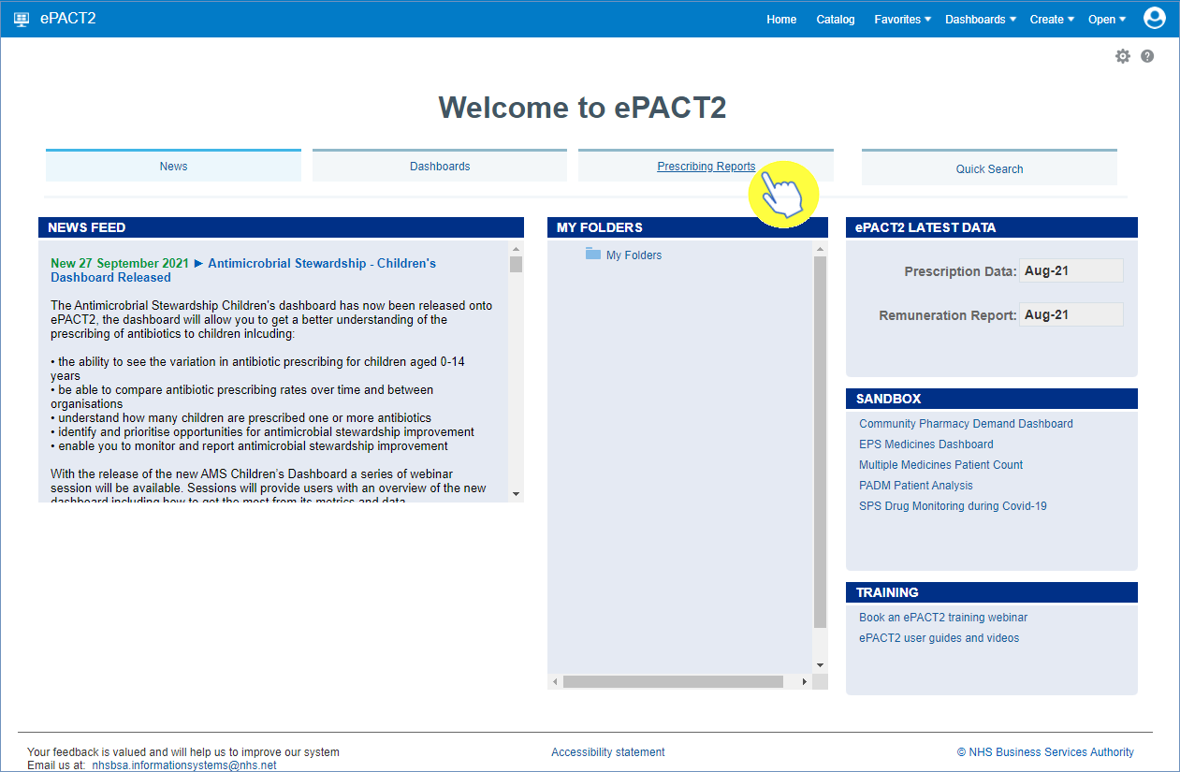

Next, expand the ‘Controlled Drug Monitoring (Beta)’ section to reveal the ‘CD Requisitions’ report and the ‘Private CD Analysis’ report
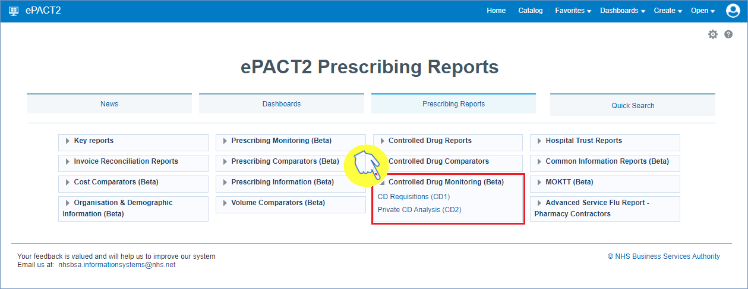
Then simply select the report you wish to use by clicking on it once.

Using the Controlled Drug Monitoring Reports
Whilst both the ‘CD Requisition’ and ‘Private CD Analysis’ reports appear as separate reports when the Controlled Drug Monitoring section is expanded, when either report is selected you will notice that in reality both of these reports are combined and can be accessed through the separate tabs in the report.
To access either, click on one of the links. In this case I have selected the CD Requisitions report (shown below with the CD Requisitions tab underscored blue)
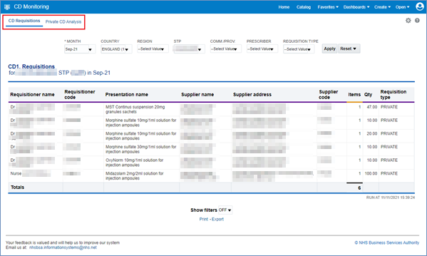
- These CD Requisitions are shown at STP level, and can be filtered on NHS or Private requisitions
- Data is presented in tab view and includes requisitioner and supplier details, as well as BNF name, items and quantity prescribed
You will then have the ability to select the criteria you wish to view (highlighted red), such as a specified time period to the STP you wish to view data for. Simply open up the drop-down list for each of the criteria you want to alter to make your selections.
Remember to click the ‘Apply’ button (highlighted yellow), when you have selected all the criteria you wish to view, in order to return the data you have requested
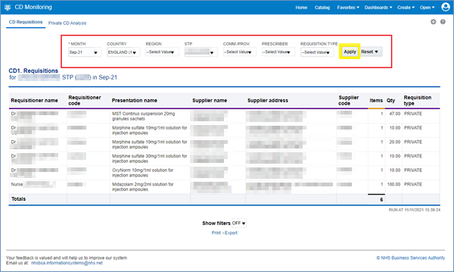

Once the system returns the results of the report you will be able to view all of the requisitions made for a particular month and within a specified STP, including whether these requisitions were NHS or private prescribing requisitions.
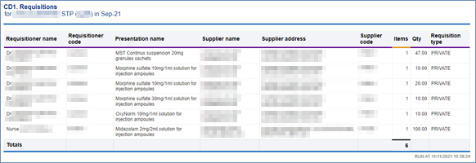
Next, we will access the ‘Private CD Analysis’ report. To access this from the ‘Prescribing Reports’ page simply click on the link for the report
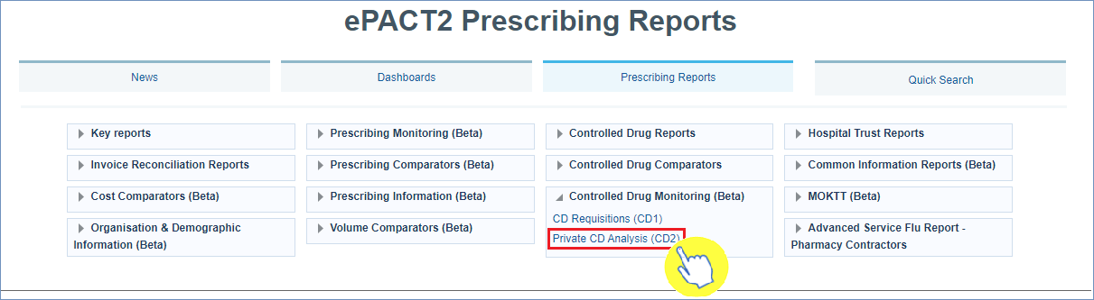

Or alternatively if you have already accessed the report through the ‘CD Requisitions’ report link, then simply select the ‘Private CD Analysis’ tab to change over to this report
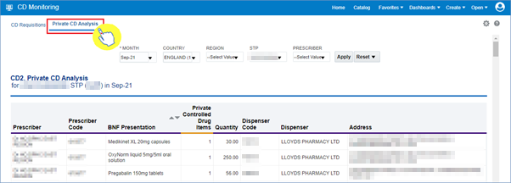

- The CD Private Analysis report provides data on the private prescribing of controlled drugs
- is shown at STP level, and includes prescriber details, BNF Name, items and quantity prescribed, dispenser details

Select the criteria you wish to view by selecting the relevant month, STP(s) etc from the drop-down lists available in the criteria selection options (highlighted red).
Remember to click the ‘Apply’ button (highlighted yellow) once all these selections have been made to return the data you want to see
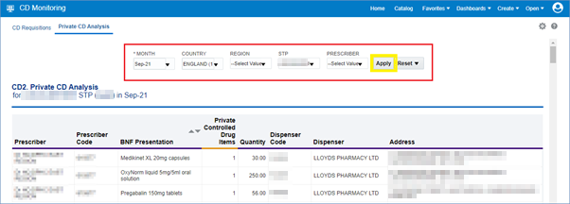

The system will then return the results for the criteria selected, showing all private prescribing of controlled drugs within the STP(s) selected
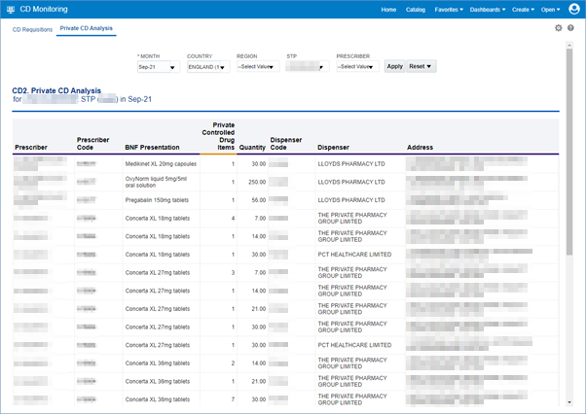
Remember: all of the data from these reports can be printed or exported out of the system using the print/export options underneath the results of each report you run:
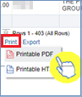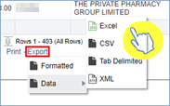

Other Reports Available for CD Accountable Officers
ePACT2 also has a variety of other reports concerning the prescribing of Controlled Drugs. These reports can be found within the ‘Controlled Drug Reports’ and ‘Controlled Drug Comparators’ sections (above the ‘Controlled Drug Monitoring’ section) within the Prescribing Reports area of ePACT2 (shown below).
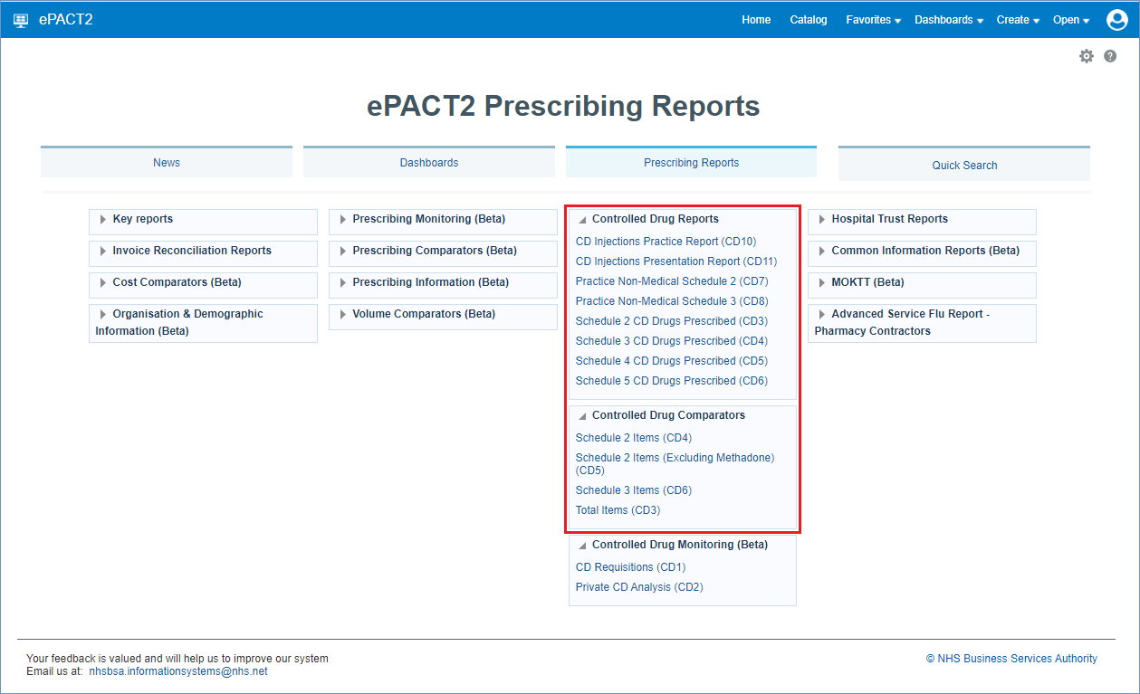

Getting more help

Additional training material and user guides
The ePACT2 training team has developed several how to guides to help you get the best out of ePACT2. These can be found on our ePACT2 user guides page
Webinar sessions
We offer a free, personalised webinar training service to all our users and you can book as many as you need.
You can let us know if you have any specific topics or reports you’d like to cover or if you would prefer an introductory tour. You can take part wherever you are as long as you can get online.
You can find our more and book you webinar by going to our ePACT2 training page

