ePACT2 user guide
STP - Reports to Get You Started

Interactive Contents
Use this interactive contents list to jump straight to the content you want to see.
Just click the titles below to go directly to that section:
How ePACT2 can be useful to you 1
What is ePACT2 1
How is it useful to you? 1
Polypharmacy Dashboard 3
Mental Health Prescribing Dashboard 4
Antimicrobial Stewardship Dashboard 6
OTC (Over the Counter) Dashboard 7
Potential Generic Savings Report 8
Getting more help 9

How ePACT2 can be useful to you

What is ePACT2
ePACT2 is an online business intelligence tool that allows you to access information on items which have been dispensed in the community and then subsequently submitted to the NHSBSA for processing.
It is important to know that when comparing the data in ePACT2 to what is in your prescribing systems it is unlikely to match completely. We only have data for prescriptions which have been submitted for processing, there may be items which have been prescribed that the patient didn’t take to get dispensed, or the dispenser hasn’t submitted for processing that we don’t have data for. The date shown in ePACT2 is the month they were submitted by the dispenser for processing and may not correlate to month the prescription was issued, we do not capture the date the prescription was issued by your organisation.
We do capture a lot of information from the prescription form during processing. As the prescriptions are processed we capture data including details of the item prescribed, who prescribed it and if the NHS Number is available on the form and we have been able to read it, the patient the prescription was issued to. This information can then be accessed through ePACT2 to allow user to identify what is being prescribed by their organisation.
Please note while we do identify the patient the prescription was issued too, using the NHS number on the prescription form, those identifiable details cannot be accessed in ePACT2. This means you cannot run your own reports to see for example patients on a combination of drugs you are interested in, but we at the NHSBSA have built and made available reports that show things like patients on 10 or more unique medicines.

How is it useful to you?
Once the data has been captured and is available in the system it can then be used in a few ways by STP’s to both monitor prescribing and to improve patient care.
There are a range of different pre-built reports available in the system which will break the data down, focussing on different clinical areas to allow you to identify any areas you may like to investigate further. The visualisations within the dashboards and reports make the information easier to interpret.
For example, you may want to identify patients which are taking multiple medicines that you would like to do a prescribing review with, the Polypharmacy dashboard will help you quickly and easily identify the number of patients taking 10, 15, 20 or more unique medicines.
You might want to identify any patients receiving antidepressants that you would like to investigate further, the Mental Health Prescribing Comparators dashboard will breakdown the prescribing of antidepressants for a range of comparators to allow you to quickly and easily identify if there are any under your organisation.
What is very useful is the ability to compare CCG’s within your specified STP. As well as helping you identify if there are any patients you may wish to carry out reviews with the system will also help you compare your organisation against every other one nationally. When you register for access to the system you will be given access to information for all organisations nationally down to practice level. This means you can compare yourself against other Practices, PCNs, CCGs etc. to identify how you are performing compared with your peers.
Access to historical data also allows you to compare how you have performed over a longer time period, and to identify the effect of any changes you may have implemented. For example, the trend over time breakdown available in the Polypharmacy dashboard will allow you to identify if any medication reviews have affected the number of patients receiving multiple medicines.

Overall, ePACT2 provides a comprehensive breakdown of the prescribing attributed to an organisation to allow users to monitor and compare ensuring the best outcomes for patients.
This guide does not detail everything you will need for your role, but we hope it offers some guidance to reports that have been produced by the NHSBSA that can help towards your goal of improving patient health.
The reports in ePACT2 by no means provide all the information you need but they should give you a starting point of places you might want to focus your resource.
We are always open to feedback, if you have found a report available within ePACT2 that you think would be of benefit to all STP users please let us know and we can add it to our guidance document: nhsbsa.epact2training@nhs.net

Polypharmacy Dashboard
We have selected this dashboard as a useful one to show you, as it has a comparator which shows the percentage of patients prescribed 10 or more unique medicines.
Polypharmacy has been described as the use of multiple medications by a patient generally, but not exclusively, older adults aged 65 and over. Polypharmacy is a key issue in health and social care, as evidence suggests that being on multiple medications increases the individuals’ risk of harm and contributes to hospital admissions and poor therapeutic outcomes. Indeed, patients on 10 or more medicines are over 300% more likely to be admitted to hospital.
The purpose of the polypharmacy prescribing comparators is to allow PCNs, GP Practices and CCGs to:
- see the variation in prescribing across GP practices, within a CCG/ PCN and across CCGs within an STP
- identify if polypharmacy is an area to be investigated
- to help prioritise potential areas of activity
- demonstrate the impact of initiatives to address polypharmacy
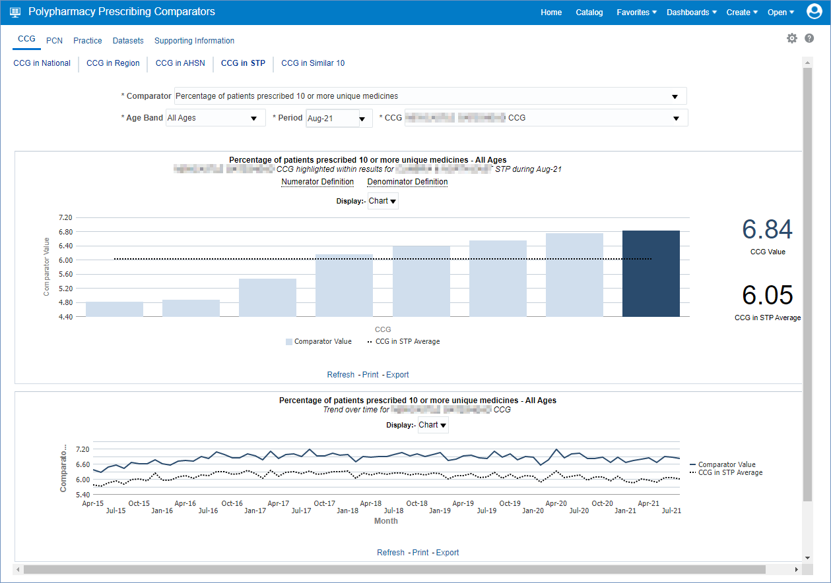

Mental Health Prescribing Dashboard
The Mental Health Prescribing dashboard has been designed to allow users to monitor the specific prescribing of items used for the treatment of mental health conditions, where there may be a possible unintended risk to health. These items can include antidepressants, antipsychotics and multiple psychotropic medicines.
The dashboard will allow you to compare your organisations performance within this area at a national level against all other CCG’s throughout England. It also allows you to make the comparison of CCG’s within the a specified STP you organisation falls under. With each of these comparisons there is the option of a ‘normalised’ view which will adapt the data to ‘per 1000 patients’ to give a fairer demographic comparison.
Within this dashboard you can also identify groups of patients being prescribed multiple antidepressants/antipsychotics, and patients under the age of 18 being prescribed mental health treatments. To identify these patients, in order to carry out investigations, we have an external request procedure that will allow the user to request the patient details (their NHS number), as long as they meet the criteria set out in the request procedure.

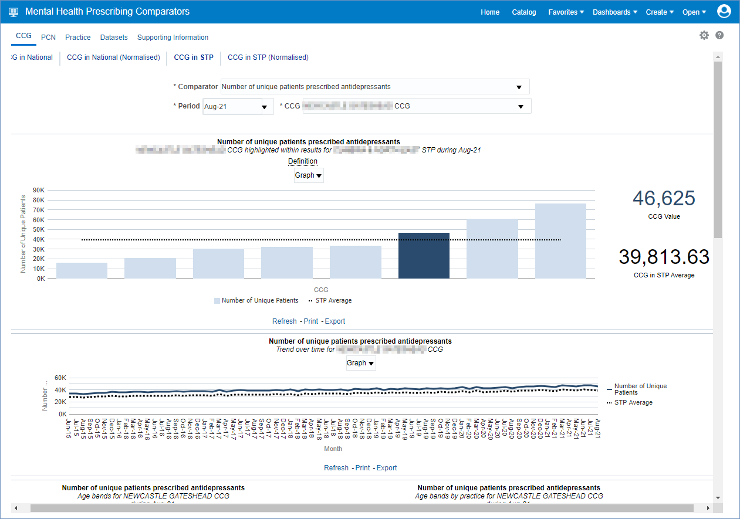
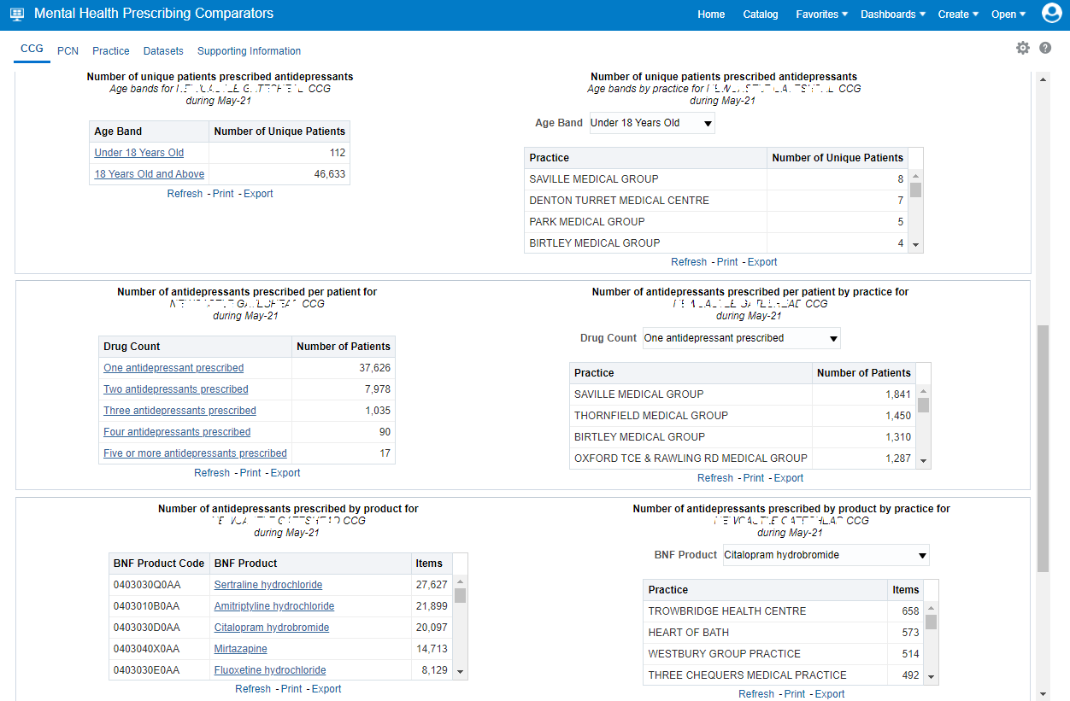

Antimicrobial Stewardship Dashboard
In collaboration with NHS Improvement, the 'Antimicrobial Stewardship' dashboard has been developed to support the national antimicrobial resistance strategy.
Within the CCG view tab of this dashboard users can monitor the prescribing of antimicrobial medicines. You can view how your organisation is performing nationally, or alternatively compare your organisations’ prescribing against that of the STP, AHSN or Similar10 that your organisation resides in.
A particular interest may be of the trend over time graph of prescribing Antibacterial BNF 5.1 items per Star PU within your organisation against a national/STP/AHSN/Similar10 comparison.
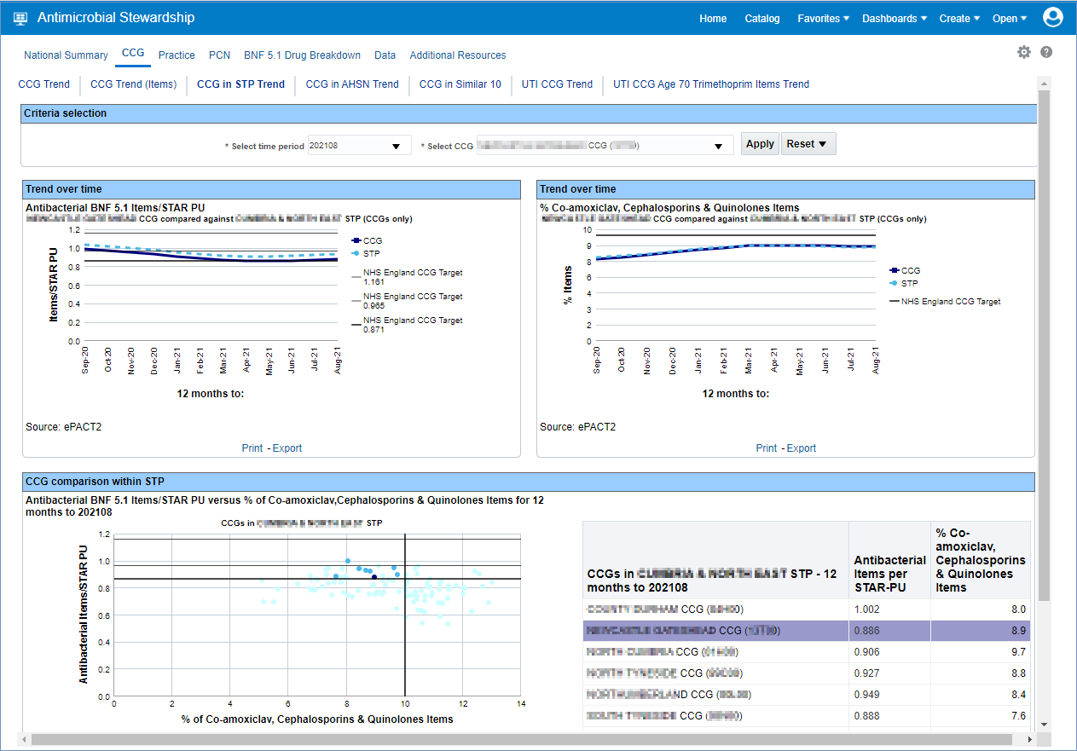

Once the report has been accessed, if this is an area you have identified for improvement you could then access the ‘Practice’ tab and breakdown the CCGs within a specified STP into its relevant practices to investigate if there are any outliers affecting your performance in this area.

OTC (Over the Counter) Dashboard
The ‘OTC (Over the Counter)’ dashboard has been designed to focus on items that have been deemed readily obtainable ‘Over the Counter’ of a dispensary and, as such, have been recommended not for routine prescribing within primary care. There is a list of conditions in which these items have been considered to be ‘Over the Counter’ and not for routine prescribing.
The list of conditions includes those that are either:
- considered to be self-limiting, so they do not need treatment as they’ll heal or be cured of their own accord
- able to lend themselves to self-care. This means the person who is suffering does not normally need medical advice, they can manage the condition by buying medicine over the counter
There are categories of items included in the dashboard:
- that can be purchased over the counter, sometimes at a lower cost what it would be through the NHS
- where there’s little evidence of clinical effectiveness
The guidance for these items has been set out by NHS England and can be found in the following link - NHS England OTC guidance for CCG's
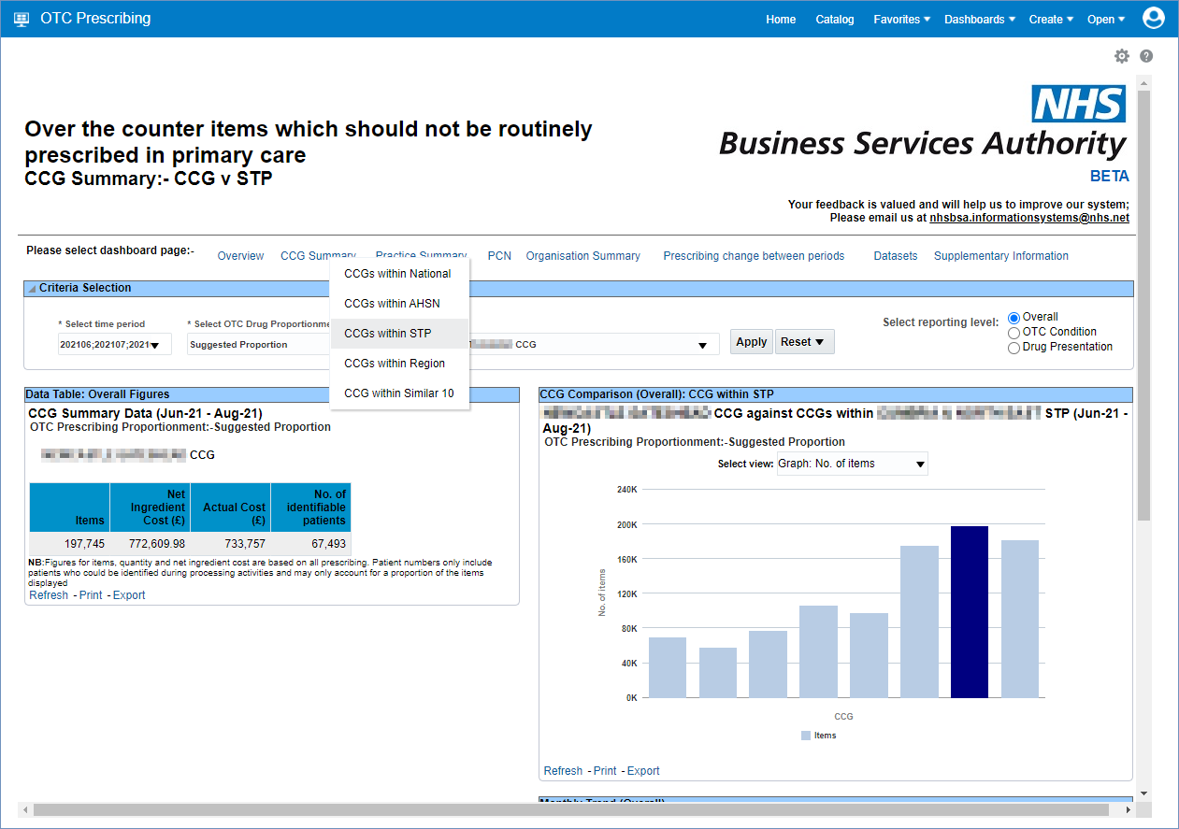

Potential Generic Savings Report
The ‘Potential Generic Savings’ report has been developed to show users the top 30 proprietary drugs that have been prescribed and dispensed for their CCG within the selected time period, where the system recognises that there is a ‘generic equivalent’ drug available that could be prescribed at a lower cost to that of the proprietary drug that was prescribed and dispensed.
What the report does not do is make any clinical judgement to the reasoning behind the prescribing of the proprietary drug, it will merely suggest that there is a generic equivalent for the proprietary drugs listed, and if these generic drugs were prescribed each time instead of the proprietaries then these are the potential savings you could make as an organisation.

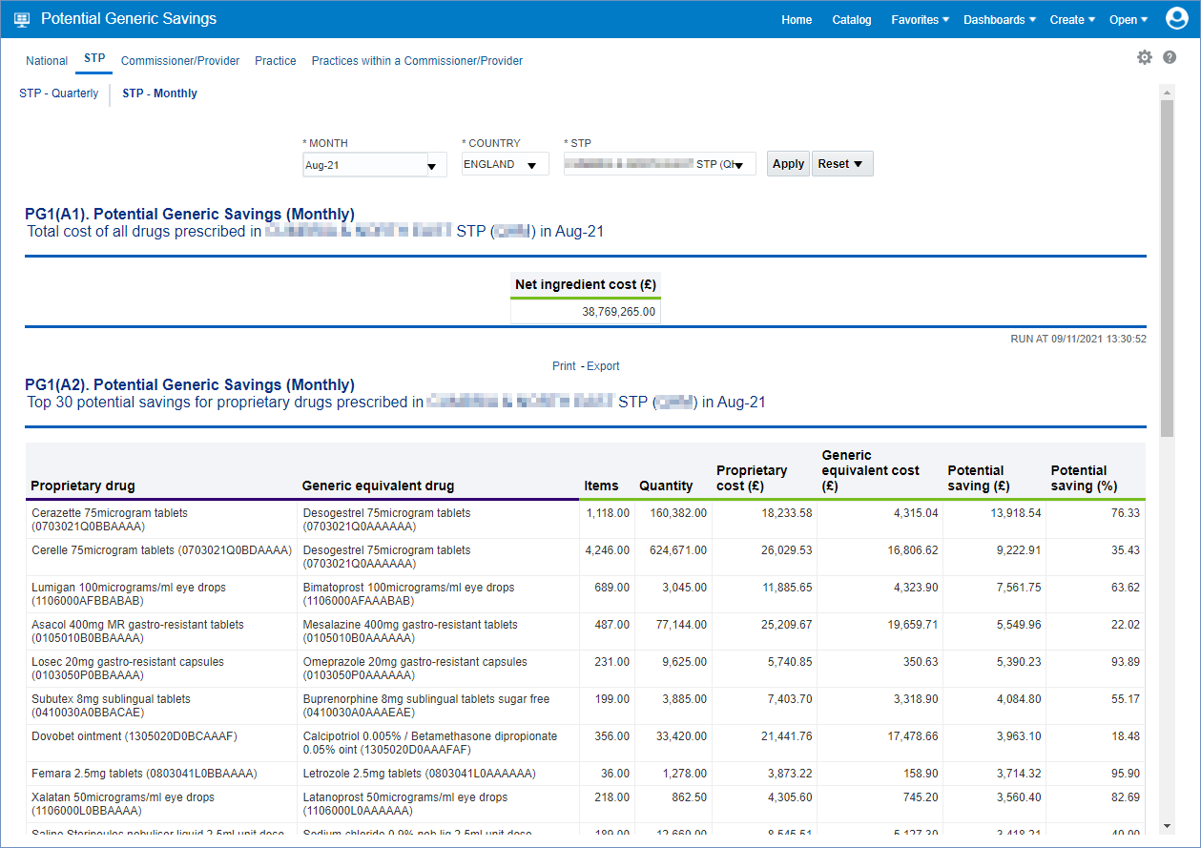

Getting more help

Additional training material and user guides
The ePACT2 training team has developed several how to guides to help you get the best out of ePACT2. These can be found on our ePACT2 user guides page
Webinar sessions
We offer a free, personalised webinar training service to all our users and you can book as many as you need.
You can let us know if you have any specific topics or reports you’d like to cover or if you would prefer an introductory tour. You can take part wherever you are as long as you can get online.
You can find our more and book you webinar by going to our ePACT2 training page

